

Project

SWIFT Integration and Monitoring System

Anastasiia Kravchenko

S32802

**Table of Contents**

Introduction: 3

What the Database Should Achieve: 4

**Who Will Use It? 5**

**What Kind of Information Will It Store? 5**

**Problems it Solves: 5**

ERD Diagram 6

What the Database Should Do: 9

Data That Could Be Stored in Each of These Tables: 10

Bibliography 15

# **Introduction:**

Imagine a system that helps a financial institution manage its money transfers and keep everything running smoothly and securely. This database is like the brain of that system, designed to store and organize all the important information about these transfers.

## **What the Database Should Achieve:**

1. **Monitoring Financial Transfers:** The database will assist the organization in maintaining a log of all financial transactions, including the date, amount, and currencies involved. This facilitates reviewing previous transactions.
2. **Verifying the Correctness of Transfers:** The database will assist in verifying that all required information is accurate and compliant with regulations before a money transfer is completed. The system will be aware of issues, such as missing account numbers.
3. **Problem Alerting:** The database will assist in creating alerts if there are any problems with the transfers or the system itself, such as a potential security issue or a processing error.
4. **Generating Reports:** The database will enable the organization to produce reports regarding money transfers and any issues that arise.
5. **Controlling Who Can Do What:** The database will assist in determining which staff members have access to various system components and what activities they are permitted to perform. For instance, some people may only be able to view reports, while others may be able to process transfers.
6. **Keeping Bank Information:** A directory of the names and codes of the various banks involved in the transfers will be kept in the database.
7. **Managing Bank Accounts:** Details regarding the bank accounts that are part of the transfers, such as account numbers and the owners, will also be kept in the database.
8. **Keeping a Record of System Activity:** The database will maintain a record of all system events, including user logins and errors. This aids in troubleshooting and security.

### **Who Will Use It?**

Employees of the financial institution who handle money transfer processing, system monitoring, user access management, and report generation will use this database.

### **What Kind of Information Will It Store?**

The database will store information about:

* Individual money transfers (when, how much, and currencies)
* Guidelines for verifying the accuracy of transfers.
* Details about various banks.
* Currency exchange rates.
* Information regarding bank accounts.
* Issues or mistakes that arise.
* System-generated reports.
* Workers who utilize the system and their capabilities.
* A record of the system's events.

### **Problems it Solves:**

This database solves the problem of managing a large number of financial transactions in an organized and secure way. It helps to:

* Reduce errors in money transfers.
* Improve the speed of processing transfers.
* Enhance the security of the system.
* Provide better insights into the transfer process through reporting.
* Ensure compliance with regulations.

# **ERD Diagram**

[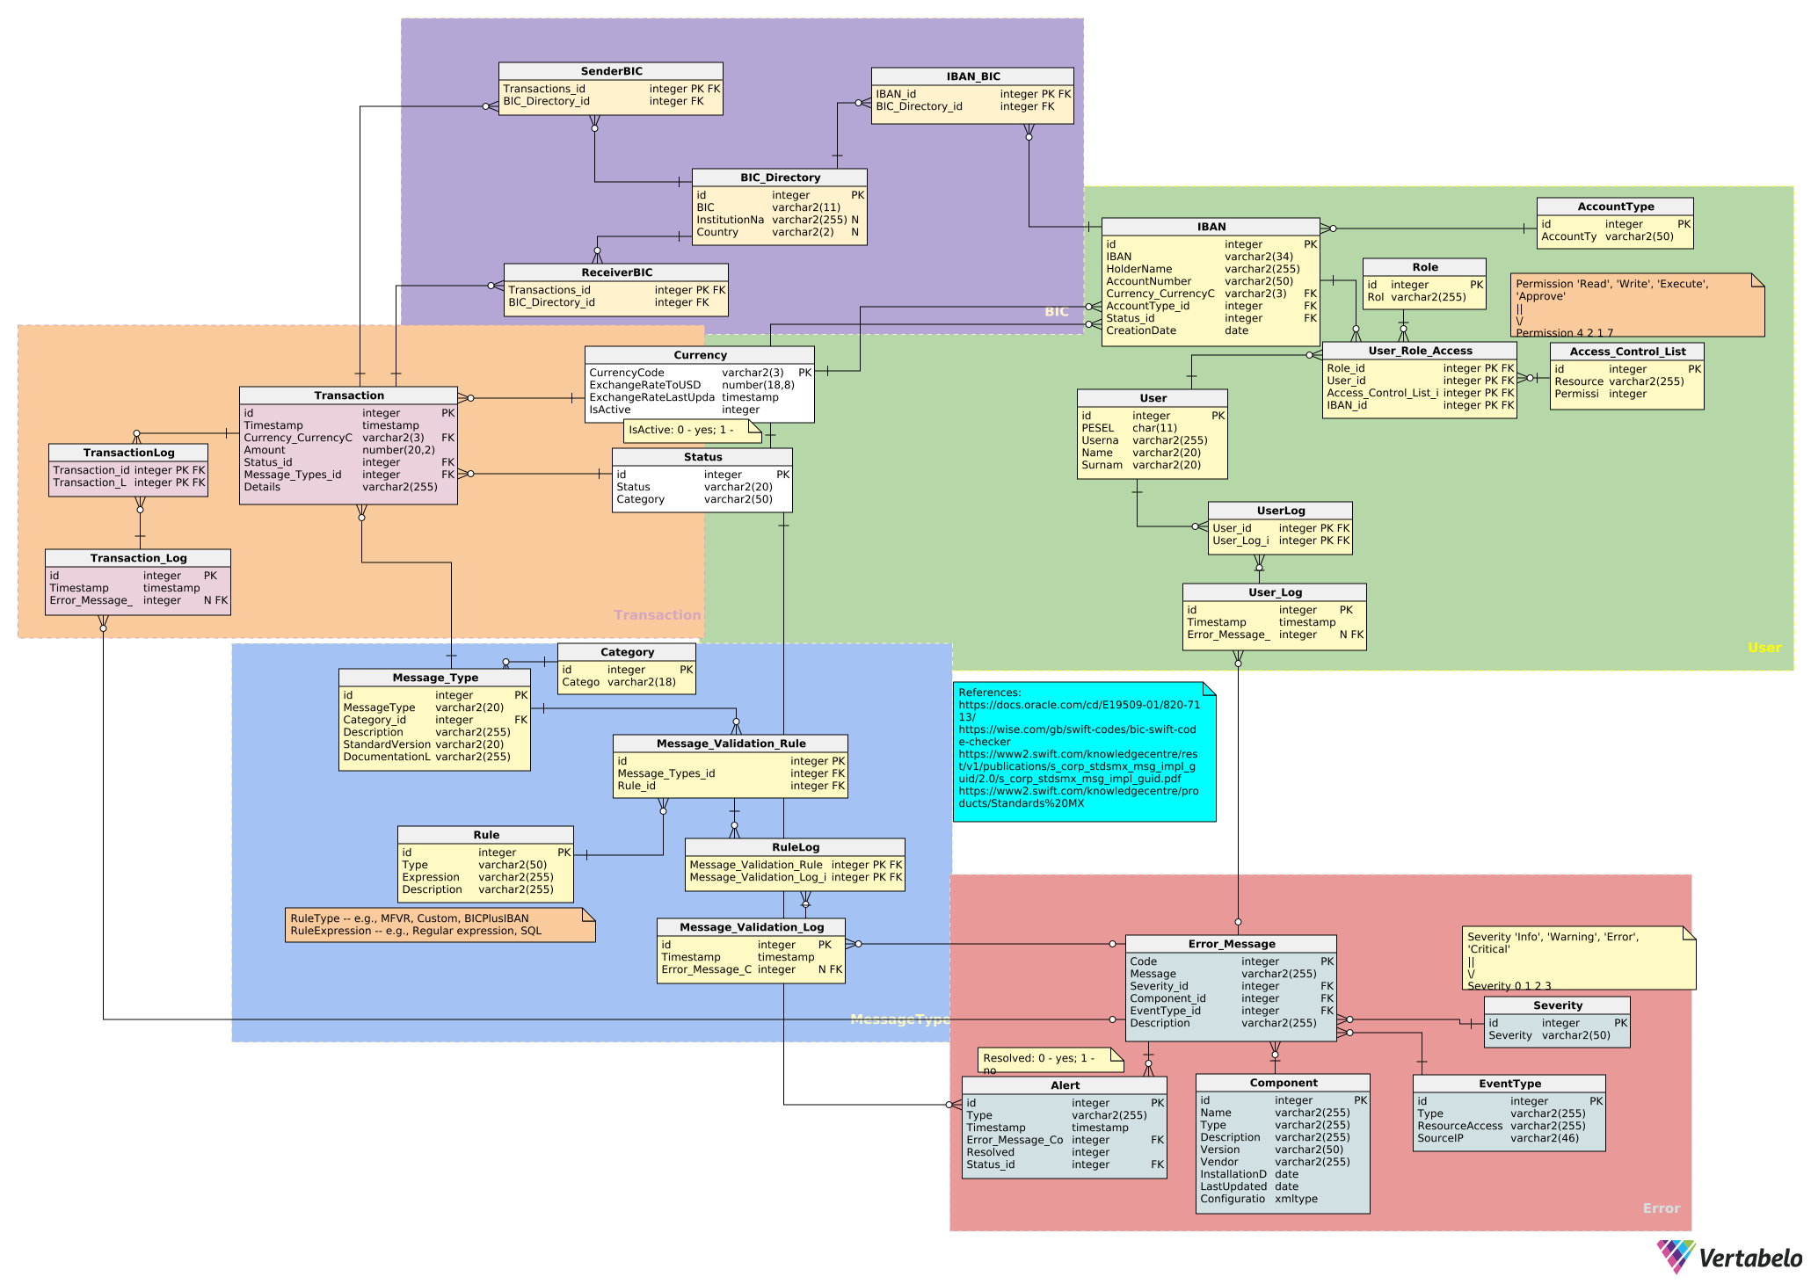](https://my.vertabelo.com/doc/8yuno2v9TNdXclj6hNCgajLXb30LpoTY)

[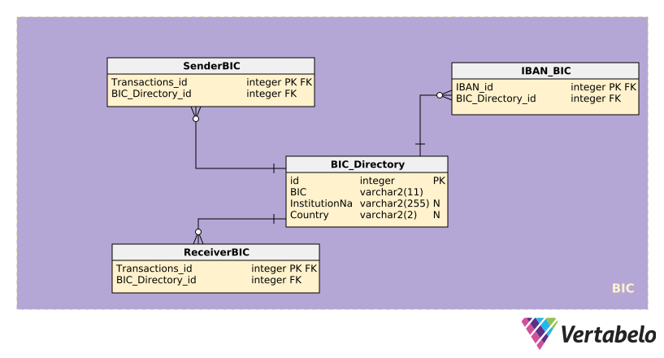](https://my.vertabelo.com/doc/8yuno2v9TNdXclj6hNCgajLXb30LpoTY)

[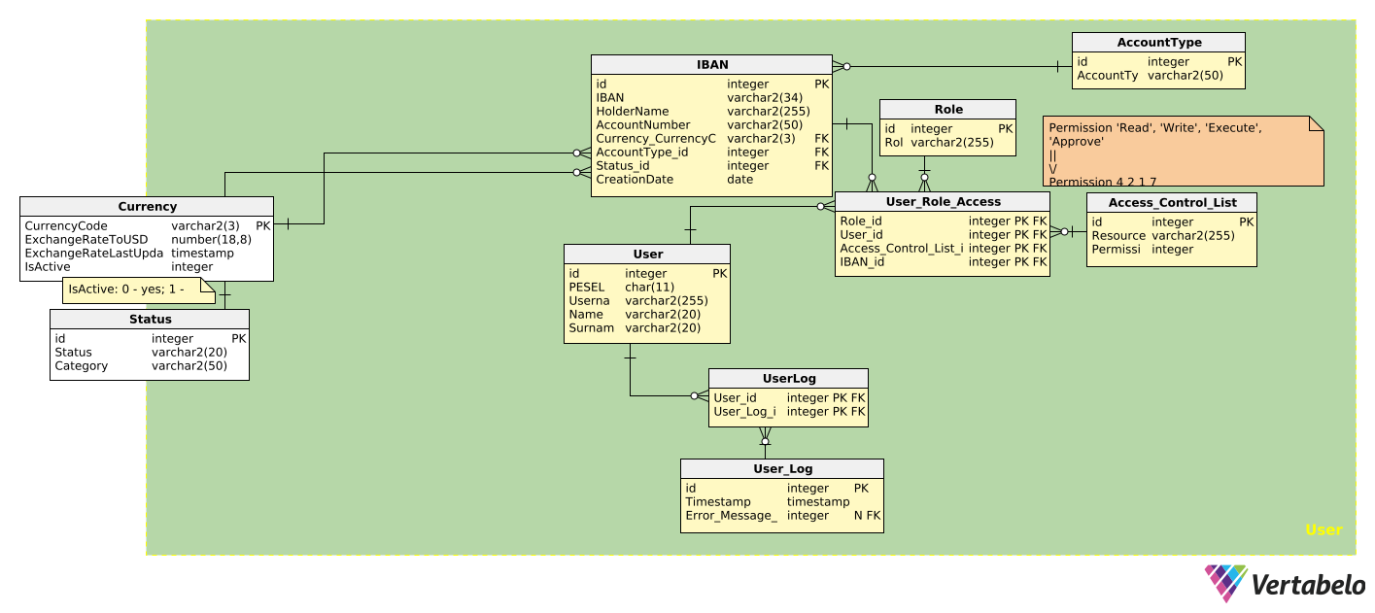](https://my.vertabelo.com/doc/8yuno2v9TNdXclj6hNCgajLXb30LpoTY)

[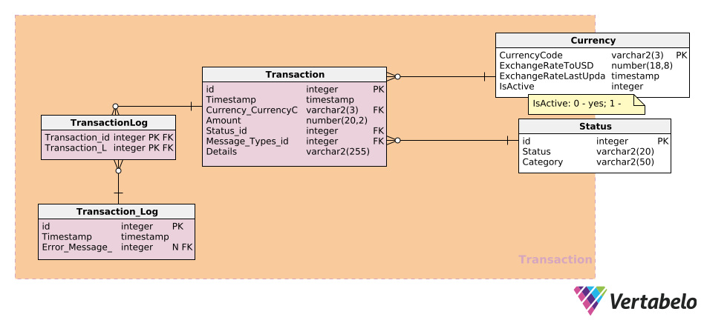](https://my.vertabelo.com/doc/8yuno2v9TNdXclj6hNCgajLXb30LpoTY)

[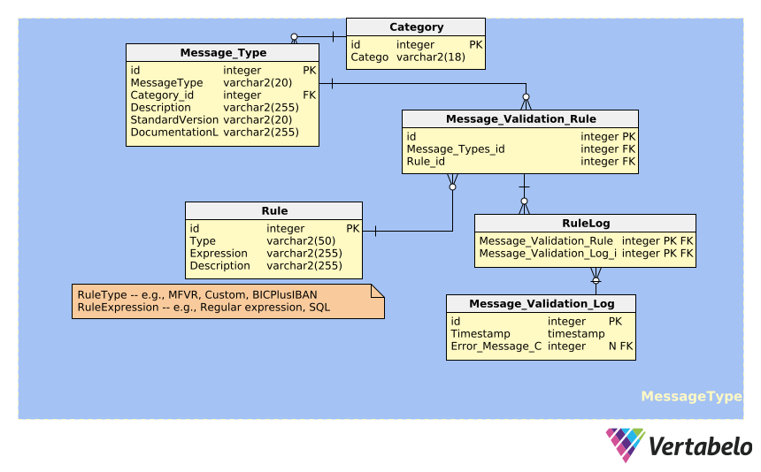](https://my.vertabelo.com/doc/8yuno2v9TNdXclj6hNCgajLXb30LpoTY)

[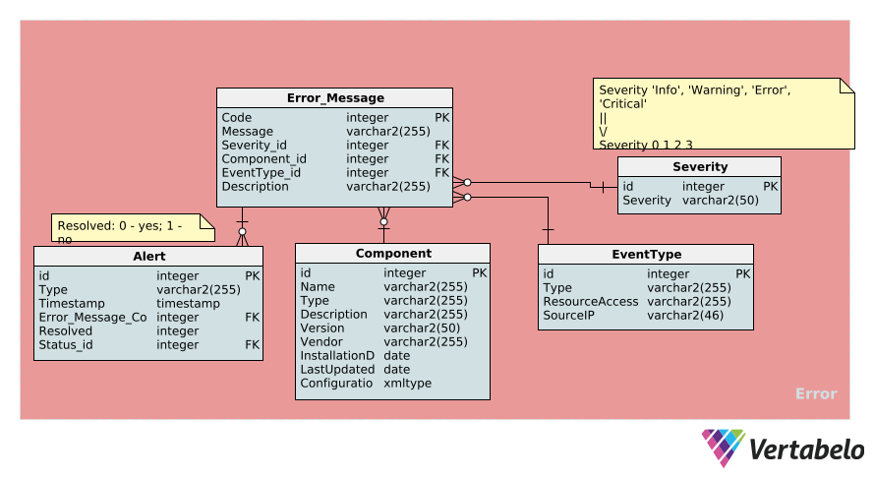](https://my.vertabelo.com/doc/8yuno2v9TNdXclj6hNCgajLXb30LpoTY)

# **What the Database Should Do:**

1. **Validate Incoming Messages:** The system shall validate incoming financial messages (MT and ISO 20022 formats) against defined validation rules.
2. **Process Credit Transfers:** The system shall process single customer credit transfer messages (MT103) and update transaction statuses.
3. **Record Transaction Details:** The system shall record all relevant details of processed transactions, including timestamp, currency, amount, and involved parties.
4. **Generate Alerts for Validation Failures:** The system shall generate alerts when incoming messages fail validation rules, including the error message code and timestamp.
5. **Search Transaction History:** The system shall allow users to search and view transaction history based on criteria such as date range, account number, or status.
6. **Manage User Roles and Permissions:** The system shall allow administrators to create and manage user roles and assign specific permissions to access system functionalities and data.
7. **Maintain BIC Directory:** The system shall allow authorized users to add, update, and view BIC directory information.
8. **Update Currency Exchange Rates:** The system shall allow authorized users to update currency exchange rates, including the last updated timestamp.
9. **Log User Login Activities:** The system shall log user login and logout activities, including timestamps and source IP addresses.
10. **Generate Message Validation Reports:** The system shall generate reports on message validation activities, including the number of successful and failed validations and the types of validation errors.

# **Data That Could Be Stored in Each of These Tables:**

**Access_Control_List Table:**

* ID: 1, Resource: User Management, Permission: 7
* ID: 2, Resource: Account Access, Permission: 5
* ID: 3, Resource: Transaction History, Permission: 3

**AccountType Table:**

* ID: 1, AccountType: Savings
* ID: 2, AccountType: Checking
* ID: 3, AccountType: Credit Card

**Alert Table:**

* ID: 1, Type: System Error, Timestamp: 2025-03-30 13:00:00, Error_Message_Code: 101, Resolved: 0, Status_id: 8
* ID: 2, Type: Security Breach, Timestamp: 2025-03-30 13:05:00, Error_Message_Code: 205, Resolved: 0, Status_id: 8
* ID: 3, Type: High Transaction Volume, Timestamp: 2025-03-30 13:10:00, Error_Message_Code: 310, Resolved: 0, Status_id: 8

**BIC_Directory Table:**

* ID: 1, BIC: ABCDUSNYXXX, InstitutionName: Bank of America, Country: US
* ID: 2, BIC: BBBBGB2LXXX, InstitutionName: Barclays Bank, Country: GB
* ID: 3, BIC: CCCCFR21XXX, InstitutionName: Credit Agricole, Country: FR

**Category Table:**

* ID: 1, Category: MT1xx
* ID: 2, Category: MT2xx
* ID: 3, Category: MT3xx

**Component Table:**

* ID: 1, Name: Alliance Access, Type: Software, Description: SWIFT messaging interface, Version: 7.4, Vendor: SWIFT, InstallationDate: 2024-01-15, LastUpdated: 2024-03-15, Configuration: <config><interface>TCP/IP</interface></config>
* ID: 2, Name: HSM, Type: Hardware, Description: Hardware Security Module, Version: v3.2, Vendor: Thales, InstallationDate: 2023-11-01, LastUpdated: 2024-02-10, Configuration: <config><keyLength>2048</keyLength></config>
* ID: 3, Name: Messaging Gateway, Type: Software, Description: Message routing service, Version: 1.5, Vendor: In-house, InstallationDate: 2024-02-01, LastUpdated: 2024-03-20, Configuration: <config><routing>XML</routing></config>

**Currency Table:**

* CurrencyCode: USD, ExchangeRateToUSD: 1.00000000, ExchangeRateLastUpdated: 2025-03-30 12:00:00, IsActive: 1
* CurrencyCode: EUR, ExchangeRateToUSD: 1.08000000, ExchangeRateLastUpdated: 2025-03-30 12:00:00, IsActive: 1
* CurrencyCode: GBP, ExchangeRateToUSD: 1.25000000, ExchangeRateLastUpdated: 2025-03-30 12:00:00, IsActive: 1

**Error_Message Table:**

* Code: 101, Message: System Error Encountered, Severity_id: 3, Component_id: 1, EventType_id: 1, Description: An unexpected system error occurred during message parsing.
* Code: 205, Message: Unauthorized Access Attempt, Severity_id: 4, Component_id: 5, EventType_id: 2, Description: An attempt to access a protected resource was made without proper authorization.
* Code: 310, Message: High Transaction Volume Detected, Severity_id: 2, Component_id: 10, EventType_id: 3, Description: The transaction volume exceeded predefined thresholds.

**EventType Table:**

* ID: 1, Type: System, ResourceAccessed: Message Processing, SourceIP: 127.0.0.1
* ID: 2, Type: Security, ResourceAccessed: Account Data, SourceIP: 192.168.1.100
* ID: 3, Type: Transaction, ResourceAccessed: Transaction Queue, SourceIP: 10.0.0.5

**IBAN Table:**

* ID: 1, IBAN: GB82WEST12345698765432, HolderName: John Smith, AccountNumber: ACC123456, Currency_CurrencyCode: GBP, AccountType_id: 2, Status_id: 1, CreationDate: 2024-03-15
* ID: 2, IBAN: DE89370400440532013000, HolderName: Maria Müller, AccountNumber: DE532013000, Currency_CurrencyCode: EUR, AccountType_id: 1, Status_id: 1, CreationDate: 2024-03-01
* ID: 3, IBAN: FR7630004000061234567890189, HolderName: Jean Dupont, AccountNumber: FR1234567890, Currency_CurrencyCode: EUR, AccountType_id: 2, Status_id: 1, CreationDate: 2024-03-22

**IBAN_BIC Table:**

* IBAN_id: 1, BIC_Directory_id: 2
* IBAN_id: 2, BIC_Directory_id: 4
* IBAN_id: 3, BIC_Directory_id: 3

**Message_Type Table:**

* ID: 1, MessageType: MT103, Category_id: 1, Description: Single Customer Credit Transfer, StandardVersion: 2023, DocumentationLink: <https://www.swift.com/mt103>
* ID: 2, MessageType: MT202, Category_id: 2, Description: General Financial Institution Transfer, StandardVersion: 2023, DocumentationLink: <https://www.swift.com/mt202>
* ID: 3, MessageType: MT300, Category_id: 3, Description: Foreign Exchange Confirmation, StandardVersion: 2023, DocumentationLink: <https://www.swift.com/mt300>

**Message_Validation_Log Table:**

* ID: 1, Timestamp: 2025-03-30 12:50:00, Error_Message_Code: 603
* ID: 2, Timestamp: 2025-03-30 12:55:00, Error_Message_Code: 402
* ID: 3, Timestamp: 2025-03-30 13:00:00, Error_Message_Code: 603

**Message_Validation_Rule Table:**

* ID: 1, Message_Types_id: 1, Rule_id: 1
* ID: 2, Message_Types_id: 1, Rule_id: 2
* ID: 3, Message_Types_id: 2, Rule_id: 3

**ReceiverBIC Table:**

* Transactions_id: 1, BIC_Directory_id: 2
* Transactions_id: 2, BIC_Directory_id: 4
* Transactions_id: 3, BIC_Directory_id: 3

**Role Table:**

* ID: 1, Role: Administrator
* ID: 2, Role: Operator
* ID: 3, Role: Auditor

**Rule Table:**

* ID: 1, Type: Regex, Expression: ^MT103.*, Description: Message type must start with MT103
* ID: 2, Type: Length, Expression: 11, Description: Sender BIC length must be 11 characters
* ID: 3, Type: Presence, Expression: NOT NULL, Description: Receiver BIC must be present

**RuleLog Table:**

* Message_Validation_Rule_id: 1, Message_Validation_Log_id: 1
* Message_Validation_Rule_id: 2, Message_Validation_Log_id: 1
* Message_Validation_Rule_id: 3, Message_Validation_Log_id: 2

**SenderBIC Table:**

* Transactions_id: 1, BIC_Directory_id: 1
* Transactions_id: 2, BIC_Directory_id: 2
* Transactions_id: 3, BIC_Directory_id: 3

**Severity Table:**

* ID: 1, Severity: Low
* ID: 2, Severity: Medium
* ID: 3, Severity: High

**Status Table:**

* ID: 1, Status: Pending, Category: Transaction
* ID: 2, Status: Completed, Category: Transaction
* ID: 3, Status: Failed, Category: Transaction

**Transaction Table:**

* ID: 1, Timestamp: 2025-03-30 12:00:00, Currency_CurrencyCode: USD, Amount: 150000.00, Status_id: 2, Message_Types_id: 1, Details: Payment for services
* ID: 2, Timestamp: 2025-03-30 12:05:00, Currency_CurrencyCode: EUR, Amount: 75000.50, Status_id: 2, Message_Types_id: 2, Details: Interbank transfer
* ID: 3, Timestamp: 2025-03-30 12:10:00, Currency_CurrencyCode: GBP, Amount: 200000.00, Status_id: 2, Message_Types_id: 3, Details: FX trade confirmation

**TransactionLog Table:**

* Transaction_id: 1, Transaction_Log_id: 1
* Transaction_id: 2, Transaction_Log_id: 2
* Transaction_id: 3, Transaction_Log_id: 3

**Transaction_Log Table:**

* ID: 1, Timestamp: 2025-03-30 12:00:10, Error_Message_Code: NULL
* ID: 2, Timestamp: 2025-03-30 12:05:15, Error_Message_Code: NULL
* ID: 3, Timestamp: 2025-03-30 12:10:20, Error_Message_Code: NULL

**User Table:**

* ID: 1, PESEL: 8001011234, Username: jsmith, Name: John, Surname: Smith
* ID: 2, PESEL: 8502025678, Username: mmuller, Name: Maria, Surname: Müller
* ID: 3, PESEL: 9003039876, Username: bjohnson, Name: Bob, Surname: Johnson

**UserLog Table:**

* User_id: 1, User_Log_id: 1
* User_id: 2, User_Log_id: 2
* User_id: 3, User_Log_id: 3

**User_Log Table:**

* ID: 1, Timestamp: 2025-03-30 12:15:00, Error_Message_Code: NULL
* ID: 2, Timestamp: 2025-03-30 12:20:00, Error_Message_Code: NULL
* ID: 3, Timestamp: 2025-03-30 12:25:00, Error_Message_Code: NULL

**User_Role_Access Table:**

* Role_id: 1, User_id: 1, Access_Control_List_id: 1, IBAN_id: 1
* Role_id: 2, User_id: 2, Access_Control_List_id: 2, IBAN_id: 2
* Role_id: 3, User_id: 3, Access_Control_List_id: 3, IBAN_id: 3

# **Bibliography**

1. [Sun Microsystems, Inc. (2008). *SWIFT Integration Projects.* Santa Clara, CA: Sun Microsystems, Inc.](https://docs.oracle.com/cd/E19509-01/820-7113/)
2. [SWIFT. (2022). *Standards MX Message Implementation Guide.* SWIFT.](https://www2.swift.com/knowledgecentre/rest/v1/publications/s_corp_stdsmx_msg_impl_guid/2.0/s_corp_stdsmx_msg_impl_guid.pdf)
3. [Wise.com. (2011). *SWIFT Code Checker.* California - San Jose - Cloudflare Inc.: Kristo Käärmann.](https://wise.com/gb/swift-codes/bic-swift-code-checker)
4. [MX Message](https://www2.swift.com/knowledgecentre/products/Standards%20MX)