BLEKINGE INSTITUTE OF TECHNOLOGY, ANASTASIA BRINATI KARLSKRONA, SWEDEN. 07-04-2023

**Assignment 3: Visualizations in Game Analytics**

**Abstract**

The present report illustrates personal considerations that could help with the development of the videogame ‘VizGuild’ through two visualization tools: spatial and non-spatial. The aim is to create a visual starting point for a discussion on the difficulty of some levels, where and whether the game designers should take action and understand what could be the cause of the difficulties.

**Introduction**

First of all, keeping in mind the goal of an impactful visualization that would give an understanding of the difficulties, we should start by choosing which could be the elements that the game developers need in order to gain confidence as to say a certain level is more difficult than another:

* I decided to consider the *time spent* on each level as a valuable metric for our scenario, because looking at how long it took for the players to complete each room could be an easily comparable measurement to give us an idea of the complexity of the structure of the level, of the riddles or maybe of the hunt for certain pieces;
* another value that was suggested to keep an eye on was the number of clicks performed by the players in a certain room on the various objects; however, even though it may help to understand if a certain item is more challenging than another, it may not be as useful to make a comparison between the levels; for example, the clicks should be normalized with the number of objects or the type of riddles.

Once we decide to look at one single room, the difficulties may emerge directly from objects and riddles, but also a composition of those, maybe trying to put or click some items in a certain order, or move them from one position to another, and so on. In this secondary analysis I believe having an idea of where, if and how often the players use certain paths or move towards certain items, could be fundamental to understand for example why a level takes longer to complete.

Therefore, the main idea I followed to design the visualisations below was to go from comparing the levels within each other to comparing the single items and paths inside each room.

**A) Define the type of visualization, e.g. what is the type of charts?** (e.g. lecture 4 and 9)

For the first part, initially my idea was to keep it simple with a very basic bar chart that had the ten levels on the x axis and displayed the average time spent by the players on each level, to compare them. However, I changed my mind because I believe this may not be as informative as if we were to look at a 2D chart with 10 boxplots, one per room, where I highlighted the mean and the median of the time spent; we can still do the comparison to try and see if a certain room takes longer to complete than another, but we can also see clearly the variation between the time values, meaning we know through shorter boxplots that every player managed to pass the level in a short/long time interval, and at the same time, through longer plots we know that there were a lot of differences between the players (larger variation), and maybe we need to look more in detail this particular room and understand why this happens.

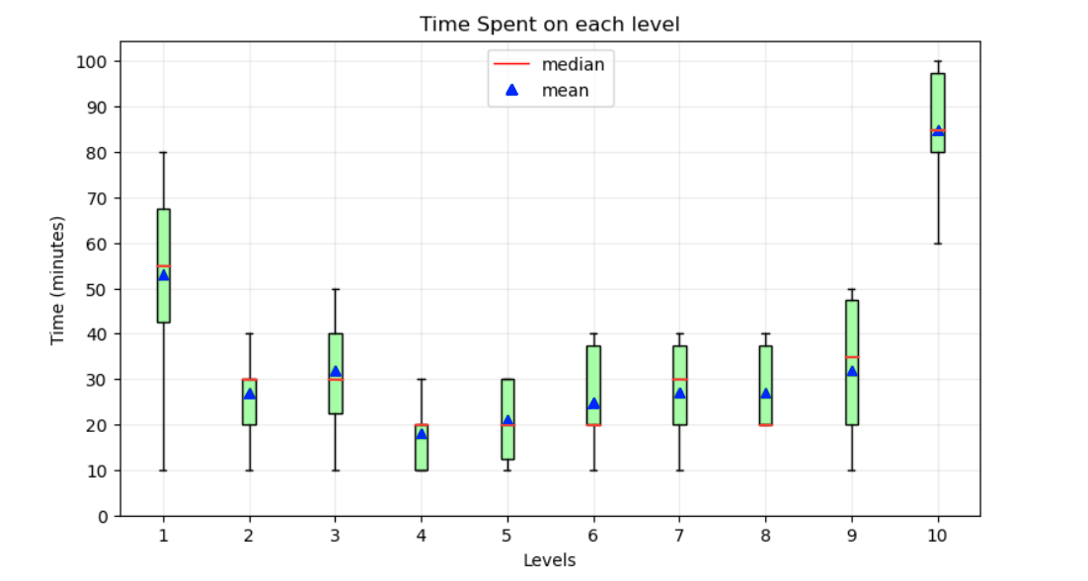

Figure 1: Visualization 1, one boxplot per level representing the time spent by the players, highlighting mean and median;

**After this visualization I would propose to look into one single room and extrapolate as much as we can from the players’ behaviours: moving around the room and interacting with the items. For this goal, at first, I thought about visualizing the map of the room in 3D and draw the players movements, maybe next to the actual path the developers had in mind, to understand if the players actually behaved as expected or found alternatives; but on a second thought I realized this may be too much for the type of game in question (“less is more”), and also that it could be more influential to find out the time spent in one area or another by most players, rather than the path taken by somebody. In the end I opted for a spatio-temporal visualization of aggregated data on a 2D map of the room as a density map based on time spent (lec. 9).**

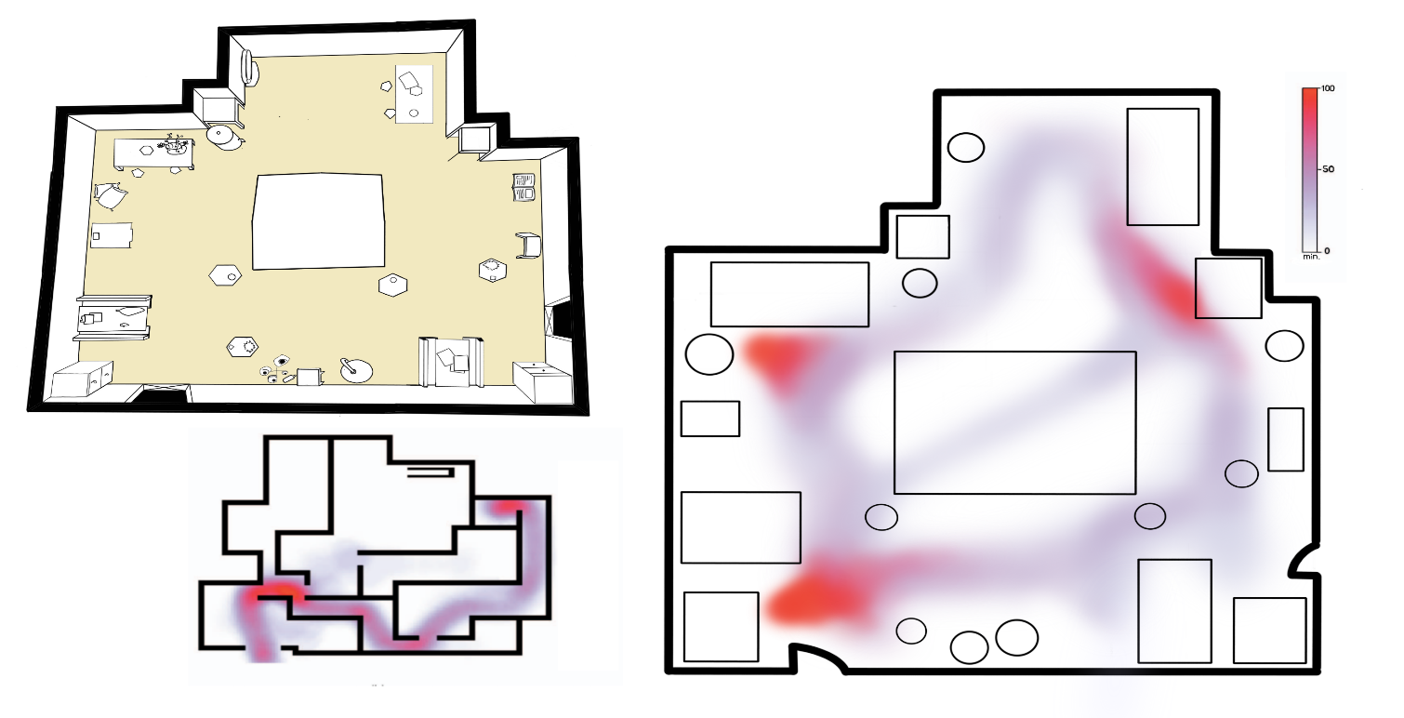

Figure 2: Visualization 2, 2D map of a level showing how much time the players spend around the room;

**B) Describe if the visualization is static or interactive and motivate your choice.**

**The first visualisation (Figure 1) should be static, no movement or zooming on any of the axis, it wouldn’t make sense to move it around because it allows to look at the data all at once and the comparison is clearer with all the plots laying close to one another. The second figure (Figure 2), on the other hand, I believe should have an interactive feature to allow the user to change the level to be analysed, but the map itself should not be interacted with.**

**C) Analyse briefly your visualization. What type of data is showing? Describe the elements of your visualizations and motivate your choices, for example specific colours or colormaps (e.g., lecture 3), marks and channels (e.g., lecture 4).**

**The main goal for the first figure was for it to be a categorical visualization, where the categories are the rooms and we show the distribution of the time values for each one. Moreover, thanks to boxplots it is clear what is the variation for each level. For the boxplots I chose a ‘lightgreen’, while for the mean and median I used two more saturated colours ‘blue’ and ‘red’ respectively, primarily for labelling the two statistics and guarantee distinctness, and secondly for having them stand out from the background (lec. 3). The effectiveness in comparing the boxplots comes not only from the statistical perspective, but also from the position on a common scale (lec. 4), given that we have the axis as a constant reference.**

**On the other hand, the second visualization shows a different type of data (spatial) and so also the goal was totally different: show the players navigating the room to know where they spend more time. In the example I present we can see from the legend that the red areas are where the players stayed more time, while the light-bluish ones are less time consuming. Allowing to read the data like this we can make assumptions on why that specific level seems more difficult because we are looking into details which areas or riddles were more** challenging**.**

**Conclusions: How can your visualization help the game designers?**

The visualizations can help the game designers navigate through the levels to understand their difficulty, going from an initial comparison of all the levels to a more in depth look at the single room and the most intense areas. I believe the two tools could be very useful to start a discussion, analyse the problems and raise questions. Of course, this could be a starting point, and further investigations will for sure bring to a much more detailed understanding of the structure of the game.