# Database Design

## ERD

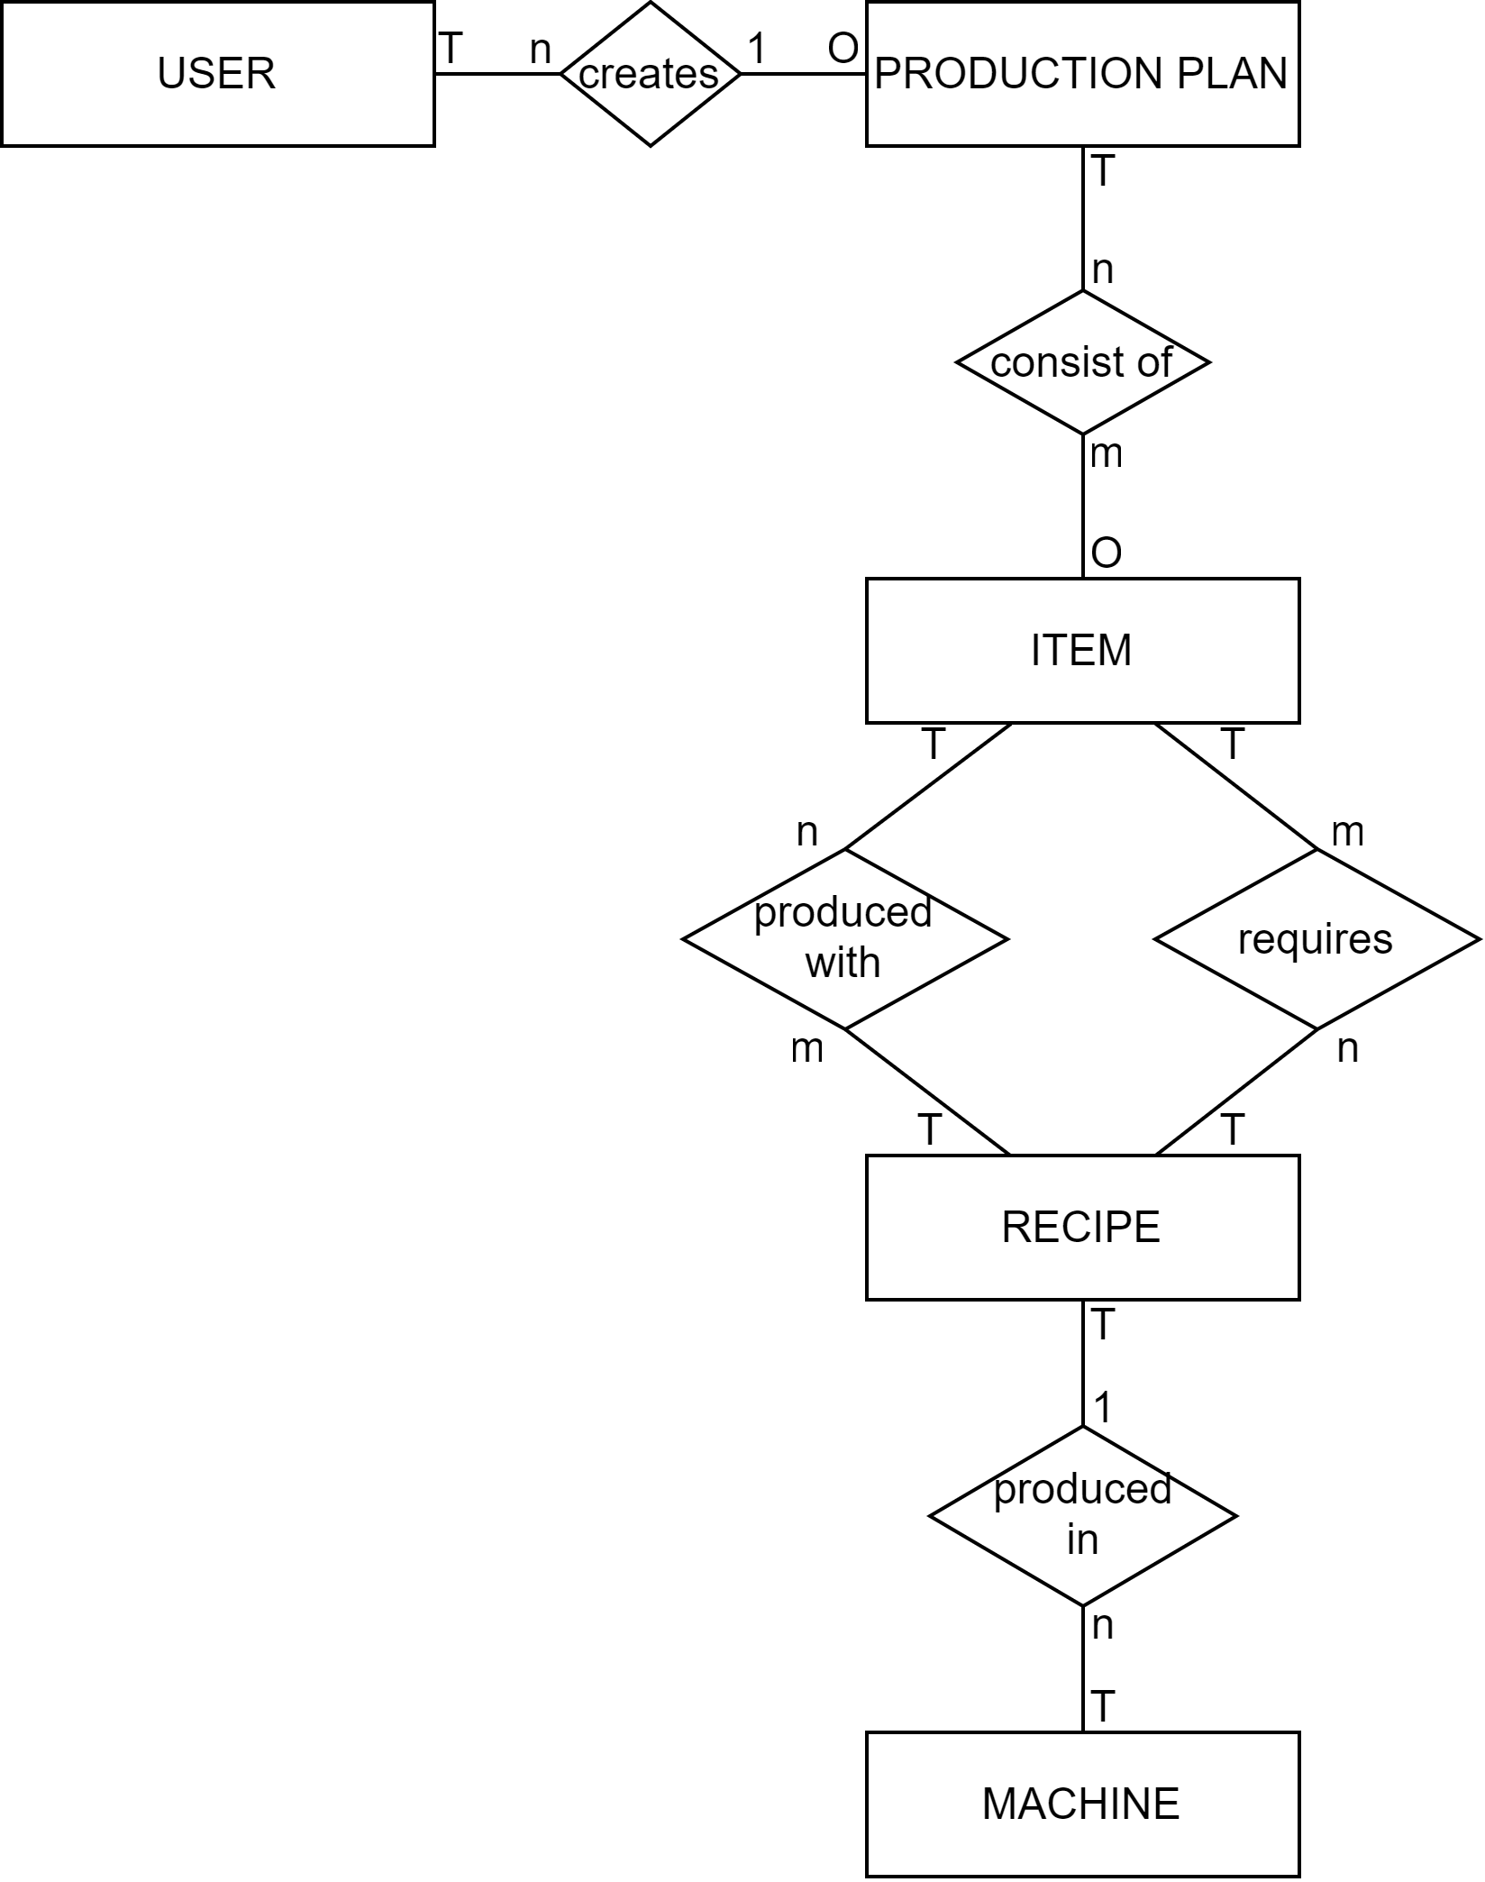

Figure 1.1 ERD

Attribute list:

USER : id, email, password

PRODUCTION PLAN : id, display_name

ITEM : id, display_name, icon_name, category, display_order

RECIPE : id, display_name

MACHINE : id, display_name, icon_name

creates :

consists of : amount

produced with : amount, is_standard_recipe

requires: : amount

produced in :

## Relational Model

USER (**id**, email, password)

PRODUCTION PLAN (**id**, ***created_by***)

foreign key '***created_by***' refers to ***id*** in USER, NULL not allowed

ITEM (**id**, display_name, icon_name, category, display_order)

RECIPE (**id**, ***produced_*in**, display_name)

foreign key '***produced_*in**' refers to ***id*** in MACHINE, NULL not allowed

MACHINE (**id**, display_name, icon_name)

PRODUCTION PLAN CONTENT (consist_of) (***plan_id***, ***item_id***, amount)

foreign key '***plan_id***' refers to ***id*** in PRODUCTION PLAN, NULL not allowed

foreign key '***item_id***' refers to ***id*** in ITEM, NULL not allowed

RECIPE OUTPUT (produced with) (***recipe_id***, ***item_id****,* amount,is_standard_recipe)

foreign key '***recipe_id***' refers to **id** in RECIPE, NULL not allowed

foreign key '***item_id***' refers to **id** in ITEM, NULL not allowed

RECIPE INPUT (requires) (***recipe_id***, ***item_id****,* amount)

foreign key '***recipe_id***' refers to **id** in RECIPE, NULL not allowed

foreign key '***item_id***' refers to **id** in ITEM, NULL not allowed

## Database Design

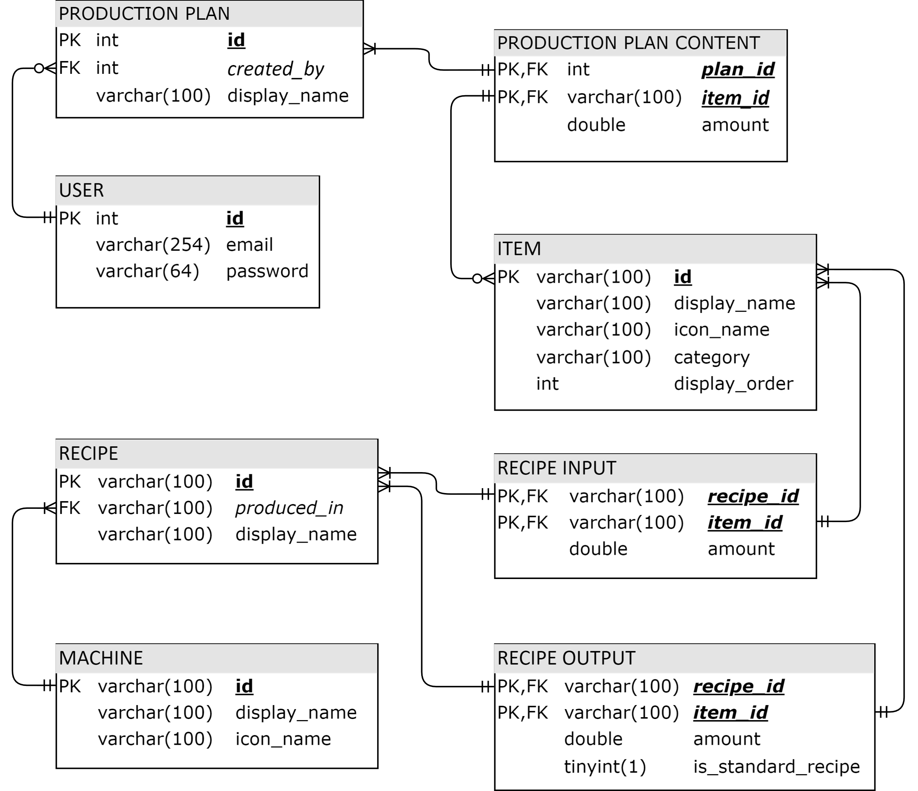

Figure 1.2 Database Design