Report. Bonus

Task 1 2

Task 2 4

Task 3 6

# Task 1

Analyze max, min and summary sales in the report below by:

* December 2000;
* Two channels: Internet and Direct Sales;
* All States.

Build the query using Oracle SQL for Aggregation and design the same report (export results to Excel).

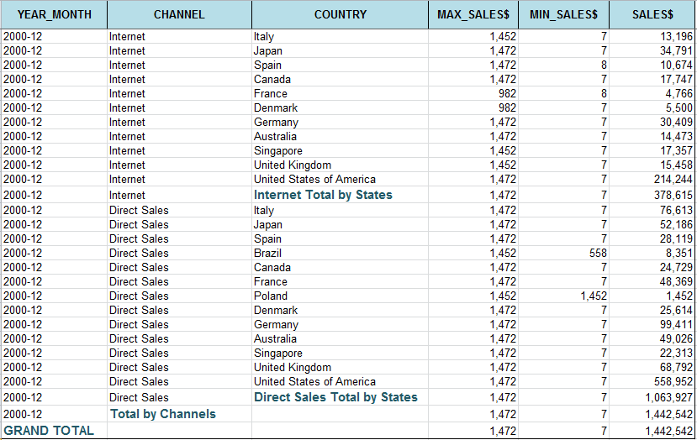

Скрипт на выполнение задания:

SELECT CASE

WHEN GROUPING_ID (TIMES.CALENDAR_MONTH_DESC,CHANNELS.CHANNEL_DESC,COUNTRIES.COUNTRY_NAME) = 7

THEN 'GRAND TOTAL'

ELSE TIMES.CALENDAR_MONTH_DESC

END YEAR_MONTH,

CASE

WHEN GROUPING_ID (TIMES.CALENDAR_MONTH_DESC,CHANNELS.CHANNEL_DESC,COUNTRIES.COUNTRY_NAME) = 3

THEN 'Total by Channels'

ELSE CHANNELS.CHANNEL_DESC

END CHANNEL,

CASE

WHEN GROUPING_ID (TIMES.CALENDAR_MONTH_DESC,CHANNELS.CHANNEL_DESC,COUNTRIES.COUNTRY_NAME) = 1

THEN CHANNELS.CHANNEL_DESC || ' Total by Sales'

ELSE COUNTRIES.COUNTRY_NAME

END COUNTRY,

TO_CHAR(MAX(AMOUNT_SOLD),'9,999') "MAX_SALES$",

TO_CHAR(MIN(AMOUNT_SOLD),'9,999') "MIN_SALES$",

TO_CHAR(SUM(AMOUNT_SOLD),'9,999,999') "SALES$"

FROM TIMES,

SALES,

CHANNELS,

COUNTRIES,

CUSTOMERS

WHERE SALES.TIME_ID=TIMES.TIME_ID and

SALES.CUST_ID=CUSTOMERS.CUST_ID and

SALES.CHANNEL_ID=CHANNELS.CHANNEL_ID and

TIMES.CALENDAR_MONTH_DESC='2000-12' and

CHANNELS.CHANNEL_DESC in ('Internet', 'Direct Sales') and

CUSTOMERS.COUNTRY_ID=COUNTRIES.COUNTRY_ID

GROUP BY ROLLUP (TIMES.CALENDAR_MONTH_DESC,

CHANNELS.CHANNEL_DESC,

COUNTRIES.COUNTRY_NAME);

Результат выполнения в Oracle:

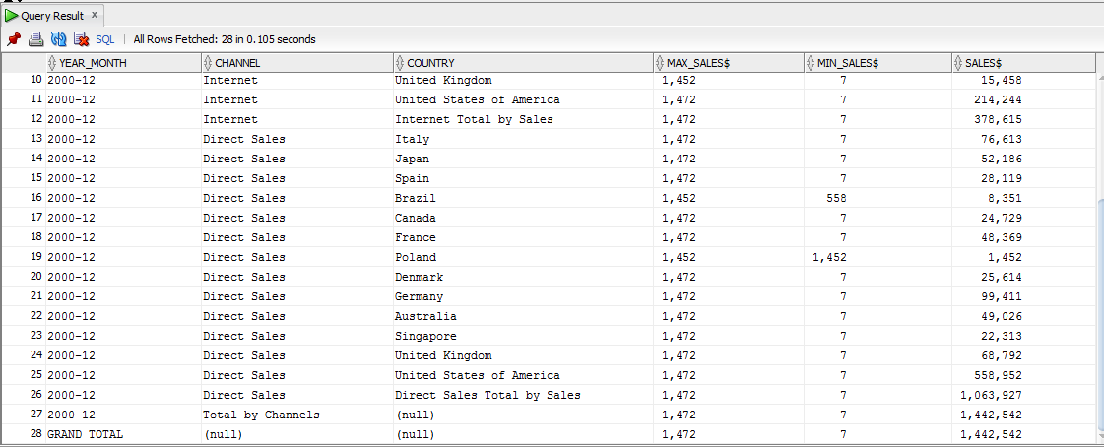

Результат экспорта в excel:

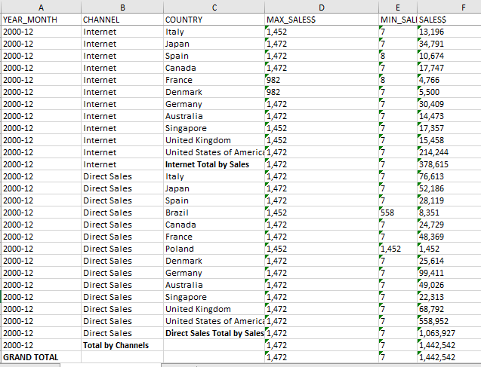

# Task 2

Напишите запрос для формирования отчёта о продажах в Азии всех продуктов из категории Photo за 2000 год по кварталам. Вычислите итоговые суммы (TOTAL и YEAR_SUM).

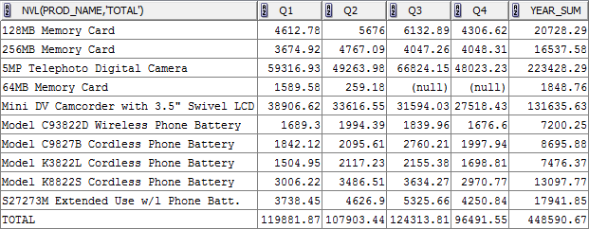

Скрипт на выполнение данной задачи:

SELECT NVL(PROD_NAME,'TOTAL') AS PRODUCT_NAME,

SUM(Q1) AS Q1,

SUM(Q2) AS Q2,

SUM(Q3) AS Q3,

SUM(Q4) AS Q4,

SUM(YEAR_SUM) AS YEAR_SUM

FROM

(SELECT DISTINCT PRODUCTS.PROD_NAME,

NTH_VALUE(SUM(AMOUNT_SOLD),1) OVER (PARTITION BY PRODUCTS.PROD_NAME ORDER BY TIMES.CALENDAR_QUARTER_NUMBER ASC RANGE BETWEEN UNBOUNDED PRECEDING AND UNBOUNDED FOLLOWING) AS Q1,

NTH_VALUE(SUM(AMOUNT_SOLD),2) OVER (PARTITION BY PRODUCTS.PROD_NAME ORDER BY TIMES.CALENDAR_QUARTER_NUMBER ASC RANGE BETWEEN UNBOUNDED PRECEDING AND UNBOUNDED FOLLOWING) AS Q2,

NTH_VALUE(SUM(AMOUNT_SOLD),3) OVER (PARTITION BY PRODUCTS.PROD_NAME ORDER BY TIMES.CALENDAR_QUARTER_NUMBER ASC RANGE BETWEEN UNBOUNDED PRECEDING AND UNBOUNDED FOLLOWING) AS Q3,

NTH_VALUE(SUM(AMOUNT_SOLD),4) OVER (PARTITION BY PRODUCTS.PROD_NAME ORDER BY TIMES.CALENDAR_QUARTER_NUMBER ASC RANGE BETWEEN UNBOUNDED PRECEDING AND UNBOUNDED FOLLOWING) AS Q4,

SUM(SUM(AMOUNT_SOLD)) OVER (PARTITION BY PRODUCTS.PROD_NAME) AS YEAR_SUM

FROM PRODUCTS,

TIMES,

SALES,

COUNTRIES,

CUSTOMERS

WHERE SALES.TIME_ID=TIMES.TIME_ID and

SALES.CUST_ID=CUSTOMERS.CUST_ID and

SALES.PROD_ID=PRODUCTS.PROD_ID and

CUSTOMERS.COUNTRY_ID=COUNTRIES.COUNTRY_ID and

PRODUCTS.PROD_CATEGORY='Photo' and

TIMES.CALENDAR_YEAR=2000 and

COUNTRIES.COUNTRY_SUBREGION='Asia'

GROUP BY PRODUCTS.PROD_NAME,

TIMES.CALENDAR_QUARTER_NUMBER

)

GROUP BY ROLLUP(PROD_NAME);

Результат выполнения в Oracle:

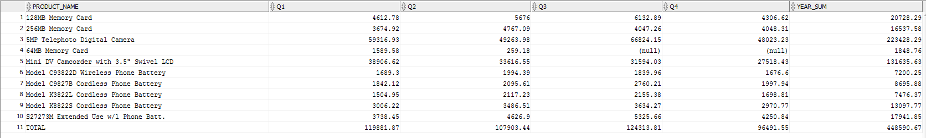

# Task 3

Написать запрос, использующий PIVOT.

SELECT *

FROM

(SELECT COUNTRIES.COUNTRY_REGION,

PRODUCTS.PROD_CATEGORY,

AMOUNT_SOLD

FROM PRODUCTS,

TIMES,

SALES,

COUNTRIES,

CUSTOMERS

WHERE SALES.TIME_ID=TIMES.TIME_ID and

SALES.CUST_ID=CUSTOMERS.CUST_ID and

SALES.PROD_ID=PRODUCTS.PROD_ID and

CUSTOMERS.COUNTRY_ID=COUNTRIES.COUNTRY_ID)

PIVOT (SUM(AMOUNT_SOLD) AS SUMS

FOR (PROD_CATEGORY) IN (('Electronics') AS Electronics,

('Hardware') AS Hardware,

('Peripherals and Accessories') AS Peripherals_and_Accessories,

('Photo') AS Photo,

('Software/Other') AS Software_Other

));

Результат выполнения в Oracle:

