**Contents**

**Task 1** 2

**Task 2** 4

**Task 3** 6

# **Task 1**

**Script:**

*SELECT*

*CASE*

*WHEN grouping_id(calendar_month_desc, channel_desc, country_name)=7*

*THEN 'GRAND TOTAL'*

*ELSE calendar_month_desc*

*END AS year_month,*

*CASE*

*WHEN grouping_id(calendar_month_desc, channel_desc, country_name) =3*

*THEN 'Total by Channels'*

*ELSE channel_desc*

*END AS channel,*

*CASE*

*WHEN grouping_id(calendar_month_desc, channel_desc, country_name) =1*

*THEN channel_desc*

*||' Total by Sales'*

*ELSE country_name*

*END AS country,*

*ROUND(MAX(amount_sold)) AS "MAX_SALES$",*

*ROUND(MIN(amount_sold)) AS "MIN_SALES&",*

*ROUND(SUM(amount_sold)) AS "SALES$"*

*FROM sales*

*JOIN channels*

*ON sales.channel_id=channels.channel_id*

*JOIN times*

*ON times.time_id=sales.time_id*

*JOIN customers*

*ON customers.cust_id = sales.cust_id*

*JOIN countries*

*ON countries.country_id = customers.country_id*

*WHERE TO_CHAR(calendar_month_desc) = '2000-12'*

*AND channel_desc IN ('Internet', 'Direct Sales')*

*GROUP BY rollup(calendar_month_desc, channel_desc, country_name);*

**Result**

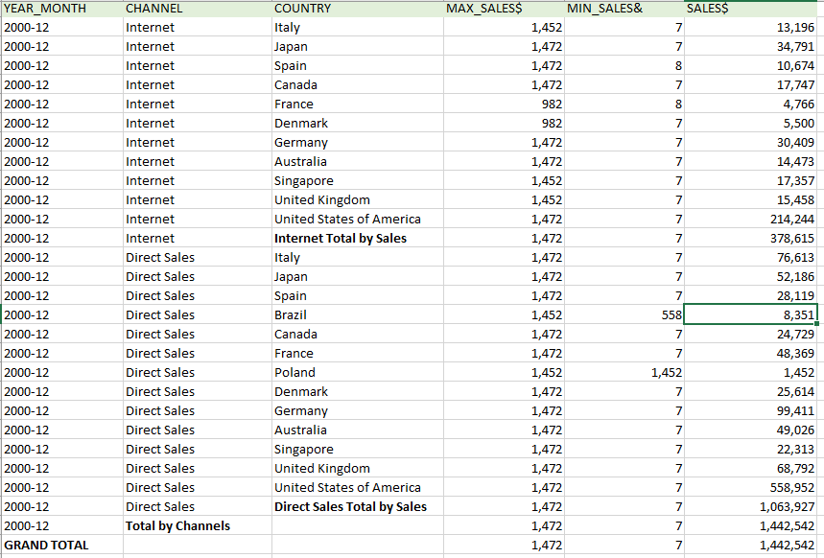

# **Task 2**

**Script:**

*SELECT NVL(products.prod_name,'TOTAL') AS Prod_name,*

*SUM(q1) AS q1,*

*SUM(q2) AS q2,*

*SUM(q3) AS q3,*

*SUM(q4) AS q4,*

*SUM(year_sum) AS year_sum*

*FROM*

*(SELECT DISTINCT products.prod_name AS prod_name,*

*NTH_VALUE(SUM(AMOUNT_SOLD),1) OVER (PARTITION BY prod_name ORDER BY times .calendar_quarter_number ASC RANGE BETWEEN UNBOUNDED PRECEDING AND UNBOUNDED FOLLOWING) AS Q1,*

*NTH_VALUE(SUM(AMOUNT_SOLD),2) OVER (PARTITION BY prod_name ORDER BY times .calendar_quarter_number ASC RANGE BETWEEN UNBOUNDED PRECEDING AND UNBOUNDED FOLLOWING) AS Q2,*

*NTH_VALUE(SUM(AMOUNT_SOLD),3) OVER (PARTITION BY prod_name ORDER BY times .calendar_quarter_number ASC RANGE BETWEEN UNBOUNDED PRECEDING AND UNBOUNDED FOLLOWING) AS Q3,*

*NTH_VALUE(SUM(AMOUNT_SOLD),4) OVER (PARTITION BY prod_name ORDER BY times .calendar_quarter_number ASC RANGE BETWEEN UNBOUNDED PRECEDING AND UNBOUNDED FOLLOWING) AS Q4,*

*SUM(SUM(AMOUNT_SOLD)) OVER (PARTITION BY prod_name) AS YEAR_SUM*

*FROM sales*

*JOIN products*

*ON sales.prod_id=products.prod_id*

*JOIN times*

*ON sales.time_id=times.time_id*

*JOIN channels*

*ON sales.channel_id=channels.channel_id*

*JOIN customers*

*ON sales.cust_id=customers.cust_id*

*JOIN countries*

*ON customers.country_id =countries.country_id*

*WHERE times.calendar_year ='2000'*

*AND country_region ='Asia'*

*AND prod_category ='Photo'*

*GROUP BY products.prod_name,*

*times .calendar_quarter_number*

*) quarters*

*JOIN products*

*ON quarters.prod_name=products.prod_name*

*GROUP BY rollup(products.prod_name) ;*

**Result:**

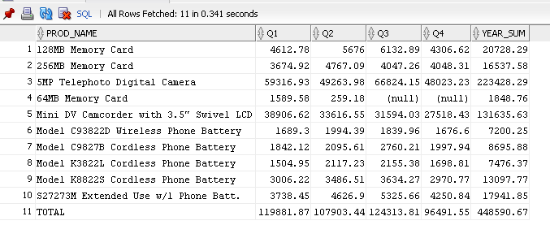

# **Task 3**

**Goal**: to find profit on products in the regions.

**Script:**

*SELECT \**

*FROM*

*(SELECT prod_name,*

*country_region,*

*amount_sold*

*FROM sales*

*LEFT JOIN products*

*ON sales.prod_id=products.prod_id*

*LEFT JOIN customers*

*ON sales.cust_id=customers.cust_id*

*LEFT JOIN countries*

*ON customers.country_id =countries.country_id*

*) PIVOT(SUM(amount_sold) FOR (country_region) IN (('Oceania')AS Oceania, ('Middle East')AS Middle_East,*

*('Europe')AS Europe, ('Africa')AS Africa , ('Asia')AS Asia , ('Americas')AS Americas )) ;*

**Result:**

