1.

|  |  |  |  |  |  |
| --- | --- | --- | --- | --- | --- |
| № | Count of Blocks | Count of Used Blocks | Count of Rows | Consistent gets | Description |
| 1(create table with 99999 rows) | 1664 | 1536 | 99999 | 1540 | We created table with 99999. Count of blocks for table is 1664. HWT is at 1536 block |
| 2(delete rows) | 1664 | 0 | 0 | 1541 | We deleted rows, but HWM stayed at the same place. Cashed consistent gets |
| 3(insert one row) | 1664 | 1 | 1 | 1541 | When we inserted new row, nothing changed. Cashed consistent gets |
| 4(truncate table) | 8 | 0 | 0 | 3 | Truncate resets the value of HWT |

The consistent gets Oracle metric is the number of times a consistent read (a logical RAM buffer I/O) was requested to get data from a data block.

2.1

Screenshot of step 5.

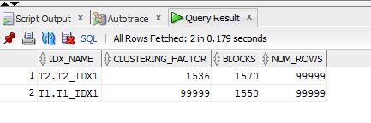

The clustering factor is a benchmark that expresses the correlation between the index row order and the table row order.

We have the different factors for indexes because of row order in tables. T1 table stores rows with the same id in one place. So index of t1 table has low clustering factor because the id is essentially the same as the table order. Here is the opposite situation with t2 table.

IN expression:

select * from t1

where id in (2,5);

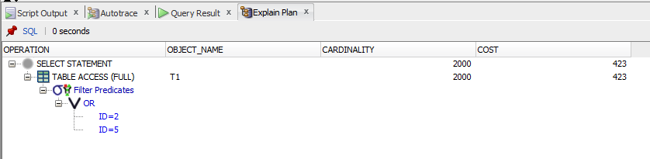

select * from t2

where id in (2,5);

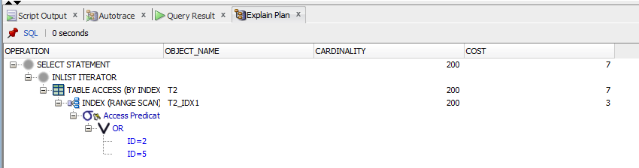

T2_idx1 has better performance while executing select clause filtered by **IN**. T1_idx1 is so bad that oracle prefer full table access.

2.2

Plan:

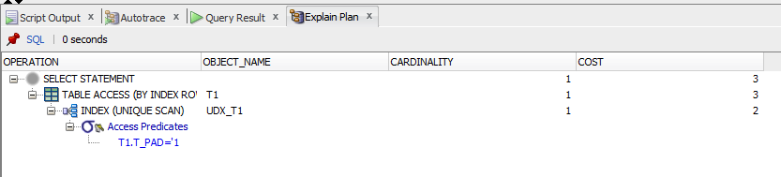

Oracle is looking for the first match and then stops searching.

2.3

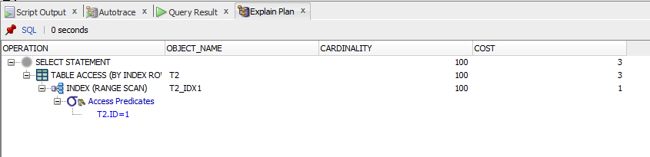

A range scan scans the index structure from the root block to the first leaf block containing an entry matching the specified condition. For this condition rowid are gotten. Then table is accessed for looking rows by rowed. After that range scan will continue looking matches in index.

2.4

Index_ss

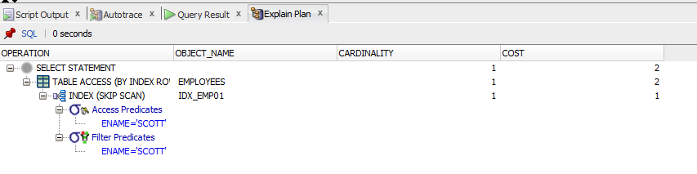

Full(emp)

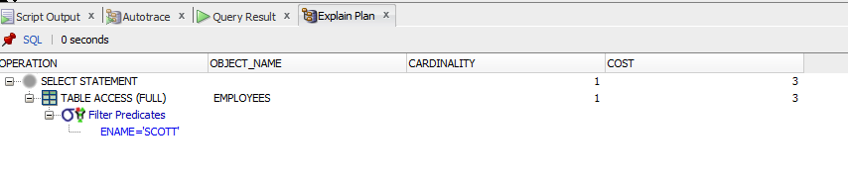

The index skip scan allow Oracle to "skip" leading-edge predicates in a multi-column index. At first oracle scans the index. It finds ename SCOTT for all empno and the take rows from table.