|  |
| --- |
|  |
|  |

Image goes here.

Contents

1. Business Description 3

1.1. Business background 3

1.2. Problems because of poor data management 3

1.3. Benefits from implementing a Data Warehouse 3

2. Dimensions of a Business 3

3. Logical Scheme 3

4. Data Flow 3

5. Fact Table Partitioning Strategy 3

6. Strategy of Parallel Load 3

7. Report Layouts 3

# Business Description

## Business background

Internet-shop of sports equipment and sports nutrition

## Problems because of poor data management

Loss of customers because of narrow range of products

## Benefits from implementing a Data Warehouse

Increment of activity, sales growth, understand the needs of some equipment and its enrichment.

# Dimensions of a Business

# Dimensional layer of business process

Шаг 1. Выбор бизнес-процесса:

Для постраения хранилища данных был выбран процесс продажи (sport equipment and sport nutrition ).

Шаг 2. Определение зерна

Зерном будет являться продажа товара.

Шаг 3. Определение измерений:

Измерения могут быть следующими:

Customer:

CREATE TABLE DimCustomer

(

CUST_ID NUMBER(8) NOT NULL PRIMARY KEY,

CUST_CODE VARCHAR2(8),

LAST_NAME VARCHAR2(50),

FIRST_NAME VARCHAR2(50),

MIDDLE_NAME VARCHAR2(50),

AGE VARCHAR2(3),

GENDER VARCHAR2(50),

ADDRESS VARCHAR2(50),

CITY VARCHAR2(50),

ATE VARCHAR2(50)

);

Supplier:

CREATE TABLE DimSupplier

(

SUP_ID NUMBER(8) NOT NULL PRIMARY KEY,

SUP_CODE VARCHAR2(8),

SUP_NAME VARCHAR2(50),

PHONE NUMBER(8),

E_MAIL VARCHAR2(50),

ADDRESS VARCHAR2(50),

CITY VARCHAR2(50),

ATE VARCHAR2(50),

CIUNTRY VARCHAR2(50),

START_DT DATE NOT NULL,

END_DT DATE NOT NULL,

IS_ACTIVE VARCHAR2(4) NOT NULL

);

Product:

CREATE TABLE DimProduct

(

PROD_ID NUMBER(8) NOT NULL PRIMARY KEY,

PROD_CODE VARCHAR2(8),

PROD_NAME VARCHAR2(50),

CATEG_NAME VARCHAR2(25),

SUBCAT_NAME VARCHAR2(25),

PROD_PRICE NUMBER(8),

PROD_DESCRIPTION VARCHAR2(50),

START_DT DATE NOT NULL,

END_DT DATE NOT NULL,

IS_ACTIVE VARCHAR2(4) NOT NULL

);

Date:

CREATE TABLE DimDate

(

"DATE_ID" DATE NOT NULL PRIMARY KEY,

"DA_OF_WEEK" NUMBER(2),

"DAY_NAME_OF_WEEK" VARCHAR2(25),

"DAY_OF_MONTH" NUMBER(8),

"DAY_OF_YEAR" NUMBER(8),

"WEEK_OF_MONTH" NUMBER(8),

"WEEK_OF_YEAR" NUMBER(8),

"MONTH_NUMBER" NUMBER(8),

"MONTH_NAME" VARCHAR2(20),

"QUARTER" NUMBER(2),

"FIRST_DAY_OF_MONTH" DATE,

"LAST_DAY_OF_MONTH" DATE,

"YEAR" NUMBER(8)

);

Payment:

CREATE TABLE DimPayment

(

PAYMENT_ID NUMBER(8) NOT NULL PRIMARY KEY,

PAYMENT_CODE VARCHAR2(8),

PAYMENT_TYPE VARCHAR2(4)

);

Шаг 4. Определение фактов:

Фактами будут являться – quantity, price_sum.

CREATE TABLE FactOrderSales

( ORDERSALES_ID NUMBER(8) PRIMARY KEY,

DATE_ID DATE,

PROD_ID NUMBER(8) NOT NULL,

SUP_ID NUMBER(8) NOT NULL,

PAYMENT_ID NUMBER(8) NOT NULL,

CUST_ID NUMBER(8) NOT NULL,

QUANTITY NUMBER,

PRICE_SUM NUMBER

);

# Logical Scheme

By adding following constraints we connect our existing tables in order to have star-scheme:

ALTER TABLE FactOrderSales

ADD CONSTRAINT "FK_DATE_ID_Fact"

FOREIGN KEY ("DATE_ID")

REFERENCES DimDate("DATE_ID");

ALTER TABLE FactOrderSales

ADD CONSTRAINT "FK_PROD_ID_Fact"

FOREIGN KEY ("PROD_ID")

REFERENCES DimProduct("PROD_ID");

ALTER TABLE FactOrderSales

ADD CONSTRAINT "FK_PAYMENT_ID_Fact"

FOREIGN KEY ("PAYMENT_ID")

REFERENCES DimPayment("PAYMENT_ID");

ALTER TABLE FactOrderSales

ADD CONSTRAINT "FK_SUP_ID_Fact"

FOREIGN KEY ("SUP_ID")

REFERENCES DimSupplier("SUP_ID");

ALTER TABLE FactOrderSales

ADD CONSTRAINT "FK_CUST_ID_Fact"

FOREIGN KEY ("CUST_ID")

REFERENCES DimCustomer("CUST_ID");

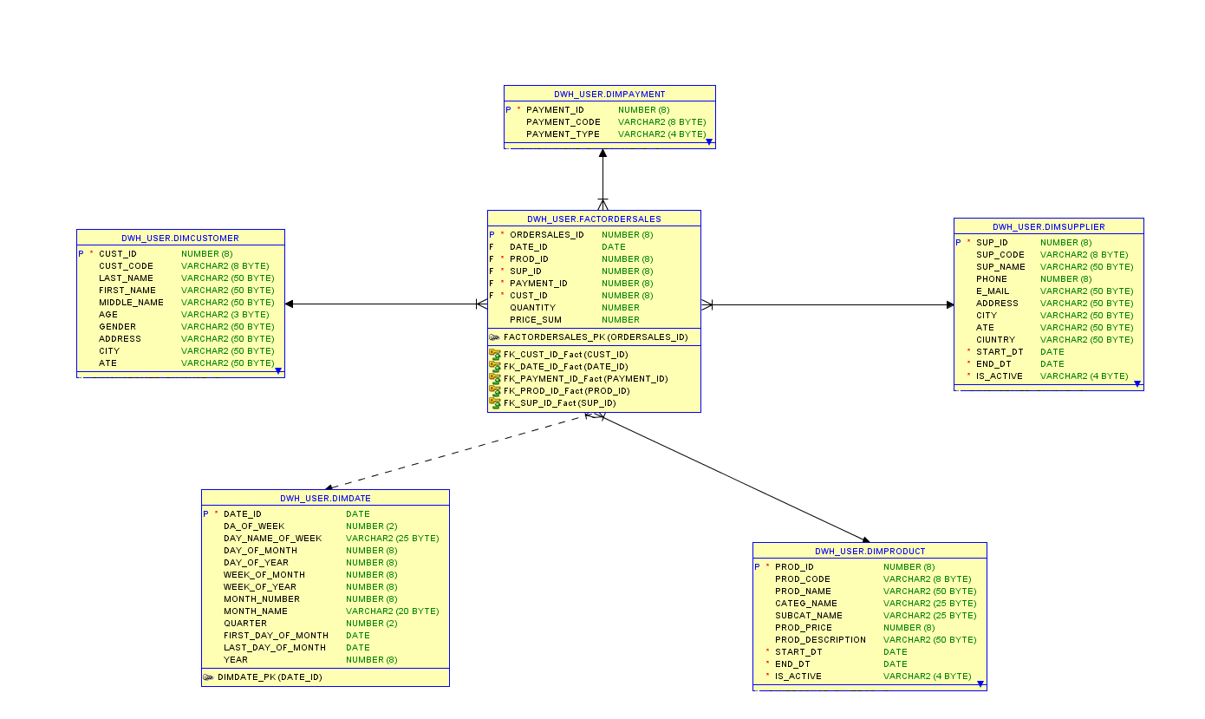

3NF LAYER:

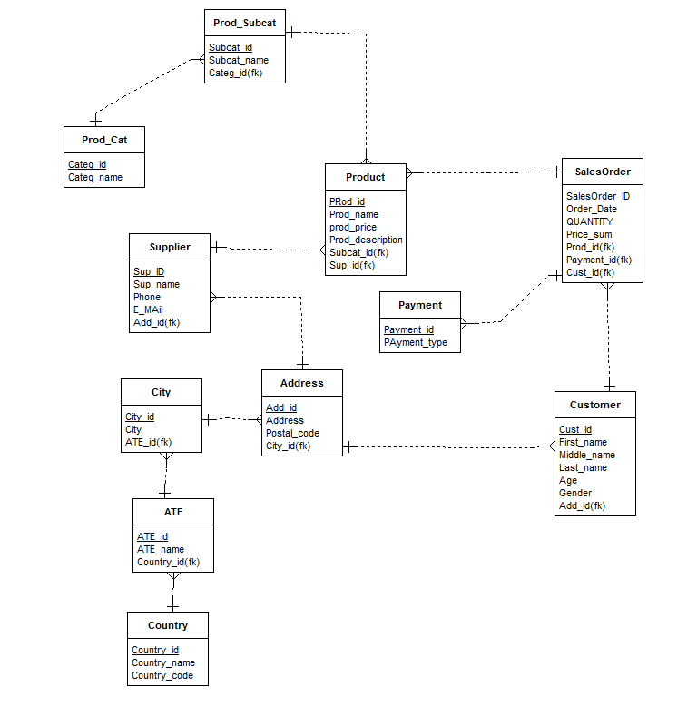

# Data Flow

# Fact Table Partitioning Strategy

It would be helpful to create partitions on table fact_SalesOrder in order to analyze data about sales from internet-shop. At first partitioning would be organized by date of sale (year). After that creating a subpartition by product category and subcategory can be done.

# Strategy of Parallel Load

# Report Layouts

I would analyze month and year sales of product (also it’s category and subcategory) in slice of customer and geodate(city) .

|  |  |  |  |  |
| --- | --- | --- | --- | --- |
| year | month | category | amount_sold | sales |
| 2017 | jan | powerlifting equipment | 1651 | 1263100 |
| 2017 | jan | nutrition | 2653 | 4196100 |
| 2017 | jan | sport outfit | 1501 | 49564060 |
| 2017 | feb | powerlifting equipment | 156 | 46018400 |
| 2017 | feb | nutrition | 5161 | 465040 |
| 2017 | feb | sport outfit | 15610 | 46546497 |
| 2017 | march | powerlifting equipment | 268 | 4645640 |
| 2017 | march | nutrition | 516 | 46064 |
| 2017 | march | sport outfit | 1623 | 465498 |