|  |
| --- |
| EPAM Systems, RD Dep. |
| MTN.BI.07 Partitioning |

|  |  |  |  |  |  |
| --- | --- | --- | --- | --- | --- |
| REVISION HISTORY | | | | | |
| Ver. | Description of Change | Author | Date | Approved | |
| Name | Effective Date |
| 1.0 | Initial status | Olga_Hilko | 13-Nov-2017 |  |  |

Contents

1. Hands-On Task 3

2. Data Modeling Task 3

3. Analytical task 3

3.1. Partitioning 3

3.2. Business 3

4. Results 3

# Hands-On Task

Создаём новую таблицу:

CREATE TABLE Date_Part (

date_key_column date PRIMARY KEY,

string_col VARCHAR2(20),

real_col number(8,2)

)

PARTITION BY RANGE (date_key_column)

(

PARTITION pr1 VALUES LESS THAN (TO_DATE('01-01-2017', 'DD-MM-YYYY')),

PARTITION pr2 VALUES LESS THAN (TO_DATE('01-01-2018', 'DD-MM-YYYY')),

PARTITION pr3 VALUES LESS THAN (MAXVALUE)

);

Заполняем её:

declare

cnt INT := 0;

begin

FOR cnt IN 0..1000 LOOP

insert into Date_Part VALUES (TO_DATE('01-01-2016', 'DD-MM-YYYY')+cnt,

to_char(( TO_DATE('01-01-2016', 'DD-MM-YYYY')+cnt),'Month'),

cast (cnt/2 as number(8,2)));

END LOOP;

END;

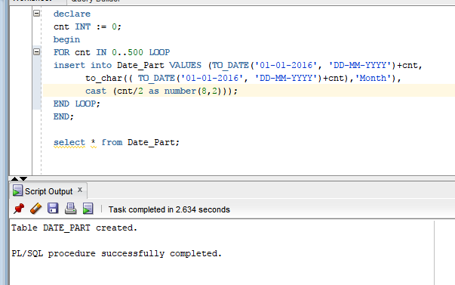

Результат проверяем, делаем commit

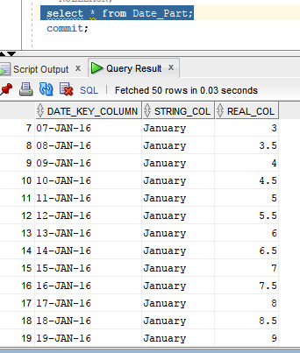

Проверка записей в таблице:

SELECT count(*) FROM Date_Part PARTITION(pr1); --2016 – високосный год

SELECT count(*) FROM Date_Part PARTITION(pr2);

SELECT count(*) FROM Date_Part PARTITION(pr3);

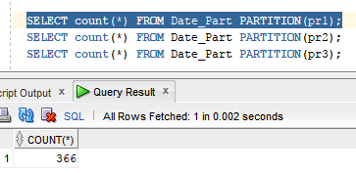 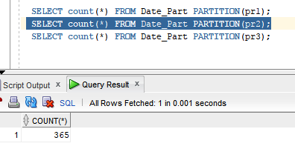 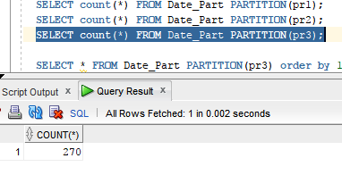Данные из последней партиции

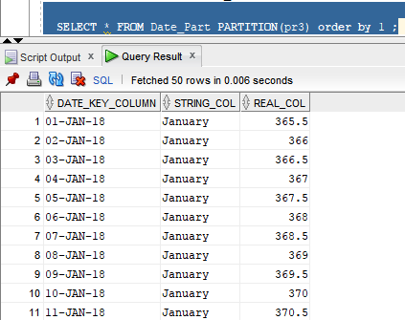

Проверка:

* select table_name, partition_name, high_value from USER_TAB_PARTITIONS

where table_name ='DATE_PART';

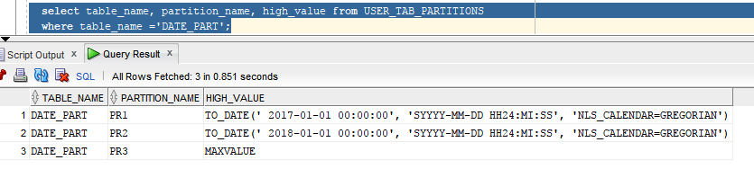

Merging partition:

ALTER TABLE Date_Part MERGE PARTITIONS pr1, pr2 INTO PARTITION pr2;

Проверка:

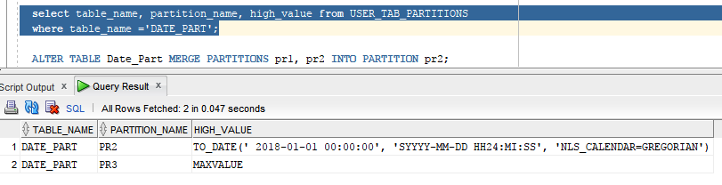

Splitting partition:

ALTER TABLE Date_Part SPLIT PARTITION pr2 AT (TO_DATE('01-01-2017', 'DD-MM-YYYY')) INTO (PARTITION pr1, PARTITION pr2);

Разделили партицию pr2 на pr1(до 01-01-2017) и pr2

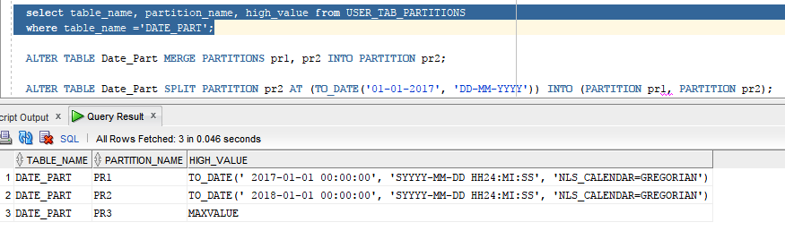

Удаление партции pr2

ALTER TABLE Date_Part DROP PARTITION pr1;

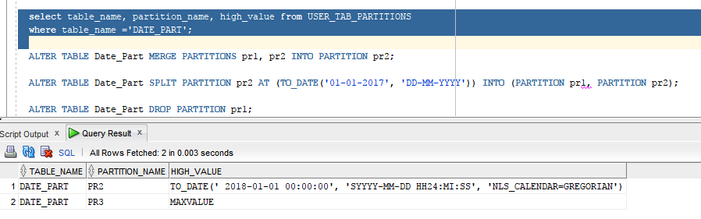

После удаления партиции, данные хранившиеся в ней теряются (все данные до 2017 были удалены).

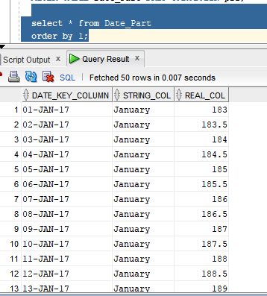

Создаём новыую таблицу с HASH партиционирование

CREATE TABLE Date_Part_Hash (

date_key_column date PRIMARY KEY,

string_col VARCHAR2(20),

real_col number(8,2)

)

PARTITION BY HASH (date_key_column)

(

PARTITION pr1,

PARTITION pr2,

PARTITION pr3

);

И её заполняем

declare

cnt INT := 0;

begin

FOR cnt IN 0..1000 LOOP

insert into Date_Part_Hash VALUES (TO_DATE('01-01-2016', 'DD-MM-YYYY')+cnt,

to_char(( TO_DATE('01-01-2016', 'DD-MM-YYYY')+cnt),'Month'),

cast (cnt/2 as number(8,2)));

END LOOP;

END;

Проверка данных по партициям та же

SELECT count(*) FROM Date_Part_Hash PARTITION(pr1)

union all

SELECT count(*) FROM Date_Part_Hash PARTITION(pr2)

union all

SELECT count(*) FROM Date_Part_Hash PARTITION(pr3);

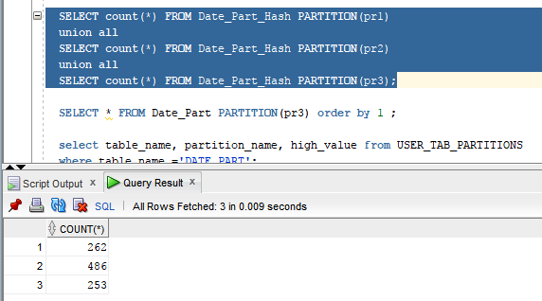

Партиции для новой таблицы

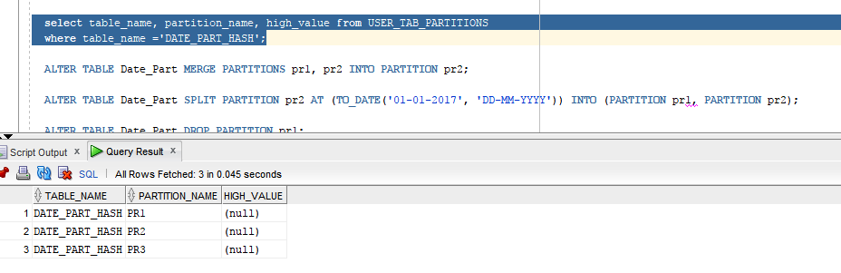

Результат добавления новой партиции

ALTER TABLE Date_Part_Hash ADD PARTITION pr4;

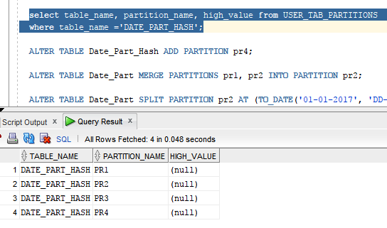

Данные из таблицы заного были разбиты на партиции

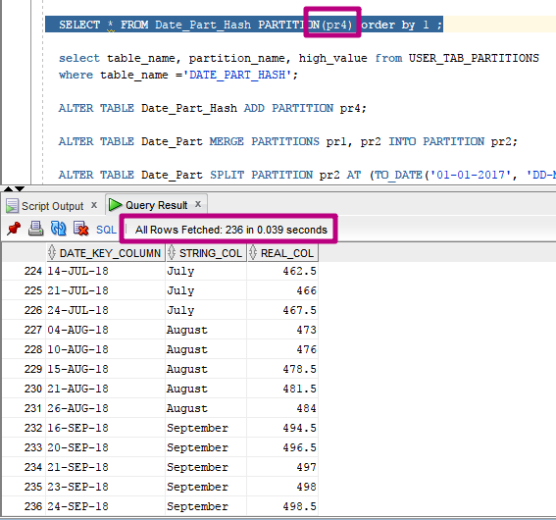

Coalescing partition

ALTER TABLE Date_Part_Hash COALESCE PARTITION; 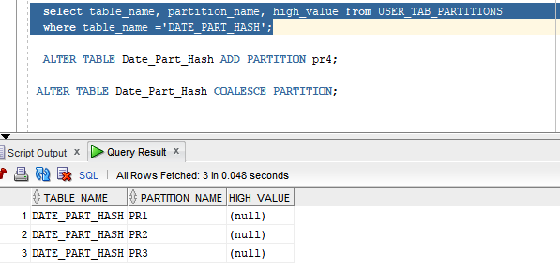

Truncating partition

ALTER TABLE Date_Part_Hash TRUNCATE PARTITION(pr1);

* select table_name, partition_name, high_value from USER_TAB_PARTITIONS

where table_name ='DATE_PART_HASH' – дает то же результат, но данные были удаленны.

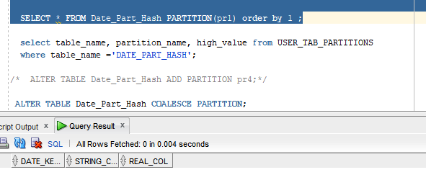

# 

# Analytical task

## Partitioning

Add chapter on describing Fact table partitioning strategy, which fields will it be based on and why (use composite partitioning).

## Business

Create a report layout of the task you are trying to solve with your DWH (e.g. 'I want to analyze my sales on month and customers' region location and product type'). It could be done in Excel (just some headers, colors, dummy numbers, and little description) or any other tool of your preference. This would help to understand what task we are trying to solve.

# Results

Result of this lab work should be:

* Screenshots and description of partitioning maintenance operations.
* Chapter in document about advantages of partitioning the fact table in described way.
* Chapter in a document describing needed reports with possible layouts.