Contents

1. Task 1 2

Task 2

Script 2

Result 3

Conclusions 3

2. Task 2 4

Task 4

Script 4

Result 5

Conclusions 5

3. Task 3 6

Task 6

Script 6

Result 6

Conclusions 6

# Task 1

### Task

Analyze max, min and summary sales in the report below by:

* December 2000;
* Two channels: Internet and Direct Sales;
* All States.

Build the query using Oracle SQL for Aggregation and design the same report (export results to Excel).

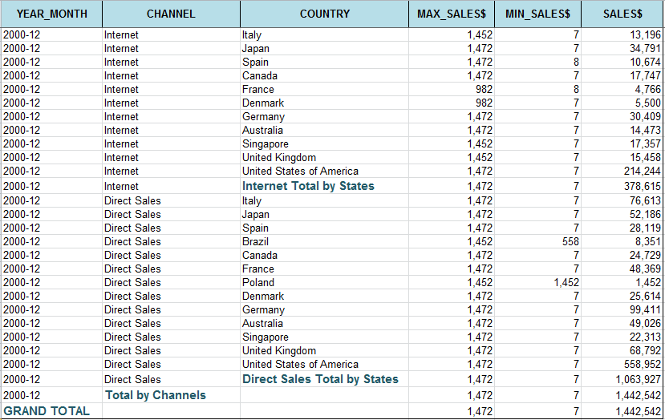

### Script

SELECT DECODE(GROUPING(calendar_month_desc),1, 'GRAND TOTAL', calendar_month_desc) AS YEAR_MONTH,

CASE

WHEN GROUPING_id(calendar_month_desc, channel_desc)=1

THEN 'Total by Channels'

WHEN sh.channels.channel_desc IS NULL

THEN' '

ELSE sh.channels.channel_desc

END AS Channel,

CASE

WHEN grouping_id(sh.channels.channel_desc,sh.countries.country_name)=1

THEN sh.channels.channel_desc

|| ' Total By States'

WHEN sh.countries.country_name IS NULL

THEN' '

ELSE sh.countries.country_name

END AS Country,

ROUND(MAX(amount_sold)) AS MAX_SALES$,

ROUND(MIN(amount_sold)) AS MIN_SALES$,

ROUND(SUM(amount_sold)) AS SALES$

FROM sh.sales

LEFT JOIN sh.channels

ON sh.sales.channel_id=sh.channels.channel_id

LEFT JOIN sh.times

ON sh.sales.time_id=sh.times.time_id

LEFT JOIN sh.customers

ON sh.sales.cust_id=sh.customers.cust_id

LEFT JOIN sh.countries

ON sh.customers.country_id=sh.countries.country_id

WHERE calendar_month_desc ='2000-12'

AND (channel_desc = 'Internet'

OR channel_desc = 'Direct Sales')

GROUP BY ROLLUP(calendar_month_desc, channel_desc, country_name);

### Result

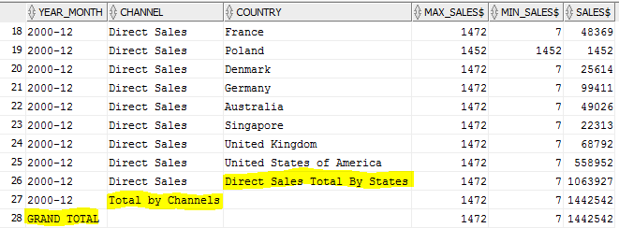

### Conclusions

CASE

WHEN grouping_id(sh.channels.channel_desc,sh.countries.country_name)=1

THEN sh.channels.channel_desc

|| ' Total By States'

WHEN sh.countries.country_name IS NULL

THEN' '

ELSE sh.countries.country_name

END

1. Concatenation allows dynamically insert required cannel_desc.
2. Grouping_is is used: a is our situation, when country_name is null because of rollup grouping_id is 1.

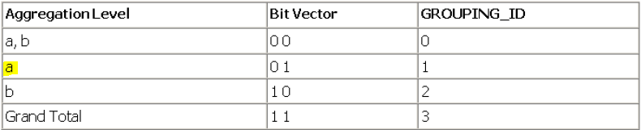

1. Here also NULL replacement is implemented, but it’s **not necessary** , because when we export in Excel it will be shown as blank space.
2. Groupings and grouping_id’s of different levels were used.
3. GROUP BY ROLLAP was used.

# Task 2

### Task

Напишите запрос для формирования отчёта о продажах в Азии всех продуктов из категории Photo за 2000 год по кварталам. Вычислите итоговые суммы (TOTAL и YEAR_SUM).

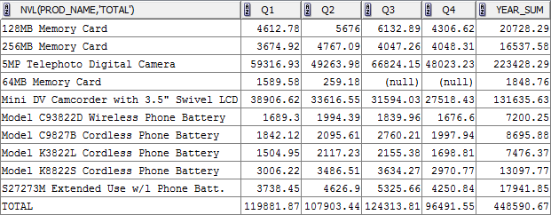

### Script

WITH quarter AS

( SELECT DISTINCT sh.products.prod_name AS prod_name,

NTH_VALUE(SUM(AMOUNT_SOLD),1) OVER (PARTITION BY prod_name ORDER BY sh.times .calendar_quarter_number ASC RANGE BETWEEN UNBOUNDED PRECEDING AND UNBOUNDED FOLLOWING) AS Q1,

NTH_VALUE(SUM(AMOUNT_SOLD),2) OVER (PARTITION BY prod_name ORDER BY sh.times .calendar_quarter_number ASC RANGE BETWEEN UNBOUNDED PRECEDING AND UNBOUNDED FOLLOWING) AS Q2,

NTH_VALUE(SUM(AMOUNT_SOLD),3) OVER (PARTITION BY prod_name ORDER BY sh.times .calendar_quarter_number ASC RANGE BETWEEN UNBOUNDED PRECEDING AND UNBOUNDED FOLLOWING) AS Q3,

NTH_VALUE(SUM(AMOUNT_SOLD),4) OVER (PARTITION BY prod_name ORDER BY sh.times .calendar_quarter_number ASC RANGE BETWEEN UNBOUNDED PRECEDING AND UNBOUNDED FOLLOWING) AS Q4,

SUM(SUM(AMOUNT_SOLD)) OVER (PARTITION BY prod_name) AS YEAR_SUM

FROM sh.sales

LEFT JOIN sh.products

ON sh.sales.prod_id=sh.products.prod_id

LEFT JOIN sh.times

ON sh.sales.time_id=sh.times.time_id

LEFT JOIN sh.channels

ON sh.sales.channel_id=sh.channels.channel_id

LEFT JOIN sh.customers

ON sh.sales.cust_id=sh.customers.cust_id

LEFT JOIN sh.countries

ON sh.customers.country_id =sh.countries.country_id

WHERE sh.times.calendar_year ='2000'

AND country_region ='Asia'

AND prod_category ='Photo'

GROUP BY sh.products.prod_name,

sh.times .calendar_quarter_number

)

SELECT NVL(sh.products.prod_name,'TOTAL') AS Prod_name,

SUM(Q1) AS Q1,

SUM(Q2) AS Q2,

SUM(Q3) AS Q3,

SUM(Q4) AS Q4,

SUM(year_sum)

FROM quarter q

LEFT JOIN sh.products

ON q.prod_name=sh.products.prod_name

GROUP BY rollup(sh.products.prod_name) ;

### Result

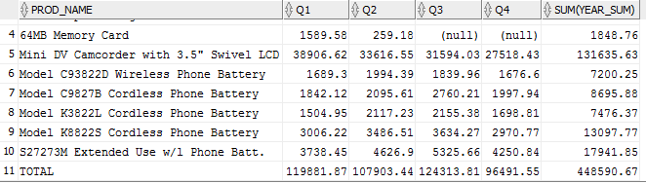

### Conclusions

1. NTH_VALUE function was used:

NTH_VALUE (SUM(AMOUNT_SOLD),4) OVER (PARTITION BY prod_name

ORDER BY sh.times .calendar_quarter_number ASC

RANGE BETWEEN UNBOUNDED PRECEDING AND UNBOUNDED FOLLOWING)

NTH_VALUE lets you find a **specific position in the analytic window** such as 2nd, 3rd, or 4th value

We partition our table by prod_name’s and then ordered them by quarters:

|  |  |  |
| --- | --- | --- |
| Prod 1 | Q1 | 1st value |
| Q1 | 1st value |
| Q1 | 1st value |
| Q2 | 2nd value |
| Q2 | 2nd value |
| Prod 2 | Q1 | 1st value |
| Q2 | 2nd value |
| … |  |  |

RANGE BETWEEN UNBOUNDED PRECEDING AND UNBOUNDED FOLLOWING – All rows are included in the window, regardless of the current row.

# Task 3

### Task

Show how many products of each model were sold in 2000 and 2001 in Asia and Europe.

### Script

SELECT *

FROM

(SELECT prod_name,

COUNTRY_REGION,

times.calendar_year,

QUANTITY_SOLD

FROM sh.sales

LEFT JOIN sh.products

ON sh.sales.prod_id=sh.products.prod_id

LEFT JOIN sh.times

ON sh.sales.time_id=sh.times.time_id

LEFT JOIN sh.customers

ON sh.sales.cust_id=sh.customers.cust_id

LEFT JOIN sh.countries

ON sh.customers.country_id =sh.countries.country_id

) PIVOT(SUM(QUANTITY_SOLD) FOR (country_region,calendar_year) IN (('Europe','2000')AS Europe_2000, ('Asia','2000')AS Asia_2000, ('Europe',2001)AS Europe_2001, ('Asia',2001)AS Asia_2001 ) ) ;

### Result

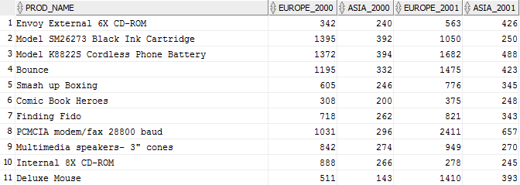

### Conclusions

Pivot – which attribute we insert

For – in which columns/