# Star schema

## The business process

A business process is a low-level activity performed by an organization.

It’s hard to define a business process without customers, but I assumed, that it’s sales accounting.

## The grain

The grain establishes exactly what a ***single fact table row*** represents. It provides the answer to the question, “How do you describe a single row in the fact table?”

One row per individual product from an employee to customer in the store each day.

## Dimensions

### Dimension Date

This dimension contains information about dates and populated with generated data for a required period (all days without exceptions, should be populated by script). It contains the following columns:

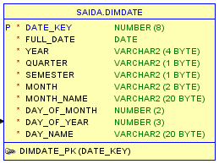

### Dimension Products

Here is information about products and categories they’re belong to.

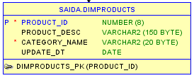

### Dimension Employees

Contains information about all employees (including their addresses).

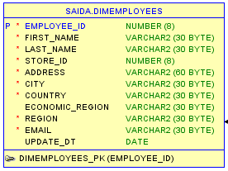

### Dimension Stores

In this dimension is retained information about stores

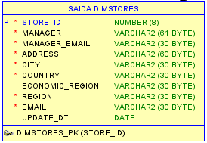

### Dimension Customers

Stores data about customers (including their addresses).

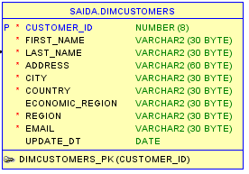

## Fact table

Here is two tables are combined in one fact table: sales and payments + all FK of dimensions.

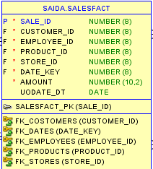

## Star schema

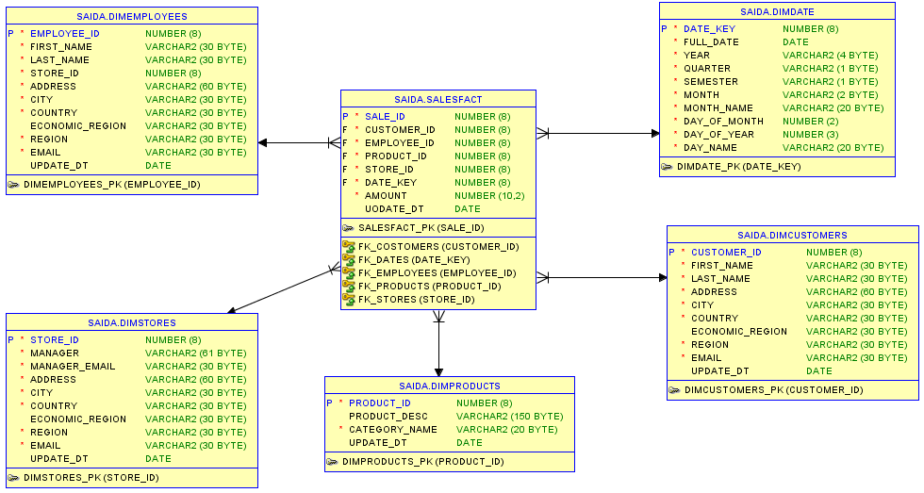

# Snowflake schema

In snowflake schema were removed low cardinality attributes from a dimension table and secondary dimension table were created, which are connected to their parent by a snowflake key. This schema is more close to the third NF.

Here were made the following changes:

* In the product dimension was added subcategory dimension.
* In the customer dimension was added geodata (regions, economic regions, countries, cities and addresses dimensions)
* In the store dimension was added geodata (regions, economic regions, countries, cities and addresses dimensions)
* In the employee dimension was added geodata (regions, economic regions, countries, cities and addresses dimensions)

*All scripts and images are in the folder.

