|  |
| --- |
|  |
|  |

Image goes here.

Contents

1. Business Description 3

1.1. Business background 3

1.2. Problems because of poor data management 3

1.3. Benefits from implementing a Data Warehouse 3

2. Dimensions of a Business 3

3. Logical Scheme 3

4. Data Flow 3

5. Fact Table Partitioning Strategy 3

6. Strategy of Parallel Load 3

7. Report Layouts 3

# Business Description

## Business background

EquipNet is the world’s most comprehensive surplus asset management company. EquipNet, Inc. is the world leader in proactive asset management services and solutions for large and small corporations alike. It specializes in the pharmaceutical, biotech, chemical, semiconductor, aerospace, automotive, and consumer packaged goods industries, as well as many other markets. EquipNet’s vision is to revolutionize the way companies manage their surplus assets. Forward-thinking corporations such as Merck, Johnson & Johnson, Unilever, Novartis and many others use EquipNet's Cascading Model™ to maximize financial returns, meet critical deadlines, avoid unnecessary costs, and prevent health, environmental, and theft hazards associated with idle assets.

## Problems because of poor data management

Store sales are influenced by many factors, including promotions, competition, school and state holidays, seasonality, and locality. With thousands of individual managers predicting sales based on their unique circumstances, the accuracy of results can be quite varied. So the problem is to predict sales.

## Benefits from implementing a Data Warehouse

DWH will be build to enable store managers to create effective staff schedules that increase productivity and motivation. This DWH will help store managers stay focused on what’s most important to them: their customers and their teams. Other benefits of implementing DWH are:

* Data retrieval is faster within data warehouses
* Prior to loading data into the data warehouse, inconsistencies are identified and resolved.
* Data warehouses can work in conjunction with and, hence, enhance the value of operational business applications, such as, for example, CRM systems.

Dataset will be based on the following resource:

<https://community.tableau.com/docs/DOC-1236>

# Dimensions of a Business

*-OrderDim*

Will include columns OrderID, DateId, ShipModeID, CustomerId, ProductID, OrderPriority, OrderQuantity, Sales, Discount, Profit, ShipimgCost

*-CustomerDim*

CustomerId, CustomerName, RegionID

*-ManagerDim*

ManagerId, ManagerName, RegionID

*-ShipDateDim*

ShipDateId, ShipDate

*-OrderDateDim*

OrderDateID, OrderDate

*-ProductDim*

ProductId, ProductName, UnitPrice, SubCategoryID, UnitPrice

*-SubCategoryDim*

SubcategoryId, SubcategoryName, CategoryID

*-CategoryDim*

CategoryID, CategoryName

*-ShipModeDim*

ShipModeID, ShipMode

*-SegmentDim*

SegmentID, Segment

*-ProvinceDim*

ProvinceID, Province

*-RegionDim*

RegionID, ProvinceID, RegionName

*-ReturnDim*

ReturnID, OrderID

## Business process

Business process are sales among regions in the sphere of office equipment *and incoming goods.*

## Grain

## Grain shows information about product that was sold (order time, quantity, ship mode etc.)

### CustomerDim

|  |  |  |
| --- | --- | --- |
| # | Name | description |
| 1 | Customer Key | Primary Key |
| 2 | Customer ID | Natural Key (business key) |
| 3 | Customer Name |  |
| 4 | Customer Surname |  |
| 5 | Customer Email |  |
| 6 | Customer Phone |  |
| 14 | Customer Region ID |  |

### ManagerDim

|  |  |  |
| --- | --- | --- |
| # | Name | description |
| 1 | Manager Key | Primary Key |
| 2 | Manager ID | Natural Key (business key) |
| 3 | Manager Name |  |
| 4 | Manager Surname |  |
| 5 | Manager Email |  |
| 6 | Manager Phone |  |

### ProductDim

|  |  |  |
| --- | --- | --- |
| # | Name | description |
| 1 | Product Key | Primary Key |
| 2 | Product ID | Natural Key |
| 3 | ProductName |  |
| 4 | SubCategory ID |  |
| 5 | UnitPrice |  |
| 6 | ProductContainer | Large box, JumboDrum etc. |
| 7 | ProductBaseMargin | *Средняя рентабельность бродукта* |

*-ReturnDim*

|  |  |  |
| --- | --- | --- |
| # | Name | description |
| 1 | ReturnId | Primary Key (PK FK) |
| 2 | OrderID | Primary Key (PK FK) |

*SubCategoryDim*

|  |  |  |
| --- | --- | --- |
| # | Name | description |
| 1 | SubCategoryId | Primary Key |
| 2 | SubCategoryName |  |
| 3 | CategoryId | Foreign Key |

*CategoryDim*

|  |  |  |
| --- | --- | --- |
| # | Name | description |
| 1 | CategoryId |  |
| 2 | CategoryName |  |

*-ShipModeDim*

|  |  |  |
| --- | --- | --- |
| # | Name | description |
| 1 | ShipModeID | Primary Key |
| 2 | ShipMode | Means how order will be delivered (Regular Air, Delivery truck etc.) |

*SegmentDim*

|  |  |  |
| --- | --- | --- |
| # | Name | Description |
| 1 | SegmentID, | Primary Key |
| 2 | Segment | What type of business make this order (small business, home office. Etc.) |

*-OrderDim*

|  |  |  |
| --- | --- | --- |
| # | Name | description |
| 1 | OrderKey | Primary Key |
| 2 | OrderID | Natural Key |
| 3 | CustomerId, |  |
| 4 | ProductID |  |
| 5 | Start_Date |  |
| 6 | End_Date |  |
| 7 | In_Process |  |
| 8 | ShipModeID | Foreign key () |
| 9 | OrderQuantity |  |
| 10 | Profit |  |
| 11 | Discount |  |
| 12 | ShipimgCost |  |
| 13 | Sales |  |
| 14 | OrderPriority | Low, Medium , High, Critical, Non Specified |
| 15 | СustomerSegmentID |  |

# 

# Logical Scheme

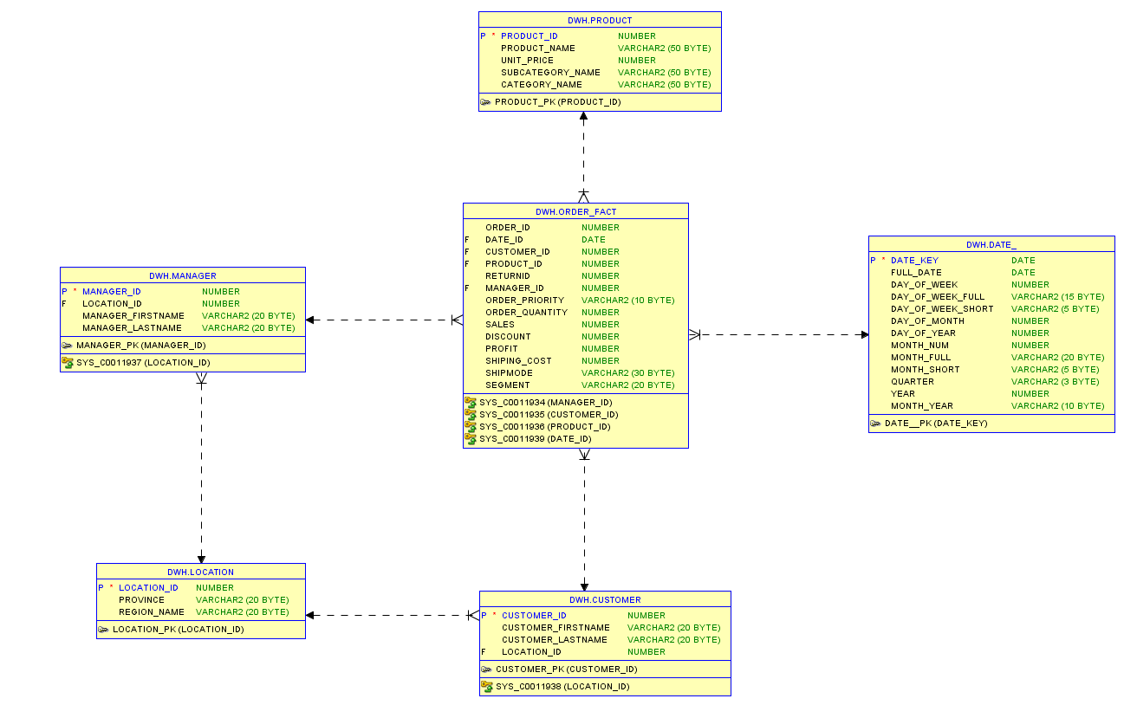

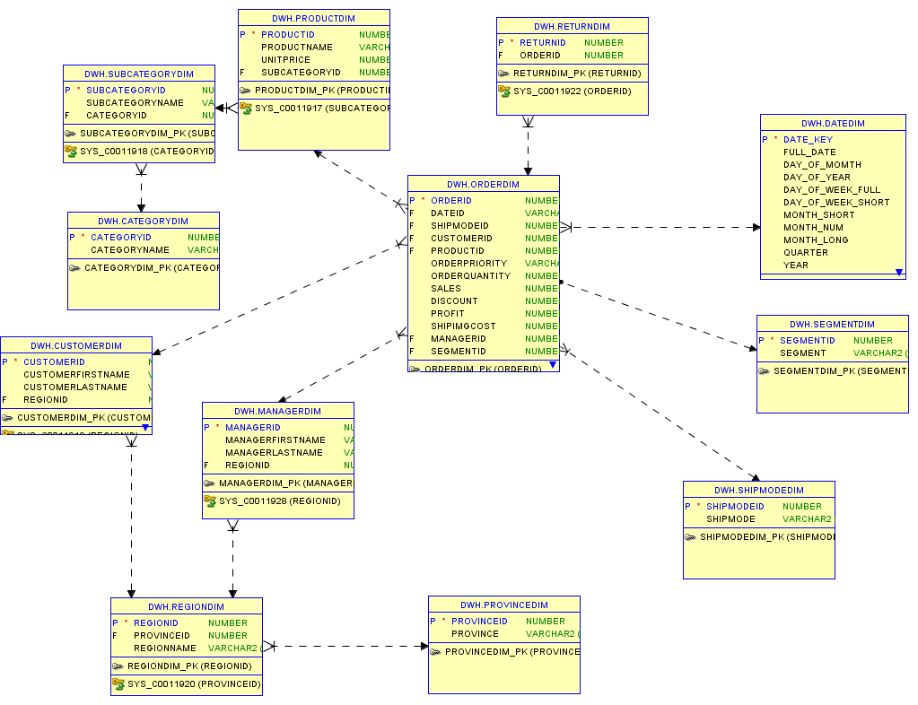

# Data Flow

# Fact Table Partitioning Strategy

Партиционирование будет происходить по датам для того, чтобы можно было просматривать продажи в определённом промежутке времени. Также, партиционирвоание можно проводить по элементу списка , такой способ фрагментации идеально подходит , когда в заданной колонке используется ограниченное число значений. В данном случае партиционирование имеет смысл проводить по колонке ShipMode и OrderPriority, для того чтобы можно быо анализировать продажи в этих разрезах.

# Strategy of Parallel Load

# Report Layouts