Analyze this set of requirements, find and categorize defects, write questions to the Customer. Please make your work layout effective, efficient and collaboration friendly.

**«File Searcher» requirements specification**

1. The «File Searcher» (FS) **(clearness)** application should automatically search for files using a given pattern.
2. The app should be written with Delphi 7 for Win XP and Win 7. **(clearness)**

- *Do you insist on implementing the application in Delphi 7? If so, why?*

1. To search for files user should enter the starting directory (or directory set). **(completeness)**.

*- What is the “Where to search” field for?*

*- Does the user have to manually enter the directory or should there be a special button?*

*- Should the file path be relative or absolute?*

FS **(clearness)** then automatically scans directories for unlimited nesting depth and displays found files on the right panel (see screenshot 1).

1. Three types of files are available for the search. User may enter a file type manually or select is from “What to search” combo box. **(atomicity)**
   1. Audio files (mp3, ogg, wav, mid).
   2. Video files (avi, mpg, mpeg).
   3. Office files (doc, docx, xls, xlsx).
2. For each found file the app should display:
   1. Name.

*- Should the user only see the name of the file or the name of the file with the extension?*

* 1. Full path. **(consistency)**
  2. Size.  
     - *Would it be comfortable for user looking at the information in kilobytes or megabytes?*
  3. Creation datetime. **(consistency and completeness)**

*- What information should be given in the datetime: created, opened or changed?*

* 1. Screenshot with the first frame. **(consistency and feasibility)**

*- Where should the screenshot column be located in the application?*

*- There is no way using screenshot with the first frame for audio and office files. Is this function should be realized only for video files?*

1. Performance.
   1. FS **(clearness)** should search for at least 500 files per second (assuming the read/write disc access speed is more than 50 Mb/sec).
   2. If expected overall operation time exceeds 1 hour, the app should not start its work. **(feasibility)**

- *How can the application estimate in advance the total time of the user’s work before launching this application?*

1. Language support.
   1. The app should support Russian and English languages by default. **(feasibility)**

*- One language can be used by default. What language should be used by default in the application?*

*- Do I understand it clearly that in the "Language" menu the user can change the current language of the application to another?*

* 1. There should be an option to add new languages. **(completeness and consistency)**

- *How should this function be realized?*

*- Do I understand it clearly that File Searcher application should support only Russian and English languages? If not, what languages should the application support?*

1. Logging.
   1. FRS should log its work. **(clearness and completeness)**

- *What is the format of the log?*

*- How is the name of the log file determined?*

*- What is the reaction of the application to the absence of a log file if it is not the first run?*

* 1. The logging should stop when the log size exceeds 1 MB. **(clearness and consistency)**

*- Should the logging stop or continue recording, overwriting the old data?*

*- Will 1 megabyte be enough for the size of the log file?*

*- When the log file size reaches 1MB, does the program have to create the next log file to continue recording work?*

* 1. Currently analyzing directory name should be displayed in “Currently analyzing” section at the bottom of the screen. **(consistency and completeness)**

- *Should the name of the directory being analyzed be displayed under "Current Analysis" at the bottom right of the screen or at the bottom left of the screen?*

1. File system support:
   1. The app should support all file systems available for Windows and UNIX. **(traceability and feasibility)**

- *Do I understand it clearly, that he app which is written for Windows XP and Windows 7 should support all file systems available for Windows? (in case that files which are supported by UNIX cannot be opened in Windows)*

* 1. If an unsupported FS is detected, FS should perform the emergency shutdown. **(clearness)**

*- What is meant by emergency shutdown?*

*- Would it be more comfortable for the user to show an error that the file is not supported by the system, rather than shutting down the application?*

1. There should be network support. **(completeness)**

*- What is meant by network support?*

*- Does the application have to have access to a remote server to search for files?*

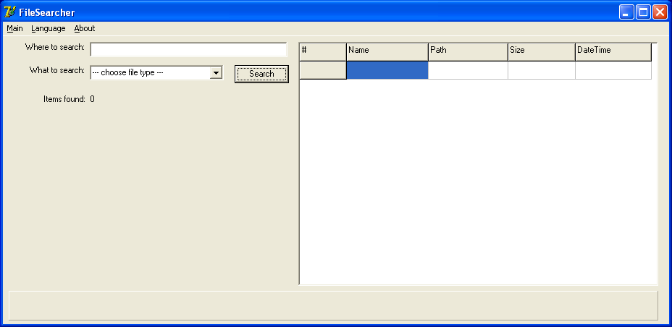Screenshot 1.

Additional questions:

1. What information should be on the “About” menu?
2. What information should be on the “Main” menu?