**МОЛДАВСКИЙ ГОСУДАРСТВЕННЫЙ УНИВЕРСИТЕТ**

**ФАКУЛЬТЕТ „МАТЕМАТИКА И ИНФОРМАТИКА”**

**ДЕПАРТАМЕНТ “ИНФОРМАТИКА”**

IA 1902

**Отчет по лабораторной работе**

**на тему «Форма приема на работу»**

# по курсу „Фреймворки для разработки веб-приложений”

Научный руководитель: _____________Бодруг Светлана, преподаватель

(подпись)

Автор: ______________ Полтавченко Анастасия

(подпись)

Кишинэу – 2021

1. <!DOCTYPE html>
2. <**html**>
3. <**head**>
4. <**title**>Angular JS Filters</**title**>
5. **<script src = "https://ajax.googleapis.com/ajax/libs/angularjs/1.3.14/angular.min.js">**
6. </**script**>
7. </**head**>
8. <**style**>
9. .info {
10. **font-weight: bold;**
11. color: red;
12. }
13. .mess {
14. font-weight: bold;
15. **text-transform: uppercase;**
16. color: red;
17. }
18. span {
19. font-weight: bold;
20. **}**
21. </**style**>
22. <**body**>
23. <**h1**>Employee</**h1**>
24. <**div** ng-app = "myApp" ng-controller = "employeeController">
25. **<form class="inputs">**
26. <**p**>Enter first name:</**p**>
27. <**input** type = "text" ng-model = "employee.firstName">
28. <**p**>Enter last name: </**p**>
29. <**input** type = "text" ng-model = "employee.lastName">
30. **<p>Enter date of birth: </p>**
31. <**input** type="date" ng-model="employee.date" id="date">
32. <**p**>Sex:</**p**>
33. <**label**>
34. <**input** type="radio" ng-model="employee.sex" value="male">
35. **Мужской**
36. </**label**>
37. <**label**>
38. <**input** type="radio" ng-model="employee.sex" value="female">
39. Женский
40. **</label>**
41. </**br**>
42. <**p**>Education:</**p**>
43. <**label**>
44. <**input** type="radio" ng-model="employee.education" value="secondary">
45. **Secondary**
46. </**label**></**br**>
47. <**label**>
48. <**input** type="radio" ng-model="employee.education" value="higher">
49. Higher
50. **</label></br>**
51. <**label**>
52. <**input** type="radio" ng-model="employee.education" value="master">
53. Master
54. </**label**></**br**>
55. **<label>**
56. <**input** type="radio" ng-model="employee.education" value="doctor">
57. Doctor
58. </**label**></**br**>
59. <**p**>Department:</**p**>
60. **<select name="department" ng-model="employee.department">**
61. <**option** value="programming">Programming</**option**>
62. <**option** value="accouting">Accounting</**option**>
63. </**select**><**br**>
64. <**p**>Estimated Salary:</**p**>
65. **<input type="number" ng-model="employee.salary">**
66. <**br**><**br**><**br**>
67. <**button** ng-click="show()" ng-disabled="checkk()">OK</**button**>
68. <**button** ng-click="reset()" ng-disabled="checkk()">Otkat</**button**>
69. </**form**>
70. **<div ng-show="showElem()">**
71. <**h1**>Info</**h1**>
72. <**div** ng-model="name"><**span**>Name:</**span**> {{name}}</**div**>
73. <**div** ng-model="birth"><**span**>Date of birth:</**span**> {{birth | date : "dd MMMM y"}}</**div**>
74. <**p**><**span**>Age:</**span**> {{a=(today | date : "yyyy") - (employee.date | date : "yyyy")}}</**p**>
75. **<p ng-show="a<18" class="mess">You are not fit for the job. you are too small!!!</p>**
76. <**p** ng-show="a>70" class="mess">you are not fit for the job. you are too old!!!</**p**>
77. <**div** ng-model="sex"><**span**>Sex:</**span**> {{sex}}</**div**>
78. <**div** ng-model="education"><**span**>Education:</**span**> {{education}}</**div**>
79. <**div** ng-model="department"><**span**>Department:</**span**> {{department}}</**div**>
80. **<div ng-model="salary"><span>Salary:</span> {{salary | currency}}</div>**
81. </**div**>
82. <**br**/>
84. <**script**>
85. **var mainApp = angular.module("myApp", []);**
87. mainApp.controller('employeeController', function($scope) {
88. $scope.show = function() {
89. $scope.flag = false;
90. **$scope.name = $scope.employee.firstName + " " + $scope.employee.lastName;**
91. $scope.birth = $scope.employee.date;
92. $scope.sex = $scope.employee.sex;
93. $scope.education = $scope.employee.education;
94. $scope.department = $scope.employee.department;
95. **$scope.salary = $scope.employee.salary;**
96. $scope.flag = true;
97. };
98. $scope.showElem = function() {
99. if ($scope.flag == true) {
100. **return true;**
101. }
102. };
103. $scope.reset = function() {
104. $scope.employee.firstName = "";
105. **$scope.employee.lastName = "";**
106. $scope.employee.date = "";
107. $scope.employee.sex = "";
108. $scope.employee.education = "";
109. $scope.employee.department = "";
110. **$scope.employee.salary = "";**
111. $scope.flag = false;
112. }
114. $scope.today = new Date();
115. **$scope.checkk = function() {**
116. if ($scope.employee.salary >= 5000 && $scope.employee.salary <= 20000) {
117. return false;
118. } else {
119. return true;
120. **}**
121. }
122. });
123. </**script**>
125. **</body>**
126. </**html**>

**Результат:**

Ввод данных с зарплатой меньше 5000 долларов. Кнопки OK и Otkat неактивны

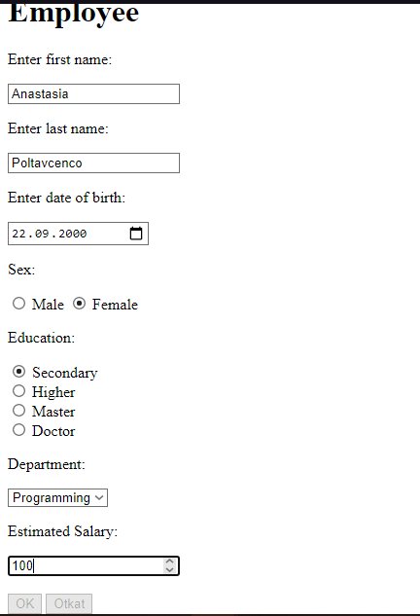

Ввод данных с зарплатой больше 5000 но меньше 20000 долларов. Кнопки OK и Otkat активны

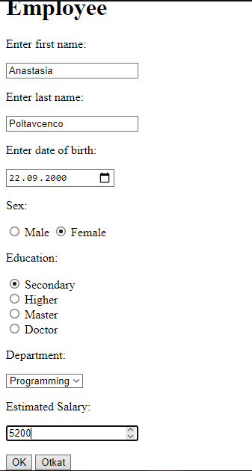

По нажатию на кнопку OK под формой отображается блок с введенной информацией  
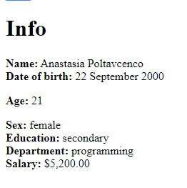

Если выбран возраст меньше 18 лет

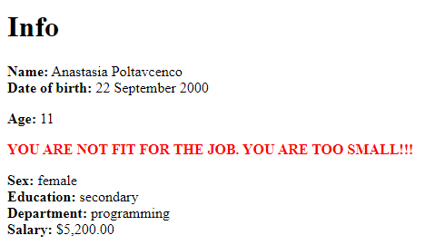

Если выбран возраст старше 70

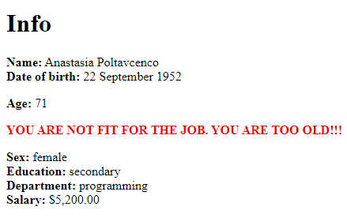

По нажатию на кнопку Otkat происходит очищение полей  
