1. <!DOCTYPE html>  
   <html>  
   <script src="https://ajax.googleapis.com/ajax/libs/angularjs/1.6.9/angular.min.js"></script>  
   <body ng-app="myApp" ng-controller="StudentCtrl">  
     
   <h2>Student List</h2>  
     
   <form ng-submit="todoAdd()">  
    <input type="text" ng-model="NewStudentInput" size="50" placeholder="Add Student">  
    <input type="number" ng-model="NoteInput" placeholder="Note">  
    <input type="submit" value="Add New">  
   </form>  
     
   <br>  
     
   <div ng-repeat="x in StudentList">  
    <input type="checkbox" ng-model="x.done"> <span ng-bind="x.Name"></span>, <span ng-bind="x.Note"></span>  
   </div>  
     
   <br>  
   <div class="buttons">  
   <button ng-click="remove()">Remove marked</button>  
   <button ng-click="expel()">Expel from USM  
   </div>  
     
   <script>  
   var ***app*** = angular.*module*('myApp', []);   
   ***app***.controller('StudentCtrl', function($scope) {  
    $scope.StudentList = [{Name:'Svetlana Bodrug', Note:10, done:false}];  
     
    $scope.todoAdd = function() {  
    $scope.StudentList.push({Name:$scope.NewStudentInput, Note:$scope.NoteInput,done:false});  
    $scope.NewStudentInput = "";  
    $scope.NoteInput = 0;  
    };  
     
    $scope.remove = function() {  
    var oldList = $scope.StudentList;  
    $scope.StudentList = [];  
    angular.forEach(oldList, function(x) {  
    if (!x.done) $scope.StudentList.push(x);  
    });  
    };  
      
    $scope.expel = function() {  
    var oldList = $scope.StudentList;  
    $scope.StudentList = [];  
    angular.forEach(oldList, function(x) {  
    if (x.Note >= 5) $scope.StudentList.push(x);  
    });  
    };  
   });  
   </script>  
     
   </body>  
   </html>

**Результат**Изначальный вариант  
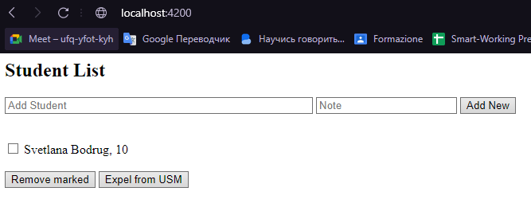  
Добавляем немного студентов  
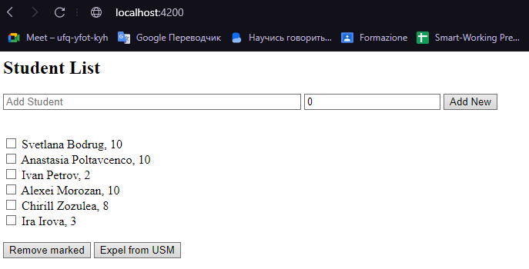

Удаляем тех, у кого оценка меньше 5  
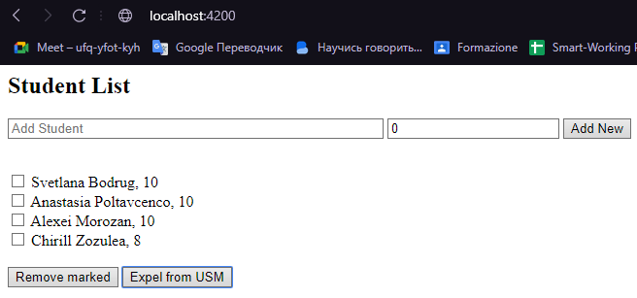  
Удаляем по выбору  
