1. <!DOCTYPE html>
2. <**html**>
3. <**script** src="https://ajax.googleapis.com/ajax/libs/angularjs/1.6.9/angular.min.js"></**script**>
4. <**body** ng-app="myApp" ng-controller="StudentCtrl">
6. <**h2**>Student List</**h2**>
8. <**form** ng-submit="todoAdd()">
9. <**input** type="text" ng-model="NewStudentInput" size="50" placeholder="Add Student">
10. **<input type="number" ng-model="NoteInput" placeholder="Note">**
11. <**input** type="submit" value="Add New">
12. </**form**>
14. <**br**>
16. <**div** ng-repeat="x in StudentList">
17. <**input** type="checkbox" ng-model="x.done"> <**span** ng-bind="x.Name"></**span**>, <**span** ng-bind="x.Note"></**span**>
18. </**div**>
20. **<br>**
21. <**div** class="buttons">
22. <**button** ng-click="remove()">Remove marked</**button**>
23. <**button** ng-click="expel()">Expel from USM
24. </**div**>
26. <**script**>
27. var app = angular.module('myApp', []);
28. app.controller('StudentCtrl', function($scope) {
29. $scope.StudentList = [{Name:'Svetlana Bodrug', Note:10, done:false}];
31. $scope.todoAdd = function() {
32. $scope.StudentList.push({Name:$scope.NewStudentInput, Note:$scope.NoteInput,done:false});
33. $scope.NewStudentInput = "";
34. $scope.NoteInput = 0;
35. **};**
37. $scope.remove = function() {
38. var oldList = $scope.StudentList;
39. $scope.StudentList = [];
40. **angular.forEach(oldList, function(x) {**
41. if (!x.done) $scope.StudentList.push(x);
42. });
43. };
45. **$scope.expel = function() {**
46. var oldList = $scope.StudentList;
47. $scope.StudentList = [];
48. angular.forEach(oldList, function(x) {
49. if (x.Note >= 5) $scope.StudentList.push(x);
50. **});**
51. };
52. });
53. </**script**>
55. **</body>**
56. </**html**>

**Результат**

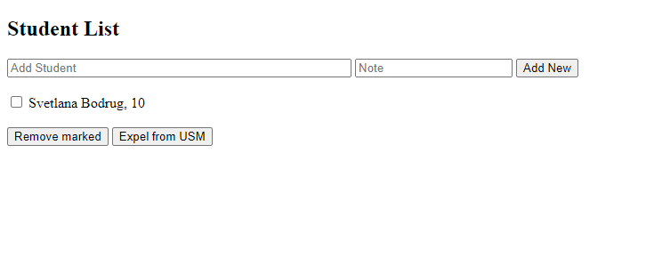

Заполняю поля и нажимаю кнопку Add New

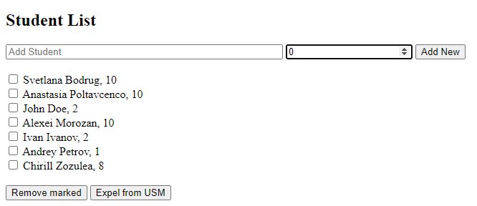

Нажимаю на кнопку Expel from USM для того чтобы удалить из списка людей с оценкой ниже 5

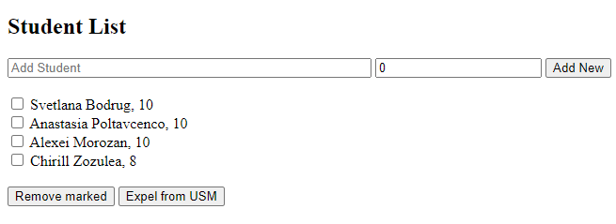

Выбираю при помощи чекбокса оставшихся людей из списка и нажимаю кнопку Remove marked, чтобы удалить выбранных людей

