**Anastasia Psarou – Assignment 9 – Project**

This is my dataflow:

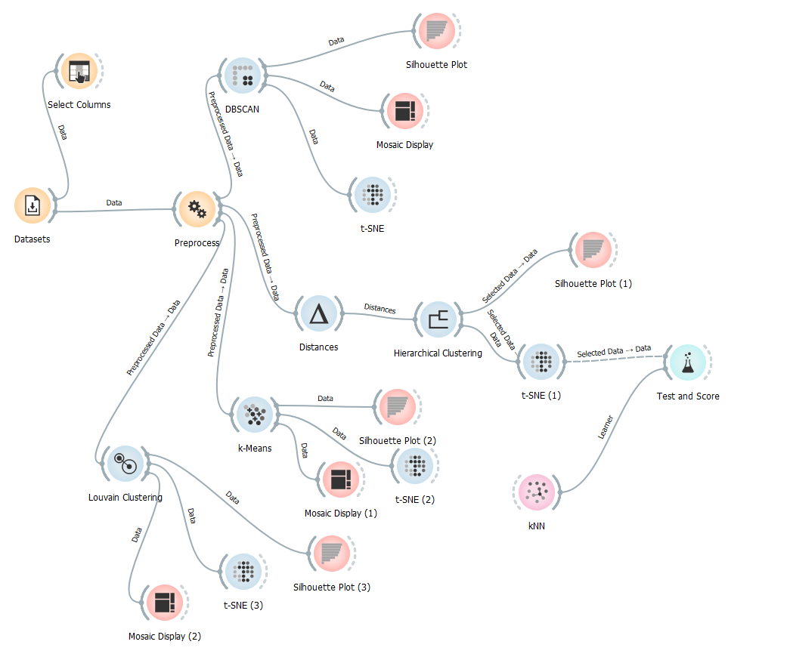

The dataset I choose is “Dermatology”.

I am going to watch the way these different clustering methods are behaving in order to end up to the best one.

I think that the t-SNE graph is the one that will help me decide which one of these methods is the best.

* **Louvain Clustering**

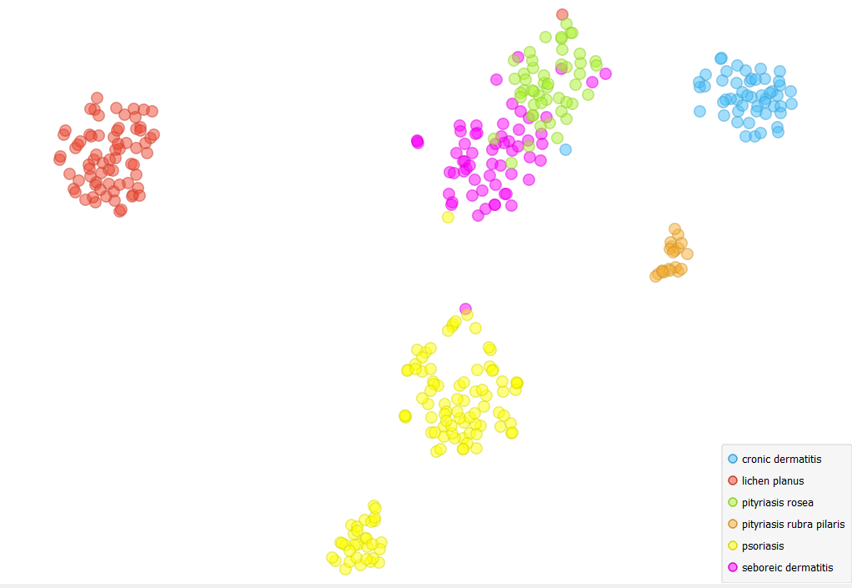

* **Hierarchical Clustering**

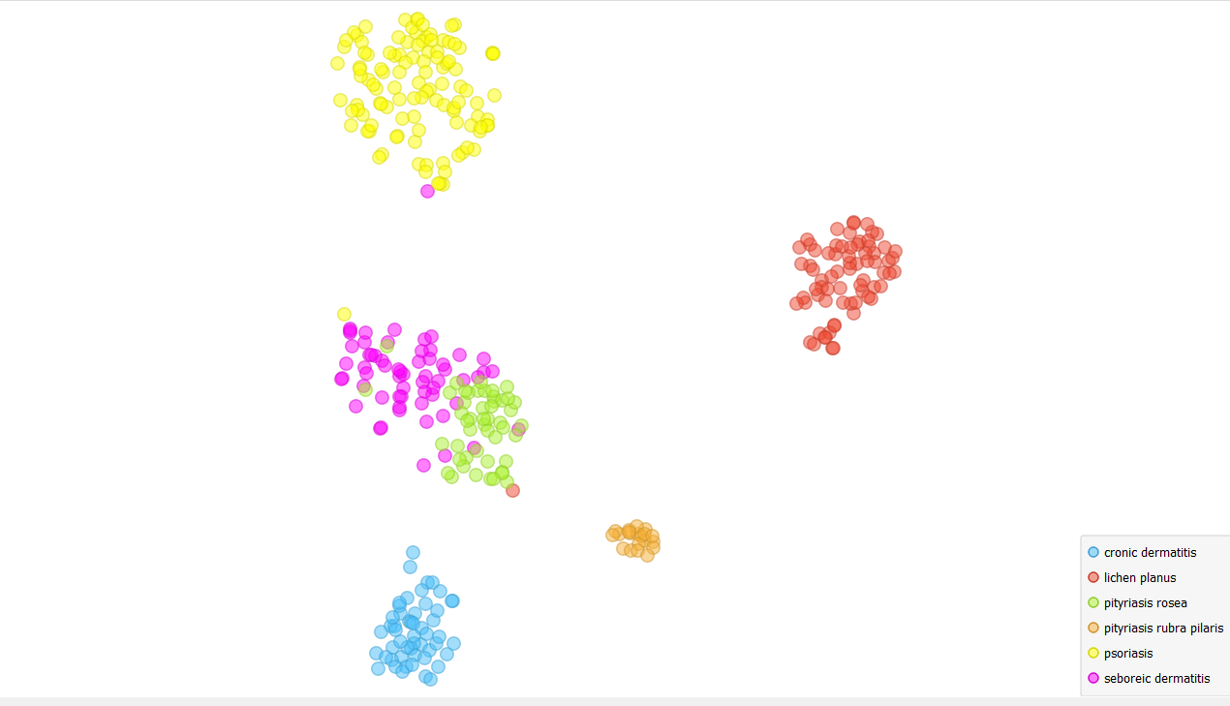

* **DBSCAN**

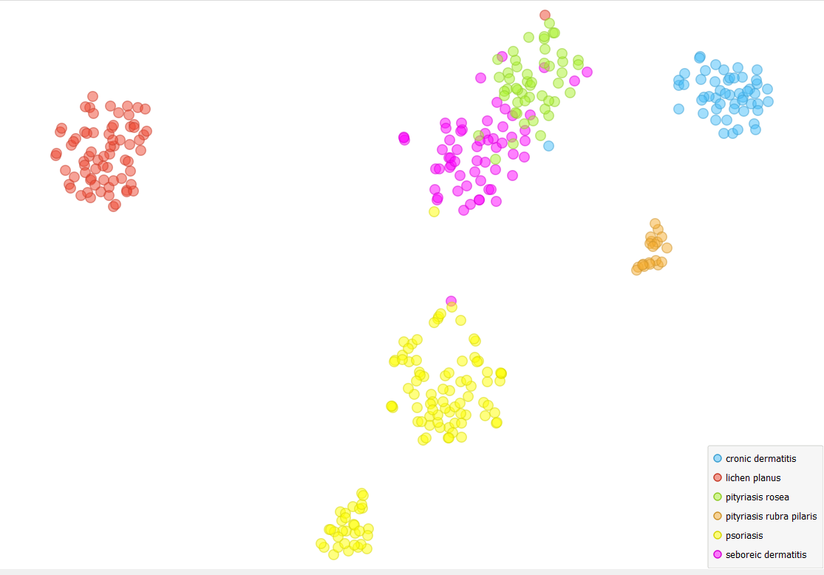

* **k-Means**

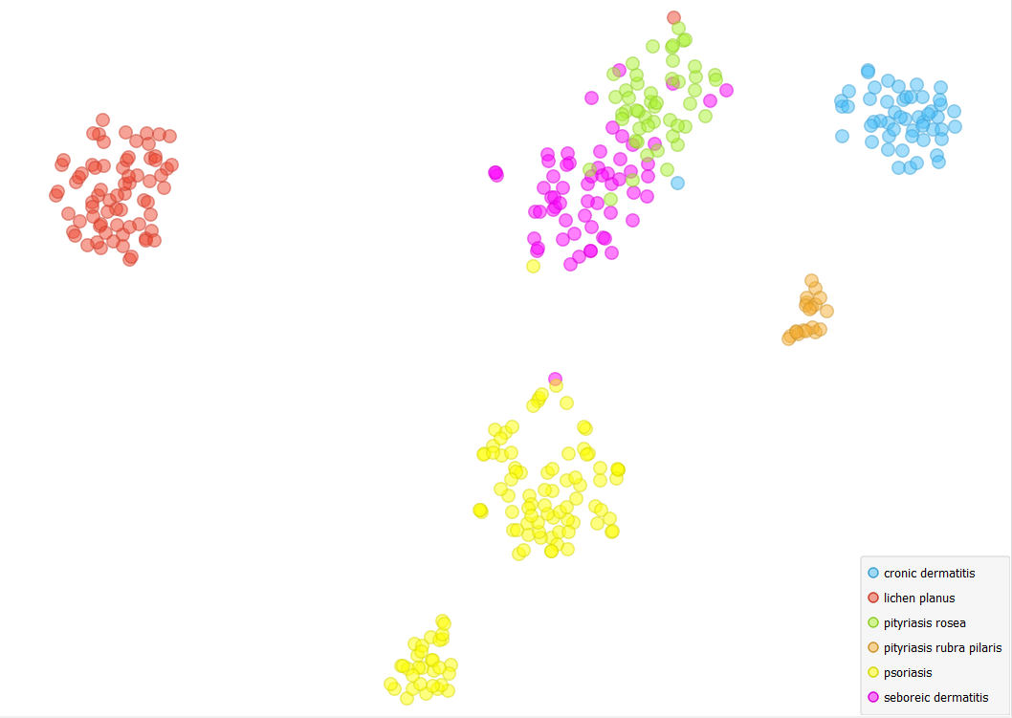

From the above results it seems to me that Hierarchical Clustering is the method that has more concentrated clusters the one between the other ones. So, I believe that as far as I am concerned Hierarchical Clustering is the best clustering method, which reconstructs the structure of the dataset classes.