Arab Open University
Lebanon Branch



Faculty of Computer Studies
Data Science

TM471: Graduation Project
Fair and Stable Credit Risk Scoring:
A Monitoring System for Model Performance and Fairness Over Time

Name and ID
Anastasia Al Rassi
240304

Supervisor
Dr. Maya Dawoud

Academic Year
2025/2026
Abstract
Machine learning models for credit risk are usually developed and evaluated at a single point in time, yet once deployed they score applicants whose characteristics, economic conditions and lending policies keep changing. Two consequences are rarely measured together: the model's ability to rank risky borrowers can decay, and a model that treated demographic groups fairly at deployment can drift into unfair behaviour without anyone noticing, because fairness audits are typically run once.
This project designs and evaluates a credit risk scoring and monitoring system built on real consumer-lending data released by Home Credit, in which every application carries a week index. Models are trained on early weeks and then replayed through later weeks as if in production. Each week the system scores new applications, raises label-free drift warnings using the Population Stability Index, and, once outcomes mature, tracks discrimination (Gini), a stability score and group fairness metrics (Disparate Impact Ratio and Equalized Odds) across protected groups. Static, periodic and drift-triggered retraining policies are compared on accuracy, stability, fairness and operational cost.
The expected contribution is twofold: a working prototype that gives analysts, loan officers and ML engineers an explainable, auditable view of a credit model over its lifetime, and empirical evidence on whether fairness is stable over time and whether drift-triggered retraining preserves fairness as well as accuracy.
Acknowledgments
I would like to express my sincere gratitude to my supervisor, Dr. Maya Dawoud, for her continuous guidance, support, and valuable feedback throughout this project.
I also thank the faculty members of the Faculty of Computer Studies at Arab Open University for providing the resources and knowledge necessary for completing this work.
Special thanks to my friends and family for their encouragement, patience, and support during the development of this project.
Finally, I appreciate everyone who contributed directly or indirectly to the completion of this final year project.
Signed Declaration
I hereby declare that this submitted report is a result of my own efforts and that I have not plagiarized any other person's work. I have provided all references of information that I have used and quoted in my assignment.
Name: Anastasia Al Rassi
Signature: ANASTASIA
Date: [submission date]
Table of Contents

[Right-click the table and choose Update Field (or press F9) after opening in Word to refresh page numbers.]

Chapter 1: Introduction

1.1 Background
Credit risk is the probability that a borrower will fail to meet their repayment obligations. Lenders estimate it for every application they receive, and those estimates drive approval decisions, credit limits and pricing. Statistical scorecards have been the industry standard for decades because they are transparent and easy to validate [10], while machine learning methods, particularly gradient-boosted tree ensembles, have repeatedly shown stronger ranking performance on credit data [1].

Most published credit models, however, are evaluated as if the world stood still: data is split at random, a model is trained once, and a single test score is reported. In practice a credit model is deployed for months or years. During that time the applicant population shifts, economic conditions change, marketing campaigns attract new customer segments, and the lender's own policies evolve. A model's performance on the day it is approved is therefore a poor guide to its performance a year later.
The same reasoning applies to fairness. Automated lending decisions must not systematically disadvantage protected groups, and fairness metrics such as the Disparate Impact Ratio and Equalized Odds are increasingly used to audit credit models [6], [7], [8]. These audits are almost always carried out once, before deployment. Whether a model that passes a fairness audit remains fair as its input population drifts is largely unmeasured.

1.2 Problem Statement
Three related problems motivate this project.
- Performance decay. Credit models lose discriminatory power after deployment as the relationship between applicant characteristics and default changes. Reported accuracy from random train/test splits systematically overstates what a lender will experience.
- Unmonitored fairness drift. A model that satisfies fairness criteria at deployment may violate them later, because group composition and group-level risk can change over time. Without continuous monitoring, such violations go undetected.
- Delayed outcomes. Default is only observed after a performance window has elapsed, so a lender cannot measure a live model's accuracy or fairness in real time. Early warning must rely on label-free signals such as shifts in the input distribution.
Existing academic systems typically address prediction accuracy, and sometimes explainability or a one-off fairness audit, but rarely treat the credit model as something that must be monitored across its lifetime for both performance and fairness.

1.3 Aim and Objectives
The aim of this project is to design, build and evaluate a credit risk scoring system that monitors its own discriminatory performance and fairness over time, and to use it to study how both evolve after deployment. The objectives are:
- O1: Build a leakage-safe, application-time feature pipeline over a real, time-indexed, multi-table consumer credit dataset.
- O2: Train and compare interpretable and ensemble classifiers using out-of-time validation rather than random splitting.
- O3: Implement a weekly replay that simulates deployment, including delayed outcome availability.
- O4: Monitor, for every simulated week, input drift (PSI), discrimination (Gini), a stability score, and fairness metrics across protected groups.
- O5: Compare static, periodic and drift-triggered retraining policies on accuracy, stability, fairness and number of retraining events.
- O6: Deliver an interface that presents scores with local explanations to loan officers and monitoring dashboards and alerts to analysts and ML engineers.

1.4 Research Questions
- RQ1: How much does a credit model's discriminatory performance degrade over time relative to its in-time validation estimate, and do model families differ in stability?
- RQ2: Do group fairness metrics remain within acceptable bounds over time for a model that satisfies them at deployment?
- RQ3: Can label-free drift indicators give early warning of performance or fairness degradation, and does drift-triggered retraining preserve fairness as well as accuracy compared with static and periodic retraining?

1.5 Target Users and Scope
The system is designed for three groups of users inside a lending institution:
- Credit risk analysts and model validators, who need evidence that a model remains accurate, stable and fair after deployment, and who decide when a model must be reviewed.
- Loan officers, who review individual applications, particularly borderline cases, and need an understandable explanation of each score.
- ML engineers, who maintain the pipeline, retrain and version models, and configure drift and fairness thresholds.
The scope of the project includes:
- Data layer: ingestion, auditing and aggregation of the Home Credit multi-table dataset into application-level features.
- Modelling layer: training and comparison of Logistic Regression and gradient-boosted tree models with out-of-time evaluation, calibration and threshold selection.
- Monitoring layer: weekly replay, drift detection, performance and fairness tracking, alerting and retraining policies.
- Presentation layer: a scoring interface with local explanations and a monitoring dashboard.
The following are explicitly out of scope: an applicant-facing portal, real-time streaming ingestion, integration with live banking systems, and the use of any private or confidential financial data. The system is an offline prototype that simulates deployment on historical data.

1.6 Project Deliverables
- A reproducible data pipeline and trained, versioned credit risk models with documented out-of-time performance.
- A monitoring engine that replays historical weeks and records drift, performance and fairness metrics, with alerts and configurable retraining policies.
- A web interface for application scoring with explanations and for monitoring dashboards.
- This technical report, including requirements, UML design, methodology, experimental results and a discussion suitable as the basis of a research publication.

1.7 Socio-Economic Inclusion
Home Credit focuses on lending to people with little or no formal credit history, a population that traditional bureau-based scoring often excludes. This makes the dataset well suited to questions of financial inclusion: a model that serves thin-file applicants well at deployment but degrades unevenly across groups can quietly reintroduce exclusion.
The system therefore treats fairness as a monitored quantity rather than a one-off check. For each protected attribute, it reports the Disparate Impact Ratio, which compares favourable-outcome rates between groups against the commonly used four-fifths (0.80) threshold [6], and Equalized Odds gaps, which compare true-positive and false-positive rates between groups [7]. Protected attributes are excluded from model inputs and retained only for auditing, and the accuracy cost of this exclusion is measured explicitly.

1.8 Structure of the Report
Chapter 2 introduces the system concept, the dataset, and the evaluation framework, and reviews the literature on credit scoring, concept drift and algorithmic fairness. Chapter 3 describes the methodology: dataset selection, preprocessing, feature engineering, temporal splitting, model training, the monitoring replay and retraining policies. Chapter 4 presents functional and non-functional requirements, the system architecture, UML diagrams, and the experimental results. Chapter 5 concludes and outlines future work. Chapter 6 lists references and Chapter 7 contains appendices.

Chapter 2: System Concept and Literature Review

2.1 Credit Risk Scoring as a Monitored System

2.1.1 System Overview
The system treats a credit model as a component with a lifecycle rather than a one-time artefact. Data flows through four layers. The data layer converts raw relational records into one feature row per application. The modelling layer trains, calibrates and versions models. The monitoring layer replays later time periods as if the model were deployed, computing drift, performance and fairness each week and raising alerts. The presentation layer exposes individual scores and explanations to loan officers, and trends and alerts to analysts and ML engineers.
Separating these layers keeps preprocessing, inference and monitoring decoupled, so a model can be retrained or replaced without changing how data is ingested or how metrics are reported.

2.1.2 Data Description
The project uses the dataset released by Home Credit for the Kaggle competition “Home Credit – Credit Risk Model Stability” [4]. Unlike most public credit datasets, it was designed to evaluate models over time: each application (identified by case_id) carries a decision date and a week index (WEEK_NUM), together with a binary default target.
The data is relational. A base table holds one row per application; depth-0 tables hold static application-level attributes; depth-1 and depth-2 tables hold historical records, such as previous applications and credit bureau entries, with many rows per application that must be aggregated. Sources include Home Credit's internal records and external credit bureau data. Feature names carry suffixes that indicate the type of transformation applied, documented in the accompanying feature definitions file.
Key characteristics relevant to this project are: [number of applications and weeks, and default rate, from the data audit]; strong class imbalance; heavy missingness in bureau-derived tables for applicants without credit history; and person-level attributes that allow a fairness audit [confirm which protected attributes are present, e.g. sex and date of birth].

2.1.3 Temporal Validation
Random train/test splitting mixes past and future applications, allowing a model to learn from conditions it would never have seen at deployment time. It therefore overstates real-world performance. This project uses out-of-time validation throughout: models are trained on the earliest weeks, selected on the following weeks, and evaluated on later weeks that remain unseen until final evaluation. The monitoring replay extends this idea week by week.

2.1.4 Model Development
Two families of supervised classifiers are compared. Logistic Regression, optionally with Weight of Evidence encoding, is the regulatory reference model because its coefficients are directly interpretable [3], [10]. Gradient-boosted tree ensembles such as LightGBM and XGBoost capture non-linear interactions and missing-value patterns without extensive manual transformation and are consistently among the strongest methods on tabular credit data [1]. Local explanations for any model are produced with SHAP values [9].

2.1.5 Evaluation Framework
Evaluation covers four dimensions.
- Discrimination: ROC-AUC and its linear transform, the Gini coefficient (2 × AUC − 1), the industry-standard measure of how well a score ranks defaulters above non-defaulters; the Kolmogorov–Smirnov statistic; and precision-recall AUC for the minority class.
- Stability: Gini computed per week, summarised with the competition’s stability score, which rewards a high mean weekly Gini and penalises a declining trend and week-to-week variability [4].
- Calibration and decisions: the Brier score for probability quality, and precision, recall and cost at the chosen decision threshold.
- Fairness: Disparate Impact Ratio and Equalized Odds gaps per protected attribute, per week, together with per-group AUC.
Input drift is measured with the Population Stability Index (PSI), which compares the binned distribution of a variable in a recent period with its reference distribution. Conventional rules of thumb treat PSI below 0.10 as stable, 0.10–0.25 as a moderate shift and above 0.25 as a significant shift [10].

2.2 Literature Review

2.2.1 Introduction
Credit evaluation has moved from the personal judgement of loan officers to statistical scorecards and, more recently, to machine learning. Early scorecards introduced consistency and scale but assumed linear relationships. Machine learning relaxes that assumption, and with it raises two questions this review focuses on: how model behaviour changes after deployment, and whether automated decisions are fair.

2.2.2 Comparative Analysis of Credit Scoring Methods
Lessmann et al. [1] benchmarked a wide range of statistical and machine learning classifiers across multiple credit-scoring datasets. Ensemble methods, including random forests and boosting, frequently outperformed logistic regression, which the authors attribute to their ability to model non-linear relationships without extensive feature engineering. They also noted the cost: reduced interpretability, which creates regulatory and operational difficulty.
Patil et al. [2] applied deep neural networks to credit risk prediction and reported strong accuracy and AUC after extensive preprocessing, while acknowledging high training cost, sensitivity to hyperparameters and limited interpretability compared with classical models.
Costa e Silva et al. [3] showed that logistic regression with careful variable selection can remain competitive on consumer default data, and emphasised that directly interpretable coefficients support transparency, auditability and regulatory validation. Yeh and Lien [11], using the widely studied Taiwanese credit card dataset, compared several data mining techniques and highlighted the importance of estimating calibrated default probabilities rather than only class labels.
A common feature of these studies is that evaluation is static: performance is reported on a hold-out sample drawn from the same period as the training data.

2.2.3 Concept Drift and Model Monitoring
Gama et al. [5] survey concept drift, where the joint distribution of inputs and target changes over time, and categorise adaptation strategies into blind approaches, which retrain periodically regardless of evidence, and informed approaches, which retrain when a drift detector signals a change. In credit risk, drift arises from economic cycles, changes in applicant mix and changes in lending policy, and is complicated by delayed labels: default is observed only after the performance window, so detectors must often rely on input distributions. Industry practice monitors characteristic and population stability with PSI for this reason [10].
The Home Credit stability competition [4] made temporal robustness the explicit objective by scoring submissions on weekly Gini with penalties for decline and variability, reflecting the lender’s need for models whose performance does not erode after deployment.

2.2.4 Fairness in Credit Scoring
Feldman et al. [6] formalised disparate impact using the ratio of favourable-outcome rates between groups and the four-fifths rule. Hardt et al. [7] proposed Equalized Odds, which requires equal true-positive and false-positive rates across groups, arguing that parity of error rates is more appropriate than parity of outcomes when base rates differ. Kozodoi et al. [8] benchmarked fairness criteria and fairness-enhancing techniques on credit scoring data and analysed the profit implications, showing that fairness can often be improved at a modest cost in profit.

2.2.5 Research Gap
The literature treats accuracy, drift and fairness largely in isolation. Credit-scoring benchmarks report static accuracy; drift research focuses on predictive performance; and fairness studies, including those specific to credit, evaluate models on a single snapshot. There is little evidence on whether fairness metrics themselves drift after deployment, whether label-free drift signals anticipate fairness degradation, or whether retraining policies designed to recover accuracy also recover fairness. This project addresses that gap with a real, time-indexed credit dataset and a system that monitors both dimensions together.

Chapter 3: Methodology

3.1 Dataset Selection
Two public datasets were explored in preliminary experiments before the final choice was made.
The UCI Default of Credit Card Clients dataset [11] contains 30,000 customers with six months of billing and repayment history. A full pipeline comparing nine model families reached a test ROC-AUC of 0.781 (Gini 0.56) with a tuned boosted-tree ensemble, and all families finished within a narrow band, indicating that performance was limited by the information in the data rather than the algorithm. However, the dataset is a single observation window with no time index, so it cannot support any analysis of change over time, and it describes behavioural scoring of existing cardholders rather than application scoring.
The Bondora peer-to-peer lending dataset [12] supports chronological evaluation and includes gender and age. An application-time model with a strict chronological split and a 12-month default horizon reached a ROC-AUC of approximately 0.70, a realistic result for application-only features evaluated out of time.
The Home Credit stability dataset [4] was selected because it combines real lending data, a weekly time index designed for stability evaluation, a rich relational structure, and person-level attributes for fairness auditing. These experiments also informed a key methodological decision: absolute AUC is bounded by the data, so the project’s contribution lies in how performance and fairness behave over time rather than in maximising a single score.

3.2 Data Collection and Audit
The dataset is obtained from Kaggle in Parquet format and processed with Polars, which handles the multi-gigabyte, multi-table structure efficiently on standard hardware. An initial audit verifies schema consistency across split files, casts columns to types indicated by their name suffixes, and records row counts, week coverage, default rate per week, and missingness per table. Protected attributes are identified and separated into an audit table that never enters the model inputs.

3.3 Preprocessing
- Date handling: absolute dates are converted to durations relative to the application decision date, so the model learns “how long before the decision” rather than calendar time, which would not generalise to future weeks.
- Point-in-time correctness: historical records dated after the decision date are excluded, so no feature uses information that would not have been available when the application was scored.
- Missing values: missingness is preserved as a signal through indicator variables; imputation, where required by the model, is fitted on training weeks only.
- Categorical variables: high-cardinality categories are grouped by training-period frequency; unseen categories in later weeks are mapped to an “other” level.

3.4 Feature Engineering
Depth-1 and depth-2 tables are aggregated to one row per application using statistics appropriate to each variable type: counts, means, minima, maxima and most recent values for numeric and date variables, and mode and number of distinct values for categorical variables. Features with near-zero variance or extreme missingness in the training weeks are removed. Candidate features are screened on training weeks with univariate AUC, Information Value and pairwise correlation, and features whose distribution is highly unstable across training weeks are flagged, since unstable inputs are a likely source of later decay.

3.5 Temporal Split
Applications are ordered by week and divided into four consecutive periods: a training period, a validation period for model and threshold selection, an out-of-time test period for a single final evaluation, and a replay period used by the monitoring simulation. [State the week ranges and row counts for each period.] No application from a later period is used in fitting any earlier step.

3.6 Model Selection and Training
Logistic Regression serves as the interpretable baseline. LightGBM and XGBoost are the main candidates. Hyperparameters are tuned with time-ordered cross-validation inside the training period, so that each fold validates on weeks later than those it trains on. The validation period then selects between model families. Protected attributes are excluded from inputs; to quantify the cost of this choice, the best model is also refitted with them included and the difference in validation AUC is reported.

3.7 Calibration and Decision Threshold
Predicted scores are calibrated on the validation period using Platt scaling or isotonic regression, selected by Brier score. The decision threshold is chosen on the same probability scale that the deployed model outputs, and a cost analysis sweeps the ratio between the cost of a missed default and the cost of a wrongly declined good applicant, since that ratio is a business input rather than something the data can supply.

3.8 Monitoring Simulation
The replay treats each week of the replay period as a live production week. For every week the system:
- scores that week’s applications with the currently deployed model;
- computes PSI for the score and for the most important input features against the training reference;
- releases the outcomes of the week that has now completed its performance window, simulating a delay of [L] weeks between scoring and outcome availability; and
- for weeks with released outcomes, computes Gini, calibration, and fairness metrics per protected group, then evaluates alert rules.

3.9 Retraining Policies
Three policies are compared over the same replay period.
Policy | Rule
P0 – Static | The model trained at deployment is never retrained. This is the reference for measuring decay.
P1 – Periodic | The model is retrained every [k] weeks on all outcomes released so far, regardless of evidence of drift.
P2 – Drift-triggered | The model is retrained when score PSI exceeds a threshold or a fairness metric breaches its bound, using only released outcomes.

Policies are compared on mean weekly Gini, the stability score, the number of weeks in which any fairness bound is violated, and the number of retraining events as a proxy for operational cost.

3.10 Fairness Evaluation
For each protected attribute and each week with released outcomes, the system computes the favourable-outcome rate per group, the Disparate Impact Ratio (lowest divided by highest favourable rate), true-positive and false-positive rate gaps (Equalized Odds), and per-group AUC. Groups below a minimum size or with too few defaults in a given week are excluded from that week’s calculation, and rolling multi-week windows are used where weekly samples are too small, to avoid reporting noise as bias.

Chapter 4: Requirements, Design and Results

4.1 Functional Requirements

4.1.1 Credit Risk Analyst / Model Validator
- Performance Monitoring: The analyst shall view weekly Gini, the stability score and calibration for the deployed model over the replay period.
- Fairness Monitoring: The analyst shall view Disparate Impact and Equalized Odds per protected attribute per week, with the four-fifths threshold marked.
- Drift Monitoring: The analyst shall view PSI for the score and key features and inspect which features shifted.
- Alert Review: The analyst shall see a log of alerts and mark each as reviewed with a comment.
- Policy Comparison: The analyst shall compare the outcomes of the retraining policies side by side.

4.1.2 Loan Officer
- Application Scoring: The user shall score an individual application or a batch uploaded as a file and receive a probability of default and a risk band (Low / Medium / High).
- Interpretability Report: The user shall view a local explanation showing the factors that contributed most to a score.
- Decision Override: The user shall record a manual decision with a written justification for borderline cases (human in the loop).

4.1.3 ML Engineer (Administrator)
- Model Lifecycle Management: The administrator shall train, version, deploy and roll back models, with metadata recording the data period and metrics behind each version.
- Threshold Configuration: The administrator shall configure PSI and fairness alert thresholds and the retraining policy.
- Retraining: The administrator shall trigger retraining manually or allow the configured policy to trigger it; every retrain shall run the fairness audit before deployment.
- Replay Control: The administrator shall run, pause and reset the monitoring replay.

4.2 Non-functional Requirements

4.2.1 Operational
- The system shall run on standard consumer hardware without GPU acceleration.
- The system shall read Parquet and CSV inputs.

4.2.2 Maintainability
- Pipeline stages shall be modular so that preprocessing, models and monitoring rules can be changed independently.
- Code and configuration shall be documented.

4.2.3 Reproducibility
- Every reported result shall be reproducible from raw data using fixed random seeds, versioned configuration and saved model artefacts.
- Hyperparameter search code shall be included, not only its selected values.

4.2.4 Policy
- The system shall use only publicly available data and shall not store private personal data.
- Protected attributes shall be used only for auditing, never as model inputs.

4.2.5 Usability
- Scores and explanations shall be presented in plain language suitable for non-technical users.
- Dashboards shall make threshold breaches visually obvious.

4.2.6 Performance
- Scoring a single application shall complete within [target, e.g. 1 second]; a full replay shall complete within [target] on the development machine.

4.2.7 Security
- Administrative functions shall be restricted to the administrator role.
- Deployed model artefacts shall be protected from unauthorised modification.

4.3 System Architecture
The system is organised into five components.
Component | Responsibility | Technology
Data pipeline | Load, audit, aggregate and split the relational data; build point-in-time features | Python, Polars, Parquet
Model training | Train, tune, calibrate and version models; persist artefacts and metadata | scikit-learn, LightGBM, XGBoost
Scoring service | Score applications and return probability, risk band and explanation | FastAPI, SHAP
Monitoring engine | Weekly replay, PSI, Gini, fairness metrics, alerts, retraining policies | Python, Polars
Dashboard | Scoring interface and monitoring views for each user role | Streamlit

4.4 UML Diagrams

4.4.1 General Use Case Diagram
[Figure to be drawn: General use case diagram]
System boundary: Credit Risk Scoring & Monitoring System.
Actors: Loan Officer, Credit Risk Analyst, ML Engineer (Administrator).
Loan Officer: Score Application («include» Validate Input), View Interpretability Report, Record Manual Decision («extend» Score Application).
Credit Risk Analyst: View Performance Trends, View Fairness Trends, View Drift Report, Review Alerts, Compare Retraining Policies.
ML Engineer: Manage Model Versions, Configure Thresholds, Run Replay, Retrain Model («include» Execute Fairness Audit).

Figure 4.1: General use case diagram
The use case diagram shows three actors. The Loan Officer scores applications, which always includes input validation, reviews the interpretability report, and can record a manual decision that extends the scoring use case for borderline cases. The Credit Risk Analyst consumes the monitoring outputs: performance, fairness and drift trends, the alert log, and the comparison of retraining policies. The ML Engineer manages model versions, configures thresholds, runs the replay and retrains models; retraining always includes a fairness audit so that no model is deployed without one.

4.4.2 Application Scoring Activity Diagram
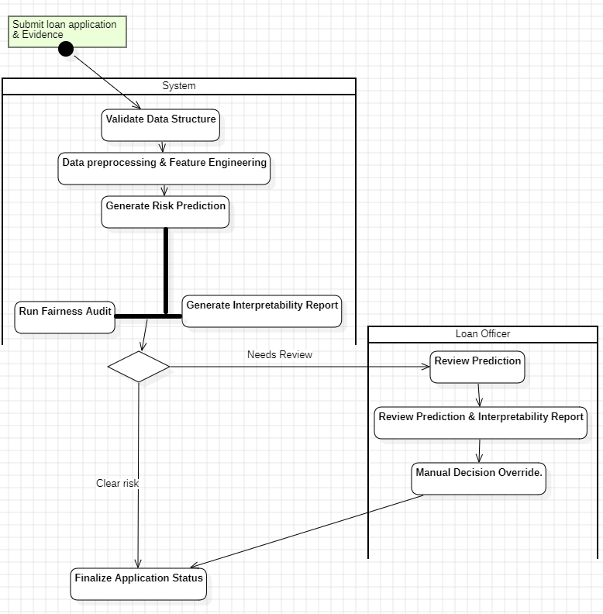
Figure 4.2: Activity diagram for scoring an application
The activity diagram shows how a single application is processed. After an application arrives, the system validates its structure, applies the same preprocessing and feature engineering used in training, and generates a risk prediction. Two activities then run in parallel: the fairness audit record is updated and an interpretability report is generated. If the score falls clearly in a low- or high-risk band, the status is finalised automatically; if it falls in the review band, the application passes to the Loan Officer, who reviews the prediction and explanation and may record a manual override before the decision is finalised.

4.4.3 Weekly Monitoring Activity Diagram
[Figure to be drawn: Weekly monitoring activity diagram]
Start: next replay week.
Score week’s applications → compute PSI (score + top features) → release outcomes for week (t − L).
Fork: compute Gini + calibration | compute fairness metrics per group.
Decision: any threshold breached? → yes: raise alert → decision: policy triggers retrain? → yes: retrain → execute fairness audit → deploy new version.
Merge → log metrics → decision: more weeks? → loop / end.

Figure 4.3: Weekly monitoring activity diagram
The monitoring activity diagram describes one iteration of the replay. The system scores the current week, computes drift immediately because it needs no outcomes, and releases the outcomes of the week whose performance window has just closed. Performance and fairness metrics are computed in parallel for that week. If any threshold is breached an alert is raised, and under the drift-triggered policy the model is retrained, audited for fairness and redeployed before the next week begins.

4.4.4 Administrator Use Case Diagram
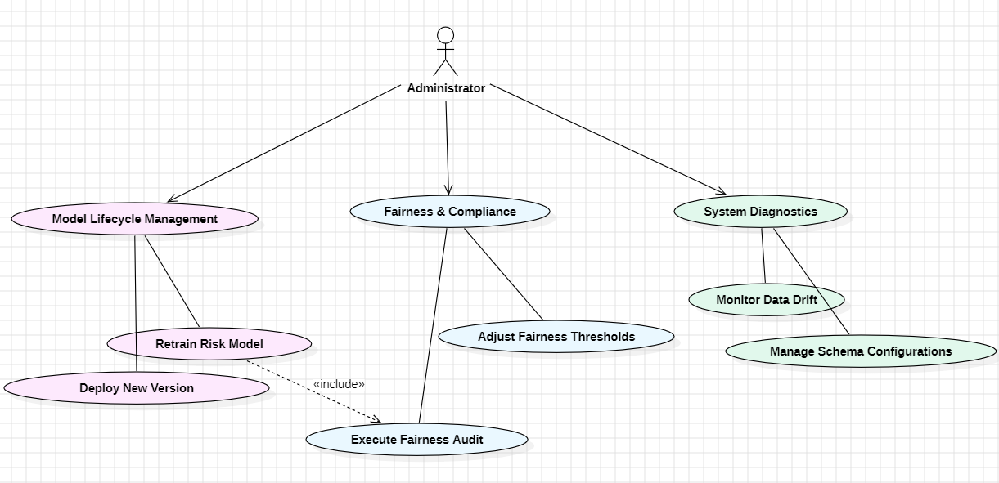
Figure 4.4: Administrator use case diagram
The Administrator interacts with three functional clusters. Under Model Lifecycle Management, the administrator deploys new versions and retrains the risk model; retraining includes an Execute Fairness Audit step so that every candidate model is checked before deployment. Under Fairness & Compliance, the administrator adjusts fairness thresholds that drive monitoring alerts. Under System Diagnostics, the administrator monitors data drift and manages schema configurations so that incoming data remains aligned with the feature pipeline.

4.5 Results and Discussion
[This section will be completed after the modelling and replay experiments. Planned subsections are listed below.]

4.5.1 Out-of-Time Model Performance
[Validation and out-of-time test Gini, KS, PR-AUC and Brier for each model family; accuracy cost of excluding protected attributes.]

4.5.2 Stability Over Time
[Weekly Gini under the static policy; stability score per model family; answer to RQ1.]

4.5.3 Fairness Over Time
[Weekly Disparate Impact and Equalized Odds per protected attribute; weeks in violation; answer to RQ2.]

4.5.4 Drift Warnings and Retraining Policies
[Lead time between PSI alerts and measured degradation; comparison of P0, P1 and P2; answer to RQ3.]

4.5.5 Limitations
[Limitations, including: a single lender and region; anonymised features limit domain interpretation; replay is a simulation of deployment rather than live use; fairness limited to the protected attributes available in the data.]

Chapter 5: Conclusion and Future Work

5.1 Conclusion
This project reframes credit risk modelling from a one-time prediction exercise into the design of a system that must remain accurate and fair throughout deployment. Using a real, time-indexed consumer lending dataset, it builds a leakage-safe pipeline, evaluates models out of time, and replays later weeks to measure how discrimination and group fairness evolve, whether drift signals anticipate degradation, and whether retraining policies recover fairness as well as accuracy.
[Summarise the main findings for RQ1–RQ3 once results are available.] Regardless of the specific results, the system provides analysts, loan officers and ML engineers with an explainable and auditable view of a credit model across its lifetime, and combines predictive modelling with continuous fairness oversight and human review.

5.2 Future Work
- Fairness mitigation: extend the system from monitoring to intervention, for example reweighing training data or adjusting thresholds, and evaluate whether mitigation remains effective over time, taking into account the legal constraints on group-specific treatment.
- Cross-dataset replication: repeat the fairness-over-time analysis on the Bondora dataset to test whether findings generalise across lenders and countries.
- Explanation stability: monitor whether the features driving individual explanations change over time, since unstable explanations undermine trust even when accuracy is stable.
- Streaming deployment: replace the batch replay with streaming ingestion, for example with Apache Kafka, and deploy the services as containers.
- Alternative data for thin-file applicants: evaluate whether additional data sources improve accuracy for applicants without credit history without widening group disparities.

Chapter 6: References
[1] S. Lessmann, B. Baesens, H.-V. Seow and L. C. Thomas, “Benchmarking state-of-the-art classification algorithms for credit scoring: An update of research,” European Journal of Operational Research, vol. 247, no. 1, 2015.
[2] V. Patil et al., “Credit Risk Modelling Using Deep Neural Network,” 2025. Available: https://www.researchgate.net/publication/397639986
[3] E. Costa e Silva et al., “A logistic regression model for consumer default risk,” 2020. Available: https://pmc.ncbi.nlm.nih.gov/articles/PMC9041570/
[4] Home Credit, “Home Credit – Credit Risk Model Stability,” Kaggle competition, 2024. Available: https://www.kaggle.com/competitions/home-credit-credit-risk-model-stability
[5] J. Gama, I. Žliobaitė, A. Bifet, M. Pechenizkiy and A. Bouchachia, “A survey on concept drift adaptation,” ACM Computing Surveys, vol. 46, no. 4, 2014.
[6] M. Feldman, S. A. Friedler, J. Moeller, C. Scheidegger and S. Venkatasubramanian, “Certifying and removing disparate impact,” in Proc. ACM SIGKDD, 2015.
[7] M. Hardt, E. Price and N. Srebro, “Equality of opportunity in supervised learning,” in Advances in Neural Information Processing Systems, 2016.
[8] N. Kozodoi, J. Jacob and S. Lessmann, “Fairness in credit scoring: Assessment, implementation and profit implications,” European Journal of Operational Research, vol. 297, no. 3, 2022.
[9] S. M. Lundberg and S.-I. Lee, “A unified approach to interpreting model predictions,” in Advances in Neural Information Processing Systems, 2017.
[10] N. Siddiqi, Credit Risk Scorecards: Developing and Implementing Intelligent Credit Scoring. Hoboken, NJ: Wiley, 2006.
[11] I.-C. Yeh and C. Lien, “The comparisons of data mining techniques for the predictive accuracy of probability of default of credit card clients,” Expert Systems with Applications, vol. 36, no. 2, 2009.
[12] Bondora, “Public loan dataset,” Bondora AS. [Add access URL and date.]

Chapter 7: Appendices

7.1 Data Audit Tables
[Row counts, week coverage, default rate per week, missingness per table.]

7.2 Feature Definitions
[Final feature list with source table and aggregation.]

7.3 Additional Results
[Per-week metric tables and supplementary figures.]

7.4 Code Repository and Reproduction Instructions
[Repository link and steps to reproduce every result.]

7.5 System Screenshots
[Scoring interface and monitoring dashboard.]

