MeanShift Homework

1. For tasks 3 I used MeanShift algorithm from OpenCV. For task 4 I used MeanShift algorithm from sclearn

2. For tasks 3 I used CamShift algorithm from OpenCV. For task 4 I used CamShift algorithm from sclearn

3. I adjasted code from this tutorial https://docs.opencv.org/master/d7/d00/tutorial_meanshift.html
To test in on the given datasets I changed the code to load the frames from images and not from video.

MeanShift script: meanshift.py
Commandline: python3 meanshift.py –images_path. /___FolderName___/img/ --roi_path ./___FolderName___/ROI.png

CamShift script: camshift.py
Commandline: python3 meanshift.py --images_path ./___FolderName___/img/ --roi_path ./___FolderName___/ROI.png

Both scripts for each image sequentially calculate track_window and rectangle and draw the image with rectangle onto the screen. Also, the rewrite the images into ./FolderName/folders img/results/meanshift/ and folders ./FolderName/img/results/meanshift/ respectively. The result images are written with the same name as corresponding frame image.

So, you can see the results of my code in the folders DragonBaby, Biker, Bird2, Bolt2, Human9 → img/results/meanshift, img/results/camshift.

Shortly about the adjustments I used and how to resume my results for each dataset:

DragonBaby:

This dataset worked comperatively good, because here we have a baby in a bright yellow costume. So the hue channel has an distribution which differ highly from the background. The costume is shined better then the background, that is why I took mask with only high measure of the saturation and the value channels. Regardles of the mask, after the baby jumps, the rectangle calculated by the CamShift algorithm explodes.

script:
python3 meanshift.py --images_path ./DragonBaby/img/ --roi_path ./DragonBaby/DragonBaby_roi.png
python3 camshift.py --images_path ./DragonBaby/img/ --roi_path ./DragonBaby/DragonBaby_roi.png

meanshift.py:
mask = cv.inRange(hsv_roi, np.array((0., 60., 32.)), np.array((180., 255., 255.)))
camshift.py:
mask = cv.inRange(hsv_roi, np.array((0., 120., 150.)), np.array((180., 255., 255.)))
cut.py(to get the ..._roi.png):
image = cv.imread("./DragonBaby/img/0001.jpg")
part = image[73:300,100:240]
cv.imwrite("./DragonBaby/DragonBaby_roi.png", part)
MeanShift results:

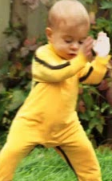 | 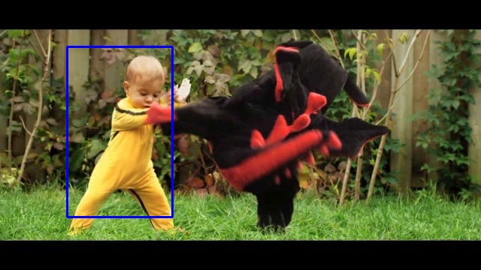 | 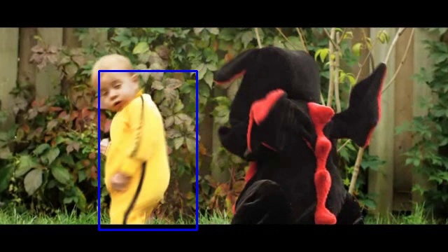
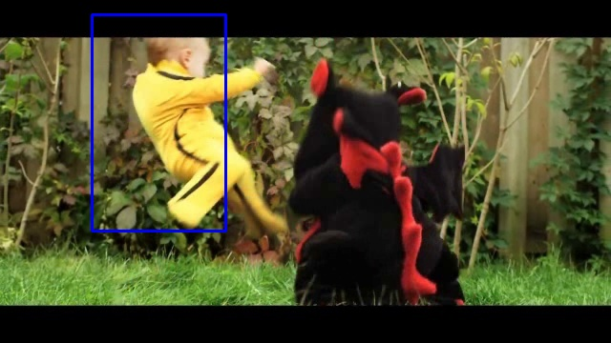 | 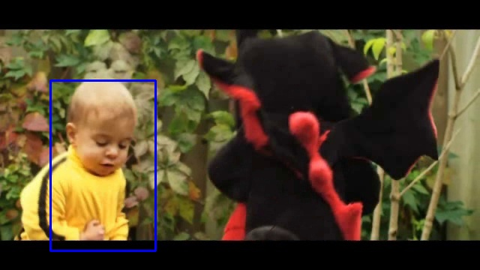 | 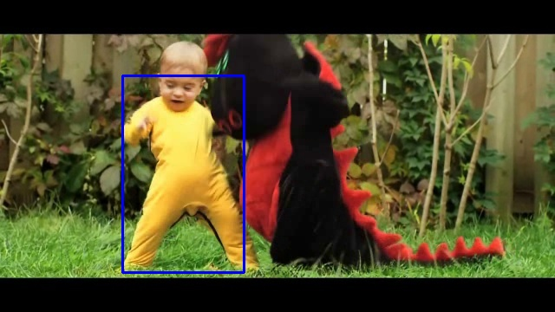

CamShift results:

 | 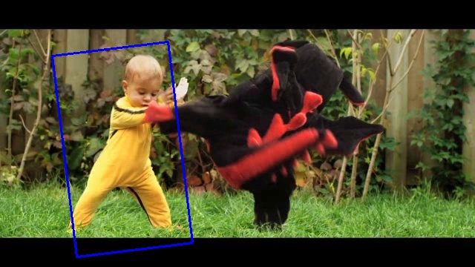 | 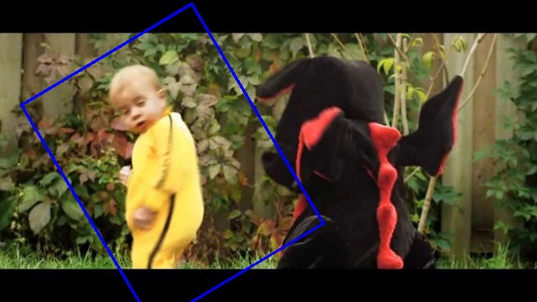
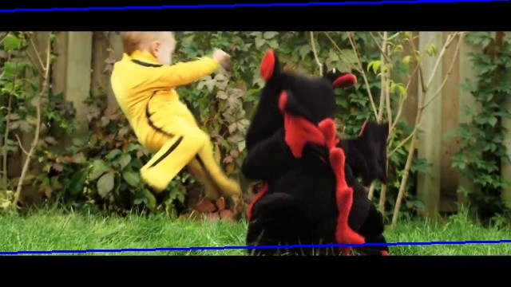 | 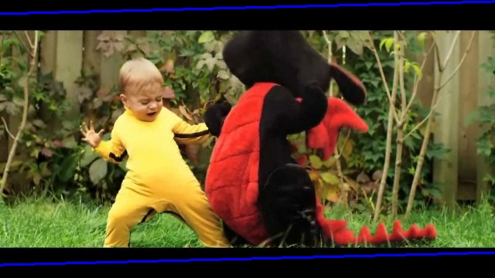 | 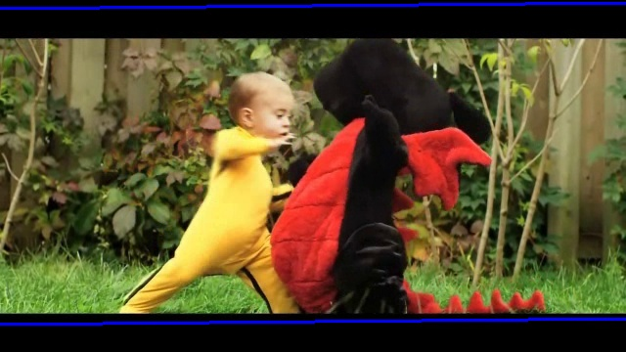

Biker:

This dataset worked perfectly, because here we have a biker in a vivid green t-shirt. So the hue channel has an distribution which differ highly from the background. The costume is shined better then the background, that is why I took mask with only high measure of the saturation and the value channels. Also in he CamShift I also chosed the hue value to be in the vicinity of green. Regardles of the mask, after the biker jumps, turns and relocates, the rectangle calculated by the CamShift algorithm explodes but only in width.

Script:
python3 meanshift.py --images_path ./Biker/img/ --roi_path ./Biker/biker_roi.png
python3 camshift.py --images_path ./Biker/img/ --roi_path ./Biker/biker_roi.png
meanshift.py:
mask = cv.inRange(hsv_roi, np.array((0., 60., 32.)), np.array((180., 255., 255.)))
camshift.py:
mask = cv.inRange(hsv_roi, np.array((50., 50., 20.)), np.array((150., 250., 250.)))

MeanShift results:

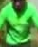 | 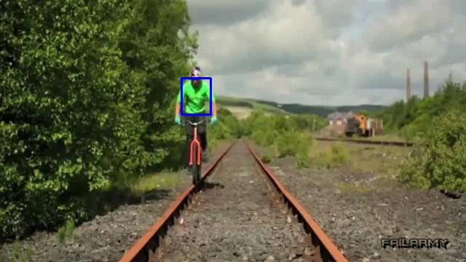 | 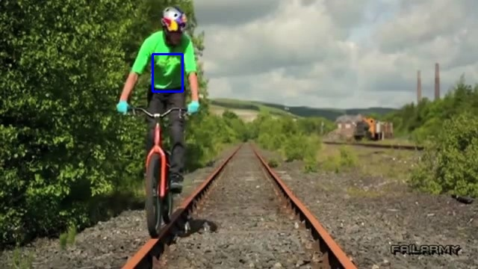
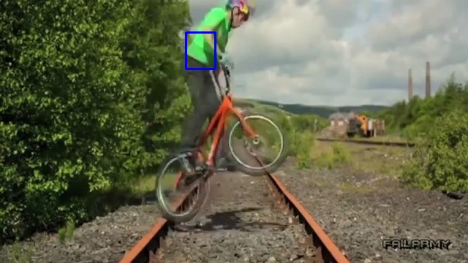 | 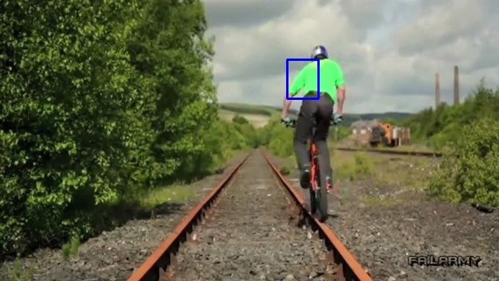 | 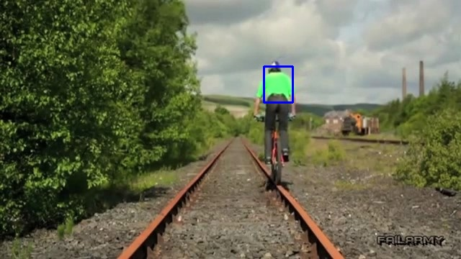

CamShift results:

 | 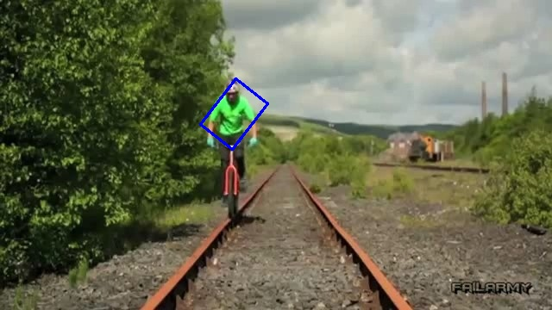 | 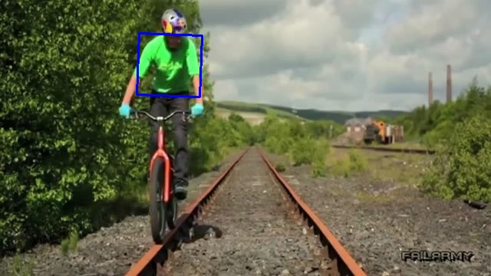
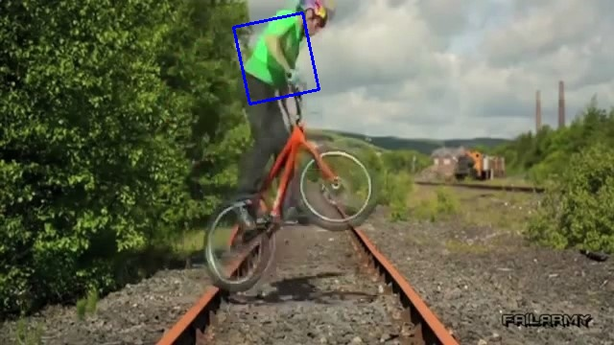 | 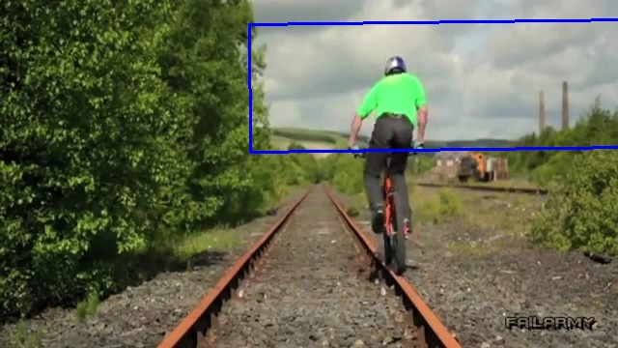 | 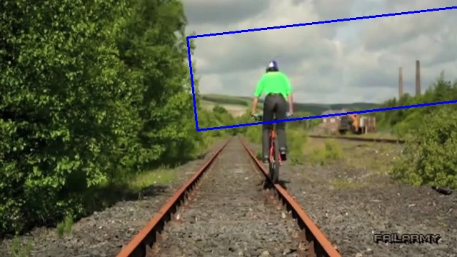

Bird2:

This dataset doesn’t work at all for the HSV format, because here we have a bird which is white/black on the vivid rose/violet/white/yellow background . So, the hue value of the black or white color contributes nothing to the hue channel, because for this colors only value channel matters the most. So, I decided to use GRAY scale instead of HSV and it worked, because the values of the black tail are really contrast amid light background. So here you can see the results for GRAY scale in the folders img/results/meanshift, img/results/camshift and for HSV channel in the folders img/results/meanshift_hsv, img/results/camshift_hsv respectively.

Script:
python3 meanshift.py --images_path ./Bird2/img/ --roi_path ./Bird2/Bird2_roi.png
python3 camshift.py --images_path ./Bird2/img/ --roi_path ./Bird2/Bird2_roi.png

meanshift.py:

# Bird2 GRAY
hsv_roi = cv.cvtColor(roi, cv.COLOR_BGR2GRAY)
mask = cv.inRange(hsv_roi, 0, 50.)

# ______________________________
# HSV
hsv_roi = cv.cvtColor(roi, cv.COLOR_BGR2HSV)
mask = cv.inRange(hsv_roi, np.array((0., 0., 0.)), np.array((180., 255., 255.)))
camshift.py:
# Bird2 GRAY
hsv_roi = cv.cvtColor(roi, cv.COLOR_BGR2GRAY)
mask = cv.inRange(hsv_roi, 0, 100.)
#______________________________
#HSV
hsv_roi = cv.cvtColor(roi, cv.COLOR_BGR2HSV)
mask = cv.inRange(hsv_roi, np.array((0., 0., 0.)), np.array((180., 255., 255.)))
#______________________________
cut.py
image = cv.imread("./Bird2/img/0001.jpg")
part = image[240:280,100:140]
cv.imwrite("Bird2_roi.png", part)

MeanShift GRAYresults:

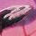 | 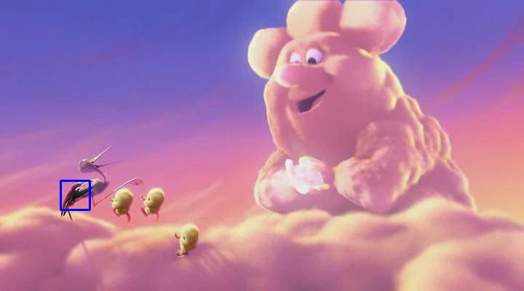 | 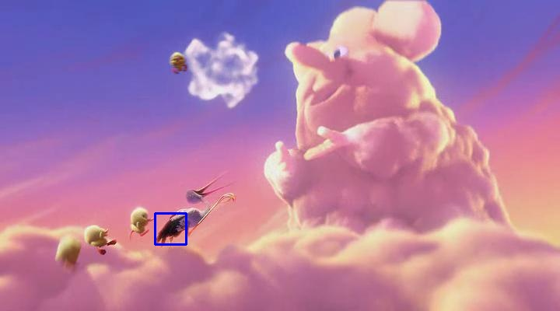
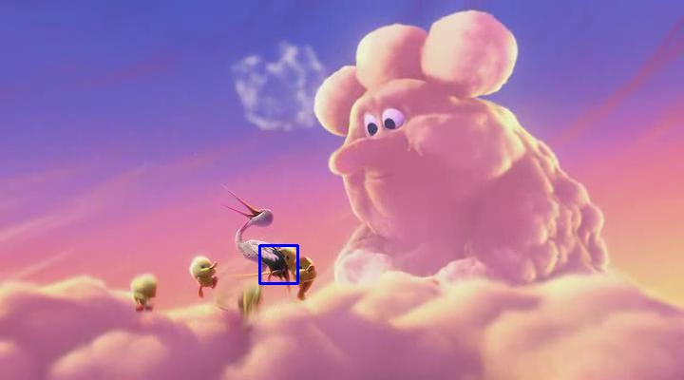 | 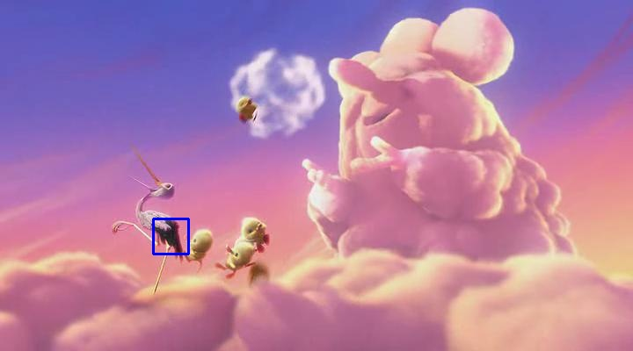 | 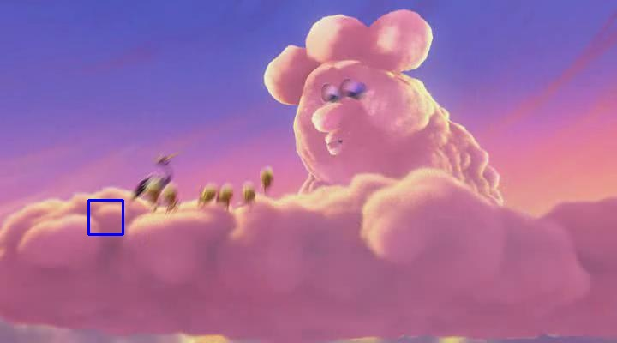

CamShift GRAY results:

 | 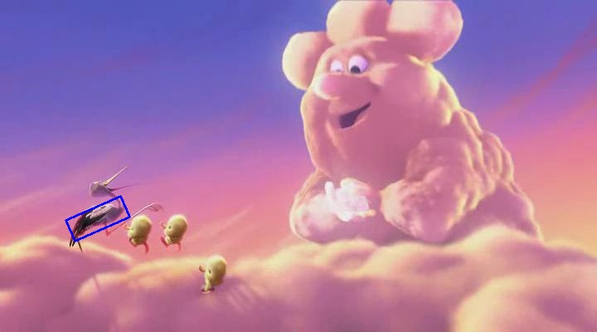 | 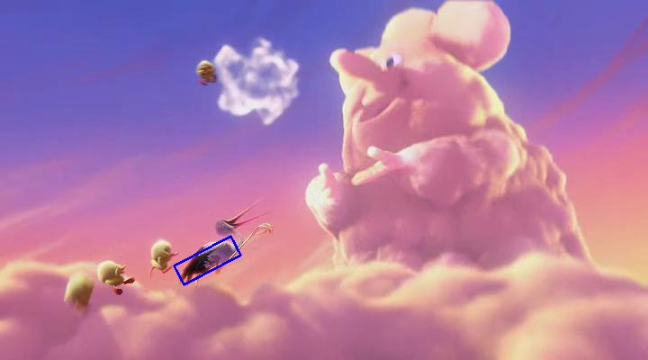
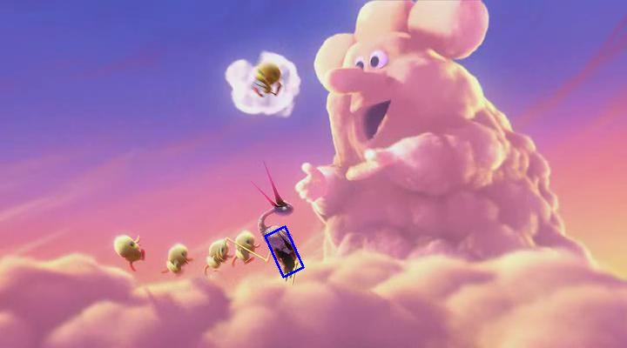 | 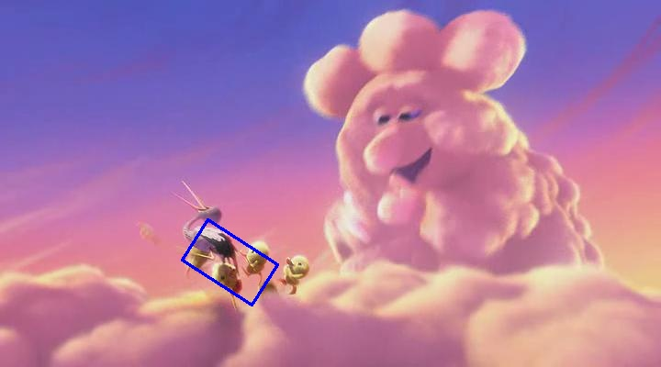 | 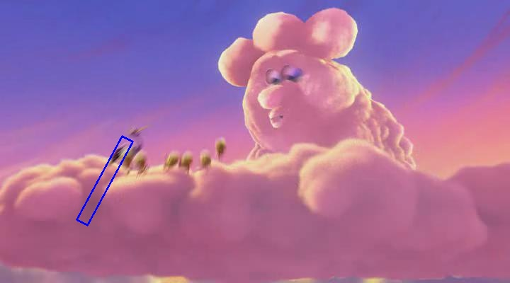

MeanShift HSV results:

 | 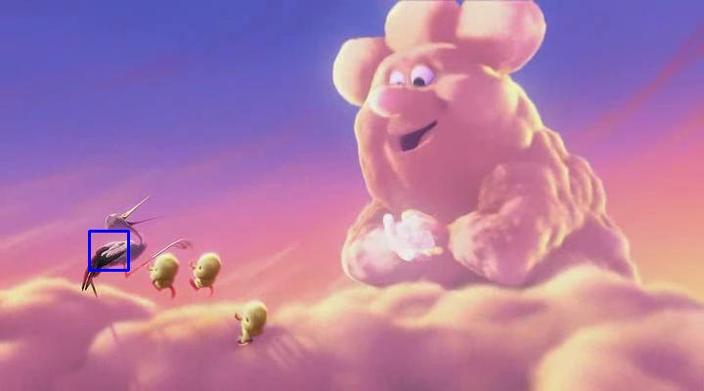 | 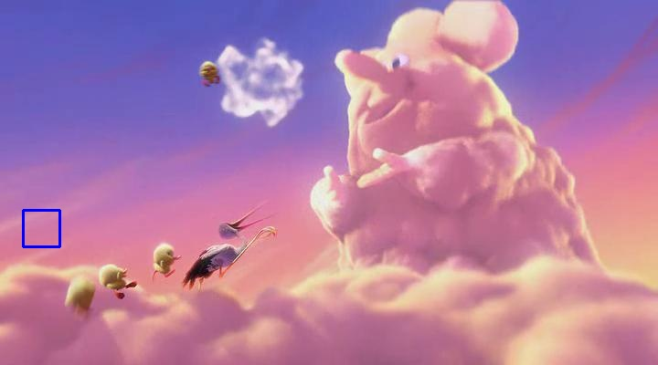
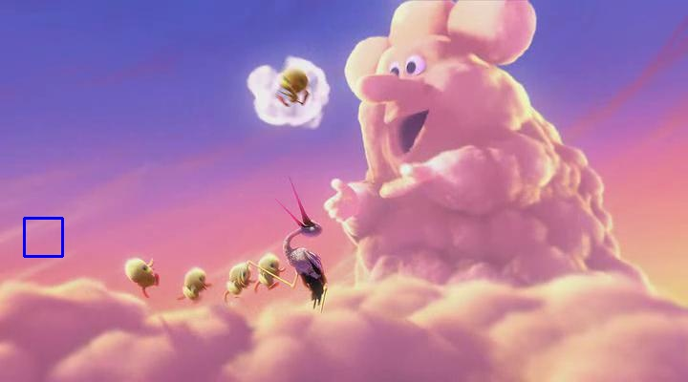 | 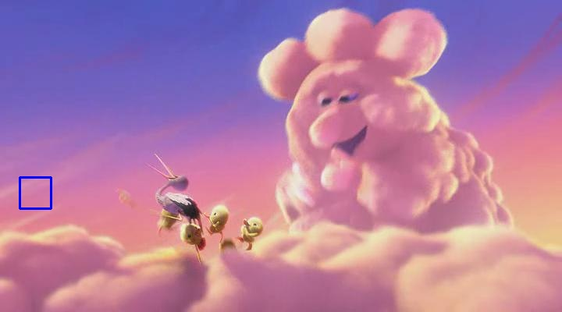 | 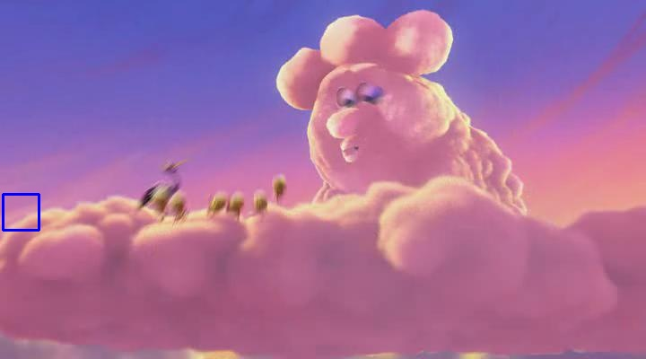

CamShift HSV results:

 | 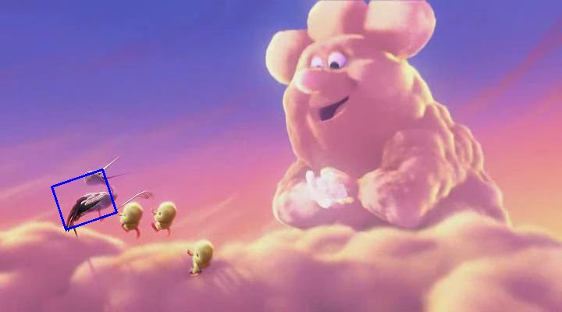 | 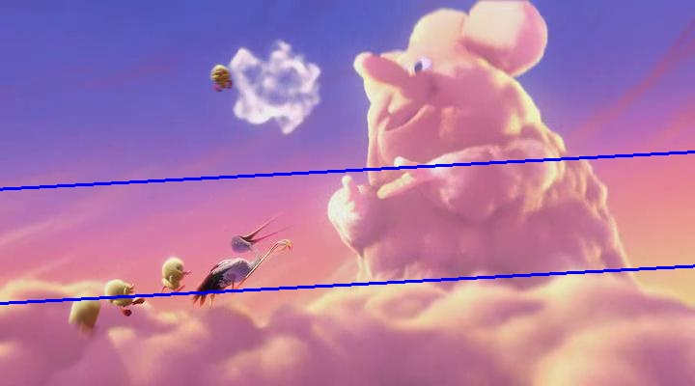
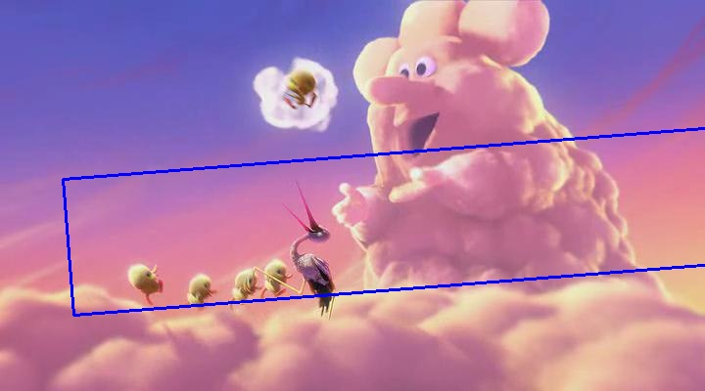 | 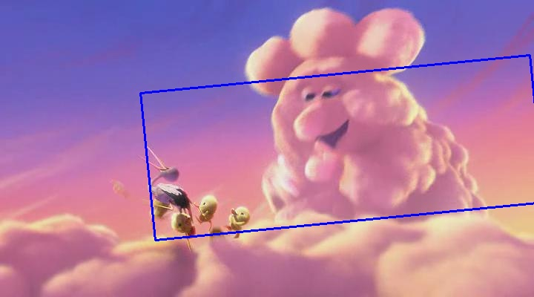 | 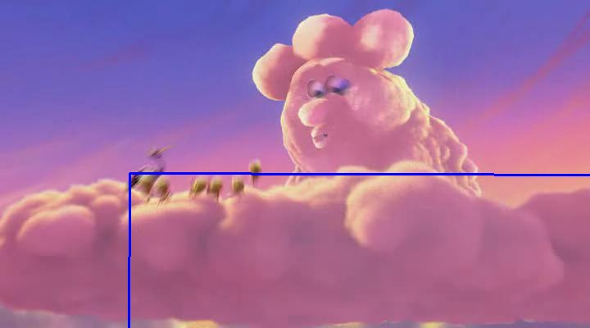

Bolt2:

On this dataset for HSV format on hue channel only the runner with the yellow t-shirt can be tracked. Also camshift explodes because of the light green grass on the background which has very similar hue value to the yellow t-shirt.

Console:
python3 meanshift.py --images_path ./Bolt2/img/ --roi_path ./Bolt2/Bolt2_roi.png
python3 camshift.py --images_path ./Bolt2/img/ --roi_path ./Bolt2/Bolt2_roi.png
meanshift.py:
mask = cv.inRange(hsv_roi, np.array((0., 80., 80.)), np.array((80., 255., 255.)))
camshift.py:
mask = cv.inRange(hsv_roi, np.array((0., 80., 80.)), np.array((80., 255., 255.)))
cut.py:
image = cv.imread("./Bolt2/img/0001.jpg")
part = image[90:120,175:190]
cv.imwrite("Bolt2_roi.png", part)

MeanShift results:

 | 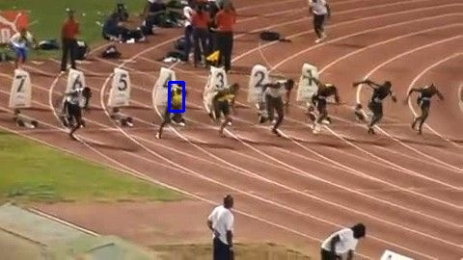 | 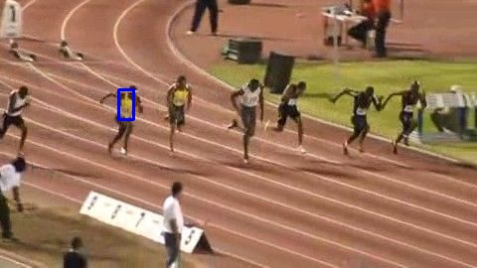
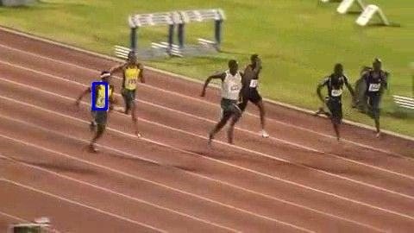 | 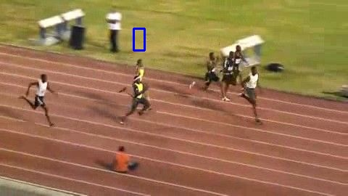 | 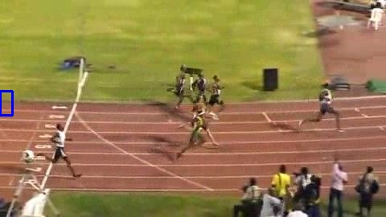

CamShift results:

 | 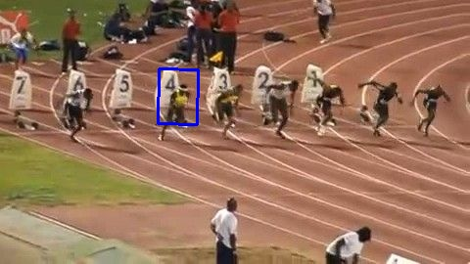 | 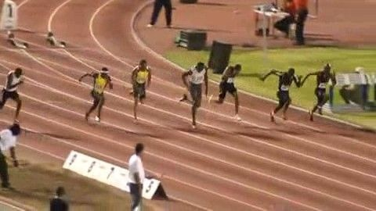
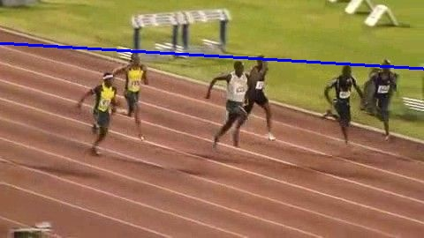 | 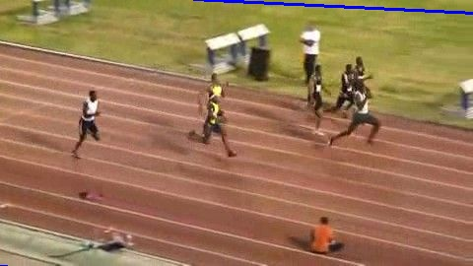 | 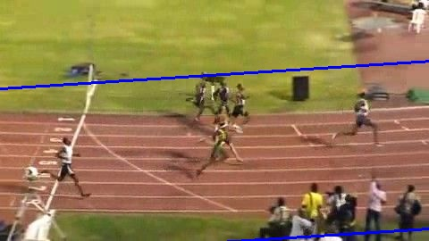

Human9:

On this dataset for HSV format on hue channel the woman in black/gray clothes is tracked only on the first few frames. Then for meanshift the algorithm converges to the rectangle with dark pillow wall. The camshift algorithm explodes, because we have many dark vertical objects on the screen.

Console:
python3 meanshift.py --images_path ./Human9/img/ --roi_path ./Human9/Human9_roi.png
python3 camshift.py --images_path ./Human9/img/ --roi_path ./Human9/Human9_roi.png
meanshift.py:
mask = cv.inRange(hsv_roi, np.array((0., 0., 0.)), np.array((180., 200., 50.)))
camshift.py:
mask = cv.inRange(hsv_roi, np.array((0., 0., 0.)), np.array((180., 90., 20.)))
cut.py:
image = cv.imread("./Human9/img/0001.jpg")
part = image[110:220,90:130]
cv.imwrite("Human9_roi.png", part)

MeanShift results:

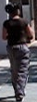 | 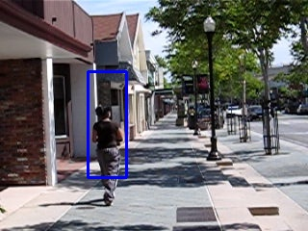 | 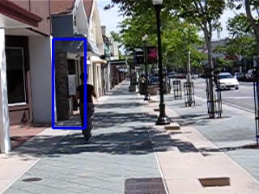
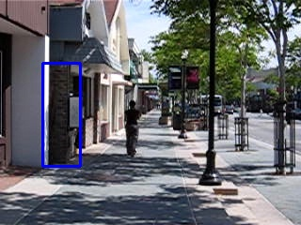 | 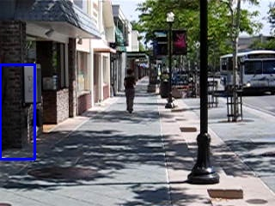 | 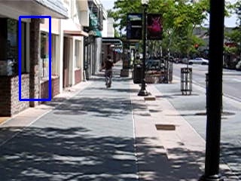

CamShift results:

 | 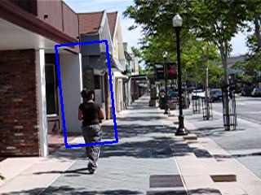 | 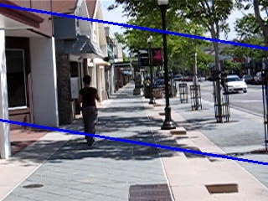
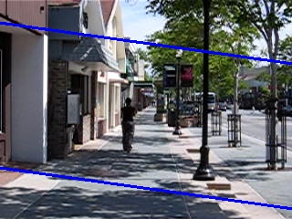 | 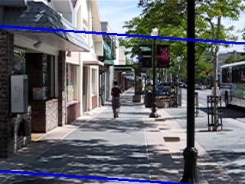 | 