Lucas Homework

1. I created only folder, because it helps me to structure on github all the homeworks from UCU

2. I implemented SSD, NCC and SAD template-matchings by myself.

script:
SSD:
python3 TemplateMatching.py --images_path ./Biker/img/ --roi_path ./Biker/biker_roi.png --method 0
NCC:
python3 TemplateMatching.py --images_path ./Biker/img/ --roi_path ./Biker/biker_roi.png --method 1
SAD:
python3 TemplateMatching.py --images_path ./Biker/img/ --roi_path ./Biker/biker_roi.png --method 2

https://github.com/Anastasiia-Khab/homeworks-ucu/blob/master/ComputerVision/CV3/LucasKanade/TemplateMatching.py

results:
SSD | NCC | SAD
https://github.com/Anastasiia-Khab/homeworks-ucu/blob/master/ComputerVision/CV3/LucasKanade/template_matching_SSD.jpg | https://github.com/Anastasiia-Khab/homeworks-ucu/blob/master/ComputerVision/CV3/LucasKanade/template_matching_NCC.jpg | https://github.com/Anastasiia-Khab/homeworks-ucu/blob/master/ComputerVision/CV3/LucasKanade/template_matching_SAD.jpg
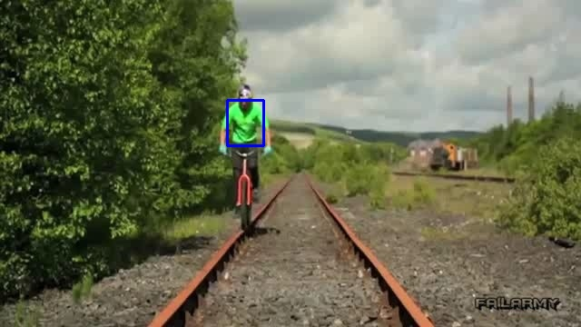

3-4. I adjusted code from this tutorial https://docs.opencv.org/3.3.1/d7/d8b/tutorial_py_lucas_kanade.html. To test in on the given datasets I changed the code to load the frames from images and not from video. Also better results where shown by calculating lucas_kanade optical flow only for feature points selected by the opencv method cv2.goodFeaturesToTrack(old_gray, mask = None, **feature_params) on the part of the image.

LucasKanade script: LucasKanade_points.py
Commandline:
python3 LucasKanade_points.py –images_path. /___FolderName___/img/ --roi_path ./___FolderName___/ROI.png
python3 LucasKanade_points_pyramids.py –images_path. /___FolderName___/img/ --roi_path ./___FolderName___/ROI.png

The script calculates optical flow for track_window (feature points and two angle points of rectangle) and draw the image with result into ./FolderName/img/results_LK_points and ./FolderName/img/results_LK_twoponts respectively. The result images are written with the same name as corresponding frame image.

So, you can see the results of my code in the folders DragonBaby, Biker, Bird2 → img/results/ results_LK_points, img/results/results_LK_twopoints .

Shortly about the adjustments I used and how to resume my results for each dataset:

DragonBaby:

This dataset worked completely bad, because movements of the baby are very fast and we have lots of fast dilation and reflection movements. Regardles of max_level of pyramids, after the baby jumps, the LucasKanade algorithm loses it’s feature points and their optical flow.

script for points:
python3 LucasKanade_points.py --images_path ./DragonBaby/img/ --roi_path ./DragonBaby/DragonBaby_roi.png
script for points with PYRAMIDS:
python3 LucasKanade_points_pyramids.py --images_path ./DragonBaby/img/ --roi_path ./DragonBaby/DragonBaby_roi.png

LucasKanade results:

https://github.com/Anastasiia-Khab/homeworks-ucu/tree/master/ComputerVision/CV3/LucasKanade/DragonBaby/img/results_LK_points
https://github.com/Anastasiia-Khab/homeworks-ucu/tree/master/ComputerVision/CV3/LucasKanade/DragonBaby/img/results_LK_twopoints
https://github.com/Anastasiia-Khab/homeworks-ucu/tree/master/ComputerVision/CV3/LucasKanade/DragonBaby/img/results_LK_pyramids

Biker:

This dataset worked comparatively good, because here we have a good features and comparatively slow and consequent motion.

script for points:
python3 LucasKanade_points.py --images_path ./Biker/img/ --roi_path ./Biker/biker_roi.png
script for points with pyramids:
python3 LucasKanade_points_pyramids.py --images_path ./Biker/img/ --roi_path ./Biker/biker_roi.png

LucasKanade results:

https://github.com/Anastasiia-Khab/homeworks-ucu/tree/master/ComputerVision/CV3/LucasKanade/Biker/img/results_LK_points
https://github.com/Anastasiia-Khab/homeworks-ucu/tree/master/ComputerVision/CV3/LucasKanade/Biker/img/results_LK_twopoints
https://github.com/Anastasiia-Khab/homeworks-ucu/tree/master/ComputerVision/CV3/LucasKanade/DragonBaby/Biker/img/results_LK_pyramids

Bird2:

Worked bad, expetially after the bird rotates and changes its side and way of movement.

script for points:
python3 LucasKanade_points.py --images_path ./Bird2/img/ --roi_path ./Bird2/Bird2_roi.png
script for points with pyramids:
python3 LucasKanade_points_pyramids.py --images_path ./Bird2/img/ --roi_path ./Bird2/Bird2_roi.png

LucasKanade results:

https://github.com/Anastasiia-Khab/homeworks-ucu/tree/master/ComputerVision/CV3/LucasKanade/Bird2/img/results_LK_points
https://github.com/Anastasiia-Khab/homeworks-ucu/tree/master/ComputerVision/CV3/LucasKanade/Bird2 /img/results_LK_twopoints
https://github.com/Anastasiia-Khab/homeworks-ucu/tree/master/ComputerVision/CV3/LucasKanade/DragonBaby/Bird2/img/results_LK_pyramids

