CA1 · Section 9: Domain model
9.1 Selected attributes
Concept | Candidate attributes | Keep / remove | Reason
Berth | berthNumber, length, depth, access, power | Keep | Needed to choose a suitable berth (FR04). berthNumber tells berths apart, as the identifiers do in the lab examples.
Vessel | vesselName, vesselType, dimensions, condition | Keep | Suitability depends on the size of the vessel. Type and condition come from the scenario.
BerthRequest | requestDate, arrivalTime, departureTime, purpose, contact, requiredServices, status, missingChecks, actualArrival, actualDeparture, accessCleared | Keep | “A request includes…”; FR01-FR03, FR14, FR15, FR22.
BerthChange | changeType, reason, recordedAt | Keep | FR07. recordedAt comes from NFR03 (who recorded it and when).
HarbourNotice | noticeType, startDate, endDate | Keep | FR05: a restriction or works affects a berth for a period.
EquipmentCategory | categoryName, ratedCapacity, authorisationNeeded, supervisionNeeded | Keep | FR12. Rated capacity describes the type of equipment.
EquipmentItem | itemNumber, condition, readiness, location, complete | Keep | FR09, FR10, A02 (an incomplete set is unavailable).
EquipmentItem | ratedCapacity | Move | Moved to EquipmentCategory, because it describes the type, not one item.
EquipmentItem | connector, compatibility | Remove | No requirement needs them.
EquipmentItem | location | Keep as attribute | Berth areas have no details of their own, so location is a simple value (“Context matters”).
EquipmentReservation | startDate, endDate, status | Keep | FR08. A status as on Reservation in the lab.
EquipmentIssue | issueDate, returnDate, responsiblePerson, intendedUse, returnCondition, recordedAt | Keep | FR11, FR13, NFR03. Only the name of the responsible person is needed, so it is a simple value.
EquipmentIssue | recordedBy | Remove | A person stored as a value would work like a foreign key.
Inspection | inspectionDate, result, status | Keep | FR09; “unresolved inspections” (E22).
IncidentReport | observations, damage, cause, recordedAt | Keep | FR16, NFR03. The cause stays empty until it is decided (Q17).
9.2 Associations
Class A | Association name or sentence | Class B | Evidence | Keep?
BerthRequest | is for | Vessel | “A request includes vessel…”; FR01 | Yes
BerthRequest | is allocated | Berth | FR06; UC04 | Yes
BerthChange | changes | BerthRequest | FR07; UC05 | Yes
BerthChange | moves to | Berth | “distinguish a changed berth from a rejected arrival” | Yes
HarbourNotice | affects | Berth | FR05; UC06 | Yes
EquipmentCategory | describes | EquipmentItem | “Different equipment categories require…”; FR12 | Yes
EquipmentReservation | reserves | EquipmentCategory | FR08; like Reservation requests Book in the lecture model | Yes
EquipmentReservation | is made with | BerthRequest | “Equipment may be reserved with a berth or independently”; FR08 | Yes
EquipmentIssue | records issue of | EquipmentItem | FR13; like Loan records borrowing of BookCopy | Yes
Inspection | checks | EquipmentItem | “awaiting inspection”; FR09 | Yes
IncidentReport | involves | Vessel | “Incidents… may involve vessel movement”; FR16 | Yes
IncidentReport | involves | EquipmentItem | “…or equipment”; FR16 | Yes
EquipmentIssue | fulfils | EquipmentReservation | The scenario does not say that an issue follows a reservation | No (speculative)
EquipmentReservation | is for | Vessel | The scenario does not say who an equipment reservation without a berth is for | No (speculative)
9.3 Multiplicities
Association | Multiplicity at Class A | Multiplicity at Class B | Reading from both ends | Evidence / rule
BerthRequest is for Vessel | 0..* | 1 | Each berth request is for exactly one vessel. A vessel may have zero or many berth requests. | “A request includes vessel”; a vessel can come more than once
BerthRequest is allocated Berth | 0..* | 0..1 | A berth request has zero or one berth (zero until a berth is allocated). A berth may be allocated to zero or many requests at different times. | FR03, FR06
BerthChange changes BerthRequest | 0..* | 1 | Each berth change belongs to exactly one request. A request may have zero or many changes. | FR07
BerthChange moves to Berth | 0..* | 0..1 | A berth change moves the vessel to zero or one new berth (zero for a delay or refusal). A berth may receive zero or many changes. | “changed berth” vs “rejected arrival”
HarbourNotice affects Berth | 0..* | 1..* | A notice affects at least one berth. A berth may have zero or many notices. | FR05; no upper limit is given, so none is invented
EquipmentCategory describes EquipmentItem | 1 | 1..* | Each item belongs to exactly one category. A category has at least one item. | “Equipment includes mobile fenders…”; like Book has copies 1..*
EquipmentReservation reserves EquipmentCategory | 0..* | 1 | Each reservation is for exactly one category. A category may have zero or many reservations. | FR08; like Reservation 0..* to 1 Book
EquipmentReservation is made with BerthRequest | 0..* | 0..1 | A reservation is made with zero or one berth request. A berth request may have zero or many reservations. | “with a berth or independently”
EquipmentIssue records issue of EquipmentItem | 0..* | 1 | Each issue is of exactly one item. An item may have zero or many issues. | FR13; like Loan 0..* to 1 BookCopy
Inspection checks EquipmentItem | 0..* | 1 | Each inspection checks exactly one item. An item may have zero or many inspections. | FR09
IncidentReport involves Vessel | 0..* | 0..* | A report may involve zero or many vessels. A vessel may be in zero or many reports. | “may involve”; no limit is given
IncidentReport involves EquipmentItem | 0..* | 0..* | A report may involve zero or many items. An item may be in zero or many reports. | “…or equipment”; no limit is given
9.4 Transactions and historical records
Information to retain | Best owning concept | Why
When the vessel wants to arrive and leave | BerthRequest | Part of the request (“arrival and departure window”).
If the request is provisional or confirmed, and which check is missing | BerthRequest | The status belongs to one request (FR03, FR22).
Which berth is allocated | Link between BerthRequest and Berth | A link between two concepts, not a value (FR06).
Move, delay or refusal, and when it was recorded | BerthChange | One request can have several changes, each with its own type and date (FR07, NFR03).
When a berth cannot be used and why | HarbourNotice | A notice has its own period and affects berths (FR05).
Actual arrival, actual departure and access cleared | BerthRequest | They describe one visit (FR14, FR15).
If an item is ready to be given out | EquipmentItem | Condition, readiness and completeness belong to one item (FR09, FR10).
Which authorisation or supervision is needed | EquipmentCategory | It depends on the type of equipment (FR12).
For which period equipment is reserved | EquipmentReservation | A reservation has its own dates and status (FR08).
Who had the item, for what use, and its condition on return | EquipmentIssue | One issue keeps the history of one giving out (FR11, FR13).
When an item was checked, the result, and if it is still open | Inspection | Each check has its own date and result (FR09, E22).
What was seen in an incident, without the cause | IncidentReport | Observations are kept, the cause is decided later (FR16, Q17).
Decision: provisional hold
A provisional hold could be its own class. It is kept as a status of BerthRequest instead, because a hold has no other details in the scenario. The only extra detail would be how long the hold lasts, and that is not agreed (Q04). The request still keeps its request date, status and the missing check, so no information is lost.

9.5 Domain model diagram
Source file: diagrams/domain-model.puml.
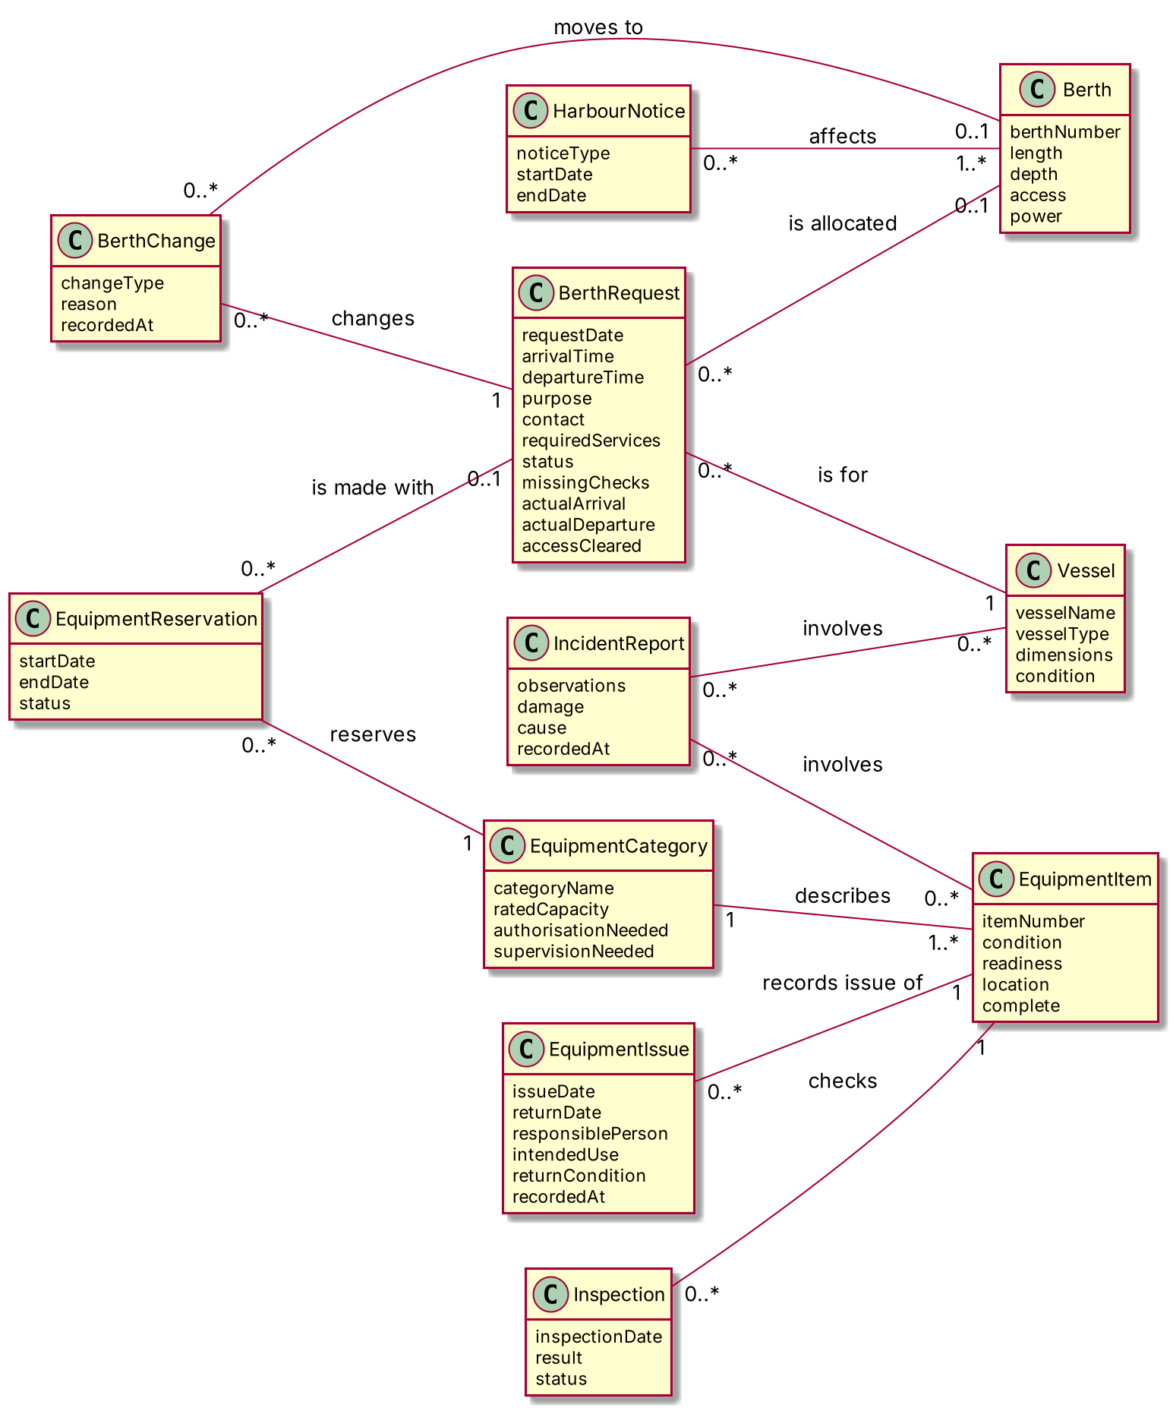

9.6 Modelling rationale
Description and physical item. EquipmentCategory and EquipmentItem are kept apart, like Book and BookCopy in the lecture model. The category keeps the authorisation rules; the item keeps its own condition, location and checks.
Reservation and issue. EquipmentReservation is linked to a category and EquipmentIssue to one item, like Reservation requests Book and Loan records borrowing of BookCopy.
Transactions. BerthRequest, BerthChange, EquipmentReservation, EquipmentIssue and Inspection keep dates, status and history, because “transactions often deserve a class”.
Provisional hold as a status. A hold is a status of BerthRequest, not a class. The only extra data would be how long it lasts, and that is not agreed (Q04).
What is not in the model. Vessel operators and the safety officer are offstage (Section 3, A07). Conflicts, delayed departures and the coordinator’s views are worked out from other records. No methods, visibility, navigability, aggregation or foreign keys are used.
Multiplicity. Zero is used where participation is optional. No upper limits are invented: where the scenario gives no limit, * is used.
9.7 Review checklist
Review question | Answer
Does every class represent a meaningful domain concept? | Yes. All 11 classes come from the glossary (Section 8.4).
Can each class be defined in a glossary? | Yes (Section 8.4).
Are important transactions and historical records represented? | Yes: BerthRequest, BerthChange, EquipmentReservation, EquipmentIssue, Inspection.
Are attributes simple descriptive values? | Yes (9.1).
Are associations supported by requirements or use cases? | Yes (9.2). Two speculative links were removed.
Does every association show multiplicity? | Yes, at both ends (9.3).
Can association names be read as domain sentences? | Yes, for example “BerthRequest is for Vessel”.
Have software-design and database elements been removed? | Yes. No methods, visibility, navigability, controllers or foreign keys.
Is the model readable at normal page size? | Yes (9.5).

