CA1 · Section 6: Use-case model
6.1 Use-case catalogue
ID | Use case | Primary actor | Meaningful outcome | Source requirement
UC01 | Record Berth Request | Harbour assistant | A berth request with the vessel details, time and services is saved | FR01
UC02 | Update Berth Request | Harbour assistant | The request shows the latest plan from the operator | FR02
UC03 | Confirm Berth Request | Harbour coordinator | The request is confirmed, or it is marked provisional with the missing check shown and the berth held | FR03, FR22
UC04 | Allocate Berth | Harbour coordinator | A suitable and free berth is given to the request | FR04, FR06
UC05 | Record Berth Change | Harbour assistant | A move, delay or refusal is saved in the log | FR07
UC06 | Record Harbour Notice | Harbour coordinator | A notice, restriction or works affecting a berth is saved | FR05
UC07 | Reserve Equipment | Harbour coordinator | Equipment is kept for a vessel, with a berth or on its own | FR08
UC08 | Update Equipment Status | Equipment officer | The status, checks and location of the equipment are saved, and unready equipment shows as unavailable | FR09, FR10
UC09 | Issue Equipment | Equipment officer | Equipment goes out only after the responsible person, use and checks are confirmed | FR11, FR12, FR13
UC10 | Return Equipment | Equipment officer | The return and the condition of the equipment are saved | FR13
UC11 | Record Vessel Arrival | Harbour assistant | The arrival is saved after the vessel, berth and services are checked | FR14
UC12 | Record Vessel Departure | Harbour assistant | The departure is saved, and the berth is freed only after equipment and access are cleared | FR14, FR15
UC13 | Record Incident | Harbour assistant | An incident or damage note is saved without deciding the cause | FR16
UC14 | View Harbour Overview | Harbour coordinator | Provisional arrivals, berth conflicts, equipment readiness and location, restrictions, delayed departures and unresolved inspections are seen in one place | FR17
UC15 | Grant Staff Access | System administrator | Only staff who are allowed to can see contact details and change records | NFR01
Note on primary actors
The scenario does not say which staff role records berth requests, confirms them, records harbour notices, reserves equipment or issues equipment. The primary actors for UC01, UC02, UC03, UC06, UC07 and UC09 are my own decision, not a fact from the scenario. The open questions are Q27 (requests and issuing equipment), Q24 (confirming requests), Q20 (harbour notices and restrictions) and Q05 (reserving equipment), see Sections 1.1 and 5. The other primary actors follow the stakeholder quotes and goals in Section 3.
Note on FR03, FR04, FR10, FR15 and FR22
Confirm Berth Request has two outcomes: the request is confirmed (FR22), or it stays provisional while a check is missing (FR03). This follows Request Activity Place in the Session 4 sample answer, which records a confirmed place or a waiting-list outcome. Who may confirm a request is still open (Q24).
FR10 (unready equipment shows as unavailable) and FR15 (a berth is freed only after equipment and access are cleared) could be treated as rules within Update Equipment Status and Record Vessel Departure rather than separate use cases. FR04 (show suitable and free berths) is a step of Allocate Berth rather than a separate goal. Not every functional requirement must become a separate use case.
Requirement coverage
Every Must, Should and Could functional requirement (FR01–FR17 and FR22) and NFR01 appears in at least one use case. FR18–FR21 are Won’t items for this release, so they have no use case. The other non-functional requirements (NFR02–NFR06) describe qualities of the system, not actor goals, so they stay in the requirements catalogue (Section 4).

6.2 Use-case diagram
Based on: Session 4 lecture
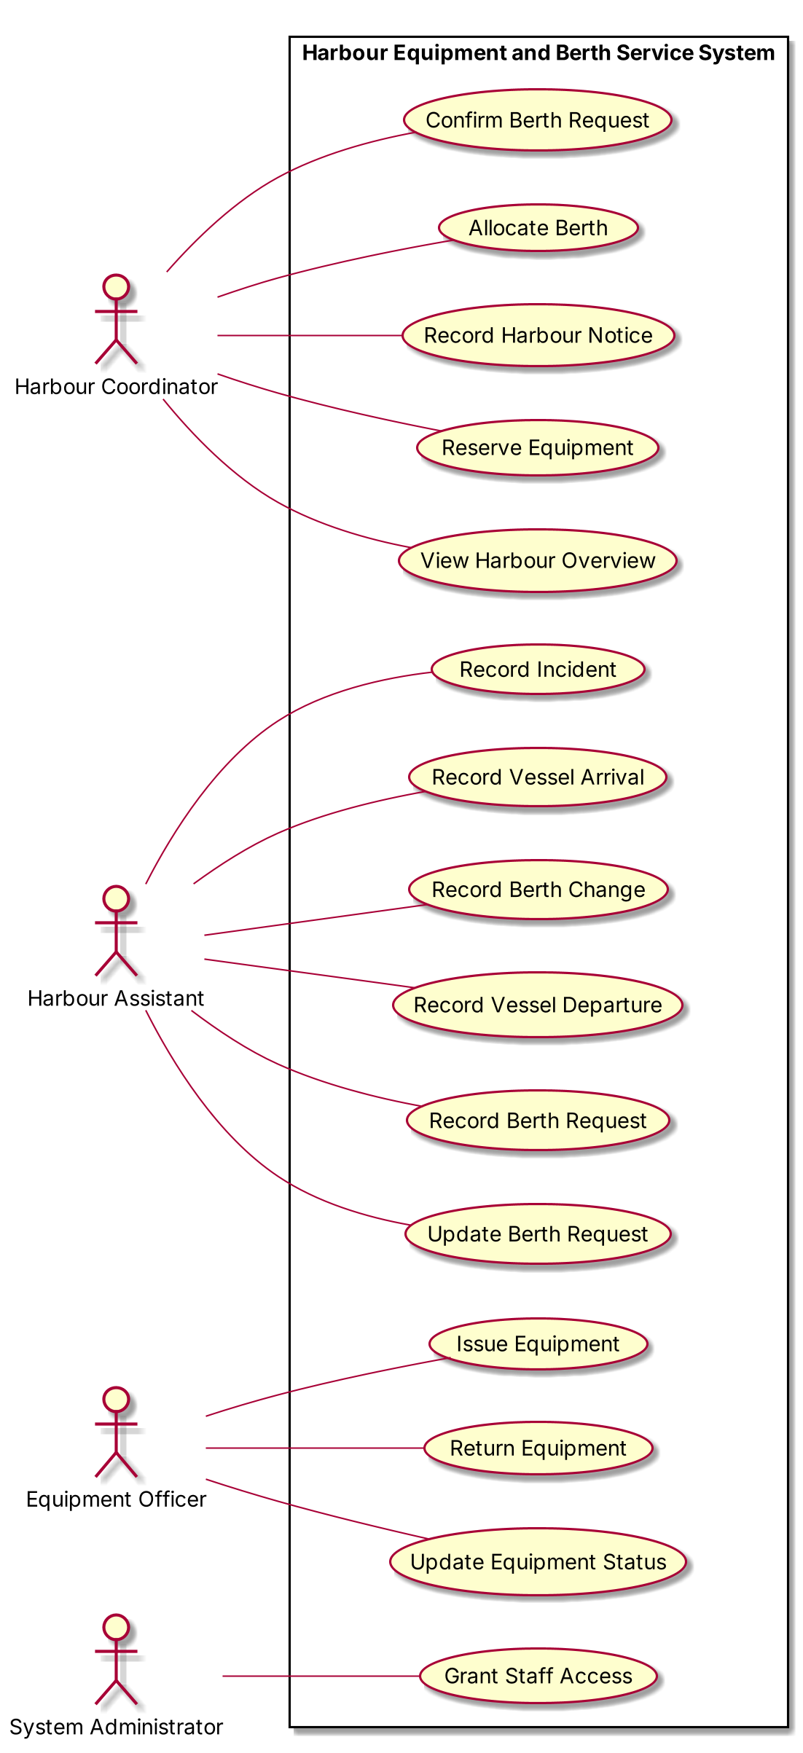

Diagram justification
- All actors appear outside the system boundary.
- Use cases appear inside the named system boundary.
- The use-case names use verb–object wording.
- Associations show participation rather than message order.
- Each use case is linked to its primary actor from the catalogue (6.1), so not every actor is connected to every use case.
- No supporting actor is drawn because the scenario does not mention an outside system that this system calls (Section 3.2).
- Vessel operators, the safety officer, the insurer and the other offstage stakeholders are not drawn because they do not use the system directly (Section 3.2, A07).
- No database, Java class, screen, field or controller appears in the diagram.
- No include or extend relationship is needed at this stage.
6.3 Detailed use case: UC04 Allocate Berth
Based on: Session 7 lecture
6.3.1 Header
Field | Content
ID and name | UC04 Allocate Berth
Scope | Harbour Equipment and Berth Service System
Level | User goal
Primary actor | Harbour coordinator
Preconditions | The berth request is recorded with the vessel details, arrival and departure time and services needed (UC01). The length, depth, access and power of each berth are known to the system (assumption: the scenario does not say how berth details are kept).
Trigger | The coordinator decides to give a berth to a recorded berth request.
Minimal guarantee | No unsuitable berth is allocated, and no berth is allocated twice for the same time. When the goal cannot be completed, the reason is shown.
Success guarantee | The request has one suitable berth for its arrival and departure time, and the berth is shown as allocated for that time.
Open issue | The exact suitability rule is not agreed (Q03). How a temporary berth is given to an early arrival is not established (Q12). That a provisional hold blocks the berth is an assumption (A01). If the request is still provisional, the berth is shown as held rather than allocated (FR03, UC03).
6.3.2 Main Success Scenario
Step | Actor intention or system responsibility
1 | The coordinator selects the berth request to be allocated.
2 | The system shows the vessel details, the arrival and departure time and the services needed.
3 | The system finds the berths that fit the vessel's length and depth, have suitable access and offer the services needed, such as power.
4 | The system confirms that these berths are not allocated or held for any part of the requested time.
5 | The system confirms that no harbour notice, restriction or works affects these berths at that time.
6 | The system shows the suitable and free berths.
7 | The coordinator chooses one berth.
8 | The coordinator confirms the allocation.
9 | The system records the berth on the request for the requested time.
10 | The system shows the berth as allocated for that time.
6.3.3 Extensions
Ref. | Condition | Response and destination
3a | No berth fits the vessel or offers the services needed. | Explain that no suitable berth exists; allocate no berth; end.
4a | All suitable berths are allocated or held for part of the requested time. | Show the berths and the time that overlaps. If the operator agrees a revised time, the request is updated (UC02) and the flow resumes at step 3; otherwise allocate no berth; end.
5a | A restriction or works affects a suitable berth for part of the requested time. | Show the restriction; leave that berth out; resume at step 6 with the other berths. If no berth is left, continue as 3a.
8a | The coordinator cancels before confirming. | Allocate no berth; the request stays without a berth; end.
6.3.4 Quick classification check
- 3a is a failure extension.
- 4a and 5a are recoverable extensions.
- 8a is a cancellation extension.

