**Analysis of customer feedback on banking service channels, products & services**

*International Conference of Young Scientists* *2022*

Artem Rukavitsa, Anastasiia Fedchenko

*Comprehensive school #1533 "LIT", Moscow, Russia*

[rukavitsa.a@yandex.ru](mailto:rukavitsa.a@yandex.ru), [nastyaf1504@gmail.com](mailto:nastyaf1504@gmail.com)

Introduction

Digital technologies have opened up new opportunities and established completely new rules of the game for companies; as a result, the competition has shifted from creating a better product/service to creating a better customer experience. According to Bain&Company's© report the income growth for banks that keep track off their customer feedback is up to 20% higher than for banks which don't do it.

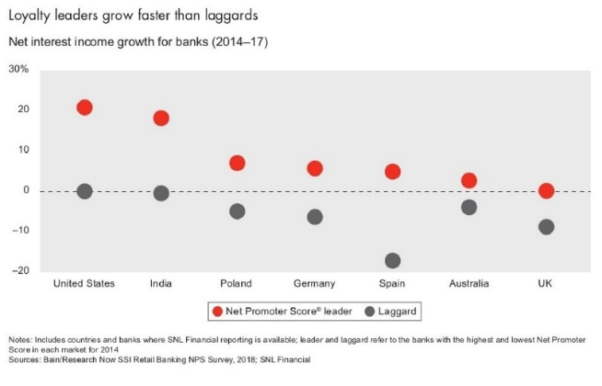

Image 1 – comparison of countries by NPS in the banking sector (source: Bain & Company’s research “In search of customers who love their bank”)

The primary goal of this project is to create an approach that can be applied to assessment and comparison of customer feedback in different spheres. We have done it on the example of the banking sector in the Russia.

Research Methodology

The purpose of our work is to create a web app that allows users to compare several banks by several criteria using interactive charts and map of bank offices and to compare banks with each other. The comparison has been carried out according to the following categories: convenience of the office, ATMs, level of service, staff, products & services, remote service channels.

As input data, we used reviews from Yandex.Maps cartographic service to offices. To create our project, we used Python and frameworks: streamlit, scikit-learn, plotly and folium.

Let's briefly describe how our task is solved.

1. Collecting addresses of bank offices from <https://1000bankov.ru> and reviews from <https://yandex.ru/maps>;
2. Removal of stop words and punctuation marks, bringing words into the initial form;
3. 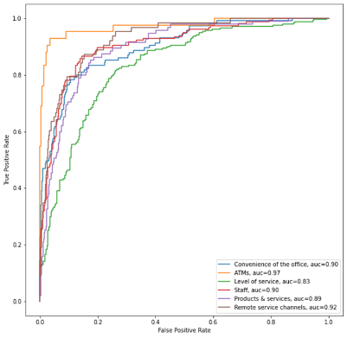Manual labeling of reviews on a random sample consisting of 1650 reviews, based on categorization;
4. Creation and training of binary classification models based on labeled reviews using support vector machine;
5. Automated labeling of all left reviews using trained models;

Image 2 - ROC-ROC curve for binary classification models

1. Visualization.

Result and Analysis

The result of our work is the web app that provides a visualization of the analysis. There are three types of diagrams and the interactive map:

1. Horizontal bar (average ratings, important words);
2. Radar chart (average ratings by categories);
3. Tornado chart (distributions of positive & negative reviews by category and on average);
4. Interactive map with detailed analytics for each office (average overall rating of bank office and average ratings by each category).

Conclusion

We have created an approach that can be applied to assessment and comparison of different types of service.

Future Work

1. Performing analysis of the reviews using other ML-methods to compare them with SVM;
2. Analysis of user reviews of banks' mobile apps from Google Play (being developed).

References

Mays E. Credit Scoring for Risk Managers. The Handbook for Lenders. Thomson; 2004