|  |  |
| --- | --- |
| Comprehensive school No. 1533 “LIT”  Moscow, Russia | |
| **PAPER** | |
| **Analysis of customer feedback on banking service channels, products & services** | |
| Made by | **Fedchenko Anastasiia** |
|  | **Rukavitsa Artem** |
| Supervisor | **Chamrov Mikhail** |

|  |  |
| --- | --- |
|  |  |

## Contents

Contents 2

1. Introduction 3

1.1 Domain analysis 3

1.2 Relevance 3

2. Problem statement 5

3. Target audience 8

4. Analogs 8

5. Solution 9

5.1 A brief solution to the problem 9

5.2 Research methods 9

5.2.1 Pearson's chi-squared test (χ2, chi-squared) 9

5.2.2 Support vector machine 10

5.2.3 Gradient boosting 11

5.3 Software implementation 11

5.3.1 Programming language, development environment, third-party programs, API 11

5.3.2 Python Libraries 11

5.3.3 Database structure 13

6. Conclusion 16

6.1 Result 16

6.2 Usage examples 16

6.2.1 Average rating for all banks 17

6.2.2 Average ratings of categories by banks and regions 18

6.3.3 Important words for different categories 21

6.3.4 Interactive map of the country's bank offices 22

7. Inferences 23

8. Future work 25

9. References 26

10. Additional materials 27

## 1. Introduction

1.1 Domain analysis

Digital technologies have opened up new opportunities and established completely new rules of the game for companies and users, as a result of which competition has shifted from creating a better product/service to creating a better customer experience. The quality of business interaction with people is calculated using Net Promoter Score (NPS). NPS is an index for determining consumers' commitment to a product or company (an index of willingness to recommend), used to assess readiness for repeat purchases. In the presented diagram, the red markers indicate the leading banks in NPS; gray markers indicate laggards in this indicator. On the graph, we can see how much net interest income has changed depending on the country and NPS over three years. Let's pay attention to the fact that the net interest income of the leaders in NPS has increased; for lagging banks, it either remained at the same level or decreased. Based on the above, customer experience is very important, and therefore our project is aimed to analyze it in different banks.

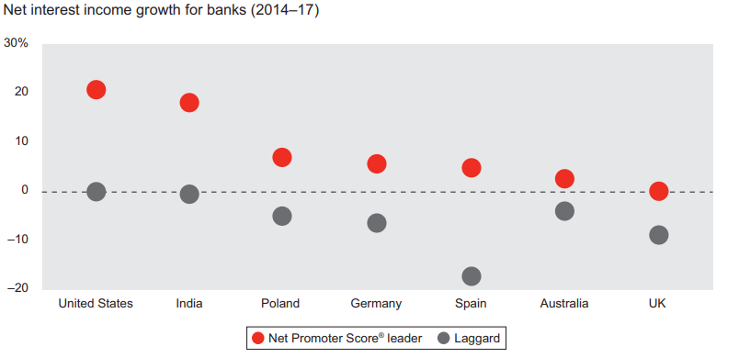

Image 1. Comparison of countries by NPS in the banking sector (source: Bain & Company’s research “In search of customers who love their bank”)

1.2 Relevance

The best customer experience includes simple, smart and trouble-free points of contact between the user and the company, personification, simplicity and clarity of use, positive emotions from the process of using the product /service (not just functional properties) in conditions of constantly changing user preferences and competitive environment.

Banks are a traditional and conservative industry (which, of course, has its own technological leaders), which is at the beginning of the path from providing traditional services and creating cost-effective processes to human-centered design.

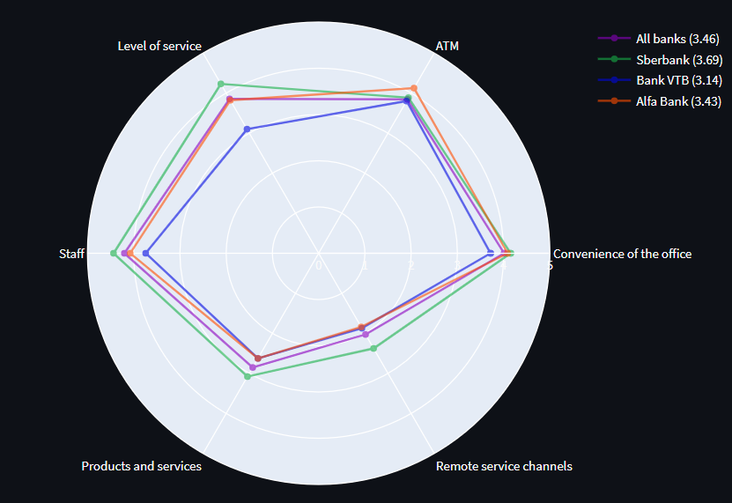So, the reason for the relevance of our product is the lack of publicly available programs / sites that compare customer experience in various banks. Our program makes it easier for users to compare several banks according to different criteria. Instead of searching for information about each bank (for example, opening official websites, forums, reviews for specific services), spending a lot of time, you can use our website and get all the necessary information quickly and conveniently, getting the result of the analysis in the form of a graph in the “web" format (example in the photo below).

Image 2. Radar chart example

## 2. Problem statement

The purpose of our work is to create a web app that allows users to compare any bank with the market on average and with the best market players, to identify areas for improvement and further development of service channels, products and services according to certain criteria: convenience of office, ATMs, cash register, level of service, staff, products and services, remote service. As an input data, we use reviews from the Yandex.Maps cartographic service (www.yandex.ru/maps) to bank offices. Based on the obtained data, we have created a model for quality assessment of banking channels, products and services with visualization of the result.

Below is a table containing a list with the names of 24 banks whose office reviews we need to analyze:

Table 1. The list of the banks for analysis

|  |  |
| --- | --- |
| 1 | Sberbank |
| 2 | Bank VTB |
| 3 | Alfa Bank |
| 4 | Gazprombank |
| 5 | Russian Agricultural Bank |
| 6 | Pochta Bank |
| 7 | Otkrytie FC Bank |
| 8 | Rosbank |
| 9 | Sovcombank |
| 10 | Raiffeisenbank |
| 11 | Promsvyazbank |
| 12 | Home Credit Bank |
| 13 | DOM.RF Bank |
| 14 | Uralsib |
| 15 | UniCredit Bank |
| 16 | Cetelem Bank |
| 17 | Rusfinance Bank |
| 18 | Renaissance Credit Bank |
| 19 | Moscow Credit Bank |
| 20 | Bank Saint Petersburg |
| 21 | SMP Bank |
| 22 | Moscow Industrial Bank |
| 23 | Ural Bank For Reconstruction and Development |
| 24 | Citibank |

To build analytics, it is necessary to divide user reviews into topics. The categorization:

1. **Convenience of the office** (convenience of location, transport accessibility, availability of parking, opening hours, ease of navigation inside the office, electronic queue / opportunity to enroll in the office, comfortable waiting area, condition and attractiveness of the office interior, cleanliness, availability of a water cooler / toilet for customers, children's corner, Wi-Fi, etc.);

2. **ATMs** (their availability, round-the-clock availability, sufficiency of the number of devices, functionality - cash withdrawal / acceptance / payments / transfers and payments, etc., operability - there is cash in the ATM / cash deposit works / the ATM has a connection / it does not hang, etc.);

3. **The level of service** (waiting time, speed of service, simplicity of documents, availability of a paperless/electronic signature of the client, availability of the service needed by the client, the authority of the staff to resolve issues on claims on the spot without redirecting to the head office);

4. **Staff** (courtesy, neatness, customer orientation /interest in solving the client's question, competence, solving the client's question without redirecting to another specialist, etc.);

5. **Products & services** (completeness and accessibility, cost, transparency of conditions, ease of use, etc. characteristics of standard products and services of the bank);

6. **Remote service channels** (convenience of Internet banking (IB) and mobile banking (MB), ease of connection, availability of operations in IB/MB without the need to visit the office, ease of performing operations in IB/MB, restrictions on operations in IB/MB, etc.);

7. **Other**. This category should include reviews that do not belong to any of the categories above.

We decided to divide our big task for every member of the team.

Artem has done these parts of the work:

1. collecting reviews on bank offices from the cartographic service Yandex.Maps,
2. preparing reviews for processing,
3. manual labeling of reviews,
4. construction of three binary classification models,
5. building regression models using gradient boosting;
6. categorization of all reviews,
7. implementation of the last two pages of the site.

Anastasiia has done these parts of the work:

1. collection of office addresses,
2. preparing reviews for processing,
3. manual labeling of reviews,
4. construction of three binary classification models,
5. categorization of all reviews,
6. implementation of the first two pages of the site.

## 3. Target audience

We assume that the target audience of our site will be two groups of people. The first is users who will be able to see the strengths and weaknesses of banks and choose the bank suitable for them. The second is companies that want to improve the process of providing services in a competitive environment with constantly changing user preferences.

## 4. Analogs

At the moment, there are many programs aimed to compare any bank with the market on average and with the best market players, determining the area of improvement and further development of service channels, products and services, but they are all parts of expensive systems and are not available for ordinary customers. That is why we do not know what the analogues look like and what qualities they have.

## 5. Solution

5.1 A brief solution to the problem

Let's briefly describe how our task is solved.

1. Collecting bank branch addresses from the website https://1000bankov.ru;
2. Collecting reviews from the website https://yandex.ru/maps;
3. Preparation of reviews for analysis: removal of stop words, punctuation marks, bringing words into the initial form;
4. Manual labeling of reviews on a random sample consisting of 1600 reviews, based on categorization from the "Problem Statement";
5. Training of binary classification models on the Google Colab service based on the feedback from paragraph 4 using the support vector machine;
6. Categorization of all reviews using trained models;
7. Visualization: creation of horizontal histograms to display average ratings and important words (based on gradient boosting), “radar” and “tornado” charts (using the Pearson's chi-squared test), interactive maps of bank offices.

5.2 Research methods

5.2.1 Pearson's chi-squared test (χ2, chi-squared)

Pearson's chi-squared test checks the significance of the discrepancy between empirical (observed) and theoretical (expected) frequencies. It is used to test the null hypothesis about the subordination of the observed random variable to a certain theoretical distribution law. The null hypothesis is that the frequencies are consistent, that is, the actual data do not contradict the expected ones.

Pearson 's consent criterion is calculated according to this formula:

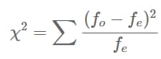,

where f0 and fe are the observed and expected frequencies, respectively. Summation is performed for all cells of the table.

In our problem, we use the Pearson's chi-squared test when checking the discrepancy between frequencies in two situations:

1) Comparison of the shares of positive and negative reviews in one bank of each category and the total shares of all categories:

The null hypothesis is as follows: The distribution of the shares of positive and negative reviews in the category has the same distribution as for all reviews of the bank as a whole.

Let the distribution of the shares of positive and negative reviews for all reviews of the bank be the expected distribution, and the distribution of the shares of positive and negative reviews for reviews of a particular category is the actual distribution.

If the probability p, which is calculated using the scipy.stats.chi2_contingency function, is greater than 0.05, then we do not show the selected category, since it is very likely similar to the distribution of shares across all reviews, that is, the null hypothesis turned out to be true.

If the probability is p <= 0.05, then the distributions differ, which means that the shares of the selected category should be shown, that is, we have refuted the null hypothesis.

2) Comparison of the shares of positive and negative reviews of each category between banks.

The null hypothesis is as follows: the distribution of the shares of positive and negative reviews within the same category among all banks coincide.

We check the distributions between the banks in pairs. We put the actual and expected distributions, respectively, positive and negative shares of reviews for each pair of banks. If there is at least one whose probability p <= 0.05, then we show the whole series, since the distributions with high probability are different, that is, the null hypothesis is refuted.

5.2.2 Support vector machine

The support vector machine is an algorithm that allows you to define a hyperplane (in a particular case, a line) that distributes data into two classes. The separating hyperplane will be the hyperplane that creates the greatest distance to two parallel hyperplanes.

We used a classifier based on the support vector machine to create two types of models:

1. definition of a review for a certain category;
2. determining whether a word belongs to positive or negative reviews.

To create models of the first type, we have labeled 1600 reviews by category (see "Problem Statement").

Input data: "clean" review and 0 or 1 (0 - review does not belong to the category, 1 - review belongs to the category).

Each of the six models determines whether or not the review belongs to a specific category.

To create models of the second type, we used reviews for each of the categories as input data and 0 or 1 (0 is the rating of the review 1 or 2 (i.e. it is negative), 1 is the rating of the review 4 or 5 (i.e. it is positive)).

Each of the six models can determine in which reviews the word occurs: positive or negative.

5.2.3 Gradient boosting

Gradient boosting is a machine learning technique for classification and regression problems that builds a prediction model in the form of an ensemble of weak predictive models, usually decision trees. Gradient boosting allows you to train algorithms sequentially (each next one learns from the mistakes of the previous one).

We use gradient boosting to identify the most important words in each of the categories.

5.3 Software implementation

5.3.1 Programming language, development environment, third-party programs, API

We chose Python as the programming language, since it is easy to write analytics and site visualization using it.

We chose PyCharm Community Edition as an environment for development. It has great functionality, is easy to use and is equipped with a Git version control system.

To work with the database, we decided to use the SQLiteStudio program. In it, we can view records from the database and make test queries in SQL.

As an API, we used the Yandex Organization Search API to search for the coordinates of the branch and its id in Yandex.Maps. We also used the Yandex API Geocoder.Maps for the location of the subject of the Russian Federation in which each office is located.

For manual labeling of reviews, we used Google Spreadsheets to deal with the selection of topics in reviews in parallel with each other.

To train models, we used the Google Colab service, as it speeds up the training of models at times.

5.3.2 Python Libraries

We used a large number of libraries to work on the project. Below we would like to tell you in more detail about the most important of them.

1. requests

So, the first library we used is requests. We need it to access sites on the Internet. Using the get() method, we received the HTML structure of the Yandex site page.Maps and [www.1000bankov.ru](http://www.1000bankov.ru/).

1. beautifulsoup4

beautifulsoup4 is a Python library for parsing HTML and XML documents. Having received the HTML structure of the page, using the BeautifulSoup class from the beautifulsoup4 library, we find the tags from which we need information (for example, the div tag with the business-review-view__body-text _collapsed class is responsible for the text of each review).

1. sqlite

The built-in Python module allowed us to work with the database quickly and conveniently. Using this library, we added the data received from Yandex.Maps reviews and with [www.1000bankov.ru](http://www.1000bankov.ru/) addresses of offices, as well as the belonging of reviews to categories and other necessary information (for more information about the database, see 6.3.3).

1. scikit-learn (sklearn)

scikit-learn is a powerful Python machine learning tool. We used four classes from this library:

* 1. sklearn.svm.SVC is a classifier based on the support vector machine, we used to create binary classification models;
  2. sklearn.feature_extraction.text.TfidfVectorizer is a transformer responsible for translating words into numbers, as well as evaluating the importance of a word in the context of a document;
  3. sklearn.pipeline.Pipeline is a class that combines transformers (in our case it is TfidfVectorizer) and models (in our case it is SVC) for sequential data processing and prediction on the processed data;
  4. sklearn.ensemble.GradientBoostingRegressor is a regressor based on gradient boosting to highlight the importance of words by category.

There were also several useful functions in this library that we used when working:

* sklearn.model_selection.train_test_split() is a function that divides the dataset into training and test data.
* sklearn.metrics.roc_auc_score, sklearn.metrics.accuracy_score - functions that show an estimate of the accuracy of models.

1. nltk

nltk (Natural Language Toolkit– is a package of libraries and programs for symbolic and statistical processing of natural language. From this library we imported a list of stop words of the Russian language that need to be removed from reviews, as well as the nltk.word_tokenize(review) function, which tokenizes suggestions of reviews by words.

Tokenization by words is the process of dividing sentences into component words. In almost all languages, a space is one of the most convenient word separators, however, problems may arise if we use only a space – in Russian, compound nouns are written differently and sometimes separated by a space.

1. pymorphy2

pymorphy2 is a morphological analyzer for the Russian language, written in Python and using dictionaries from OpenCorpora.

This module is necessary to bring words into the initial form for the correct processing of "cleared" reviews.

1. plotly

The plotly library allows you to build beautiful and easy-to-view charts. With its help, we have built three types of diagrams:

* horizontal histogram;
* Radar Chart;
* Tornado Chart.

1. streamlit

Streamlit is a framework specifically designed for visualization of applications using machine learning. This library works great with plotly, so our choice fell on streamlet. Thanks to streamlet, we have kept the interactivity and functionality of charts.

1. folium

We used the folium library to build an interactive map of bank offices across the country and by region. This library allowed us to make our own icons for banks, as well as quickly build a map by connecting markers with banks in clusters.

5.3.3 Database structure

The photo below shows the database schema.

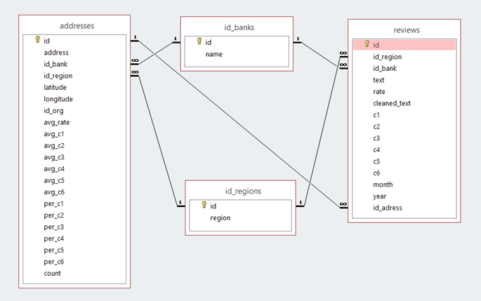

Image 3. Database structure

Let's explain the structure of each table.

1. id_banks - a table that stores pairs of id-bank name;

2. id_regions - a table that stores pairs of id-region of the Russian Federation;

3. addresses - a table in which the addresses of bank offices are stored:

1. id – a unique identifier;
2. address – the address of the office taken from the site 1000bankov.ru;
3. id_bank - ID of the bank from the id_banks table, the office of which is the address from the previous address column;
4. id_region - ID of the region where the office is located;
5. latitude and longitude – respectively the latitude and longitude of the coordinates of the department. These columns are necessary to avoid the problem of duplicating addresses from the site 1000bankov.ru (this problem is described in section 7.1.1 Selecting the source of bank office addresses);
6. id_org - the organization id obtained from the Yandex Organizations Search API. It is needed to get feedback.
7. avg_rate – average rating of reviews that are left for a particular department;
8. avg_c1 - average rating of reviews for the department in the category "Office convenience";
9. avg_c2 - average rating of reviews for the in the category "ATMs";
10. avg_c3 - average rating of reviews for the department in the category "Service level";
11. avg_c4 - average rating of reviews for the department in the "Staff" category;
12. avg_c5 - average rating of reviews for the department in the category "Products and services";
13. avg_c6 - average rating of reviews for the department in the category "Remote service channels";
14. per_c1 - share of reviews in the "Office Convenience" category;
15. per_c2 - share of reviews by category "ATMs";
16. per_c3 - share of reviews by category "Service level";
17. per_c4 - share of reviews by category "Staff";
18. per_c5 - share of reviews by category "Products and services";
19. per_c6 - share of reviews in the category "Remote service channels";
20. count – the number of reviews per department.

Columns 8-20 are needed to quickly build an interactive map of bank offices.

4. reviews - a table in which reviews are stored:

1. id – a unique identifier;
2. id_region - id of the region in which the office is located, for which the review was left;
3. id_bank - ID of the bank whose office has been reviewed;
4. text – the text of the review;
5. rate - the rating that the user left;
6. cleaned_text - cleared review;
7. c1 - the review belongs to the category "Office convenience" (0 or 1);
8. c2 - belonging of the review to the category "ATMs" (0 or 1);
9. c3 - belonging of the review to the category "Service level" (0 or 1);
10. c4 - belonging of the review to the category "Personnel" (0 or 1);
11. c5 - belonging of the review to the category "Products and services" (0 or 1);
12. c6 - belonging of the review to the category "Remote service channels" (0 or 1);
13. month – the month in which the review of the department was left;
14. year – the year in which the review was left for the department;
15. id_address - the ID of the department to which a specific review was left (necessary for the analysis of average ratings by category for each department).

## 6. Conclusion

6.1 Result

The result of our work is a web app that provides visualization of the analysis performed on the collected data.

There are three types of diagrams and an interactive map available to the user on our website:

1. horizontal histogram (to display average grades and important words);
2. radar chart (for convenient display of average ratings by category);
3. tornado chart (to display all distributions of positive and negative reviews by category and on average, as well as only those distributions that differ greatly from the average distribution and from the distribution by category between banks);
4. interactive map of bank offices of the Russian Federation with detailed analytics for each office from the database.

We have created a product whose approach is applicable to the evaluation and comparison of various types of services, for example, applications of banks and food delivery, food supermarket chains, etc. To build analytics, you only need reviews, as well as their categorization (what users write about).

6.2 Usage examples

Let's go to the website, the user is asked to choose the language (Russian / English) and one of the pages: the average rating for all banks, average ratings of categories by banks and regions, important words to different categories, an interactive map of bank offices.

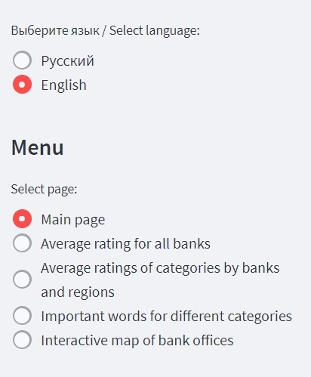

Image 4. Menu with language and page selection

6.2.1 Average rating for all banks

When going to the first page, the user can see a chart of the average rating for all banks. It is possible to select the time period for which the data will be displayed. This chart is great for analyzing changes in customer experience in all banks as a whole over a certain period of time.

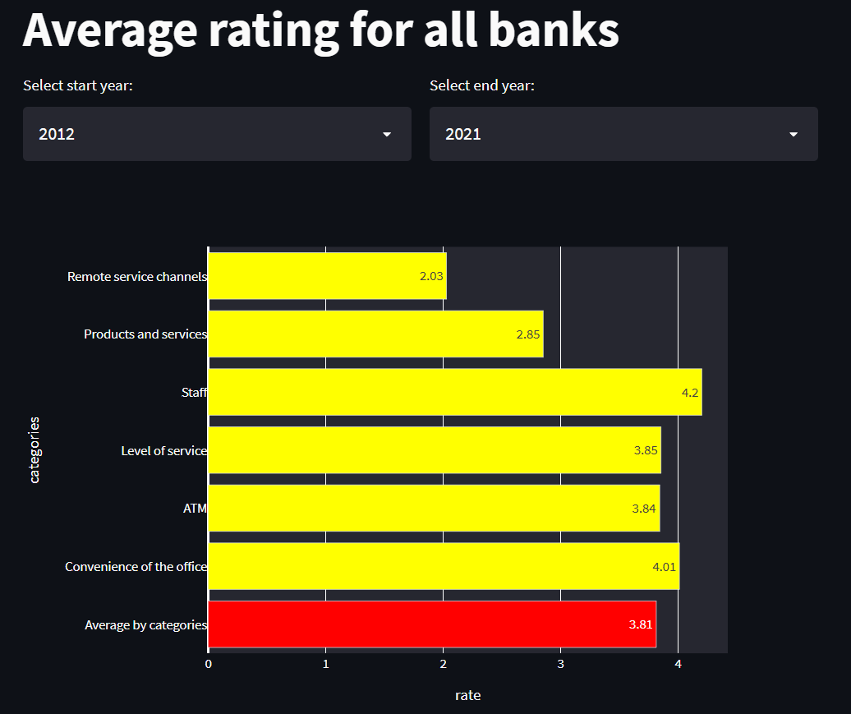

Image 5. “Average rating for all banks” diagram from 2012 to 2021

6.2.2 Average ratings of categories by banks and regions

On the second page, the user has access to a radar chart of average ratings of categories by banks and regions. This format makes it easy to compare several banks with each other. For this chart, it is also possible to select a time period, banks (no more than 4) and regions, which will respectively extend to other charts on this page.

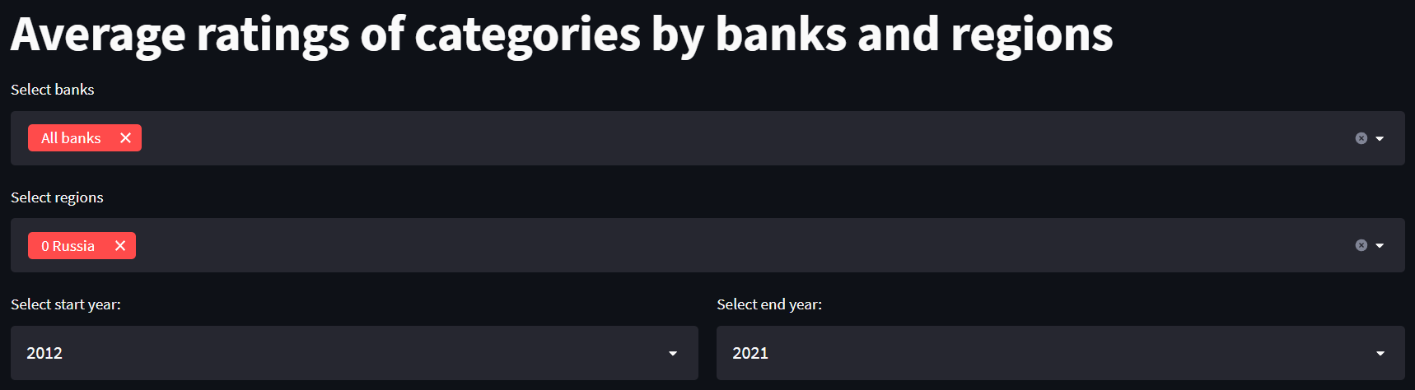

Image 6. Initial values for the second page

The initial values of the parameters are shown above.

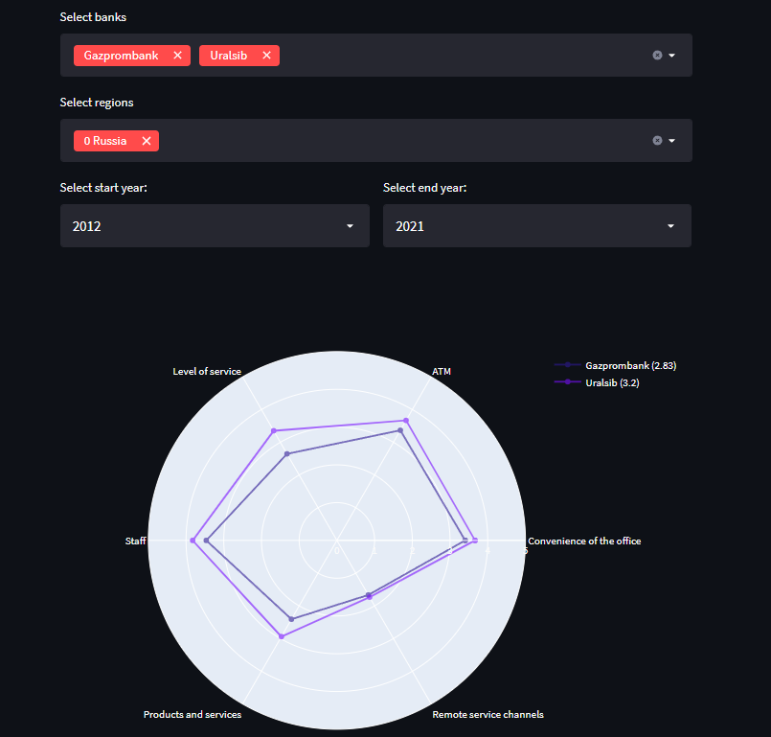

Image 7. Radar chart for Gazprombank and Uralsib

In this picture you can see an example of choosing two banks and a region.

Below is a tornado chart comparing the percentage of reviews with positive and negative ratings for each selected bank by category. This diagram is presented in three versions. The first one shows all the distributions of ratings, and the other two show only those that differ significantly from the final average in the bank or differ the selected banks by categories among themselves.

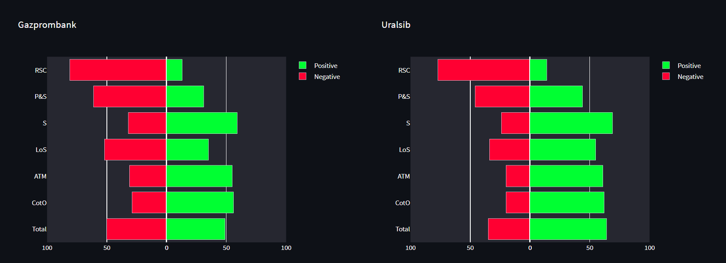

Image 8. Tornado chart that shows all categories

The user can independently choose which version to watch.

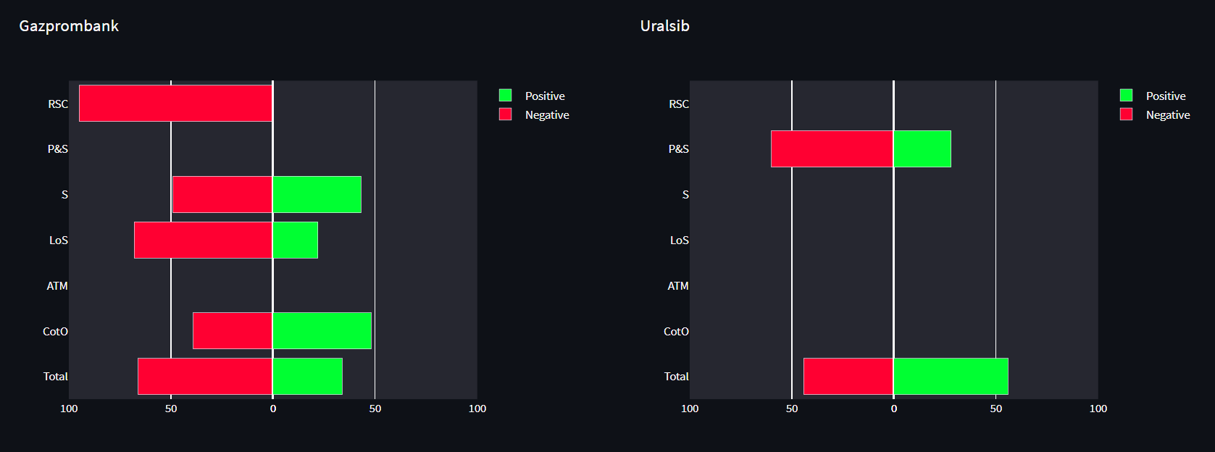

Image 9. Tornado chart which shows only those categories that differ significantly from the final distribution within the bank

When viewing this diagram, we can conclude that in Gazprombank only two categories are similar to the average, and in Uralsib, on the opposite, only one differs from the total.

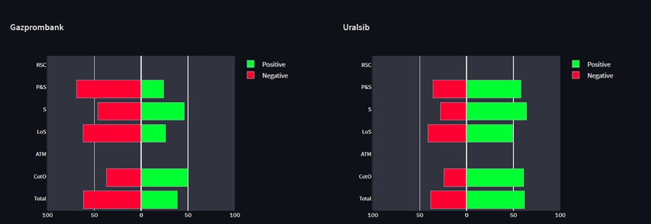

Image 10. Tornado chart which shows only those that strongly differ from the selected banks

Here we can see that the ratio of reviews in the banks we have selected corresponds only in two of the six categories.

6.3.3 Important words for different categories

When we created models for categorizing reviews, separate words were allocated, which are used to determine the relationship of a review to a particular category. So we decided to make a diagram based on them, taking into account their importance, and we also took into account how certain words affect the rating left by the user. As a result, we have such a diagram. In the drop-down list, you can select the category for which the user wants to view the chart.

We have presented only the 20 most important words, they are arranged line by line in descending order of importance. Each lexical unit corresponds to a coefficient of importance.

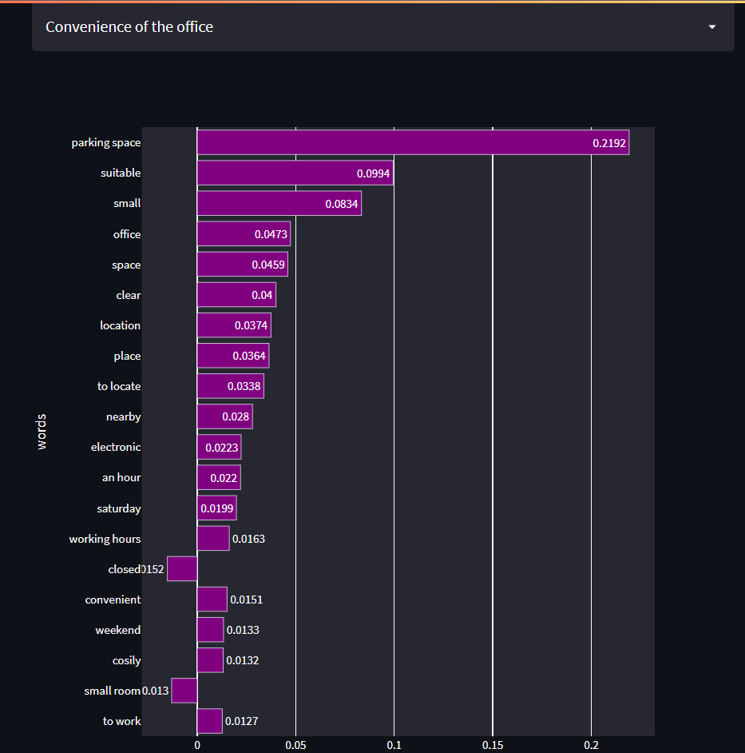

Image 11. Important words for “Convenience of the office” category

6.3.4 Interactive map of the country's bank offices

On the fourth page, the user can select banks and regions to display bank branches on the map.

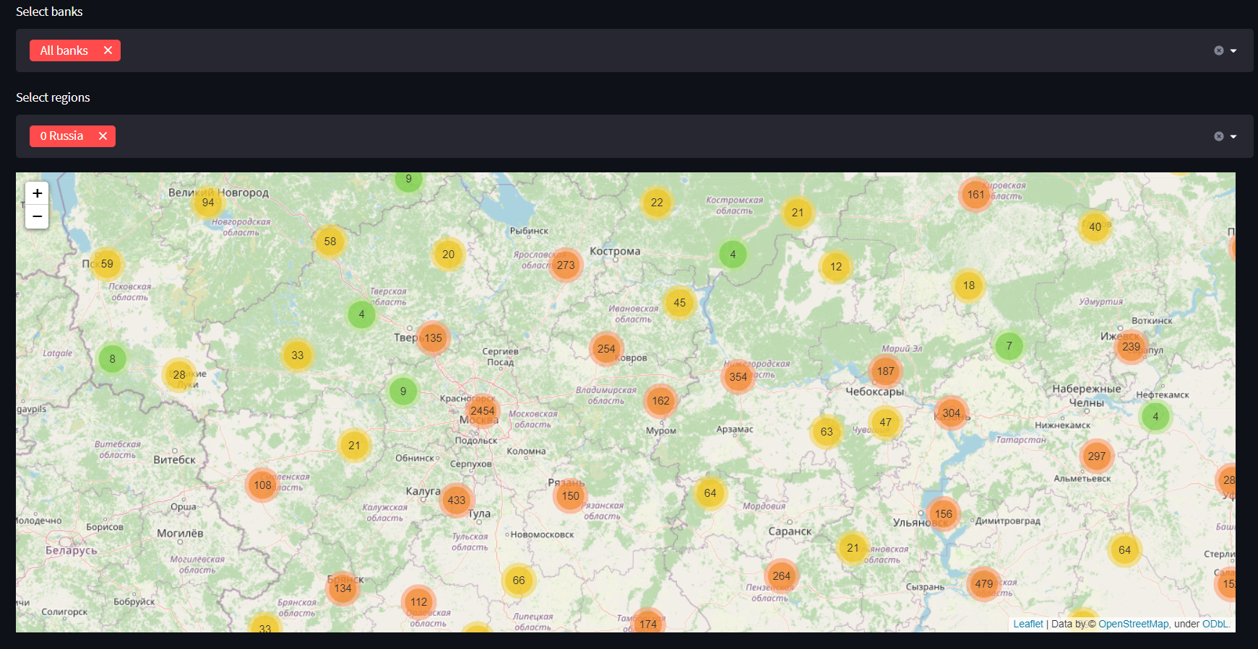

Image 12. The interactive map of bank offices (general view)

The user can see office’s detailed characteristics when he/she selects it. Bank name, address, average rating, number of reviews, average ratings and % of reviews (of the total number) by category are displayed.

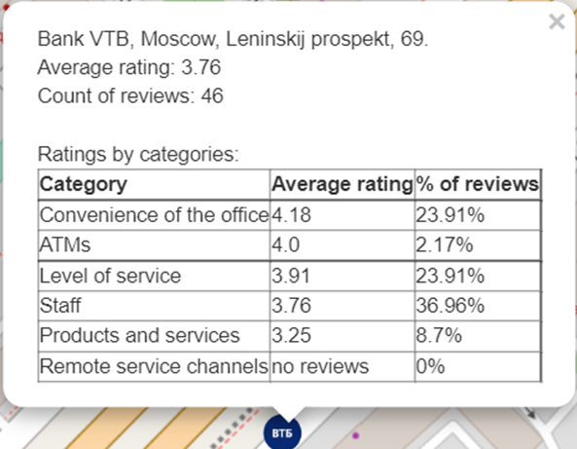

Image 13. The table with detailed information for one of the Bank VTB offices in Moscow

## 7. Inferences

Over the past three years the level of banking services’ providing at the offices has increased (the average rating has increased up by 0.5 points out of 5).

Table 2. Comparison of average ratings for all categories for 2017-2018 and 2020-2021

|  |  |  |  |  |  |  |
| --- | --- | --- | --- | --- | --- | --- |
|  | **Average rating (2017-2018)** | **Category share in all categories (2017-2018)** | **Average rating (2020-2021)** | **Category share in all categories (2020-2021)** | **Change of the average rating** | **Change of the category share** |
| **Convenience of the office** | 3.59 | 16.8% | 4.02 | 17.6% | **+0.43** | **+0.8%** |
| **ATMs** | 3.26 | 15.1% | 3.91 | 9.8% | **+0.65** | **-5.3%** |
| **Level of service** | 3.3 | 35.6% | 3.87 | 30% | **+0.57** | **-5.6%** |
| **Stuff** | 3.63 | 24% | 4.22 | 28.4% | **+0.59** | **+4.4%** |
| **Products & services** | 2.38 | 6.9% | 2.77 | 6.8% | **+0.39** | **-0.1%** |
| **Remote service channels** | 1.63 | 2.2% | 2.03 | 1.5% | **+0.4** | **-0.7%** |

The increase of the average ratings caused by a huge increase in the average ratings in each of the categories.

Over the past three years, the customers’ preferences of bank offices have changed: users began to write more often about the staff, but less often about ATMs and the level of service.

The changes in average estimates are caused by a rapid improvement of the level of banking services’ providing by the main bank of Russia – Sberbank (occupies ~ 50% of the banking market of the Russian Federation). The rest of the banks from the top-10 list, which is given in the problem statement, have no special changes in estimates. Sberbank can be called the driver of changes in the entire banking sector in Russia for three years.

We can say that Sberbank and Tinkoff Bank, which is aimed at remote service, have set a new trend in remote service channels (Sberbank's average score for 2017-2018 is 1.79, 2020-2021 is 2.86). Despite the decrease in the share of this category in all reviews, people began to evaluate banks’ applications more often (most likely, customers write reviews about apps in Apple Store and Play Market stores) and bank call centers; many banks have created remote channels during this period. Bank customers leave feedback on this category only when they visit a bank office due to poor operation of the app or call center, which is why this category has the lowest average score (it means that people complain).

Bank customers have become much more likely to leave reviews on cartographic services (for example, Yandex.Maps, reviews from which we analyzed). In 2017-2018, users wrote about 25 thousand reviews, and in 2020-2021 – already 380 thousand. As we can see, the number of reviews has increased more than 15 times over the last period.

## 8. Future work

1. Performing analysis of the reviews using other MLmethods to compare them with SVM;
2. Analysis of user reviews of banks' mobile apps from Google Play (being developed).
3. Analysis of detailed customer reviews of bank services in the "People's Rating" on the website www.banki.ru

This task is more difficult because on the "People's Rating" users mostly write reviews not about specific advantages (competent staff, lack of queues, etc.) or disadvantages of the office (inconvenient opening hours, non-working ATMs, etc.), but about banking services in general.

## 9. References

1. Mays E. Credit Scoring for Risk Managers. The Handbook for Lenders. Thomson; 2004
2. Streamlit: Welcome to Streamlit — Streamlit 0.82.0 documentation. [Online]. Available from: https://docs.streamlit.io/en/stable/ [Accessed 28th September 2021]
3. Towards Data Science: Running Chi-Square Tests with Die Roll Data in Python | By Jake Huneycutt | Towards Data Science. [Online]. Available from: https://towardsdatascience.com/running-chi-square-tests-in-python-with-die-roll-data b9903817c51b [Accessed 27th October 2021]
4. Plotly: Plotly Python Graphic Library | Python | Plotly. [Online]. Available from: https://plotly.com/python/ [Accessed 19th November 2021]

## 10. Additional materials

|  |  |
| --- | --- |
| Image 14. precision-recall curve for «Convenience of the office» model | Image 15. precision-recall curve for «ATMs» model |
| Image 16. precision-recall curve for «Level of service» model | Image 17. precision-recall curve for «Staff» model |
| Image 18. precision-recall curve for «Products & services» model | Image 19. precision-recall curve for «Remote service channels» model |

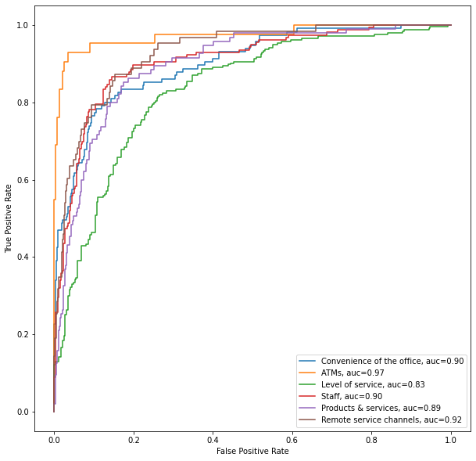

Image 20. ROC-AUC curve for binary classification models

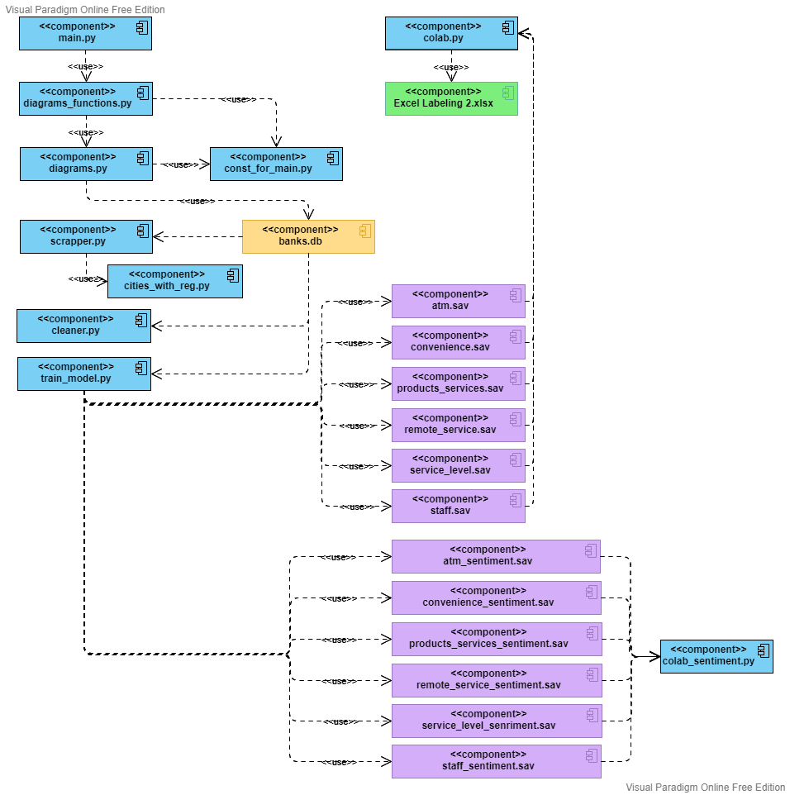

Image 21. Component Diagram