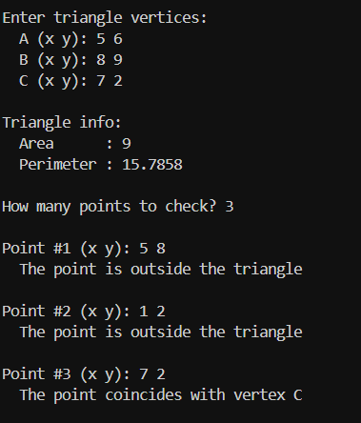
main.cpp
#include "biblia.h"

int main() {
run();
return 0;
}

Biblai.h
#pragma once
#include <string>

struct Point {
double x, y;

bool operator==(const Point &other) const;
};

struct Triangle {
Point A, B, C;

double perimeter() const;
double area() const;
bool isValid() const;
bool contains(const Point &P) const;
void checkPoint(const Point &P) const;

private:
bool isOnEdge(const Point &P, const Point &p1, const Point &p2, const std::string &name) const;
};

double distance(const Point &A, const Point &B);
void run();

biblia.cpp
#include "biblia.h"
#include <iostream>
#include <cmath>
#include <algorithm>

bool Point::operator==(const Point &other) const {
return std::hypot(x - other.x, y - other.y) < 1e-9;
}

double distance(const Point &A, const Point &B) {
return std::hypot(A.x - B.x, A.y - B.y);
}

double Triangle::perimeter() const {
return distance(A, B) + distance(B, C) + distance(C, A);
}

double Triangle::area() const {
return 0.5 * std::fabs((B.x - A.x) * (C.y - A.y) -
(C.x - A.x) * (B.y - A.y));
}

bool Triangle::isValid() const {
return area() > 1e-9;
}

bool Triangle::contains(const Point &P) const {
double S = area();
double S1 = Triangle{A, B, P}.area();
double S2 = Triangle{B, C, P}.area();
double S3 = Triangle{C, A, P}.area();
return std::fabs(S - (S1 + S2 + S3)) < 1e-9;
}

bool Triangle::isOnEdge(const Point &P,
const Point &p1, const Point &p2,
const std::string &name) const {
double cross = (P.x - p1.x) * (p2.y - p1.y) -
(P.y - p1.y) * (p2.x - p1.x);
if (std::fabs(cross) > 1e-9) return false;

double dot = (P.x - p1.x) * (p2.x - p1.x) +
(P.y - p1.y) * (p2.y - p1.y);
double len2 = (p2.x - p1.x) * (p2.x - p1.x) +
(p2.y - p1.y) * (p2.y - p1.y);

if (dot >= -1e-9 && dot <= len2 + 1e-9) {
std::cout << " The point is on edge " << name << "\n";
return true;
}
return false;
}

void Triangle::checkPoint(const Point &P) const {
if (P == A) { std::cout << " The point coincides with vertex A\n"; return; }
if (P == B) { std::cout << " The point coincides with vertex B\n"; return; }
if (P == C) { std::cout << " The point coincides with vertex C\n"; return; }

if (contains(P)) {
if (isOnEdge(P, A, B, "AB")) return;
if (isOnEdge(P, B, C, "BC")) return;
if (isOnEdge(P, C, A, "CA")) return;
std::cout << " The point is strictly inside the triangle\n";
} else {
std::cout << " The point is outside the triangle\n";
}
}

static Triangle readTriangle() {
Triangle t;
while (true) {
std::cout << "\nEnter triangle vertices:\n";
std::cout << " A (x y): "; std::cin >> t.A.x >> t.A.y;
std::cout << " B (x y): "; std::cin >> t.B.x >> t.B.y;
std::cout << " C (x y): "; std::cin >> t.C.x >> t.C.y;

if (t.isValid()) break;
std::cout << " Degenerate triangle — points are collinear. Try again.\n";
}
return t;
}

void run() {
Triangle ABC = readTriangle();

std::cout << "\nTriangle info:\n";
std::cout << " Area : " << ABC.area() << "\n";
std::cout << " Perimeter : " << ABC.perimeter() << "\n";

int n;
std::cout << "\nHow many points to check? "; std::cin >> n;

for (int i = 1; i <= n; i++) {
Point P;
std::cout << "\nPoint #" << i << " (x y): "; std::cin >> P.x >> P.y;
ABC.checkPoint(P);
}
}

https://github.com/AnastasiiaHaisha/MyFisrtCppRepo.git

