Operating controls in cytometry analysis

PART 1. Isotypic control vs minimal concentration

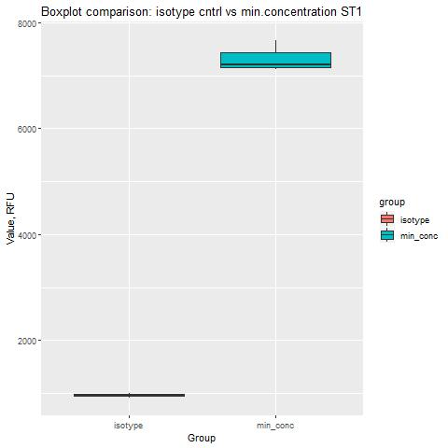

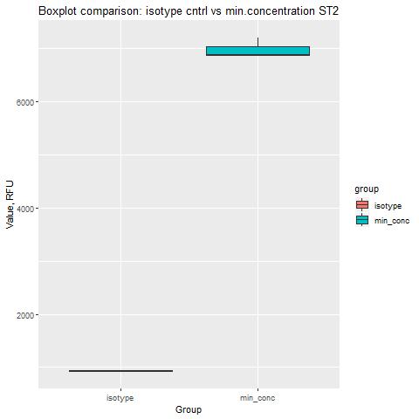

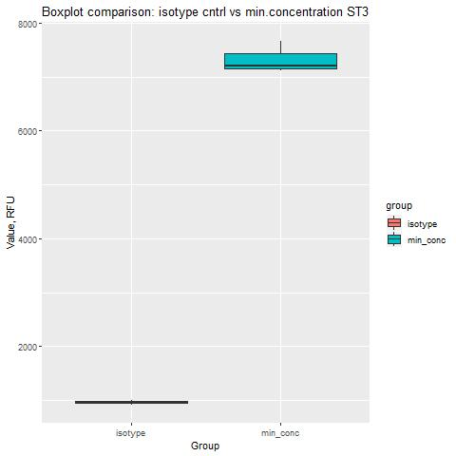

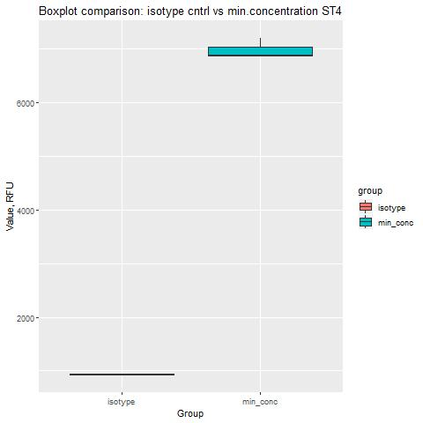

Student's t-test results

| Name | p-value | High_conf | Low_conf | Method | Alternative |
| --- | --- | --- | --- | --- | --- |
| ST_1 | 0.00056594362820016 | -7083.26233819133 | -5644.00432847533 | Welch Two Sample t-test | two.sided |
| ST_2 | 0.000317956436648062 | -6525.9794702298 | -5558.4205297702 | Welch Two Sample t-test | two.sided |
| ST_3 | 0.00056594362820016 | -7083.26233819133 | -5644.00432847533 | Welch Two Sample t-test | two.sided |
| ST_4 | 0.000317956436648062 | -6525.9794702298 | -5558.4205297702 | Welch Two Sample t-test | two.sided |

PART 2. Unstained vs negative control

| Name | p-value | Method | Alternative |
| --- | --- | --- | --- |
| PLATE_1 | 0.0022 | Wilcoxon rank sum test | two.sided |
| PLATE_2 | 0.0022 | Wilcoxon rank sum test | two.sided |