Государственный Университет Молдовы
Факультет Математики и Информатики
Департамент Прикладной Информатики

Индивидуальная работа №5

По курсу «Операционные системы»
Tema: “ ”

Выполнила студентка группы IA 2304: Шелестян А.
Проверил преподаватель:
Препелица А.

Кишинэу, 2023

Условия выполнения индивидуальной работы

76. В файле query4 выбрать все строки, в которых дата продажи - 1-е число любого месяца и года.
77. В файле query1 выбрать все строки, в которых должность - не ‘SALESPERSON’.
78. В файле query2 выбрать все строки, в которых номер телефона начинается с ‘555’.
79. В файле query3 выбрать все строки, в которых в названии есть текст, взятый в кавычки, а в нем -
слово ‘GUIDE’.
80. В файле query4 выбрать все строки, в которых сумма содержит целое число сотен.

Структура файла query 4

612 ALLEN 104 15-JAN-91 5860

605 WARD 106 14-JUL-90 8374

620 TURNER 100 12-MAR-91 4450

613 TURNER 108 01-FEB-91 6400

614 MARTIN 102 01-FEB-91 23940

617 TURNER 105 05-FEB-91 46370

618 MARTIN 102 15-FEB-91 3083

549 PETERS 226 27-DEC-90 1620

516 PETERS 228 30-SEP-89 1815

553 PETERS 228 02-FEB-91 4400

526 WEST 221 04-MAR-90 7700

543 WEST 221 04-SEP-90 8400

555 WEST 221 04-MAR-91 8540

528 WEST 224 24-MAR-90 3770

558 WEST 224 31-MAR-91 1700

565 ROSS 227 01-JUN-91 4900

574 SHAW 201 10-OCT-91 1685

576 SHAW 201 13-OCT-91 2058.9

503 SHAW 201 25-MAR-89 1876

518 SHAW 201 20-OCT-89 2932.5

544 ROSS 202 11-SEP-90 2358

524 ROSS 202 22-FEB-90 1979

562 SHAW 203 04-MAY-91 2044.5

578 DUNCAN 204 19-NOV-91 2275.6

536 SHAW 206 21-MAY-90 2135.6

542 DUNCAN 208 11-AUG-90 2409

573 SHAW 201 10-OCT-91 1627

566 SHAW 201 09-JUN-91 3389.2

527 DUNCAN 204 27-FEB-90 3054.4

522 DUNCAN 204 07-JAN-90 2578.8

569 SHAW 205 16-JUL-91 2073

550 SHAW 205 27-JAN-91 2356

561 ROSS 207 20-APR-91 2558.3

506 DUNCAN 208 27-APR-89 2600.4

530 DUNCAN 208 03-APR-90 3026.5

557 DUNCAN 208 08-MAR-91 2461.8

546 DUNCAN 208 17-OCT-90 3663

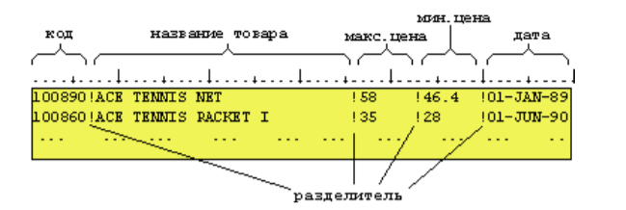

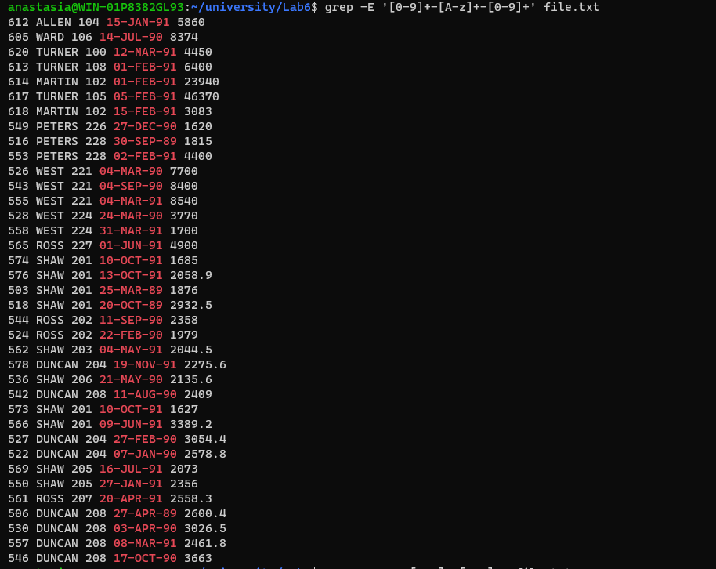

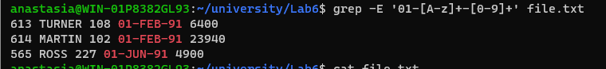

Структура файла query1

7369 JOHN Q SMITH CLERK RESEARCH DALLAS 800
7499 KEVIN J ALLEN SALESPERSON SALES CHICAGO 1600
7505 JEAN K DOYLE MANAGER SALES NEW-YORK 2850
7506 LYNN S DENNIS MANAGER SALES DALLAS 2750
7507 LESLIE D BAKER MANAGER OPERATIONS NEW-YORK 2200
7521 CYNTHIA D WARD SALESPERSON SALES CHICAGO 1250
7555 DANIEL T PETERS SALESPERSON SALES NEW-YORK 1250
7557 KAREN P SHAW SALESPERSON SALES NEW-YORK 1250
7560 SARAH S DUNCAN SALESPERSON SALES DALLAS 1250
7564 GREGORY J LANGE SALESPERSON SALES DALLAS 1250
7566 TERRY M JONES MANAGER RESEARCH DALLAS 2975
7569 CHRIS L ALBERTS MANAGER RESEARCH NEW-YORK 3000
7600 RAYMOND Y PORTER SALESPERSON SALES NEW-YORK 1250
7609 RICHARD M LEWIS STAFF OPERATIONS DALLAS 1800
7654 KENNETH J MARTIN SALESPERSON SALES CHICAGO 1250
7676 DENISE D SOMMERS STAFF OPERATIONS CHICAGO 1850
7698 MARION S BLAKE MANAGER SALES CHICAGO 2850
7782 CAROL F CLARK MANAGER ACCOUNTING NEW-YORK 2450
7788 DONALD T SCOTT ANALYST RESEARCH DALLAS 3000
7789 LIVIA N WEST SALESPERSON SALES DALLAS 1500
7799 MATTHEW G FISHER ANALYST RESEARCH NEW-YORK 3000
7820 PAUL S ROSS SALESPERSON SALES BOSTON 1300
7839 FRANCIS A KING PRESIDENT ACCOUNTING NEW-YORK 5000
7876 DIANE G ADAMS CLERK RESEARCH DALLAS 1100
7900 FRED S JAMES CLERK SALES CHICAGO 950
7902 JENNIFER D FORD ANALYST RESEARCH DALLAS 3000
7916 GRACE M ROBERTS ANALYST RESEARCH NEW-YORK 2875
7919 MICHAEL A DOUGLAS CLERK RESEARCH NEW-YORK 800
7934 BARBARA M MILLER CLERK ACCOUNTING NEW-YORK 1300
7950 ALICE B JENSEN CLERK SALES NEW-YORK 750
7954 JAMES T MURRAY CLERK SALES DALLAS 750

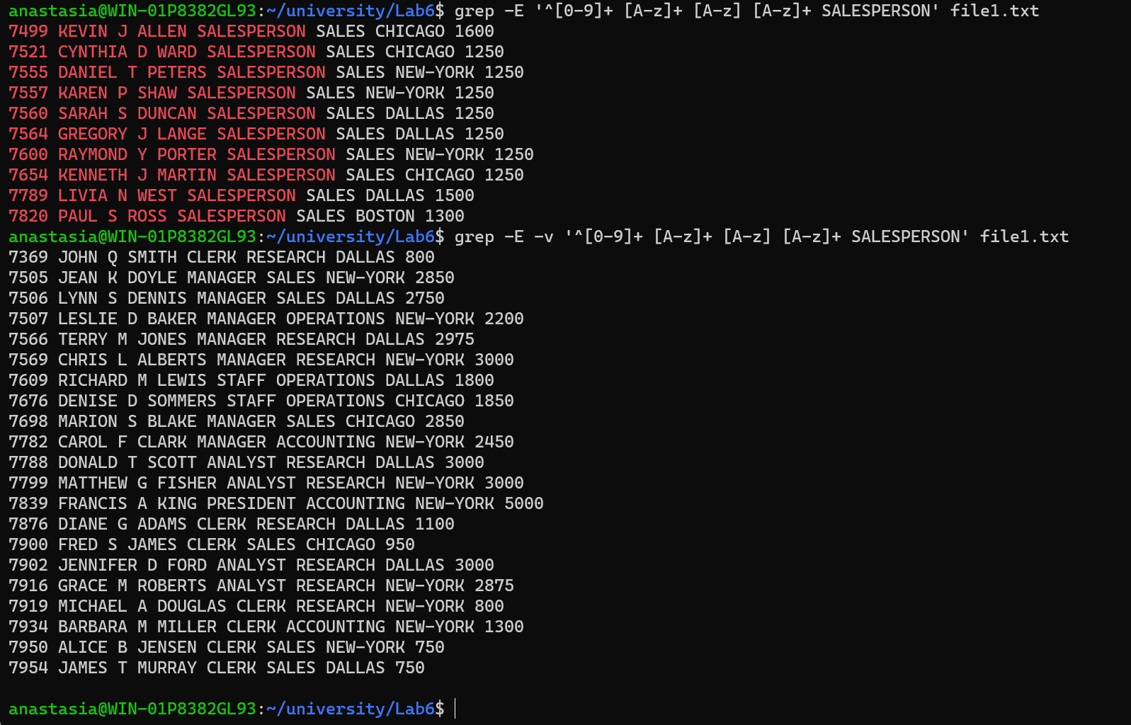

Структура файла query2

100:JOCKSPORTS :345 VIEWRIDGE :BELMONT :CA:96711:5986609:5000
101:TKB SPORT SHOP :490 BOLI RD. :REDWOOD CITY :CA:94061:3681223:10000
102:VOLLYRITE :9722 HAMILTON :BURLINGAME :CA:95133:6443341:7000
103:JUST TENNIS :HILLVIEW MALL :BURLINGAME :CA:97544:6779312:3000
104:EVERY MOUNTAIN :574 SURRY RD. :CUPERTINO :CA:93301:9962323:10000
105:K + T SPORTS :3476 EL PASEO :SANTA CLARA :CA:91003:3769966:5000
106:SHAPE UP :908 SEQUOIA :PALO ALTO :CA:94301:3649777:6000
107:WOMENS SPORTS :VALCO VILLAGE :SUNNYVALE :CA:93301:9674398:10000
108:NORTH WOODS HEALTH CENTER :98 LONE PINE WAY :HIBBING :MN:55649:5669123:8000
201:STADIUM SPORTS :47 IRVING PL. :NEW YORK :NY:10003:5555335:10000
202:HOOPS :2345 ADAMS AVE. :LEICESTER :MA:01524:5557542:5000
203:REBOUND SPORTS :2 E. 14TH ST. :NEW YORK :NY:10009:5555989:10000
204:THE POWER FORWARD :1 KNOTS LANDING :DALLAS :TX:75248:5550505:12000
205:POINT GUARD :20 THURSTON ST. :YONKERS :NY:10956:5554766:3000
206:THE COLISEUM :5678 WILBUR PL. :SCARSDALE :NY:10583:5550217:6000
207:FAST BREAK :1000 HERBERT LN. :CONCORD :MA:01742:5551298:7000
208:AL AND BOB&#39;S SPORTS :260 YORKTOWN CT. :AUSTIN :TX:78731:5557631:4000
211:AT BAT :234 BEACHEM ST. :BROOKLINE :MA:02146:5557385:8000
212:ALL SPORT :1000 38TH ST. :BROOKLYN :NY:11210:5551739:6000
213:GOOD SPORT :400 46TH ST. :SUNNYSIDE :NY:11104:5553771:5000
214:AL&#39;S PRO SHOP :45 SPRUCE ST. :SPRING :TX:77388:5555172:8000
215:BOB&#39;S FAMILY SPORTS :400 E. 23RD :HOUSTON :TX:77026:5558015:8000
216:THE ALL AMERICAN :547 PRENTICE RD. :CHELSEA :MA:02150:5553047:5000
217:HIT, THROW, AND RUN :333 WOOD COURT :GRAPEVINE :TX:76051:5552352:6000
218:THE OUTFIELD :346 GARDEN BLVD. :FLUSHING :NY:11355:5552131:4000
221:WHEELS AND DEALS :2 MEMORIAL DRIVE :HOUSTON :TX:77007:5554139:10000
222:JUST BIKES :4000 PARKRIDGE BLVD. :DALLAS :TX:75205:5558735:4000
223:VELO SPORTS :23 WHITE ST. :MALDEN :MA:02148:5554983:5000
224:JOE&#39;S BIKE SHOP :4500 FOX COURT :GRAND PRARIE :TX:75051:5559834:6000
225:BOB&#39;S SWIM, CYCLE, AND RUN:300 HORSECREEK CIRCLE:IRVING :TX:75039:5558388:7000
226:CENTURY SHOP :8 DAGMAR DR. :HUNTINGTON :NY:11743:5553006:4000
227:THE TOUR :2500 GARDNER RD. :SOMERVILLE :MA:02144:5556673:5000
228:FITNESS FIRST :5000 85TH ST. :JACKSON HEIGHTS:NY:11372:5558710:4000

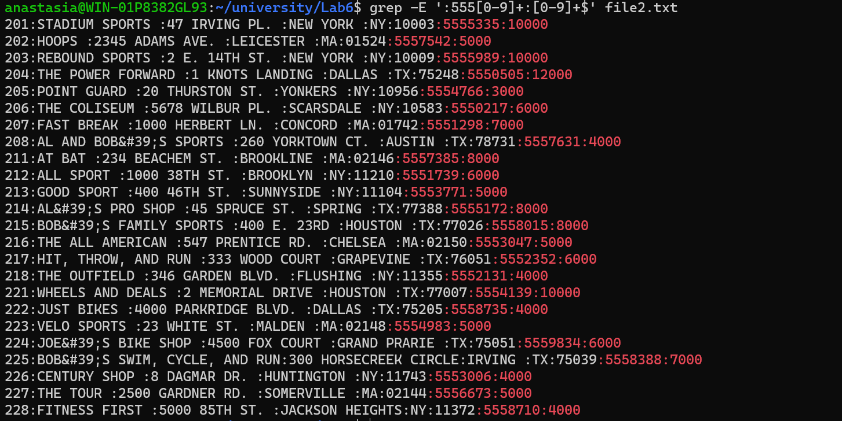

Структура файла query3

100890!ACE TENNIS NET !58 !46.4 !01-JAN-89
100860!ACE TENNIS RACKET I !35 !28 !01-JUN-90
100861!ACE TENNIS RACKET II !45 !36 !01-JUN-90
100870!ACE TENNIS BALLS-3 PACK !2.8 !2.4 !01-JAN-90
100871!ACE TENNIS BALLS-6 PACK !5.6 !4.8 !01-JAN-90
101860!SP TENNIS RACKET !24 !18 !15-FEB-89
101863!SP JUNIOR RACKET !12.5 !9.4 !15-FEB-89
102130!RH: &quot;GUIDE TO TENNIS&quot; !3.4 !2.8 !18-AUG-89
200376!SB ENERGY BAR-6 PACK !2.4 !1.75 !15-NOV-90
200380!SB VITA SNACK-6 PACK !4 !3.2 !15-NOV-90
103120!WIFF SOFTBALL BAT I !25 !20 !01-JUN-90
103121!WIFF SOFTBALL BAT II !30 !24 !01-JUN-90
103130!WIFF SOFTBALL, SMALL !4.2 !3.6 !01-JAN-90
103131!WIFF SOFTBALL, LARGE !4.5 !3.9 !01-JAN-90
103140!WIFF SOFTBALL MITT (LH) !20 !15 !15-FEB-89
103141!WIFF SOFTBALL MITT (RH) !20 !15 !15-FEB-89
102132!RH: &quot;GUIDE TO SOFTBALL&quot; !3.4 !2.8 !18-AUG-89
104350!DUNK BASKETBALL INDOOR !44 !35.3 !01-JUN-90
104351!DUNK BASKETBALL OUTDOOR !26 !20.8 !01-JUN-90
104352!DUNK BASKETBALL PROFESSIONAL!58.3 !40.8 !01-JUN-90
104360!DUNK HOOP !39 !32 !01-JAN-90
104361!DUNK HOOP W/FIBERGLASS BOARD!50 !35 !01-JAN-90
104362!DUNK NETS - RAINBOW !5 !4 !15-FEB-89
102134!RH: &quot;GUIDE TO BASKETBALL&quot; !3.4 !2.8 !18-AUG-89
105123!YELLOW JERSEY BICYCLE HELMET!40 !34 !01-JUN-90
105124!YELLOW JERSEY BICYCLE GLOVES!15 !10 !01-JUN-90
105125!YELLOW JERSEY WATER BOTTLE !3 !2.6 !01-JAN-90
105126!YELLOW JERSEY BOTTLE CAGE !6 !5 !01-JAN-90
105127!YELLOW JERSEY FRAME PUMP !6 !5 !15-NOV-90
105128!YELLOW JERSEY SADDLE PACK !10 !8 !15-NOV-90
102136!RH: &quot;GUIDE TO CYCLING&quot; !3.4 !2.8 !18-AUG-89

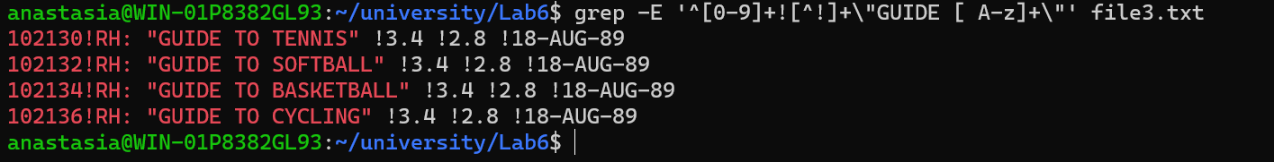

Структура файла query4

612 ALLEN 104 15-JAN-91 5860
605 WARD 106 14-JUL-90 8374
620 TURNER 100 12-MAR-91 4450
613 TURNER 108 01-FEB-91 6400
614 MARTIN 102 01-FEB-91 23940
617 TURNER 105 05-FEB-91 46370
618 MARTIN 102 15-FEB-91 3083
549 PETERS 226 27-DEC-90 1620
516 PETERS 228 30-SEP-89 1815
553 PETERS 228 02-FEB-91 4400
526 WEST 221 04-MAR-90 7700
543 WEST 221 04-SEP-90 8400
555 WEST 221 04-MAR-91 8540
528 WEST 224 24-MAR-90 3770
558 WEST 224 31-MAR-91 1700
565 ROSS 227 01-JUN-91 4900
574 SHAW 201 10-OCT-91 1685
576 SHAW 201 13-OCT-91 2058.9
503 SHAW 201 25-MAR-89 1876
518 SHAW 201 20-OCT-89 2932.5
544 ROSS 202 11-SEP-90 2358
524 ROSS 202 22-FEB-90 1979
562 SHAW 203 04-MAY-91 2044.5
578 DUNCAN 204 19-NOV-91 2275.6
536 SHAW 206 21-MAY-90 2135.6
542 DUNCAN 208 11-AUG-90 2409
573 SHAW 201 10-OCT-91 1627
566 SHAW 201 09-JUN-91 3389.2
527 DUNCAN 204 27-FEB-90 3054.4
522 DUNCAN 204 07-JAN-90 2578.8
569 SHAW 205 16-JUL-91 2073
550 SHAW 205 27-JAN-91 2356
561 ROSS 207 20-APR-91 2558.3
506 DUNCAN 208 27-APR-89 2600.4
530 DUNCAN 208 03-APR-90 3026.5
557 DUNCAN 208 08-MAR-91 2461.8
546 DUNCAN 208 17-OCT-90 3663

Структура файла query4

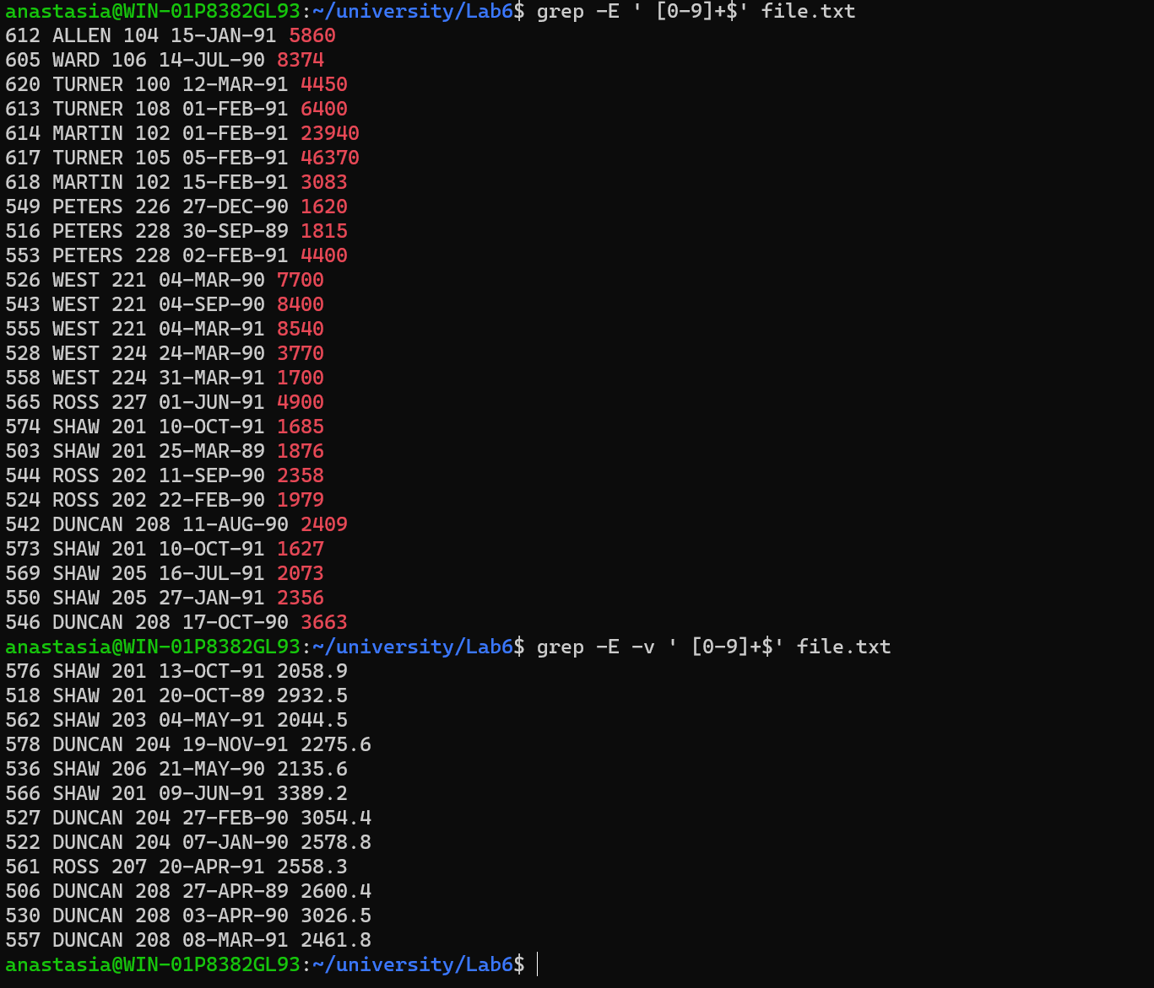

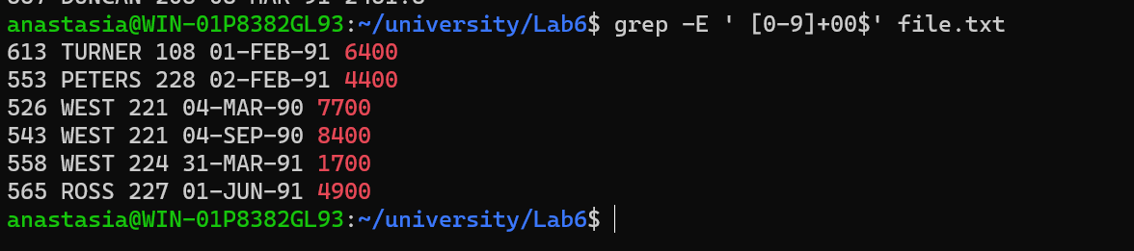

Литература
- https://help.ubuntu.ru
- https://ru.wikipedia.org/wiki/Linux

