NOTES**/ACTIONS**

* **Find a text editor with directory search function and spell check**
* $CASE directory is described before $SOURCE
  + Is this a problem? In the Overview section where $CASE is introduced we are describing all the files that would need to be in a single folder, so WEC-Sim can find all the right input files. In Code Structure where $SOURCE is defined more information is provided on where the source code and the objects, libraries, etc are located. The location of $SOURCE and $CASE can be separate, and I don’t think we need to adjust where each directory is defined/described.
  + Looking through the documentation, we reference the $SOURCE directory in the Getting Started section without defining it explicitly. I think the easiest way to handle this is by defending $SOURCE in the Install WEC-Sim subsection, specifically in Step 1. Add WEC-Sim Source Code to MATLAB Path. It is mentioned here but not explicitly defined.
* Duplicate references, one in Tutorials, the other in Theory
  + K. Ruehl,…, 2014, wasn’t cited in the theory documentation. I removed it from the theory bibliography.
  + Thanks. I’m still getting 3 other duplicate label errors  
    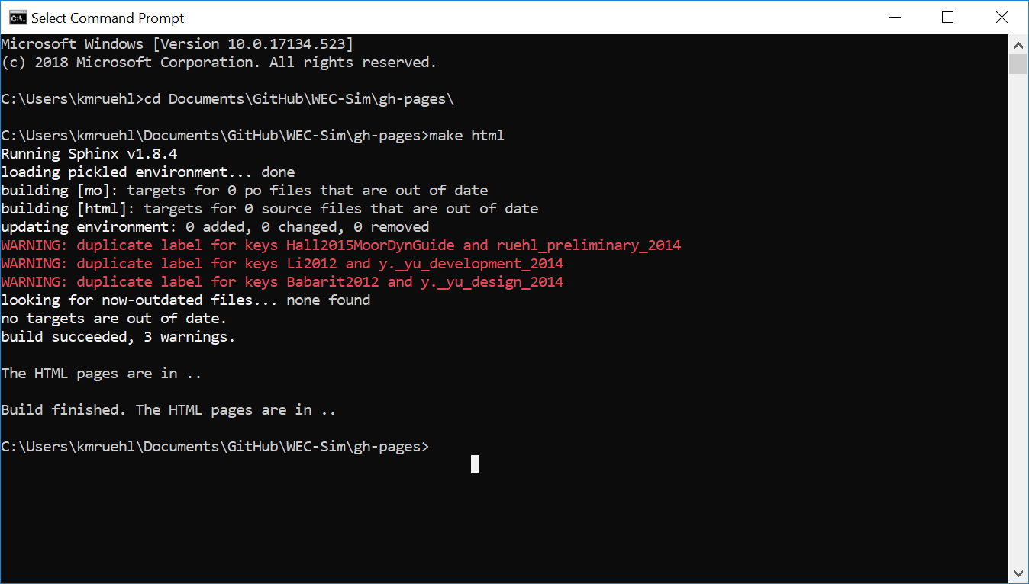
* Non-linear hydrodynamics vs non-linear buoyancy vs ME
  + I believe we have defined Nonlinear Buoyancy and Froude-Krylov Forces and Torques and Morison Elements as separate and moved away from using the term nonlinear hydrodynamics to describe either of these modeling capabilities.
  + Thanks, I see that here now (<http://wec-sim.github.io/WEC-Sim/advanced_features.html#non-linear-buoyancy-and-froude-krylov-excitation>).
    - Variable is defined as *simu.nlHydro,* do we want to change that?
    - The webinar is called “non-linear hydrodynamics,” do we want to change that?