

„Технически университет“ - Варна

Факултет по изчислителна техника и автоматизация

Катедра: Софтуерни и интернет технологии

Курсов проект

по

Системи с бази от данни

ТЕМА: Хотел

Задание : 8

Проверил:

/доц. Гео Василев Кунев /

Изготвил: Анастасия Силичева

Фак. №: 19621833

Курс: 3

Група: 3 \ б

Специалност: СИТ

Варна, 2021/2022

**Практическа работа СБД**

**Задание**

Да се проектира и реализира база от данни за **ХОТЕЛ**, която да съхранява следната информация:

• Клиент - име, адрес, телефон;

• Служител - име, позиция, телефон;

• Стая - номер, вид, цена

• Резервация - клиент, служител, стая, дата, период;

Правила:

• Всеки клиент може да има повече от една резервация, в различно време.

• Всяка стая може да има само един клиент по всяко време.

Базата от данни трябва да е **нормализирана** и да позволява:

1.**Въвеждане и корекции** на данни.

2.**Търсене/резервиране** на стая по: тип, дата, период.

3.**Справки** за:

• обща сметка на клиент;

• свободни стаи за тип/дата/период;

• резервации за служител, подредени по дата.

Документацията към реализирания проект трябва да съдържа:

• Модели (Oracle Data Modeler) - 4 седмица;

• Примерни данни;

• SQL команди - DDL, DML - 8 седмица;

• Резултати от изпълнението на заявките;

• PL/SQL процедури/тригери/курсори - 12 седмица.

Relation and Logical Model by DDM

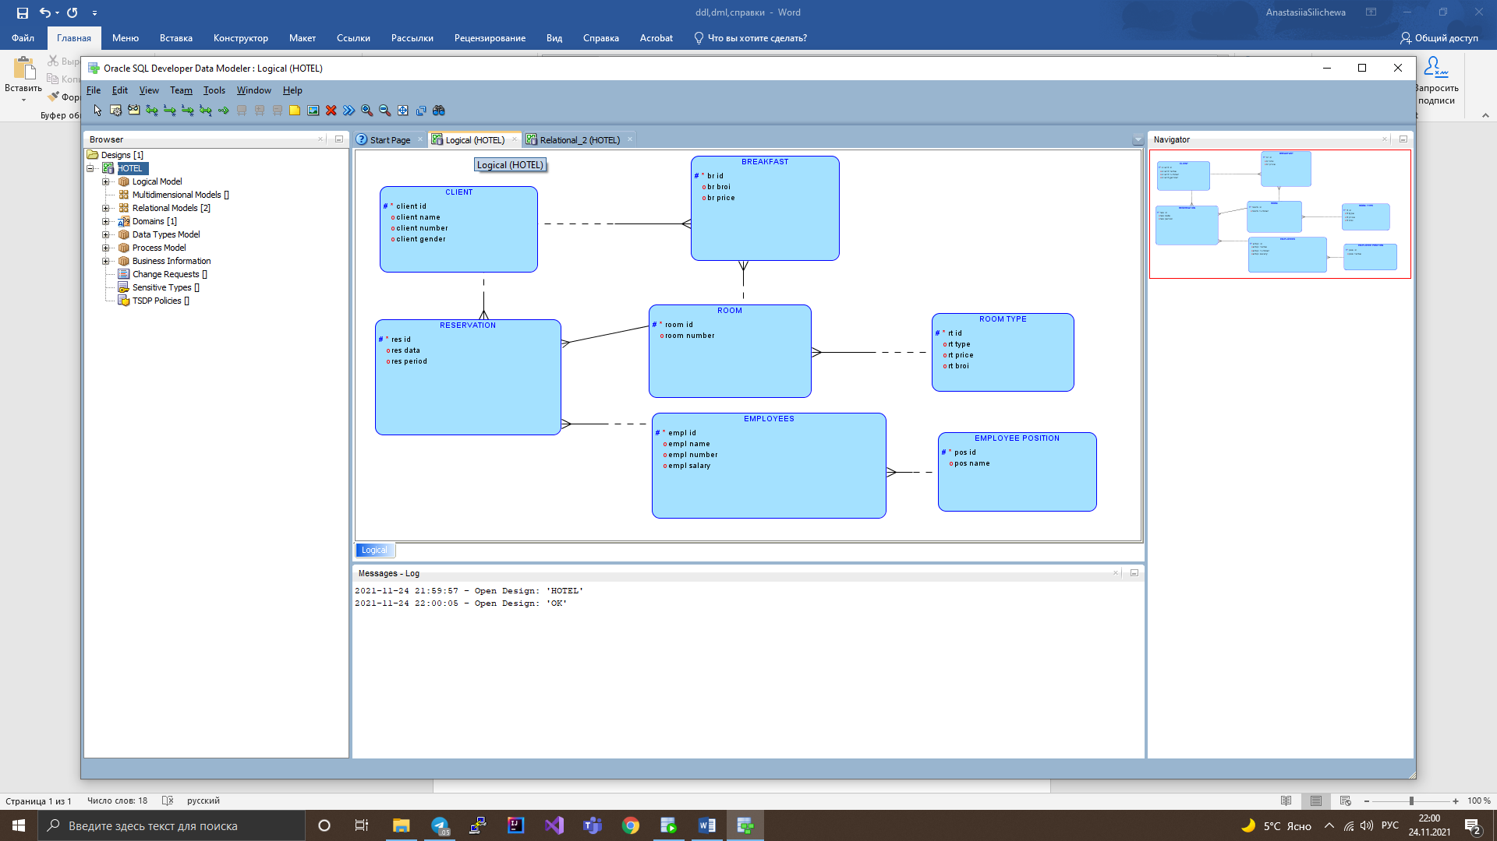

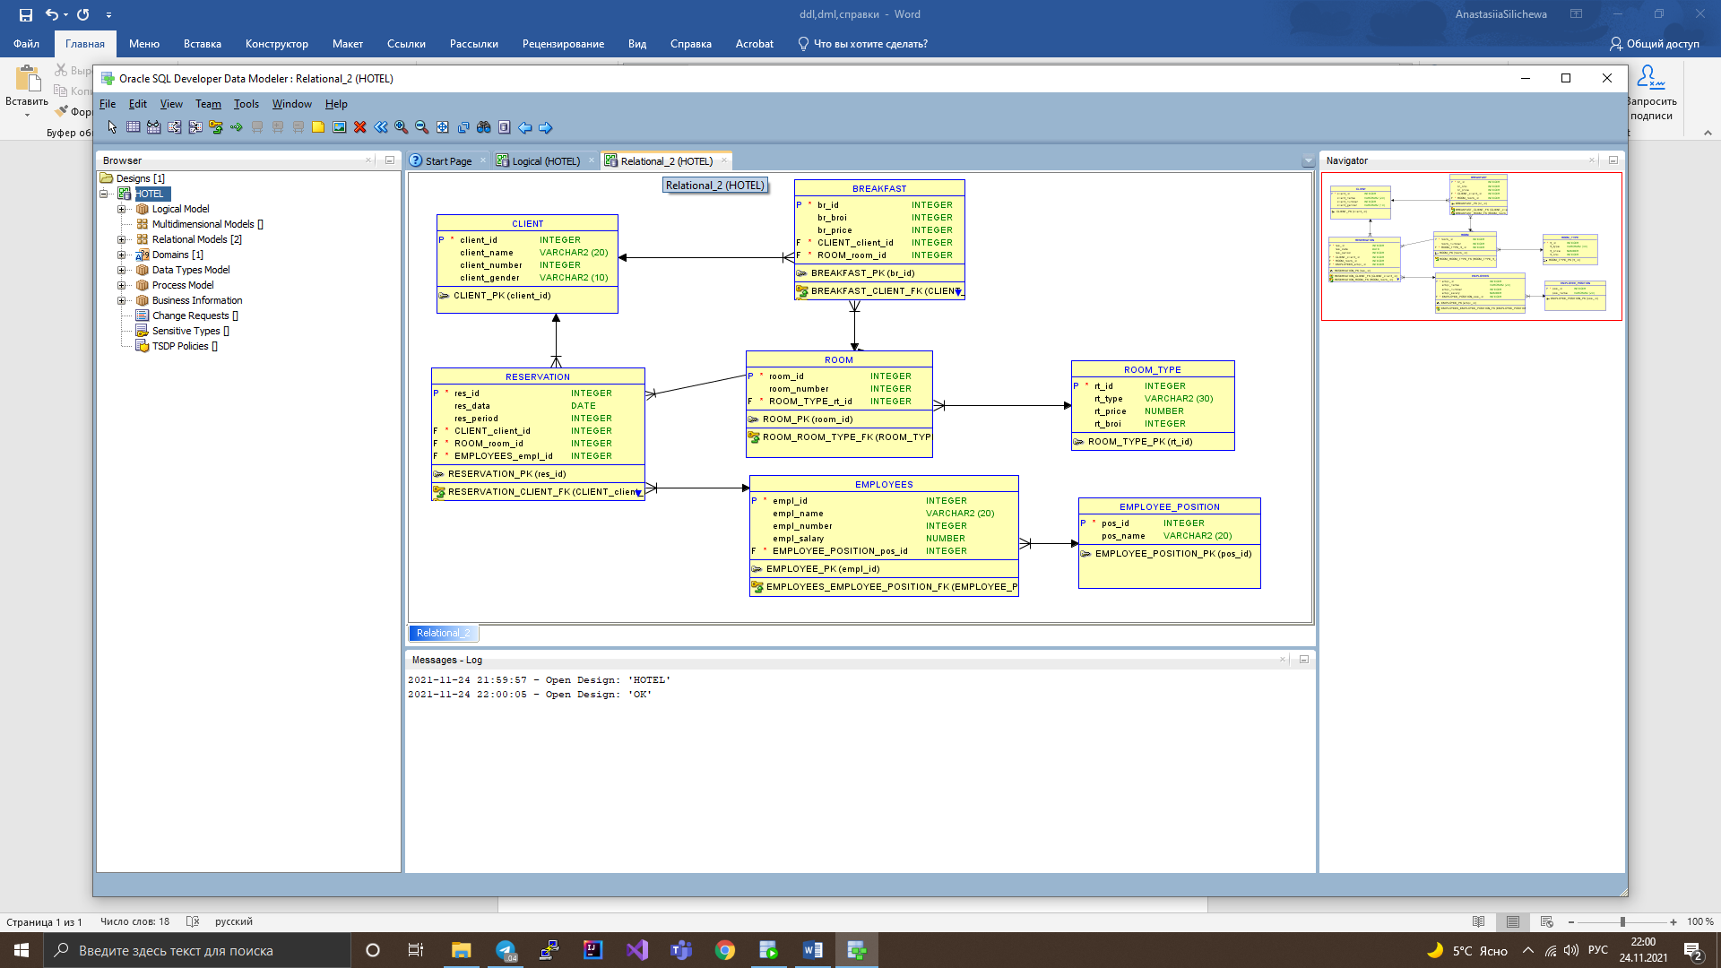

/*////////////////////////////////////////////////////////////////////////////////// CREATE AND PK AND FK /////////////////////////////////////////////////*/

CREATE TABLE CLIENT(

client_id INTEGER NOT NULL,

client_name VARCHAR2(20),

client_number INTEGER NOT NULL,

client_gender VARCHAR2(10));

ALTER TABLE CLIENT ADD CONSTRAINT CLIENT_PK PRIMARY KEY(client_id);

CREATE TABLE EMPLOYEE_POSITION(

pos_id INTEGER NOT NULL,

pos_name VARCHAR2(20)

);

ALTER TABLE EMPLOYEE_POSITION ADD CONSTRAINT EMPLOYEE_POSITION_PK PRIMARY KEY(pos_id);

CREATE TABLE EMPLOYEES(

empl_id INTEGER NOT NULL,

empl_name VARCHAR2(20),

empl_number INTEGER NOT NULL,

empl_salary NUMBER,

pos_id INTEGER);

ALTER TABLE EMPLOYEES ADD CONSTRAINT EMPLOYEES_PK PRIMARY KEY(empl_id);

ALTER TABLE EMPLOYEES ADD CONSTRAINT EMPLOYEES_EMPLOYEE_POSITION_FK FOREIGN KEY(pos_id)

REFERENCES EMPLOYEE_POSITION(pos_id);

CREATE TABLE ROOM_TYPE(

rt_id INTEGER NOT NULL,

rt_type VARCHAR2(20) ,

rt_price NUMBER,

rt_broi INTEGER NOT NULL);

ALTER TABLE ROOM_TYPE ADD CONSTRAINT ROOM_TYPE_PK PRIMARY KEY(rt_id);

CREATE TABLE ROOM(

room_id INTEGER NOT NULL,

room_number INTEGER NOT NULL,

rt_id INTEGER);

ALTER TABLE ROOM ADD CONSTRAINT ROOM_PK PRIMARY KEY (room_id);

ALTER TABLE ROOM ADD CONSTRAINT ROOM_ROOM_TYPE_FK FOREIGN KEY(rt_id)

REFERENCES ROOM_TYPE(rt_id);

CREATE TABLE BREAKFAST(

br_id INTEGER NOT NULL,

br_broi INTEGER NOT NULL ,

br_price INTEGER NOT NULL,

client_id INTEGER,

room_id INTEGER);

ALTER TABLE BREAKFAST ADD CONSTRAINT BREAKFAST_PK PRIMARY KEY(br_id);

ALTER TABLE BREAKFAST ADD CONSTRAINT BREAKFAST_CLIENT_FK FOREIGN KEY(client_id)

REFERENCES CLIENT(client_id);

ALTER TABLE BREAKFAST ADD CONSTRAINT BREAKFAST_ROOM_FK FOREIGN KEY(room_id)

REFERENCES ROOM(room_id);

CREATE TABLE RESERVATION(

res_id INTEGER NOT NULL,

res_data Date,

res_period INTEGER NOT NULL,

client_id INTEGER,

room_id INTEGER,

empl_id INTEGER);

ALTER TABLE RESERVATION ADD CONSTRAINT RESERVATION_PK PRIMARY KEY (res_id);

ALTER TABLE RESERVATION ADD CONSTRAINT RESERVATION_CLIENT_FK FOREIGN KEY(client_id)

REFERENCES CLIENT(client_id);

ALTER TABLE RESERVATION ADD CONSTRAINT RESERVATION_ROOM_FK FOREIGN KEY(room_id)

REFERENCES ROOM(room_id);

ALTER TABLE RESERVATION ADD CONSTRAINT RESERVATION_EMPLOYEES_FK FOREIGN KEY(empl_id)

REFERENCES EMPLOYEES(empl_id);

/*////////////////////////////////////////////////////////////////////////////////////////////// INSERT ///////////////////////////////////////////////////////////////////////*/

INSERT INTO CLIENT(

client_id ,

client_name ,

client_number ,

client_gender )

Values(1,'Natalya Bogach',359893018956,'Female');

INSERT INTO CLIENT(

client_id ,

client_name ,

client_number ,

client_gender )

Values(2,'Valeria Svoy',359892015247,'Female');

INSERT INTO CLIENT(

client_id ,

client_name ,

client_number ,

client_gender )

Values(3,'Alexandr Chavdar',359893065892,'Male');

INSERT INTO CLIENT(

client_id ,

client_name ,

client_number ,

client_gender )

Values(4,'Svetoslav Phedorov',359893021476,'Male');

INSERT INTO CLIENT(

client_id ,

client_name ,

client_number ,

client_gender )

Values(5,'Andrey Muhin',359893065473,'Male');

INSERT INTO CLIENT(

client_id ,

client_name ,

client_number ,

client_gender )

Values(6,'Elizabeth Bezverhaya',359893036548,'Female');

INSERT INTO CLIENT(

client_id ,

client_name ,

client_number ,

client_gender )

Values(7,'Mariya Makarova ',359893039863,'Female');

INSERT INTO CLIENT(

client_id ,

client_name ,

client_number ,

client_gender )

Values(8,'Nikita Butrik',359893065897,'Male');

INSERT INTO CLIENT(

client_id ,

client_name ,

client_number ,

client_gender )

Values(9,'Nikolay Onishenko',359893036547,'Male');

INSERT INTO CLIENT(

client_id ,

client_name ,

client_number ,

client_gender )

Values(10,'Arina Nalivanaya',359893036547,'Female');

/*/////////////////////////////////////////////////////////////////////////////////////////////////////////////////////////////////////*/

INSERT INTO EMPLOYEE_POSITION(

pos_id ,

pos_name )

Values(1,'Hotel Manager');

INSERT INTO EMPLOYEE_POSITION(

pos_id ,

pos_name )

Values(2,'Front Desk Clerks');

INSERT INTO EMPLOYEE_POSITION(

pos_id ,

pos_name )

Values(3,'Room Service');

INSERT INTO EMPLOYEE_POSITION(

pos_id ,

pos_name )

Values(4,'Waiter/Waitress');

INSERT INTO EMPLOYEE_POSITION(

pos_id ,

pos_name )

Values(5,'Kitchen Staff');

INSERT INTO EMPLOYEE_POSITION(

pos_id ,

pos_name )

Values(6,'Kitchen Manager');

INSERT INTO EMPLOYEE_POSITION(

pos_id ,

pos_name )

Values(7,'Restaurant Manager');

INSERT INTO EMPLOYEE_POSITION(

pos_id ,

pos_name )

Values(8,'Executive Chef');

INSERT INTO EMPLOYEE_POSITION(

pos_id ,

pos_name )

Values(9,'Market and Advert');

INSERT INTO EMPLOYEE_POSITION(

pos_id ,

pos_name )

Values(10,'Event Planner');

INSERT INTO EMPLOYEE_POSITION(

pos_id ,

pos_name )

Values(11,'Assis Hotel Manag');

/*////////////////////////////////////////////////////////////////////////////////////////////////////////////////////////////////*/

INSERT INTO EMPLOYEES(

empl_id ,

empl_name ,

empl_number ,

empl_salary ,

pos_id )

Values(1,'Merry Berry',359874568925,810.99,11);

INSERT INTO EMPLOYEES(

empl_id ,

empl_name ,

empl_number ,

empl_salary ,

pos_id )

Values(2,'Nikolas Champe',359874565896,610.99,10);

INSERT INTO EMPLOYEES(

empl_id ,

empl_name ,

empl_number ,

empl_salary ,

pos_id )

Values(3,'Mariyana Nikolova',359874566589,780.99,9);

INSERT INTO EMPLOYEES(

empl_id ,

empl_name ,

empl_number ,

empl_salary ,

pos_id )

Values(4,'Vasya Vaasilyev',359874565872,855.99,8);

INSERT INTO EMPLOYEES(

empl_id ,

empl_name ,

empl_number ,

empl_salary ,

pos_id )

Values(5,'Artur Dimitrenko',359874562536,720.99,7);

INSERT INTO EMPLOYEES(

empl_id ,

empl_name ,

empl_number ,

empl_salary ,

pos_id )

Values(6,'Boris Vasilev',359874566478,730.99,6);

INSERT INTO EMPLOYEES(

empl_id ,

empl_name ,

empl_number ,

empl_salary ,

pos_id )

Values(7,'Ekaterina Dobrova',359864788925,520.99,5);

INSERT INTO EMPLOYEES(

empl_id ,

empl_name ,

empl_number ,

empl_salary ,

pos_id )

Values(8,'Nina Bezrukova',359876782925,489.99,4);

INSERT INTO EMPLOYEES(

empl_id ,

empl_name ,

empl_number ,

empl_salary ,

pos_id )

Values(9,'Taisiya Uzun',358735832925,456.99,3);

INSERT INTO EMPLOYEES(

empl_id ,

empl_name ,

empl_number ,

empl_salary ,

pos_id )

Values(10,'Valeriya Scripnik',359874214925,465.99,2);

INSERT INTO EMPLOYEES(

empl_id ,

empl_name ,

empl_number ,

empl_salary ,

pos_id )

Values(11,'Valentin Krupin',359874583625,982.99,1);

INSERT INTO EMPLOYEES(

empl_id ,

empl_name ,

empl_number ,

empl_salary ,

pos_id )

Values(12,'Nikita Bessonov',359876754875,489.99,4);

/*///////////////////////////////////////////////////////////////////////////////////////////////////////////////////////////////////////*/

INSERT INTO ROOM_TYPE(

rt_id ,

rt_type ,

rt_price,rt_broi )

Values(1,'For 1 person',59.99,15);

INSERT INTO ROOM_TYPE(

rt_id ,

rt_type ,

rt_price,rt_broi )

Values(2,'For 2 person',109.99,12);

INSERT INTO ROOM_TYPE(

rt_id ,

rt_type ,

rt_price,rt_broi )

Values(3,'For 3 person',149.99,6);

INSERT INTO ROOM_TYPE(

rt_id ,

rt_type ,

rt_price,rt_broi )

Values(4,'For family ',185.99,2);

INSERT INTO ROOM_TYPE(

rt_id ,

rt_type ,

rt_price,rt_broi )

Values(5,'For 1 person LUXE',89.99,8);

INSERT INTO ROOM_TYPE(

rt_id ,

rt_type ,

rt_price,rt_broi )

Values(6,'For 2 person LUXE',139.99,5);

INSERT INTO ROOM_TYPE(

rt_id ,

rt_type ,

rt_price,rt_broi )

Values(7,'For 1 person VIP',109.99,6);

INSERT INTO ROOM_TYPE(

rt_id ,

rt_type ,

rt_price,rt_broi )

Values(8,'For 2 person VIP',186.99,8);

/*/////////////////////////////////////////////////////////////////////////////////////////////////////////////////////////////////////////////*/

INSERT INTO ROOM(

room_id ,

room_number ,

rt_id )

Values(1,101,2);

INSERT INTO ROOM(

room_id ,

room_number ,

rt_id )

Values(2,121,1);

INSERT INTO ROOM(

room_id ,

room_number ,

rt_id )

Values(3,421,7);

INSERT INTO ROOM(

room_id ,

room_number ,

rt_id )

Values(4,461,7);

INSERT INTO ROOM(

room_id ,

room_number ,

rt_id )

Values(5,251,4);

INSERT INTO ROOM(

room_id ,

room_number ,

rt_id )

Values(6,181,1);

INSERT INTO ROOM(

room_id ,

room_number ,

rt_id )

Values(7,381,5);

INSERT INTO ROOM(

room_id ,

room_number ,

rt_id )

Values(8,361,6);

INSERT INTO ROOM(

room_id ,

room_number ,

rt_id )

Values(9,131,2);

INSERT INTO ROOM(

room_id ,

room_number ,

rt_id )

Values(10,191,1);

INSERT INTO ROOM(

room_id ,

room_number ,

rt_id )

Values(11,498,7);

INSERT INTO ROOM(

room_id ,

room_number ,

rt_id )

Values(12,423,6);

INSERT INTO ROOM(

room_id ,

room_number ,

rt_id )

Values(13,412,6);

INSERT INTO ROOM(

room_id ,

room_number ,

rt_id )

Values(14,191,2);

/*/////////////////////////////////////////////////////////////////////////////////////////////////////////////////////////////////////////////////////*/

INSERT INTO BREAKFAST(

br_id ,

br_broi ,

br_price ,

client_id ,

room_id )

Values(1,2,19.99,2,4);

INSERT INTO BREAKFAST(

br_id ,

br_broi ,

br_price ,

client_id ,

room_id )

Values(2,1,8.99,7,2);

INSERT INTO BREAKFAST(

br_id ,

br_broi ,

br_price ,

client_id ,

room_id )

Values(3,2,31.99,8,5);

INSERT INTO BREAKFAST(

br_id ,

br_broi ,

br_price ,

client_id ,

room_id )

Values(4,3,32.99,7,7);

INSERT INTO BREAKFAST(

br_id ,

br_broi ,

br_price ,

client_id ,

room_id )

Values(5,1,11.99,7,8);

INSERT INTO BREAKFAST(

br_id ,

br_broi ,

br_price ,

client_id ,

room_id )

Values(6,2,22.99,7,11);

/*////////////////////////////////////////////////////////////////////////////////////////////////////////////////////////////////////////////////////*/

INSERT INTO RESERVATION(

res_id ,

res_data ,

res_period ,

client_id ,

room_id ,

empl_id )

Values(1,'23-DEC-2021',14,1,1,4);

INSERT INTO RESERVATION(

res_id ,

res_data ,

res_period ,

client_id ,

room_id ,

empl_id )

Values(2,'12-DEC-2021',4,2,6,2);

INSERT INTO RESERVATION(

res_id ,

res_data ,

res_period ,

client_id ,

room_id ,

empl_id )

Values(3,'5-JAN-2021',8,3,5,3);

INSERT INTO RESERVATION(

res_id ,

res_data ,

res_period ,

client_id ,

room_id ,

empl_id )

Values(4,'10-JAN-2022',9,4,2,1);

INSERT INTO RESERVATION(

res_id ,

res_data ,

res_period ,

client_id ,

room_id ,

empl_id )

Values(5,'2-FEB-2022',8,5,4,10);

INSERT INTO RESERVATION(

res_id ,

res_data ,

res_period ,

client_id ,

room_id ,

empl_id )

Values(6,'20-MAY-2022',14,6,3,11);

INSERT INTO RESERVATION(

res_id ,

res_data ,

res_period ,

client_id ,

room_id ,

empl_id )

Values(7,'25-MAY-2022',10,7,8,1);

INSERT INTO RESERVATION(

res_id ,

res_data ,

res_period ,

client_id ,

room_id ,

empl_id )

Values(8,'5-DEC-2021',5,8,7,10);

INSERT INTO RESERVATION(

res_id ,

res_data ,

res_period ,

client_id ,

room_id ,

empl_id )

Values(9,'12-DEC-2021',6,8,11,11);

INSERT INTO RESERVATION(

res_id ,

res_data ,

res_period ,

client_id ,

room_id ,

empl_id )

Values(10,'12-FEB-2022',10,10,10,1);

/*///////////////////////////////////////////////////////////////////////////////////////////////////////////////////////////////////////////////////*/

/*////////////////////////////////////////////////////////////////// FOR DELETE ///////////////////////////////////////////////////////*/

INSERT INTO RESERVATION(

res_id ,

res_data ,

res_period ,

client_id ,

room_id ,

empl_id )

Values(11,'22-FEB-2022',11,10,10,10);

/*//////////////////////////////////////////////////////////////// UPDATE ///////////////////////////////////////////////////////////////////////////////*/

UPDATE CLIENT

SET

CLIENT_NAME='Lisa Belka'

WHERE CLIENT_ID=3;

UPDATE BREAKFAST

SET BR_BROI=4

WHERE BR_ID=3;

UPDATE EMPLOYEE_POSITION

SET POS_NAME='M. MANAGER '

WHERE POS_ID=2;

UPDATE EMPLOYEES

SET EMPL_NAME='Mira Verenkova'

WHERE EMPL_ID=3;

UPDATE RESERVATION

SET RES_DATA='25-MAR-2022',

RES_PERIOD=5,

CLIENT_ID=3,

ROOM_ID=2,

EMPL_ID=10

WHERE RES_ID=2;

UPDATE ROOM

SET ROOM_NUMBER=254

WHERE ROOM_ID=4;

UPDATE ROOM_TYPE

SET

RT_BROI=5

WHERE RT_ID=1;

/*/////////////////////////////////////////////////////////////////////// DELETE //////////////////////////////////////////////*/

DELETE FROM RESERVATION

WHERE RES_ID=11;

/*//////////////////////////////////////////////////////////////////////////////////// SEARCHING ///////////////////////////////////*/

SELECT R.RES_DATA,R.RES_PERIOD,CL.CLIENT_NAME,RM.ROOM_NUMBER

FROM RESERVATION R

JOIN ROOM RM ON RM.ROOM_ID=R.ROOM_ID

JOIN CLIENT CL ON CL.CLIENT_ID=R.CLIENT_ID

WHERE R.RES_DATA LIKE '%&RESDATA%'

AND R.RES_PERIOD LIKE '%&RESERVATIONPERIOD%'

AND CL.CLIENT_NAME LIKE '%&CLIENTNAME%'

AND RM.ROOM_NUMBER LIKE '%&ROOMNUMBER%';

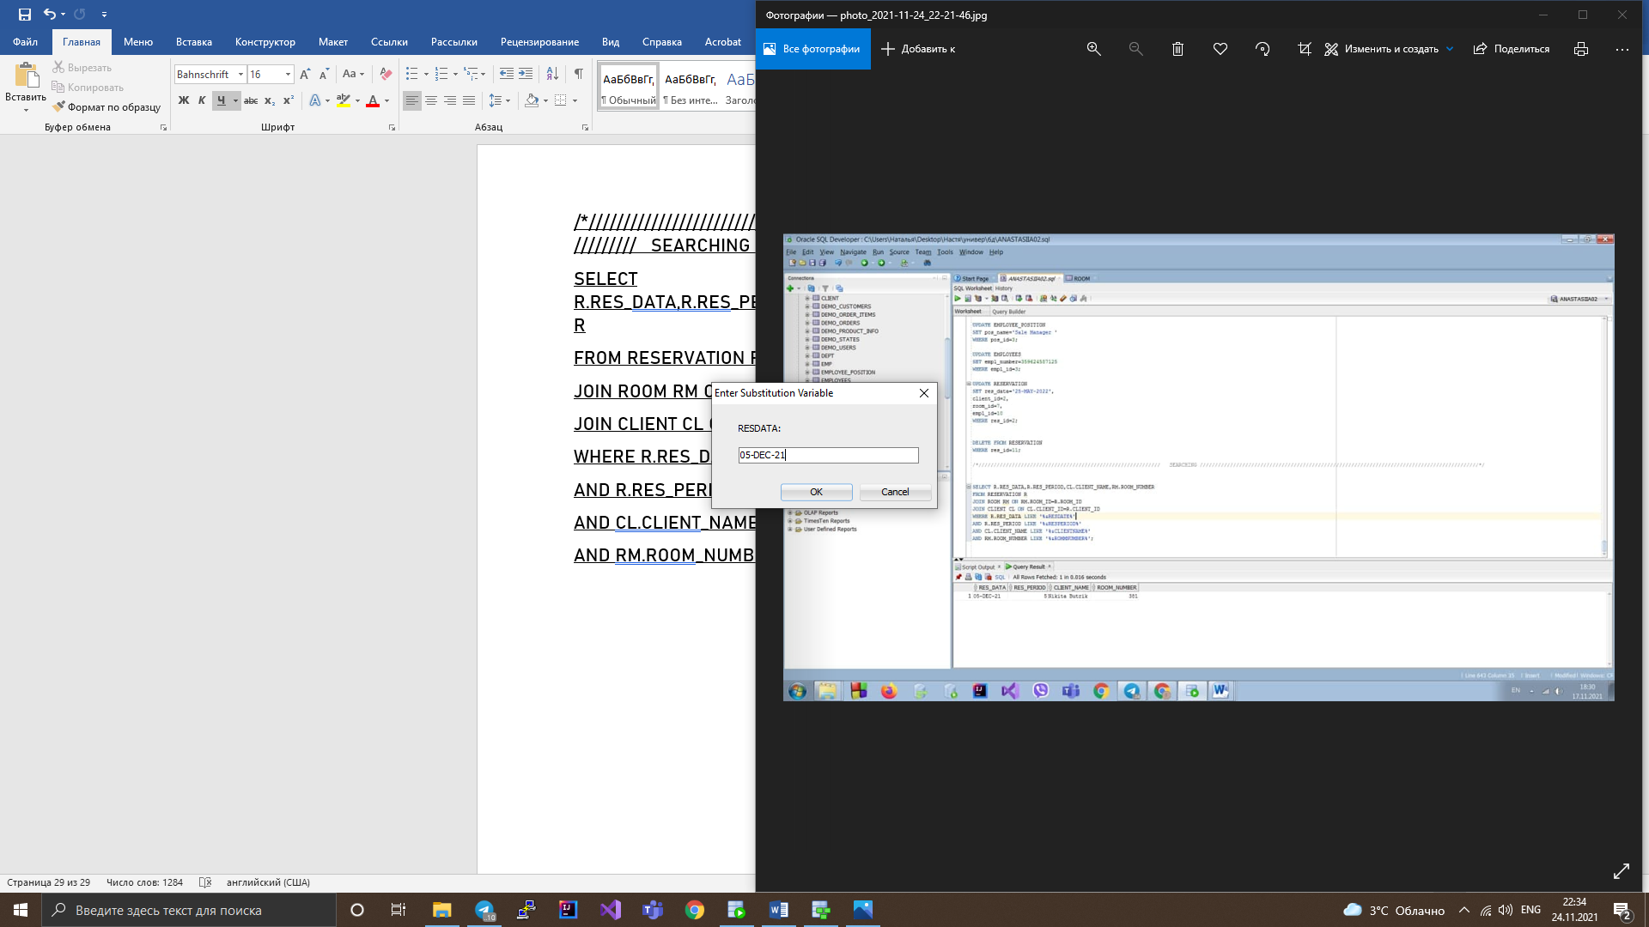

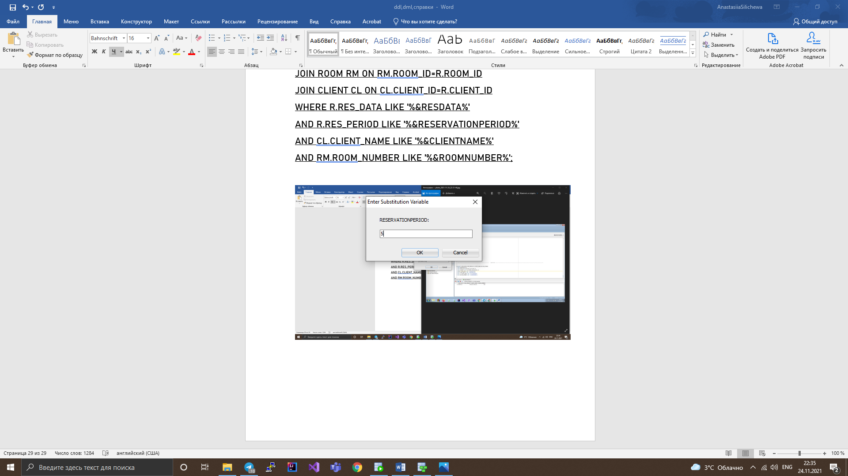

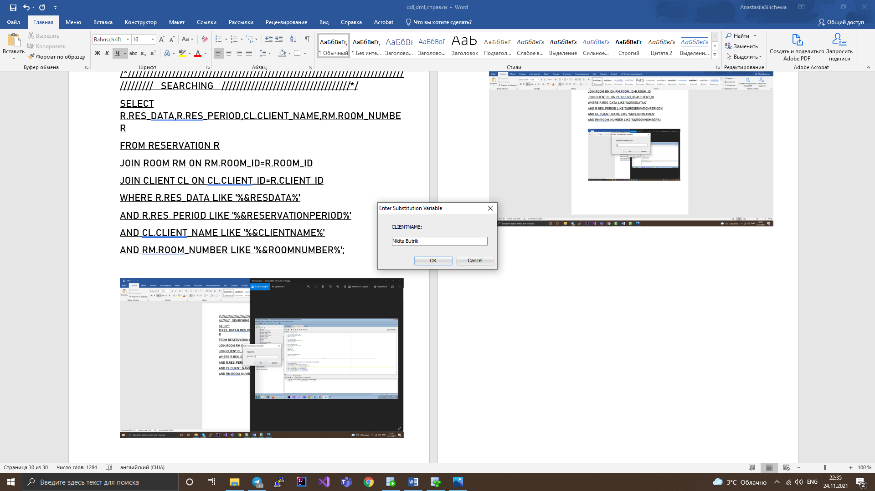

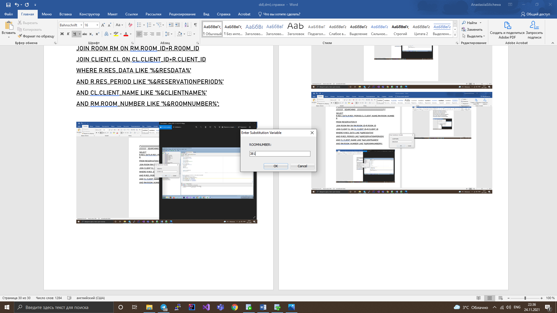

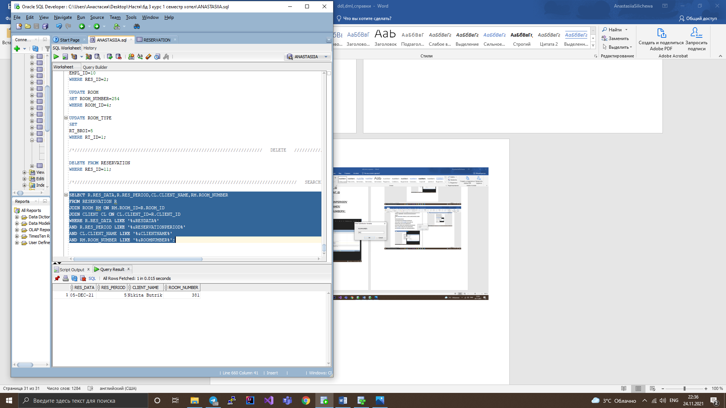

/*////////////////////////////////////////////////////////////////////////////// REQUESTS //////////////////////////////////////////////////////*/

SELECT CL.CLIENT_NAME,E.EMPL_NAME,R.RES_DATA

FROM RESERVATION R

JOIN CLIENT CL ON CL.CLIENT_ID=R.CLIENT_ID

JOIN EMPLOYEES E ON E.EMPL_ID=R.EMPL_ID

ORDER BY RES_DATA DESC;

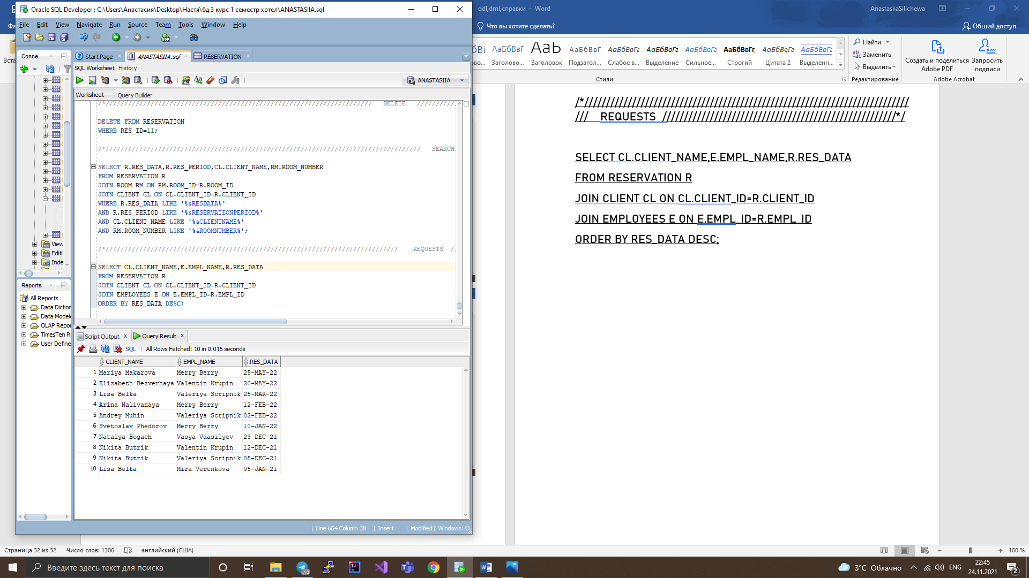

SELECT CL.CLIENT_NAME,EM.EMPL_NAME,R.RES_DATA,R.RES_PERIOD,RM.ROOM_NUMBER

FROM RESERVATION R

JOIN CLIENT CL ON CL.CLIENT_ID=R.CLIENT_ID

JOIN EMPLOYEES EM ON EM.EMPL_ID=R.EMPL_ID

JOIN ROOM RM ON RM.ROOM_ID=R.ROOM_ID

ORDER BY RES_PERIOD , RES_DATA DESC;

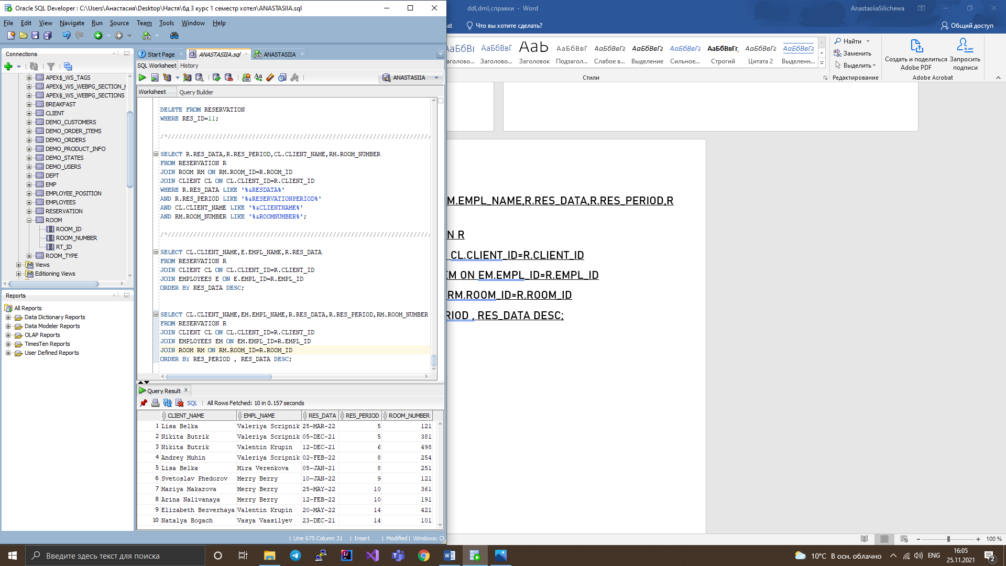

SELECT R.RT_PRICE,R.RT_TYPE,R.RT_BROI,RM.ROOM_NUMBER

FROM ROOM RM

JOIN ROOM_TYPE R ON R.RT_ID=RM.RT_ID

ORDER BY RT_PRICE;

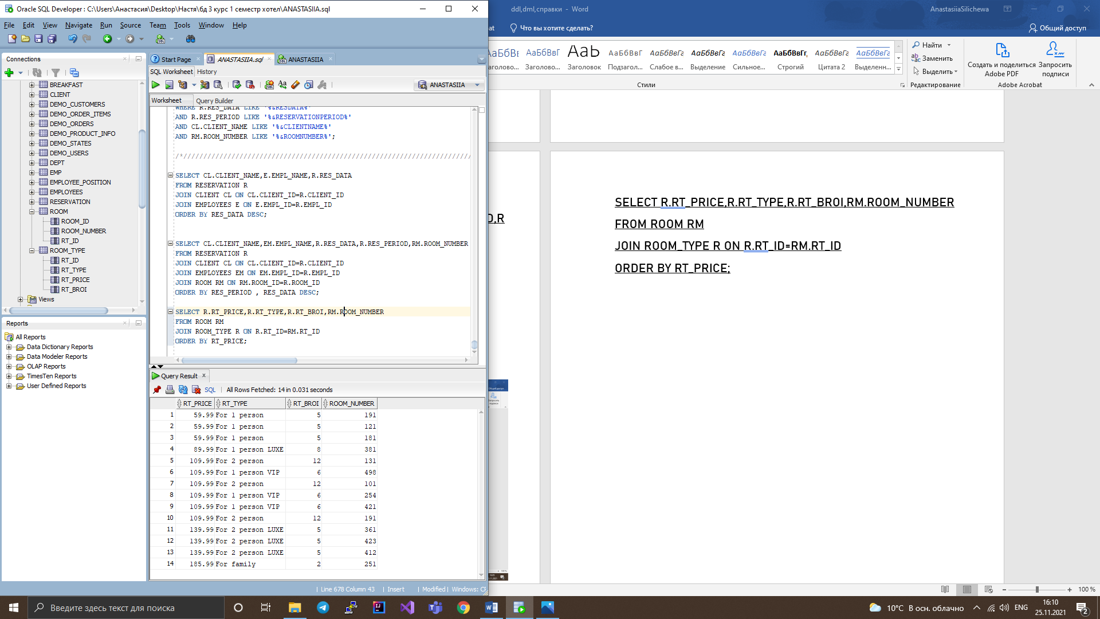

/*////////////////////////////////////////////////////////////////////// PROCEDURE //////////////////////////////////////////////////*/

/*/////////////////////////////////////////////////////////////////////// INSERT /////////////////////////////////////////////////////////*/

create or replace procedure client_insert

(

clientId client.client_id%type,

clientName client.client_name%type,

clientNumber client.client_number%type,

clientGender client.client_gender%type

)

as

begin

insert into client(client_id,client_name, client_number,client_gender)

values(clientId,clientName,clientNumber,clientGender);

commit;

end;

EXEC client_insert(11,'Daniel Smirnov',359457862,'Male');

create or replace procedure employeePosition_insert

(

posId employee_position.pos_id%type,

posName employee_position.pos_name%type

)

as

begin

insert into employee_position(pos_id,pos_name)

values(posId,posName);

commit;

end;

EXEC employeePosition_insert(12,'Ass Mid');

create or replace procedure rentType_insert

(

-- rtId room_type.rt_id%type,

rtType room_type.rt_type%type,

rtPrice room_type.rt_price%type,

rtBroi room_type.rt_broi%type

)

as

begin

insert into room_type(rt_type,rt_price,rt_broi)

values( rtType,rtPrice,rtBroi);

commit;

end;

/*/////////////////////////////////////////////////////// UPDATE ///////////////////////////////////////////////////////*/

create or replace procedure updateEmployees

(

employeesId EMPLOYEES.EMPL_ID%type,

positionFk employees.pos_id%type

)

as

counter int :=0;

begin

select count(*) into counter

from EMPLOYEES

where empl_id = employeesId;

if counter > 0 then

Update employees

set pos_id = positionFk

Where empl_id = employeesId;

commit;

dbms_output.put_line('Updated Successfully');

else

dbms_output.put_line('There is no records in the table for update');

end if;

end;

EXEC updateEmployees(8,11);

/*//////////////////////////////////////////////////////////////// DELETE ///////////////////////////////////////////*/

CREATE OR REPLACE PROCEDURE roomDelete

(

roomId ROOM.ROOM_ID%TYPE

)

AS

counter int:=0;

BEGIN

SELECT COUNT(*) INTO counter

FROM ROOM

WHERE ROOM_ID = roomId;

IF counter != 0 THEN

DELETE FROM ROOM WHERE ROOM_ID = roomId;

DBMS_OUTPUT.PUT_LINE('Record is successfully deleted');

ELSE

DBMS_OUTPUT.PUT_LINE('Record does not found');

END IF;

END;

EXEC roomDelete(14);

/*/////////////////////////////////////////////////////////////////// CURSOR TYPE /////////////////////////////////////////////////////////*/

create or replace procedure rentPeriod

as

begin

for rent_App IN (SELECT res_data, res_period FROM RESERVATION

where RESERVATION.res_data between '05-JAN-2021' and '05-DEC-2021')

LOOP

DBMS_OUTPUT.put_line( rent_App.res_data||' '||rent_App.res_period);

END LOOP;

end;

/

SET SERVEROUTPUT ON;

EXEC rentPeriod();

/*/////////////////////////////////////////////////////// TRIGGER /////////////////////////////////////////////////////////////////////*/

create or replace trigger triggerClient

before insert on CLIENT

for each row

begin

if inserting then

if :NEW."CLIENT_ID" is null then

select SEQUENCE1.nextval into :NEW."CLIENT_ID" from dual;

end if;

end if;

end;

create or replace trigger triggerRoomType

before insert on ROOM_TYPE

for each row

begin

if inserting then

if :NEW."RT_ID" is null then

select SEQUENCE1.nextval into :NEW."RT_ID" from dual;

end if;

end if;

end;

/*////////////////////////////////////////////////////////////// INSERT WITH TRIGGER //////////////////////////////////////////////////////////////////////*/

EXEC rentType_insert('For family VIP',196.99,2);

create or replace PROCEDURE searchingRentByClientName

(

clName CLIENT.CLIENT_NAME%TYPE

)

IS

BEGIN

DECLARE

CURSOR nameCl IS --name of the cursorSS

select RESERVATION.RES_DATA,RESERVATION.RES_PERIOD, CLIENT.CLIENT_NAME

from RESERVATION

JOIN CLIENT on (RESERVATION.CLIENT_ID = CLIENT.CLIENT_ID)

where clName = CLIENT.CLIENT_NAME;

BEGIN

FOR ClRecord IN nameCl -- priceRecord recordname

LOOP

DBMS_OUTPUT.PUT_LINE('Client:' || ClRecord.CLIENT_NAME ||' Res date: '|| ClRecord.RES_DATA ||' Res period: '|| ClRecord.RES_PERIOD);

END LOOP;

END;

END;

SET SERVEROUTPUT ON;

EXEC searchingRentByClientName('&CLIENT_NAME');

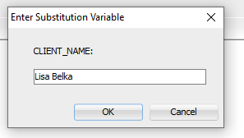



create or replace procedure rentPeriod

as

begin

for rent_App IN (SELECT res_data, res_period FROM RESERVATION

where RESERVATION.res_data between '05-JAN-2021' and '05-DEC-2021')

LOOP

DBMS_OUTPUT.put_line( rent_App.res_data||' '||rent_App.res_period);

END LOOP;

end;

/

SET SERVEROUTPUT ON;

EXEC rentPeriod();



create or replace PROCEDURE searchingRentByDate

(

resDate RESERVATION.RES_DATA%TYPE

)

IS

BEGIN

DECLARE

CURSOR resDt IS --name of the cursorSS

select RESERVATION.RES_DATA,RESERVATION.RES_PERIOD, CLIENT.CLIENT_NAME ,ROOM.ROOM_NUMBER

from RESERVATION

JOIN CLIENT on (RESERVATION.CLIENT_ID = CLIENT.CLIENT_ID)

JOIN ROOM on (RESERVATION.ROOM_ID = ROOM.ROOM_ID)

where resDate = RESERVATION.RES_DATA;

BEGIN

FOR resRecord IN resDt -- priceRecord recordname

LOOP

DBMS_OUTPUT.PUT_LINE('Client:' || resRecord.CLIENT_NAME ||' Res date: '|| resRecord.RES_DATA ||' Res period: '|| resRecord.RES_PERIOD||' Room number: '|| resRecord.ROOM_NUMBER);

END LOOP;

END;

END;

SET SERVEROUTPUT ON;

EXEC searchingRentByDate('&RES_DATE');

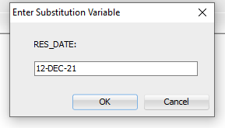



create or replace PROCEDURE searchingRentByPeriod

(

resPeriod RESERVATION.RES_PERIOD%TYPE

)

IS

BEGIN

DECLARE

CURSOR resPr IS --name of the cursorSS

select RESERVATION.RES_DATA,RESERVATION.RES_PERIOD, CLIENT.CLIENT_NAME ,ROOM.ROOM_NUMBER,EMPLOYEES.EMPL_NAME

from RESERVATION

JOIN CLIENT on (RESERVATION.CLIENT_ID = CLIENT.CLIENT_ID)

JOIN ROOM on (RESERVATION.ROOM_ID = ROOM.ROOM_ID)

JOIN EMPLOYEES on (RESERVATION.EMPL_ID = EMPLOYEES.EMPL_ID)

where resPeriod = RESERVATION.RES_PERIOD;

BEGIN

FOR resPerRecord IN resPr-- priceRecord recordname

LOOP

DBMS_OUTPUT.PUT_LINE('Client:' || resPerRecord.CLIENT_NAME ||' Res date: '|| resPerRecord.RES_DATA ||' Res period: '|| resPerRecord.RES_PERIOD||' Room number: '|| resPerRecord.ROOM_NUMBER||' Employee name: '|| resPerRecord.EMPL_NAME);

END LOOP;

END;

END;

SET SERVEROUTPUT ON;

EXEC searchingRentByPeriod('&RES_PERIOD');

