Payment Advice

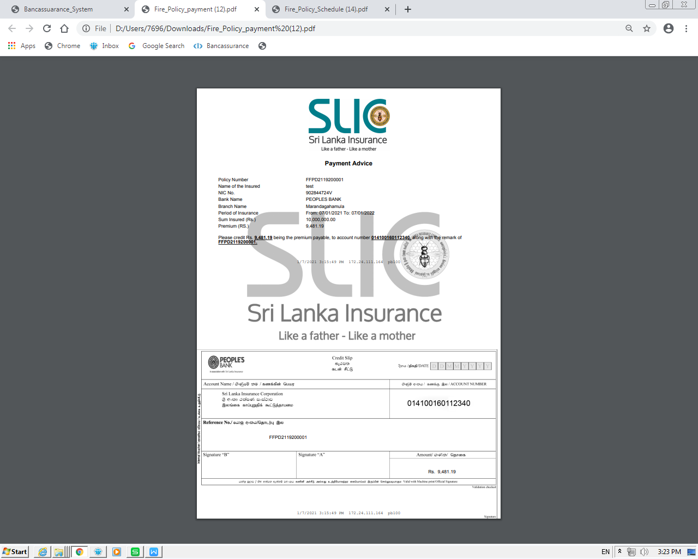

Once the payment advice is printed tear it off the “Credit Slip“ and deposit the payment for the mentioned account before printing the policy schedule.

Please mention the policy number as the reference when settling the payment.

Credit Slip

