1. Display the employee number, fu0ll employee name, job and hire date of all

employees hired in January of any year with the most recently hired employee

displayed first and then alphabetically by their full name.

Full name should be in the form *Lastname, Firstname* with an alias FullName.

Hire date should point to the closer first of month (January or February) and be in the form *January First of 1997* with an alias *Start Date*.

Ans. **select emp_no,ename||','||fname as "FullName",**

**job,**

**TO_CHAR((ROUND(hiredate,'MM')), 'Month fmDdspth "of" YYYY') "Start Date"**

**from employee**

**where hiredate like '%JAN%'**

**order by 4 desc, 2;** 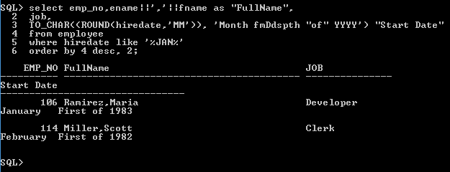

1. Display the employee number and full name of every employee whose last

name contains an ‘e’ or an ‘o’ and whose first or last name begins with an ‘M’, but only if their Full Name format is shorter than 15 characters and they work in Toronto only. Full name should be in the form *Lastname, Firstname* with an alias **Full Name** Display as the third component of this query the last four letters of every employee’s last name as well, with an alias **Last** and city as well with an alias **Location.** Sort the output according the Full Name alphabetically.

This is one possible row.

|  |  |  |  |
| --- | --- | --- | --- |
| **EMP_NO** | **Full Name** | **Last** | **Location** |
| 114 | Miller, Scott | ller | TORONTO |

Ans. **select e.emp_no,e.ename||','||e.fname "Full Name",**

**SUBSTR(ename,-4,4) "Last",d.locn**

**from employee e JOIN department d**

**ON(e.dept_no=d.dept_no)**

**WHERE length('Full Name')<15 and ((LOWER(ename) LIKE '%e%') OR (LOWER(ename) LIKE '%o%'))**

**AND ((fname like 'M%') OR (ename LIKE 'M%'))**

**AND UPPER(locn)= 'TORONTO'**

**order by 2;**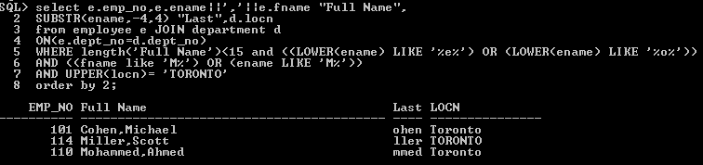

1. Display the employee last name, first name, salary, job and manager# of all

employees not assigned a commission or if they work as Analysts, but only

if their total annual salary (including commission) with $3,000 included annual bonus is greater than $120,000. If an employee does not have a manager then display the word ‘NONE’ instead. This column should have an alias **Manager#.**Display the Total annual salary as well in the form of $564,000.0 with an alias

**Total Pay.**

Sort the result so that best paid employees are shown first.

Ans. **select ename, fname,**

**COALESCE( (((sal*12)+((comm*sal*12)/100))+3000), ((sal*12)+3000) ) "Salary With Bonus",**

**comm, NVL2(TO_CHAR(mgr), TO_CHAR(mgr), 'NONE') Manager#,**

**sal "Monthly",TO_CHAR((sal*12), '$999,999.0') "Total Pay"**

**from employee**

**where (job='Analyst' or comm=0)**

**and COALESCE( (((sal*12)+((comm*sal*12)/100))+3000), ((sal*12)+3000) ) > 120000**

**order by 3 desc**

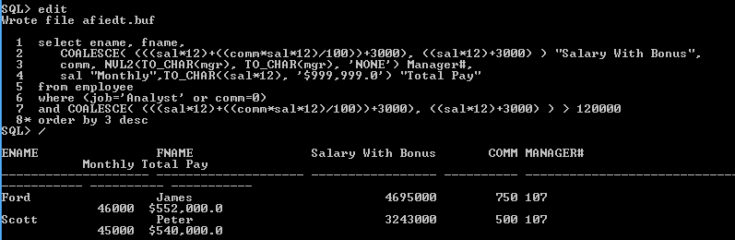

1. Display the project name under an alias Project Name and then as a second component of the query employee number, dollars charged (formatted as dollars and cents) and log date for all projects whose name includes the word ‘Payroll’ or ‘Warehouse’, but for the month of October only, sorted by log date descending and then by employee number. Second column should have an alias **Project Charges** and look like this:

*Employee #101 charged $169.00 on 1st of October in 1998*

Ans. **SELECT PNAME “Project name” ,’Employee#’||emp_no||‘ charged ’||TO_CHAR(dollars_charged,’ ‘$99999.00’)|| ‘ on ’||TO_CHAR(time_log_date, ‘ddth “ of ” Month “ in ” YYYY’) “Project Charges”**

**FROM PROJECT P JOIN PROJECT_HOUR H**

**USING(PROJECT_NO)**

**WHERE ((PNAME LIKE ‘%Payroll%’) OR (PNAME LIKE ‘%Warehouse%’))**

**AND TIME_LOG_DATE LIKE ‘%OCT%’**

**ORDER BY TIME_LOG_DATE DESC,EMP_NO ASC;**

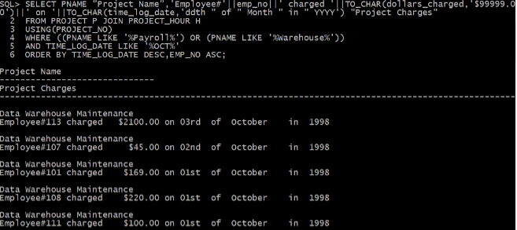

1. Display the name of every project, the project's total charges, the earliest charge date, the date of the most recent charge and how many days elapsed on that project. Exclude projects with names containing word WAREHOUSE and those with # of elapsed days greater than 320.You should include all projects, even ones that have been NOT charged yet. For all columns use appropriate alias names as Init Caps. Sort the output by project name alphabetically.

Ans.  **select pname "Project Name",SUM(NVL(DOLLARS_CHARGED,0)*HOURS_LOGGED) "Total Project Charge",MIN(TIME_LOG_DATE)"Earliest",MAX(TIME_LOG_DATE) "Latest",ROUND(MONTHS_BETWEEN(MAX(TIME_LOG_DAT**

**E),MIN(TIME_LOG_DATE))*30,0) "Days Elapsed"**

**from project**

**LEFT OUTER JOIN PROJECT_HOUR USING(PROJECT_NO)**

**WHERE UPPER(PNAME) NOT LIKE '%WAREHOUSE%'**

**GROUP BY PNAME**

**HAVING ROUND(MONTHS_BETWEEN(MAX(TIME_LOG_DATE),MIN(TIME_LOG_DATE))*30,0)<320**

**ORDER BY PNAME**

**/**

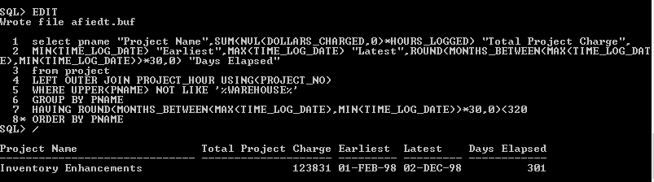

1. Display the name of every project alphabetically that has had a charge made by an employee in the Operations or Research departments.

You MUST solve this problem by strictly using the Subquery Method

(without joining tables).

Ans. **select pname**

**from project**

**where project_no IN(select distinct project_no from project_hour where emp_no**

**IN(select emp_no from employee where dept_no IN(select dept_no from department**

**where dept_name IN ('Operations','Research'))**

**and dollars_charged > 0))**

**order by pname asc /**

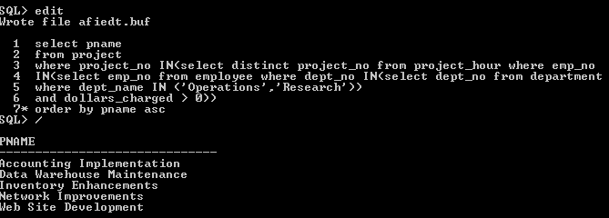

1. Display alphabetically the full name, job, salary (formatted as a currency amount incl. two decimals) and department number for each unionized employee (i.e. not the president or a manager or an analyst), whose salary is less than the average salary of all unionized employees and who work in the Research or Operations departments. Full name should be displayed as *Firstname Lastname.* Sort the output according the Firstname alphabetically.

You MUST solve this problem by strictly using the Subquery Method (without joining tables).

Ans. select fname||' '||ename "Full Name",job "Job",

TO_CHAR(sal ,'$999,99.00') "Salary",dept_no "Department Number"

from employee

where job NOT IN ('President','Manager','Analyst') and

sal < ANY(select avg(sal)

from employee

where job NOT IN ('President','Manager','Analyst')) and

dept_no IN (select dept_no from department where UPPER(dept_name) IN('RESEARCH','OPERATIONS'))

order by fname asc /

