ORA725 Lab 4
Submitted by – Naderi Vadakkeperatta, Anaswara

1. Display the department name, city, street address and postal code for all
departments. Use the JOIN and USING form of syntax.
Sort the output by department name descending.

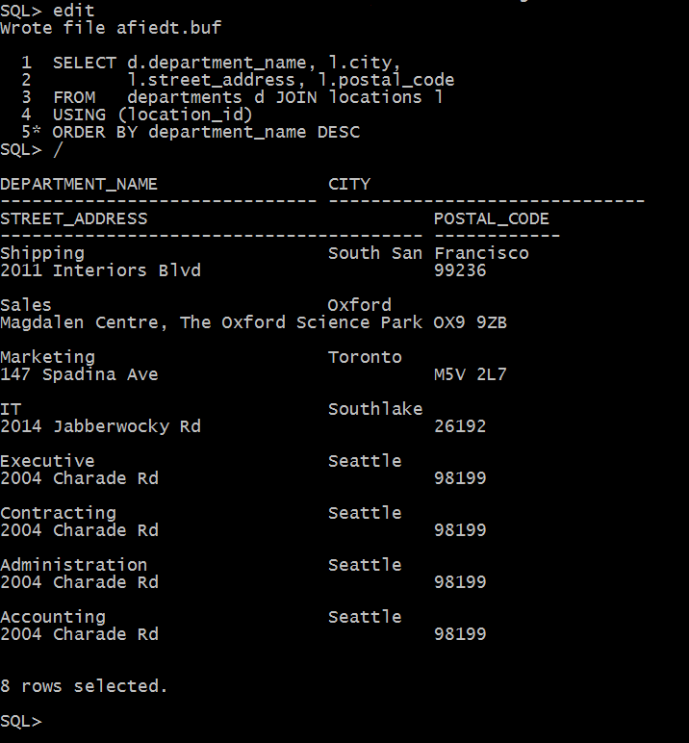

2. Display full name of the employees, their hire date and salary together with
their department name, but only for departments which names start with A or S. Full name should be in format of :
First / Last. Use the JOIN and ON form of syntax.
Sort the output by department name and then by last name.

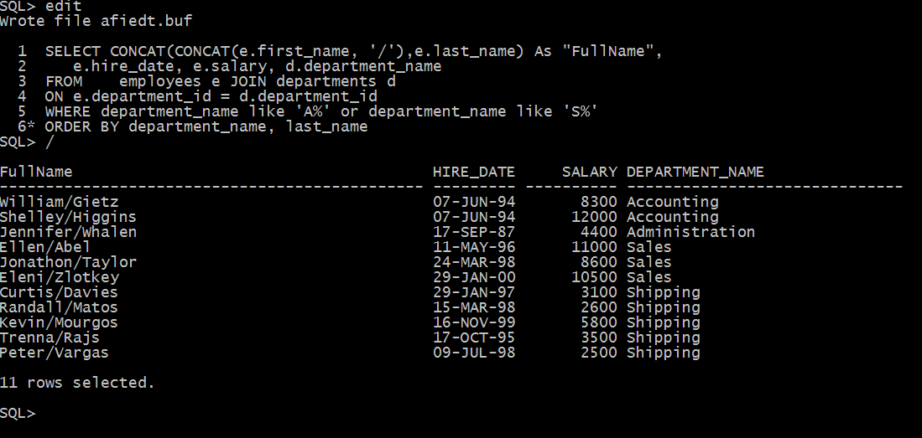

3. Rewrite the previous question by using Standard (Old -- prior to Oracle9i) Join
method.

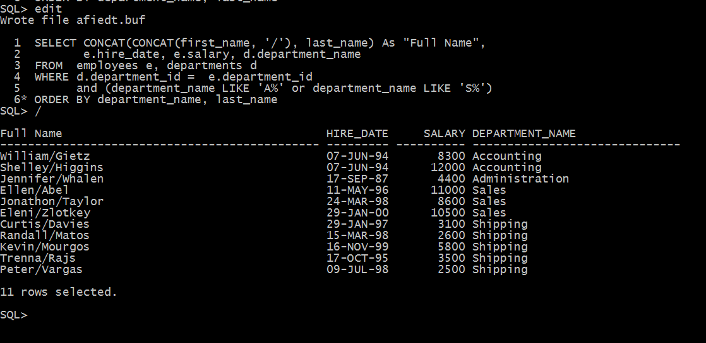

4. Display full name of the manager of each department in provinces Ontario,
California and Washington plus department name, city, postal code and province name. Full name should be in format of :
Last, First. Use the JOIN and ON form of syntax.
Sort the output by city and then by department name.

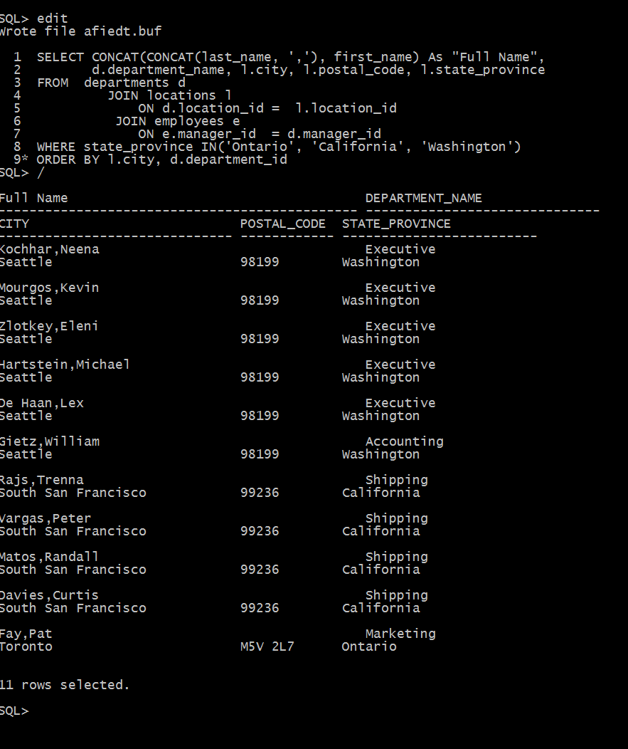

5. Rewrite the previous question by using Standard (Old -- prior to Oracle9i) Join
method.

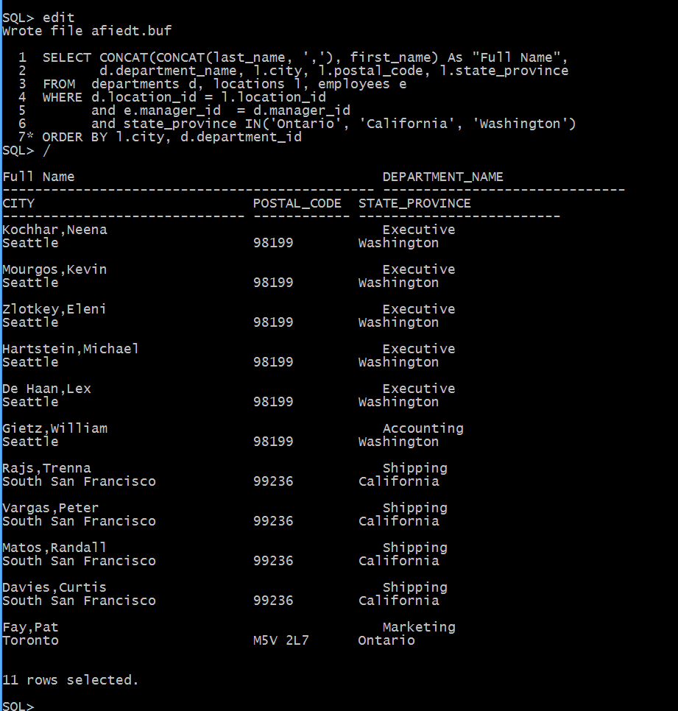

6. Display the department name and Highest, Lowest and Average pay per each
department. Name these results High, Low and Avg.
Use JOIN and ON form of the syntax.
Sort the output so that department with highest average salary are shown first.
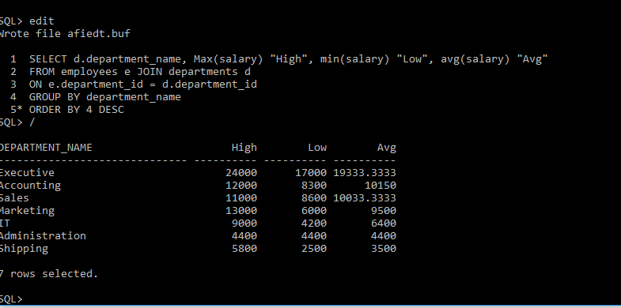

7. Display the employee last name and employee number along with their
manager’s last name and manager number.
Label the columns Employee, Emp#, Manager and Mgr#.
respectively. Include also employees who do NOT have a manager and also
employees who do NOT supervise anyone (or you could say managers without
employees to supervise).

