ORA725 Lab 8
Submitted by: Naderi Vadakkeperatta, Anaswara

Due by Friday, December 15th by 4pm

You will create 2 tables firstly, then remove / restore these tables and also to add / modify /remove certain database objects like views in this lab.

1. Create table CITIES from table LOCATIONS, but only for location numbers less than 2000 (do NOT create this table from scratch).
→ You will have exactly 10 rows here.
When you describe CITIES, the output is shown below:

SQL> DESC cities
Name Null? Type
----------------------------------------- -------- -----------------
LOCATION_ID NUMBER(4)
STREET_ADDRESS VARCHAR2(40)
POSTAL_CODE VARCHAR2(12)
CITY NOT NULL VARCHAR2(30)
STATE_PROVINCE VARCHAR2(25)
COUNTRY_ID CHAR(2)

Solution:

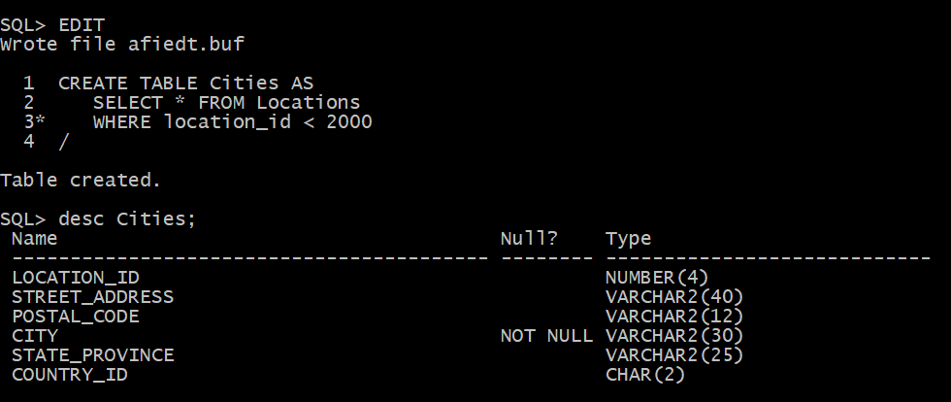

2. Create table TOWNS from table LOCATIONS, but only for location numbers less than 1500 (do NOT create this table from scratch). This table will have same structure as table CITIES.
→ You will have exactly 5 rows here.

Solution:

1 CREATE TABLE Towns As
2 SELECT * FROM Locations
3* WHERE location_id < 1500
SQL> /
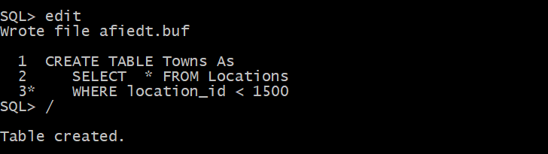
3. Now you will empty your RECYCLE BIN with one powerful command. Then remove your table TOWNS, so that will remain in the recycle bin. Check that it is really there and what time was removed.
Solution:
PURGE Recyclebin;
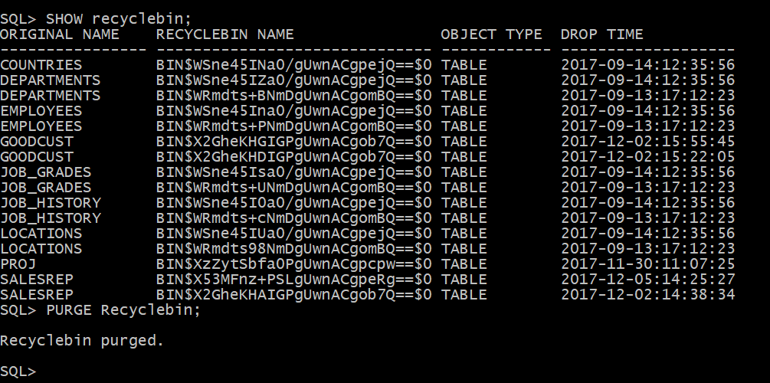

DROP TABLE Towns;

SQL> SELECT original_name, droptime
FROM recyclebin ;
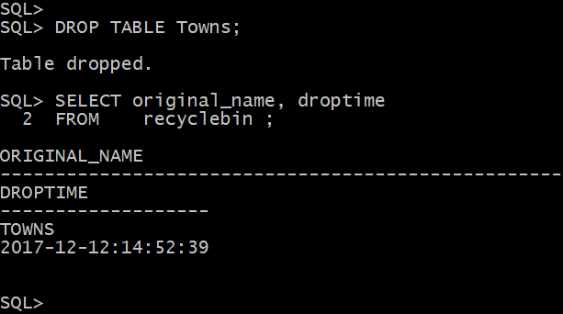
4. Restore your table TOWNS from recycle bin and describe it. Check what is in your recycle bin now.
Solution:

FLASHBACK TABLE Towns TO BEFORE DROP
DESC Towns;

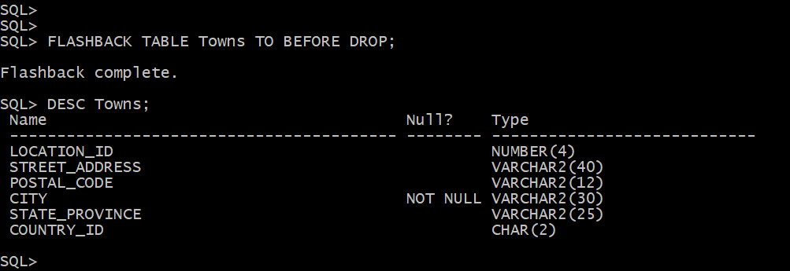

SELECT original_name, droptime
FROM Recyclebin

5. Now remove table TOWNS so that does NOT remain in the recycle bin. Check that is really NOT there and then try to restore it. Explain what happened?
Solution:

DROP TABLE Towns PURGE
DESC Towns
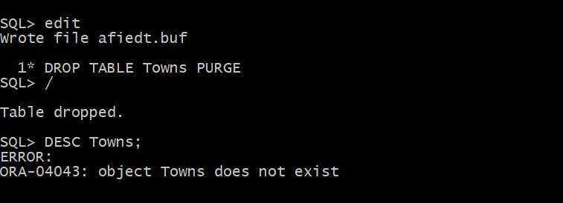

SHOW recyclebin;


FLASHBACK TABLE Towns TO BEFORE DROP

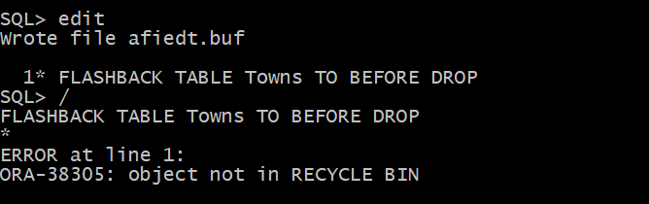

Error : Because Towns is not in recycle bin as it is deleted with Purge option

6. Create simple view called CAN_CITY_VU, based on table CITIES so that will contain only columns Street_Address, Postal_Code, City and State_Province for locations only in CANADA. Then display all data from this view.

Solution:

1 CREATE VIEW Can_city_vu AS
2 SELECT Street_Address, Postal_Code, City, State_Province
3 FROM Cities
4* WHERE COUNTRY_ID IN ('CA')
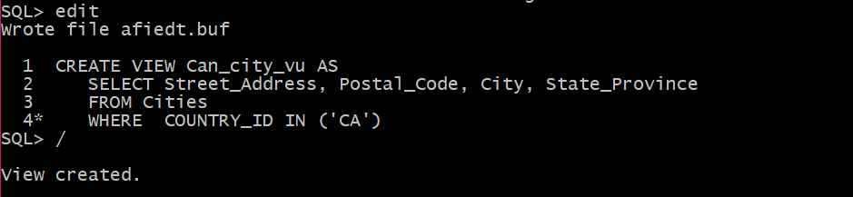

SELECT * FROM Can_city_vu

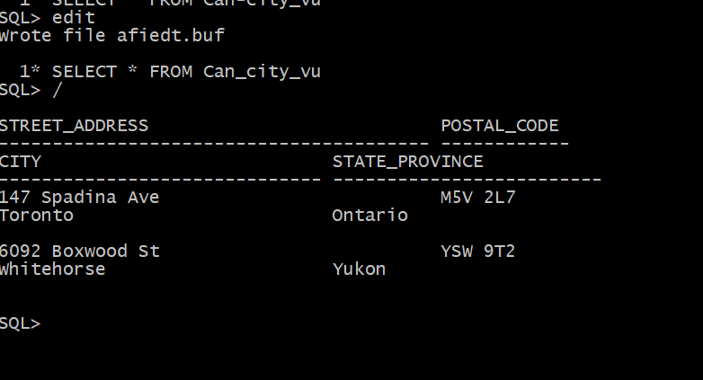

7. Modify your simple view so that will have following aliases instead of original column names: Str_Adr, P_Code, City and Prov and also will include cities from ITALY as well. Then display all data from this view.

Solution:

1 CREATE OR REPLACE VIEW Can_city_vu(Str_Adr, P_Code, City, Prov) AS
2 SELECT Street_Address, Postal_Code, City, State_Province
3 FROM Cities
4* WHERE COUNTRY_ID IN ('CA', 'IT')
5 /

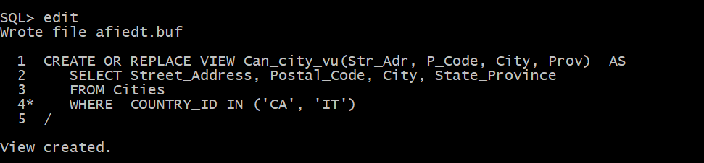

SELECT * FROM Can_city_vu;

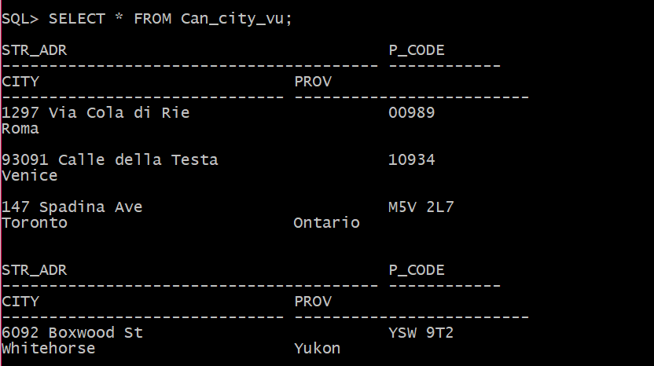

8. Create complex view called CITY_DNAME_VU, based on tables LOCATIONS and DEPARTMENTS, so that will contain only columns Department_Name, City and State_Province for locations in ITALY or CANADA. Include situations even when city does NOT have department established yet. Then display all data from this view.

Solution:

CREATE VIEW City_dname_vu AS
SELECT d.department_name, l.city, l.state_province
FROM Locations l LEFT OUTER JOIN Departments d
USING(location_id)
WHERE l.country_id IN ('CA', 'IT')

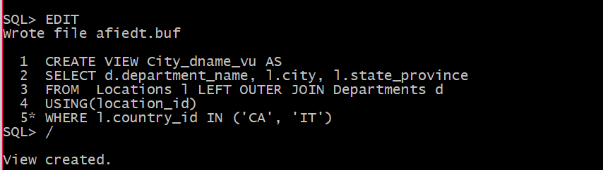

SQL> SELECT * FROM City_dname_vu;

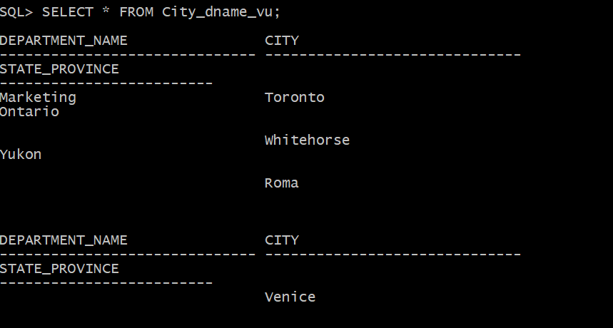

9. Modify your complex view so that will have following aliases instead of original column names: DName, City and Prov and also will include all cities outside United States
Include situations even when city does NOT have department established yet. Then display all data from this view.

Solution:

CREATE OR REPLACE VIEW City_dname_vu(DName, City, Prov) AS
SELECT d.department_name, l.city, l.state_province
FROM Locations l LEFT OUTER JOIN Departments d
USING(location_id)
WHERE l.country_id NOT IN ('US')
/

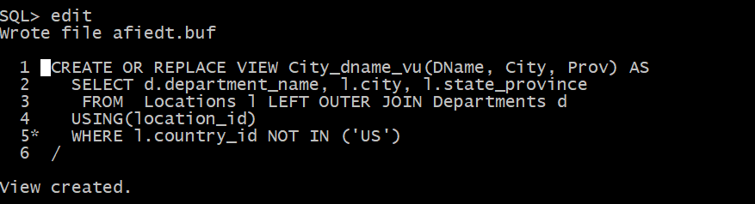

SELECT * FROM City_dname_vu;
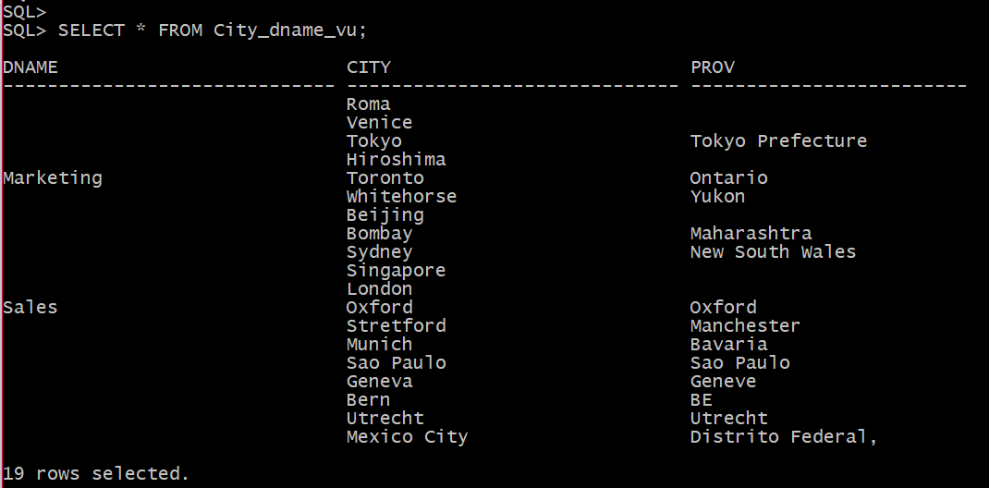

10. Check in the Data Dictionary What Views (their names and definitions) are created so far in your account. Then drop your CITY_DNAME_VU and check Data Dictionary again. What is different?

Solution:

SELECT view_name, text
FROM user_views

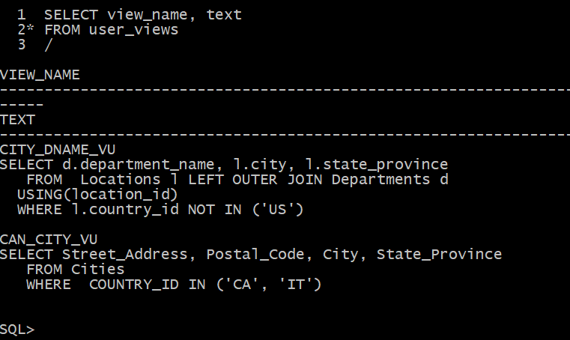
DROP VIEW City_dname_vu;

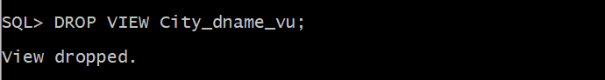

SQL> SET LONG 200
SQL> edit
Wrote file afiedt.buf

1 SELECT view_name, text
2* FROM user_views
3 /

