ORA725 Lab 9
Submitted by: Anaswara Naderi Vadakkeperatta

1) Write the PL/SQL code that may be used as a temperature system converter -- you will enter firstly your current (input) scale as C or F and then the value to be converted. The output value should be rounded to only one decimal. Use IF .. THEN logic.
Solution:
ACCEPT scale PROMPT 'Enter your input scale (C or F) for temperature: '
ACCEPT temp PROMPT 'Enter your temperature value to be converted : '
DECLARE
v_scale CHAR(1) := '&scale';
v_temperature NUMBER(5,1) := &temp;
v_result NUMBER(5,1) := 0;
BEGIN
IF (v_scale='C') THEN
v_result := ((9/5)*v_temperature + 32);
DBMS_OUTPUT.PUT_LINE('Your converted temperature in ' || v_scale || ' is exactly '|| ROUND(v_result,1));
ELSIF (v_scale='F') THEN
v_result := ((v_temperature - 32)*(5/9));
DBMS_OUTPUT.PUT_LINE('Your converted temperature in ' || v_scale || ' is exactly ' || ROUND(v_result,1));
ELSE
DBMS_OUTPUT.PUT_LINE('This is NOT a valid scale. Must be C or F.');
END IF;
END;
/
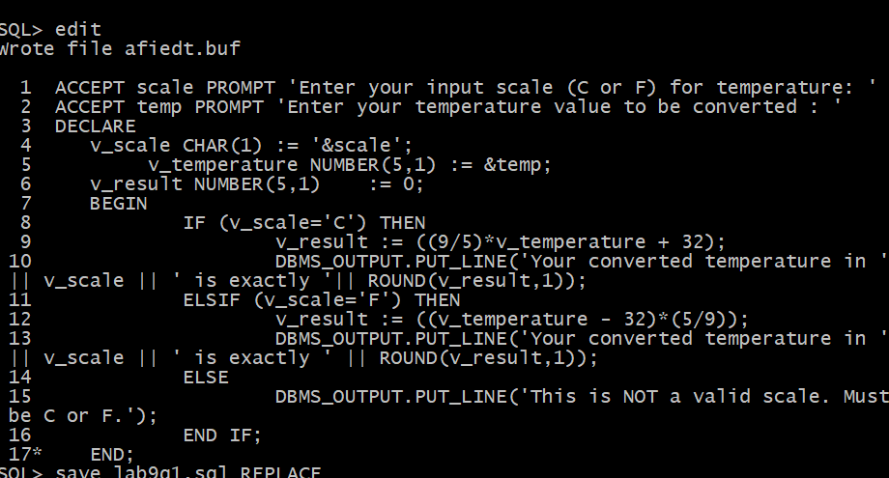
Possible output screenshots:
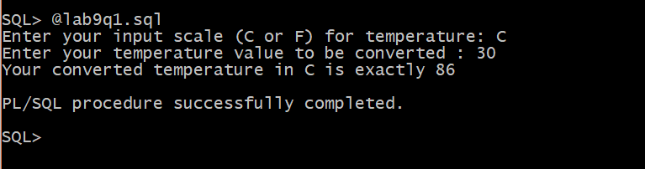
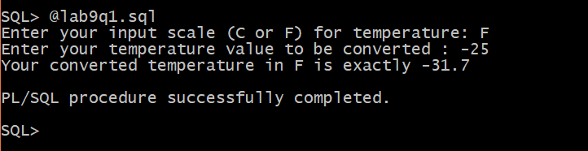
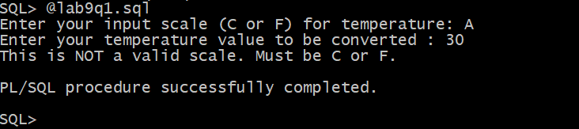

2) Write a PL/SQL block that will ask for Instructor’s Id and then will figure out how many sections does teach that person. It will display then an appropriate message based on that number. Use CASE … WHEN logic.
Top of Form
Top of Form
Top of Form

ACCEPT instructor PROMPT 'Please enter the instructor id : '
DECLARE
v_instructor instructor.instructor_id%TYPE := &instructor;
v_count NUMBER(3) := 0 ;
v_fname instructor.first_name%TYPE;
v_lname instructor.last_name%TYPE;
instructor_not_Valid EXCEPTION;
BEGIN
IF (v_instructor < 101 OR v_instructor > 110) THEN
RAISE instructor_not_valid; -- raise exception if instructor id is not valid
END IF;
SELECT instructor_id, first_name, last_name
INTO v_instructor, v_fname, v_lname
FROM instructor
WHERE instructor_id = v_instructor;
SELECT COUNT(section_id)
INTO v_count
FROM section
WHERE instructor_id = v_instructor;
CASE
WHEN (v_instructor >= 101 OR v_instructor <=110) THEN
CASE v_count
WHEN 10 THEN
DBMS_OUTPUT.PUT_LINE('Instructor, '|| v_fname || ' ' || v_lname ||', teaches ' || v_count || ' section(s).This instructor needsto rest in the next term.');
WHEN 9 THEN
DBMS_OUTPUT.PUT_LINE('Instructor, '|| v_fname || ' ' || v_lname ||', teaches ' || v_count || ' section(s).' ||' This instructor teaches enough sections.');
WHEN 0 THEN
DBMS_OUTPUT.PUT_LINE('Instructor, '|| v_fname || ' ' || v_lname ||', teaches ' || v_count || ' section(s).' || ' This instructor may teach more sections. ');
END CASE;
END CASE;
EXCEPTION
WHEN instructor_not_valid THEN
-- handle the error
DBMS_OUTPUT.PUT_LINE('This is not a valid instructor.');
END;
/
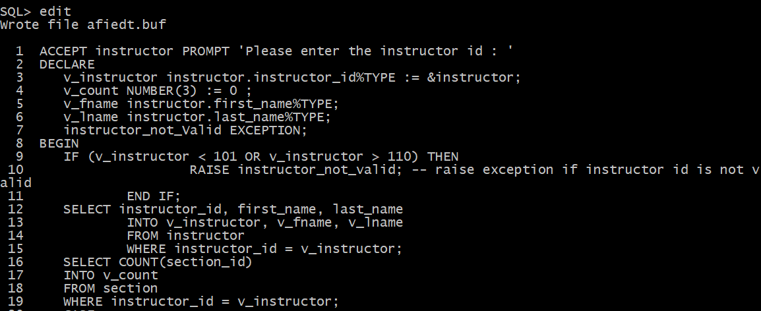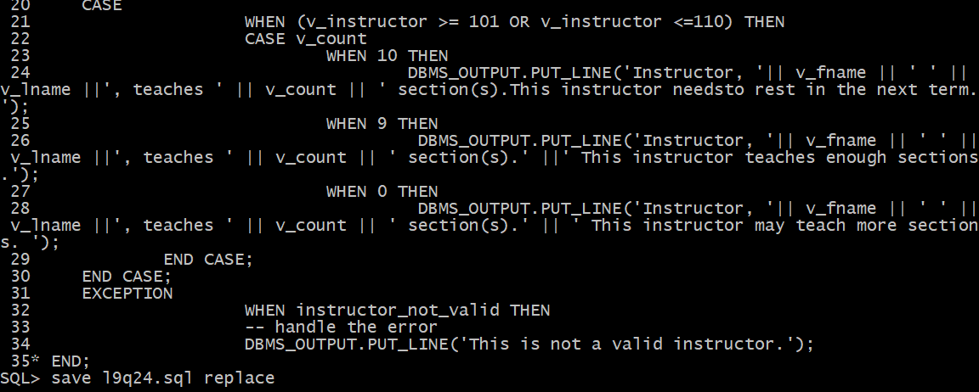
Please enter the Instructor Id: |  | 
Top of Form
This is not a valid instructor
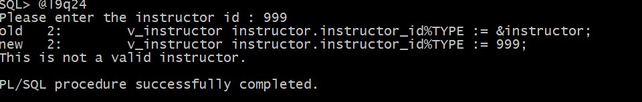
Please enter the Instructor Id: |  | 
Top of Form
Instructor, Tom Wojick, teaches 10 section(s)
This instructor needs to rest in the next term.
PL/SQL procedure successfully completed.
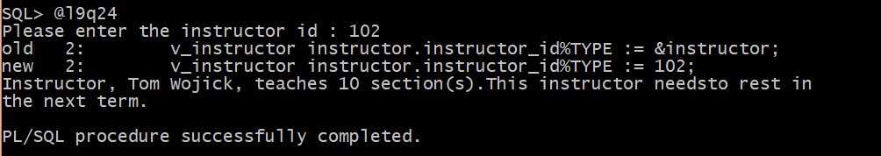
Please enter the Instructor Id: |  | 
Top of Form

Instructor, Fernand Hanks, teaches 9 section(s)
This instructor teaches enough sections.
PL/SQL procedure successfully completed.

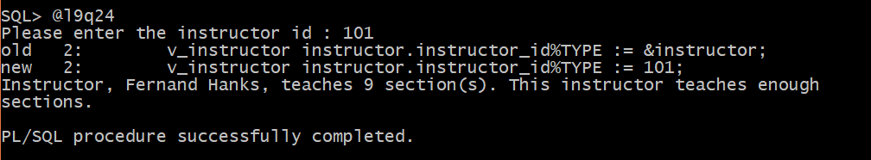

Top of Form
Please enter the Instructor Id: |  | 
Top of Form
Instructor, Rick Chow, teaches 0 section(s)
This instructor may teach more sections.
PL/SQL procedure successfully completed.
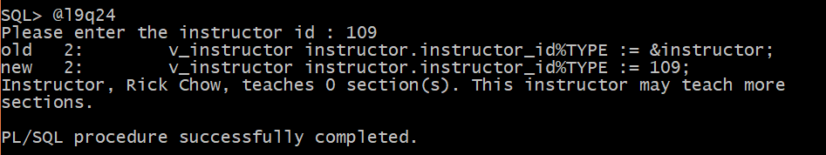

3) Write a PL/SQL block that will ask for a Positive Integer input and then will calculate the sum of all Even ( or Odd) integers between 1 and that value, depending whether the input value is Even or Odd. Use WHILE LOOP control logic. Here are the possible outputs:
DECLARE
v_odd_iteration NUMBER(5);
v_even_iteration NUMBER(5);
v_number NUMBER(5) := &number;
v_modulus NUMBER(1);
v_sum NUMBER(6);
BEGIN
v_sum :=0;
v_odd_iteration :=1;
v_even_iteration :=2;
SELECT MOD(v_number,2)
INTO v_modulus
FROM DUAL;
WHILE (v_modulus=0 AND v_even_iteration <= v_number)
LOOP
v_sum := v_sum + v_even_iteration;
v_even_iteration := v_even_iteration + 2;
END LOOP;
WHILE (v_modulus=1 AND v_odd_iteration <= v_number) LOOP
v_sum := v_sum + v_odd_iteration;
v_odd_iteration := v_odd_iteration + 2;
END LOOP;
IF(v_modulus = 0) THEN
DBMS_OUTPUT.PUT_LINE('The sum of Even integers between 1 and ' || v_number || ' is ' || v_sum);
ELSE
DBMS_OUTPUT.PUT_LINE('The sum of ODD integers between 1 and ' || v_number || ' is ' || v_sum);
END IF;
END;
/
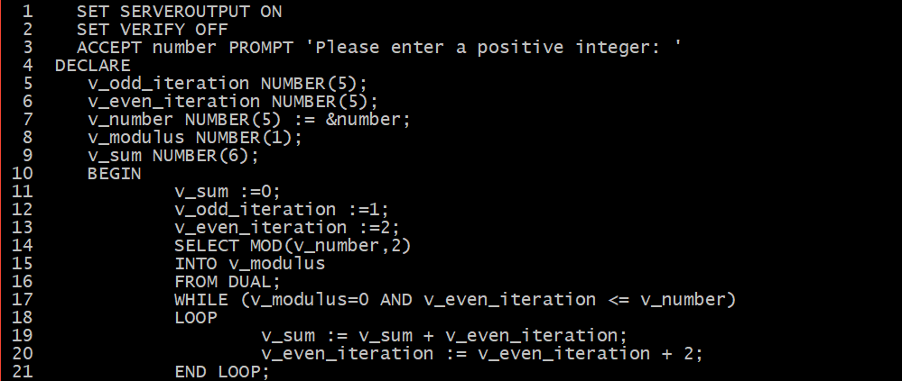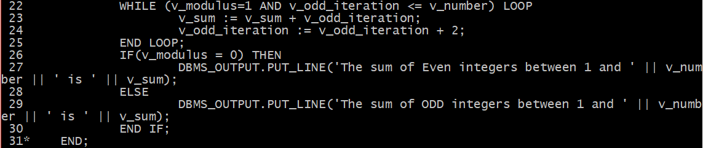

Top of Form
Please enter a Positive Integer: |  | 
The sum of Even integers between 1 and 12 is 42
PL/SQL procedure successfully completed.


Top of Form
Please enter a Positive Integer: |  | 
The sum of Odd integers between 1 and 901 is 203401
PL/SQL procedure successfully completed.
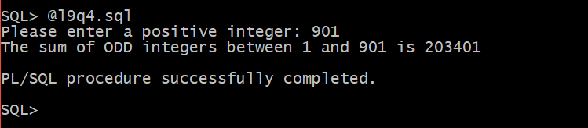

4) Write a PL/SQL block that will ask for department’s Location Id and then will
figure out how many departments exist there and how many employees work on that location.
Based on these answers you will construct a Nested For Loop that will display these answers in a numeric format like shown below.
The first location 1800 has only one department with 2 employees, while the other location 1400 has 3 departments with 7 employees altogether (after the Update).
Obviously, without an explicit cursor you can NOT show how many employees works in each department. So, this is just an exercise in creating nested loops.
But, firstly you need to relocate departments 40 and 70 to location 1400.
Do NOT commit, you will rollback it when you finish your block.

Top of Form
UPDATE Departments
SET location_id = 1400
WHERE department_id IN (40,70)
ACCEPT location PROMPT 'Enter valid Location Id:'
DECLARE
v_location_id locations.location_id%TYPE :=&location;
v_department_id departments.department_id%TYPE;
v_employee_id employees.employee_id%TYPE;
v_depart_count NUMBER(2) := 0;
v_employee_count NUMBER(2) := 0;
i NUMBER(3);
j NUMBER(3);
BEGIN
i:=1;
j:=1;
SELECT COUNT(department_id)
INTO v_depart_count
FROM departments
WHERE location_id = v_location_id;
SELECT COUNT(employee_id)
INTO v_employee_count
FROM employees
WHERE department_id IN (SELECT department_id
FROM departments
WHERE location_id = v_location_id);
DBMS_OUTPUT.PUT_LINE('location is ' || v_location_id);
DBMS_OUTPUT.PUT_LINE('count of deprtments ' || v_depart_count);
DBMS_OUTPUT.PUT_LINE('count of employees ' || v_employee_count);
FOR i IN 1 .. v_depart_count LOOP
DBMS_OUTPUT.PUT_LINE('Outer Loop: Department #' || i);
FOR j IN 1 .. v_employee_count LOOP
DBMS_OUTPUT.PUT_LINE('Inner Loop: Employee #' || j);
END LOOP;
END LOOP;
EXCEPTION
WHEN NO_DATA_FOUND THEN
DBMS_OUTPUT.PUT_LINE('no data');
WHEN TOO_MANY_ROWS THEN
DBMS_OUTPUT.PUT_LINE('too many rows');
END;
/

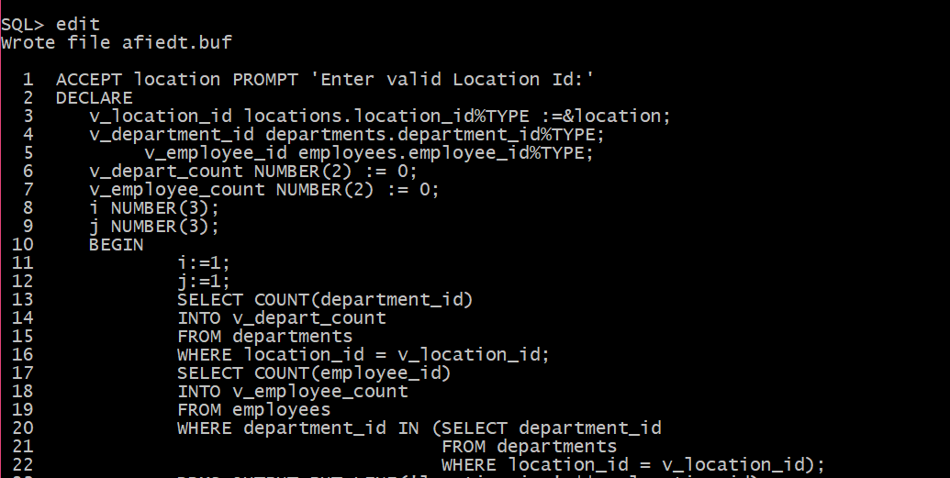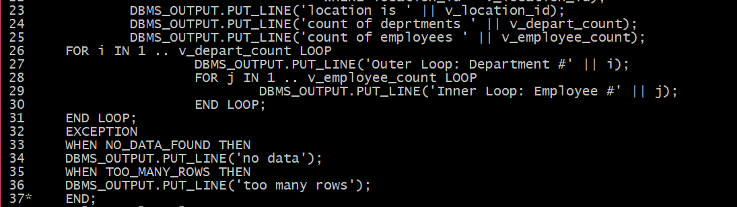
Top of Form
Enter valid Location Id: |  | 
Top of Form

Outer Loop: Department #1
* Inner Loop: Employee #1
* Inner Loop: Employee #2
PL/SQL procedure successfully completed.

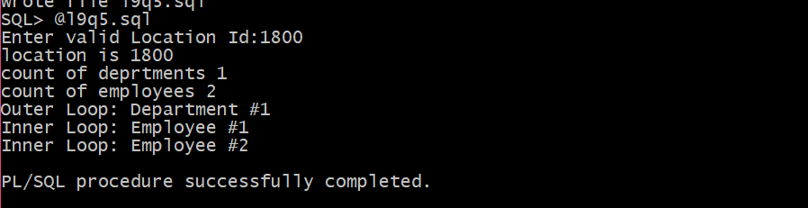

Top of Form
Enter valid Location Id: |  | 
Bottom of Form
Outer Loop: Department #1
* Inner Loop: Employee #1
* Inner Loop: Employee #2
* Inner Loop: Employee #3
* Inner Loop: Employee #4
* Inner Loop: Employee #5
* Inner Loop: Employee #6
* Inner Loop: Employee #7
Outer Loop: Department #2
* Inner Loop: Employee #1
* Inner Loop: Employee #2
* Inner Loop: Employee #3
* Inner Loop: Employee #4
* Inner Loop: Employee #5
* Inner Loop: Employee #6
* Inner Loop: Employee #7
Outer Loop: Department #3
* Inner Loop: Employee #1
* Inner Loop: Employee #2
* Inner Loop: Employee #3
* Inner Loop: Employee #4
* Inner Loop: Employee #5
* Inner Loop: Employee #6
* Inner Loop: Employee #7
PL/SQL procedure successfully completed.

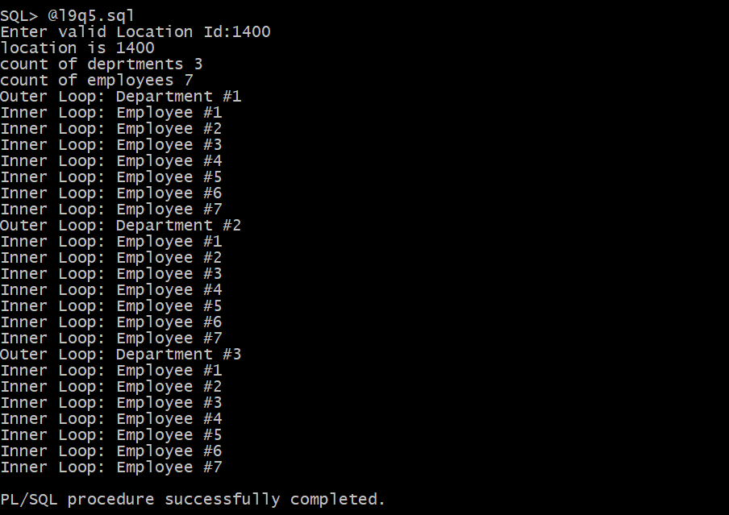
ROLLBACK
Rollback complete.

