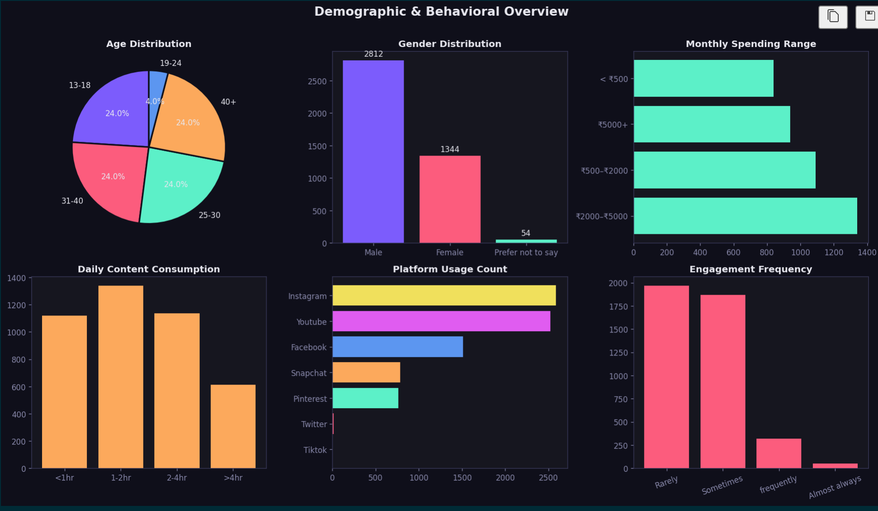📊 1. Demographic Insights

👥 Gender Distribution
👉 Majority users are Male (~2812 vs 1344 Female)

💡 Business Conclusion:
- Platform is male-dominated
- Marketing strategies may currently favor male audience behavior

📌 Action:
- If product is gender-neutral → increase female-targeted campaigns
- If male-focused → double down on current strategy

🎂 Age Distribution
👉 Almost equal distribution in:
- 13–18
- 25–30
- 31–40
- 40+
👉 Very low in 19–24 (~4%)

💡 Business Conclusion:
- Audience is widely distributed across age groups
- Missing engagement in 19–24 segment

📌 Action:
- Target 19–24 with:
  - reels / short content
  - influencer campaigns

💰 2. Spending Behavior

💸 Monthly Spending
👉 Highest users in:
- ₹2000–₹5000 range
👉 Followed by:
- ₹500–₹2000

💡 Business Conclusion:
- Majority users are mid-level spenders
- Good potential for upselling

📌 Action:
- Offer:
  - bundle deals
  - premium upgrades
  - subscription models

⏱️ 3. User Activity

📱 Daily Content Consumption
👉 Most users spend:
- 1–2 hours (highest)
- Then 2–4 hours

💡 Business Conclusion:
- Users are moderately active (not extreme users)

📌 Action:
- Content should be:
  - short
  - engaging
  - high-impact

📊 4. Engagement Behavior

🔥 Engagement Frequency
👉 Majority:
- Rarely / Sometimes
👉 Very few:
- Frequently
- Almost always

💡 Business Conclusion:
- Low engagement problem ⚠️
- Users consume but don’t interact

📌 Action:
- Improve:
  - CTA (Call-to-action)
  - interactive posts
  - influencer trust

📱 5. Platform Usage (Critical Insight)
👉 From your earlier KPI:
- Instagram → highest
- TikTok → lowest

💡 Business Conclusion:
- Instagram = primary marketing channel
- TikTok = low ROI currently

📌 Action:
- Focus ads on Instagram & YouTube
- Re-evaluate TikTok strategy

🔗 6. CROSS-INSIGHT (Most Important 🔥)
Combine findings:
👉 Users:
- Spend 1–2 hrs
- Engage rarely
- Use Instagram most

💡 Strong Conclusion:
“Users are active consumers but passive engagers, especially on dominant platforms like Instagram.”
🎯 FINAL BUSINESS SUMMARY
The analysis reveals that the user base is predominantly male and distributed across multiple age groups, with a noticeable gap in engagement among the 19–24 segment. Most users fall within a moderate spending range (₹2000–₹5000), indicating strong monetization potential.

User activity patterns show that individuals spend 1–2 hours daily on content consumption, yet engagement levels remain low, with most users interacting rarely or occasionally. This suggests a gap between content consumption and active participation.

Platform analysis highlights Instagram as the most utilized platform, making it the most effective channel for targeted marketing, while TikTok shows minimal engagement and may require strategic reconsideration.

Overall, the data indicates an opportunity to improve user engagement through targeted campaigns, enhanced content strategies, and platform-specific optimization.

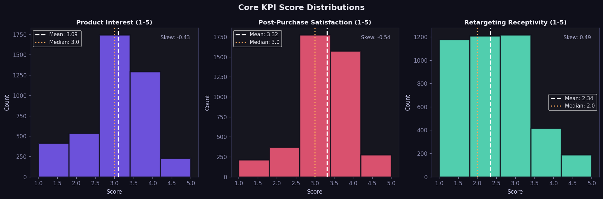

🎯 What this chart is (concept)
Each panel is a histogram (distribution) of scores:
- X-axis: Score (1–5)
- Y-axis: Number of users
- White dashed line: Mean (average)
- Orange dotted line: Median
- Skew value: Shape of distribution (bias)
👉 Purpose: understand user sentiment intensity, not just averages.

📊 1. Product Interest (Mean ≈ 3.09, Skew ≈ -0.43)

🔍 What it means:
- Scores cluster around 3 (neutral to slightly positive)
- Slight negative skew → more users leaning toward higher scores (3–4)

💡 Business Insight:
- Users are interested but not strongly convinced
- Product appeal exists, but not compelling enough to drive strong intent

📌 Action:
- Improve:
  - product positioning
  - influencer storytelling
  - differentiation
👉 Goal: push users from “interested” → “excited to buy”

📊 2. Post-Purchase Satisfaction (Mean ≈ 3.32, Skew ≈ -0.54)

🔍 What it means:
- Slightly higher than interest → experience is better than expectation
- Stronger negative skew → many users giving 4 ratings

💡 Business Insight:
- Customers are generally satisfied after purchase
- Product/service quality is not the main issue

📌 Action:
- Leverage this:
  - testimonials
  - reviews
  - user-generated content
👉 Turn satisfaction into trust-building marketing

📊 3. Retargeting Receptivity (Mean ≈ 2.34, Skew ≈ +0.49)

🔍 What it means:
- Scores are low (closer to 2)
- Positive skew → many users giving low ratings (1–2)

💡 Business Insight:
- Users do NOT like retargeting ads ⚠️
- Current retargeting strategy is ineffective or annoying

📌 Action:
- Fix retargeting:
  - reduce ad frequency
  - personalize ads
  - improve timing
👉 Otherwise → wasted ad spend

🔥 CROSS-KPI INSIGHT (Most Important)
👉 Combine all 3:
KPI | Insight
Interest | Moderate
Satisfaction | Good
Retargeting | Weak

🎯 Strong Business Conclusion:
Users are moderately interested and satisfied after purchase, but marketing (especially retargeting) is failing to convert and re-engage them effectively.

🚀 Strategic Implications

1. Funnel Gap
- Interest → OK
- Purchase → happens
- Retargeting → weak
👉 Problem is in conversion & re-engagement stage

2. Marketing vs Product
- Product = working ✅
- Marketing = underperforming ❌

3. Opportunity Area
👉 Biggest opportunity:
- Improve conversion strategy
- Not necessarily product redesign

🧠 Final Report Statement (use this directly)
The KPI distribution analysis reveals that product interest and post-purchase satisfaction scores are centered around moderate to slightly positive values, indicating that while users are generally satisfied, the product lacks strong differentiation to drive high purchase intent.
In contrast, retargeting receptivity scores are significantly lower, suggesting that current remarketing strategies are ineffective and potentially disengaging users.
This indicates a critical gap in the marketing funnel, where users are

🎯 What is “Skew” in your chart?
👉 Skewness measures:
How asymmetric (tilted) your data distribution is

📊 In your code
You used:
sk = stats.skew(data)
👉 This is from scipy.stats
It automatically calculates skewness using a standard formula.

🧠 Intuition (VERY IMPORTANT)

🔹 Skew = 0
👉 Perfectly symmetric (balanced)

🔹 Negative Skew (< 0)
👉 Tail is on the left side
👉 More values on the right (higher scores)
Example:
- Many 4s and 5s
- Few 1s

🔹 Positive Skew (> 0)
👉 Tail is on the right side
👉 More values on the left (lower scores)
Example:
- Many 1s and 2s
- Few 5s

📌 Your Results Explained

1. Product Interest (Skew ≈ -0.43)
👉 Slight negative skew
✔ More users giving:
- 3–4
✔ Fewer giving:
- 1–2
👉 Interpretation:
Users lean slightly positive

2. Satisfaction (Skew ≈ -0.54)
👉 More negative skew
✔ Even more users at:
- 4–5
👉 Interpretation:
Stronger positive experience

3. Retargeting (Skew ≈ +0.49)
👉 Positive skew
✔ More users at:
- 1–2
👉 Interpretation:
Users dislike retargeting
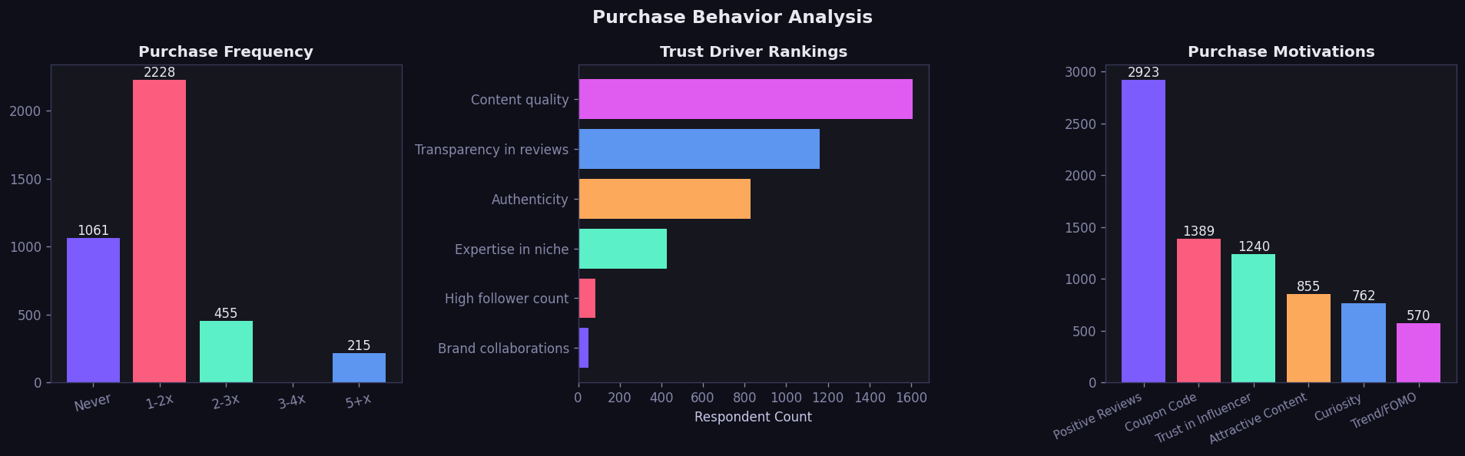

🎯 1. Purchase Frequency Analysis

🔍 Observation:
- Majority: 1–2 purchases (~2228 users)
- Many users: Never purchased (~1061)
- Very few: frequent buyers (3+ times)

💡 Business Insight:
👉 Users are mostly first-time or low-frequency buyers
There is low customer retention and repeat purchase behavior

📌 Business Actions:
- Introduce:
  - loyalty programs
  - repeat purchase discounts
  - subscription models
👉 Goal: convert 1–2x buyers → repeat customers

🔥 2. Trust Driver Rankings

🔍 Observation:
Top drivers:
- Content quality (highest)
- Transparency in reviews
- Authenticity
Least important:
- Follower count
- Brand collaborations

💡 Business Insight:
👉 Users trust:
- what is said (content)
NOT:
- who says it (followers)

📌 Business Actions:
- Focus on:
  - honest reviews
  - detailed demonstrations
  - real experiences
👉 Avoid:
- fake influencer hype
- follower-based marketing

🚀 3. Purchase Motivation Analysis

🔍 Observation:
Top motivator:
- Positive reviews (2923) 🔥
Moderate:
- Coupon codes
- Trust in influencer
Low:
- Curiosity
- Trend / FOMO (lowest)

💡 Business Insight:
👉 Social proof dominates decision-making
👉 FOMO (urgency marketing) is ineffective

📌 Business Actions:
- Invest in:
  - customer reviews
  - testimonials
  - ratings
👉 Reduce reliance on:
- “limited time offer” pressure tactics

🔗 4. CROSS-INSIGHT (VERY IMPORTANT 🔥)
Combine all 3 graphs:

🎯 Key Pattern:
👉 Users:
- Trust content quality
- Are influenced by reviews
- But still purchase only 1–2 times

💡 Strong Conclusion:
“While users trust the content and are influenced by reviews, this trust is not translating into long-term purchase behavior.”

⚠️ Core Business Problem
👉 Conversion is happening ONCE
👉 Retention is weak

🧠 Strategic Interpretation
Stage | Status
Awareness | Good
Trust | Strong
First Purchase | Happens
Repeat Purchase | Weak ❌

🚀 Final Business Conclusion (Use in Report)
The purchase behavior analysis indicates that while users are influenced by high-quality content and positive reviews, most purchases are limited to 1–2 transactions, highlighting a lack of repeat engagement.
Trust drivers such as content quality and transparency significantly outweigh superficial factors like follower count, suggesting that authenticity plays a critical role in influencing consumer decisions.
Positive reviews emerge as the dominant purchase motivator, whereas FOMO-based strategies show minimal impact, indicating that consumers rely more on social proof than urgency-driven tactics.
Overall, the key business challenge lies in improving customer retention and encouraging repeat purchases by leveraging trust-based marketing strategies and enhancing post-purchase engagement.

🔥 One-line powerful takeaway (for viva)
“Trust and reviews drive first purchase, but lack of retention strategies prevents repeat buying.”

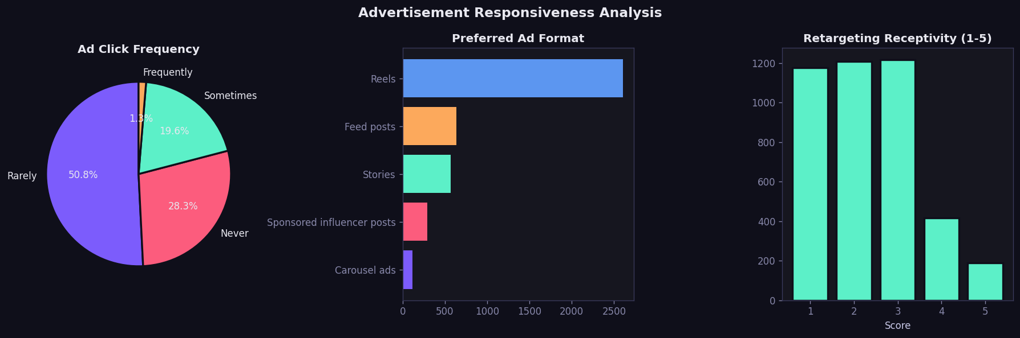

🎯 1. Ad Click Frequency (User Behavior)

🔍 Observation:
- Rarely → ~50.8% (majority)
- Never → ~28.3%
- Sometimes → ~19.6%
- Frequently → ~1.3% ❌

💡 Business Insight:
👉 Ad engagement is extremely low
Most users are either ignoring or actively avoiding ads

📌 Business Action:
- Improve:
  - ad relevance
  - targeting accuracy
  - personalization
👉 Current ads are not compelling enough to click

🎥 2. Preferred Ad Format (Very Important 🔥)

🔍 Observation:
- Reels → highest by far (~2600+)
- Feed posts → second
- Stories → moderate
- Influencer posts → low
- Carousel → very low

💡 Business Insight:
👉 Users strongly prefer:
Short-form video content (Reels)
👉 Traditional formats are underperforming

📌 Business Action:
- Shift budget to:
  - reels
  - short videos
- Reduce:
  - static posts
  - carousel ads

📉 3. Retargeting Receptivity

🔍 Observation:
- Most users rate 1–3 (low to neutral)
- Very few at 4–5 (high receptivity)

💡 Business Insight:
👉 Retargeting ads are:
ineffective and possibly annoying

📌 Business Action:
- Fix retargeting:
  - reduce repetition
  - improve timing
  - personalize content

🔗 4. CROSS-INSIGHT (VERY POWERFUL 🔥)
Combine all 3:

🎯 Key Pattern:
👉 Users:
- Prefer Reels
- But still rarely click ads
- And dislike retargeting

💡 Strong Business Conclusion:
“Even though users prefer modern ad formats like reels, the current execution fails to engage them effectively, leading to low click-through rates and poor retargeting performance.”

⚠️ CORE BUSINESS PROBLEM
👉 Content format is correct
👉 Execution is weak

🚀 Strategic Breakdown
Area | Status
Ad format | Correct ✅
Engagement | Low ❌
Retargeting | Poor ❌
Conversion funnel | Weak ❌

🎯 FINAL BUSINESS CONCLUSION (USE IN REPORT)
The advertisement responsiveness analysis reveals that user engagement with ads is significantly low, with over 50% of users rarely clicking on advertisements and only a negligible proportion engaging frequently.
Despite this, users show a strong preference for short-form video content such as reels, indicating that while the format aligns with user preferences, the content itself lacks effectiveness in driving interaction.
Additionally, retargeting strategies are poorly received, with most users rating them low, suggesting issues with ad relevance, frequency, or personalization.
Overall, the findings highlight a critical gap between preferred ad formats and actual user engagement, emphasizing the need for more targeted, engaging, and user-centric advertising strategies to improve click-through rates and conversion.

🔥 One-line powerful takeaway (for viva)
“Users prefer reels but still don’t click ads—so the issue is not format, but content relevance and targeting.”

🧠 1. What this SNA tab is doing (BIG PICTURE)
👉 This entire block builds 4 different network models from your dataset:
Network Type | Meaning
Platform Co-occurrence | Which platforms are used together
Trust ↔ Motivation | What trust factors lead to what motivations
Content Co-occurrence | Which content types appear together + drive purchase
Influence Flow DAG | Full funnel: Trust → Engagement → Purchase

⚙️ 2. CORE IDEA: How networks are built
All networks follow this pattern:
Nodes = entities (platform / trust / content etc.)
Edges = relationship between them
Weight = how many users show that relationship
👉 This is called co-occurrence based graph modeling
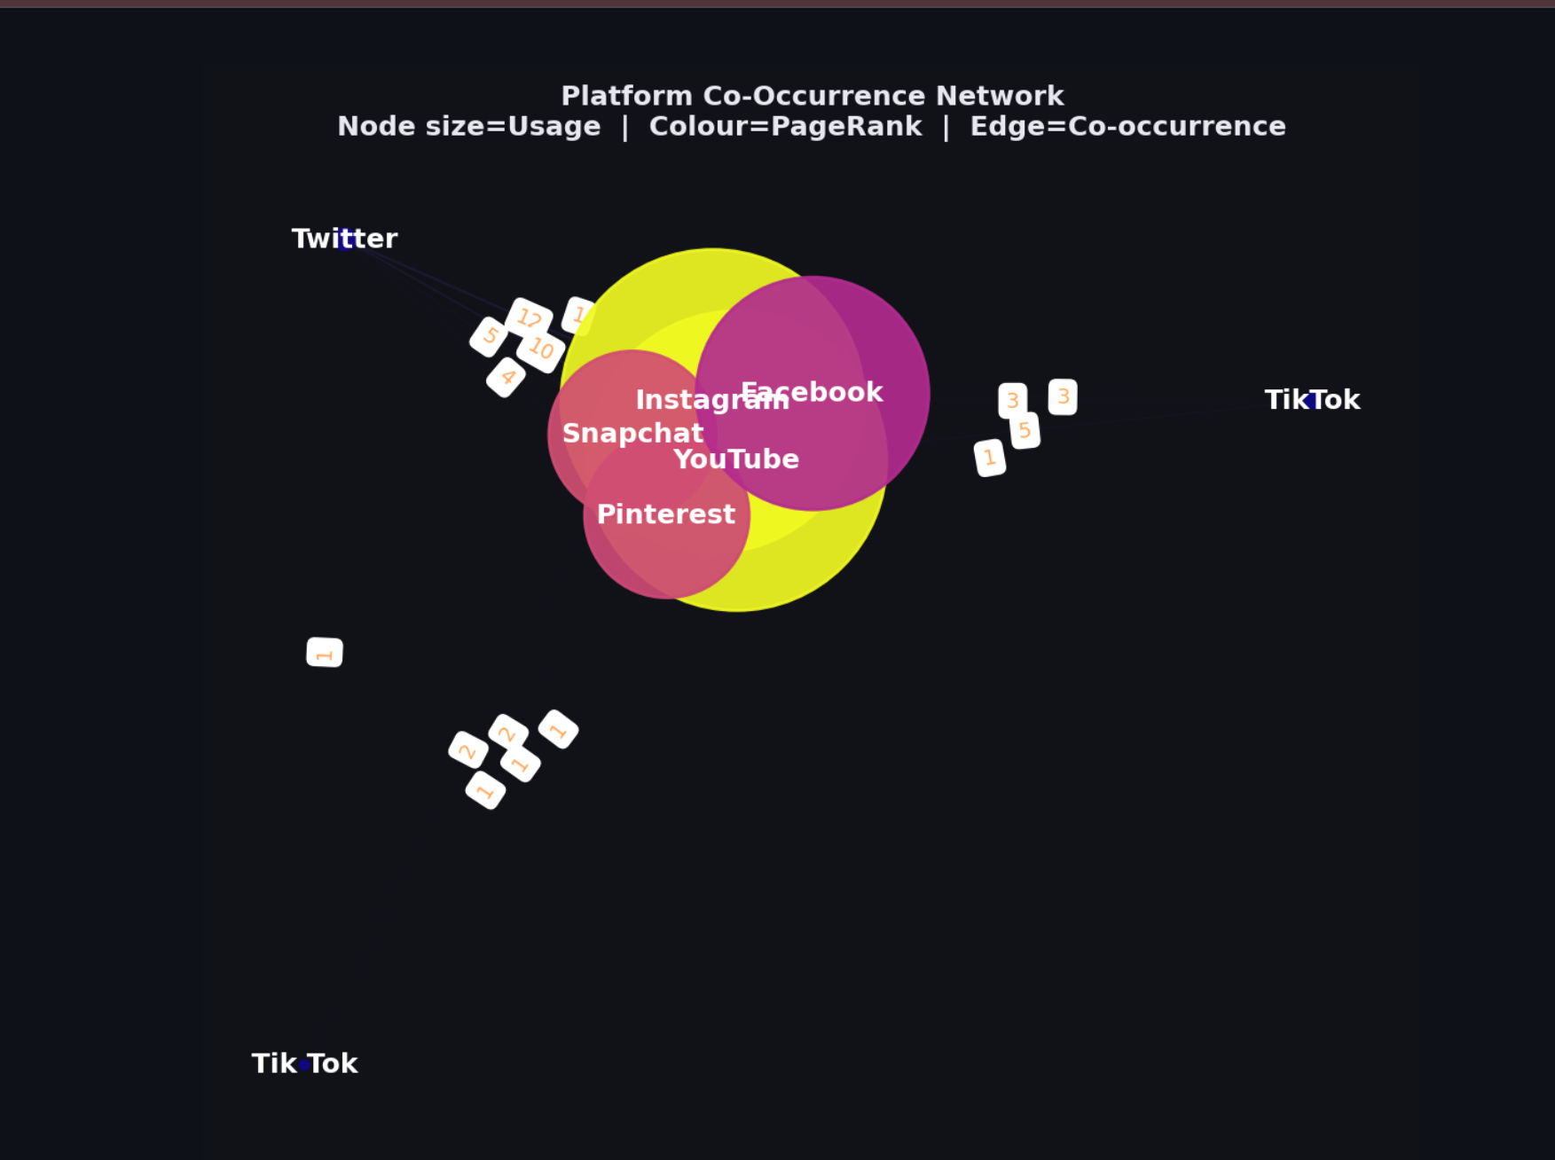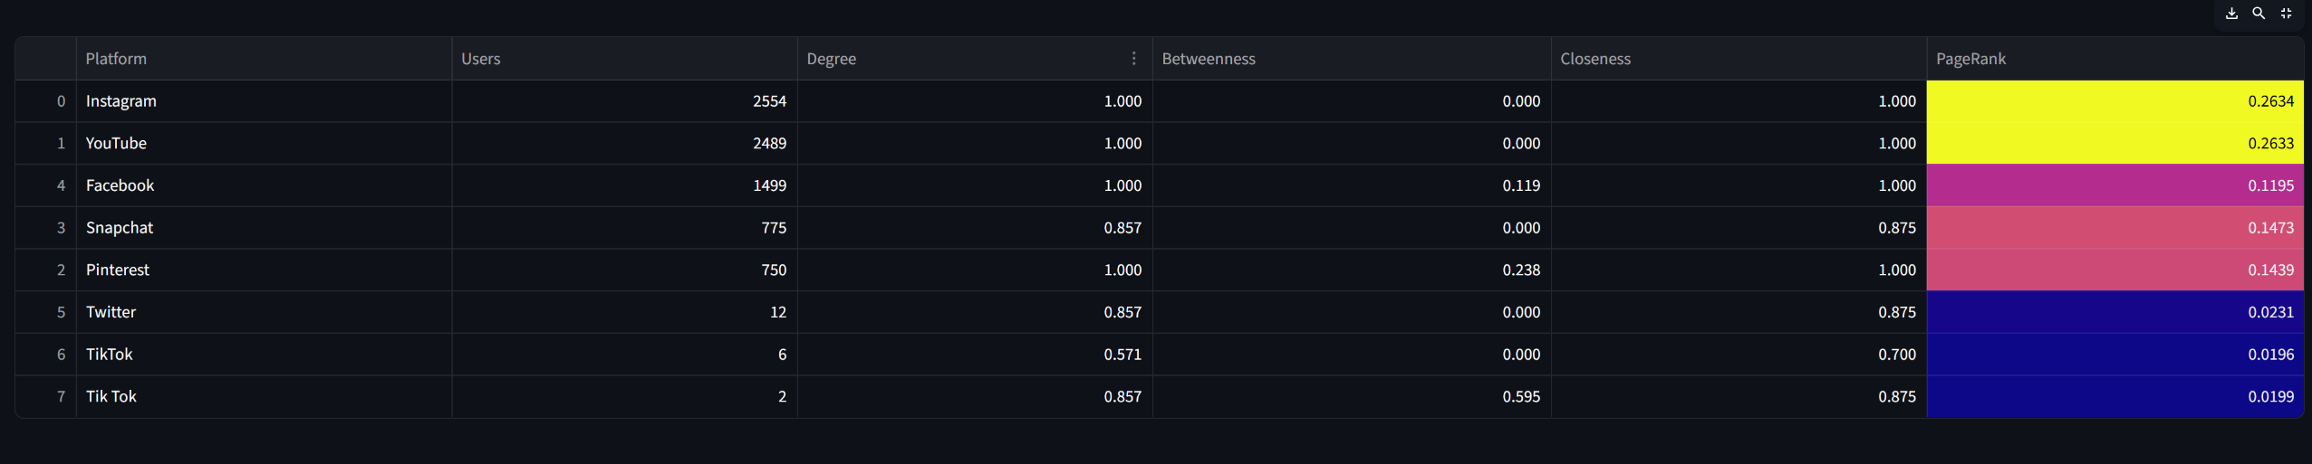

🧠 1. What “Platform Co-Occurrence” means
👉 Your data has rows like:
User 1 → Instagram; YouTube; Facebook
User 2 → Instagram; Snapchat
User 3 → YouTube; Pinterest

🔗 What the model does
For each user:
👉 It connects platforms used together
So:
- Instagram ↔ YouTube
- Instagram ↔ Facebook
- YouTube ↔ Facebook

💡 Meaning
“These platforms are used together by the same users”

🎯 What does ONE user using multiple platforms mean?
👉 Same idea as before, but now for platforms:

🧠 Users are NOT single-platform
They behave like:
- “I use Instagram + YouTube daily”
- “I switch between multiple apps”

💥 Business Meaning
👉 Users exist in a multi-platform ecosystem
NOT:
❌ Instagram-only audience
❌ YouTube-only audience
BUT:
✅ Overlapping audiences

🎨How to read YOUR graph

Node size = Number of users
👉 Bigger = more popular platform

Node color = PageRank
👉 More yellow = more influential

Edge thickness = Co-usage
👉 Thicker = more users use both platforms together

🔥 Let’s decode YOUR graph

🟡 Instagram & YouTube (Big + Bright)
👉 Highest PageRank:
- Instagram → 0.2634
- YouTube → 0.2633
💡 Meaning:
These are the most influential platforms in the ecosystem

🔗 Strong connection: Instagram ↔ YouTube
👉 Many users use both
💡 Meaning:
This is your strongest platform pair

🟣 Facebook (Medium)
👉 Moderate PageRank (0.1195)
💡 Meaning:
Still relevant, but less central than IG + YouTube

🔵 TikTok & Twitter (Very small)
👉 Very low users + PageRank
💡 Meaning:
Weak presence in your dataset

🚀 So what does co-occurrence HELP with?
This is your main question 👇

❓ “If users use multiple platforms, what does it help?”

Answer:
👉 It helps you understand platform combinations for marketing

🔥 Example insight
User behavior:
Instagram + YouTube + Snapchat
👉 Meaning:
- Campaign on Instagram → can extend to YouTube
- Same audience exists there

🎯 REAL BUSINESS USE

🔥 1. Multi-platform campaigns
👉 Instead of:
❌ Running ads only on Instagram
👉 Do:
✅ Instagram + YouTube combined campaigns

🔥 2. Budget allocation
Platform | Role
Instagram | Core platform
YouTube | Support + video content
Facebook | Secondary
TikTok | Low priority (in your data)

🔥 3. Cross-platform retargeting
👉 If user:
- Watches YouTube
→ Retarget on Instagram

🔥 4. Influencer strategy
👉 Choose influencers who:
- Are active on multiple platforms

💥 KEY BUSINESS INSIGHTS FROM YOUR DATA

🔥 Insight 1:
“Instagram and YouTube form the central hub of the platform ecosystem”

🔥 Insight 2:
“Users heavily overlap between Instagram and YouTube, making them ideal for dual-platform campaigns”

🔥 Insight 3:
“Facebook plays a secondary role, while TikTok and Twitter have minimal influence in this dataset”

🔥 Insight 4:
“Single-platform marketing is ineffective—multi-platform strategies are necessary”

🧩 FINAL REPORT STATEMENT
Platform co-occurrence analysis reveals that users actively engage across multiple social media platforms rather than remaining confined to a single platform.
Instagram and YouTube emerge as the most central and influential platforms, with the highest PageRank values, indicating their dominant role in the digital ecosystem.
A strong co-occurrence between Instagram and YouTube suggests significant audience overlap, making them ideal for coordinated multi-platform marketing campaigns.
In contrast, platforms like TikTok and Twitter show minimal presence, indicating lower relevance within this specific audience segment.
Overall, the findings emphasize the importance of integrated, cross-platform marketing strategies to effectively reach and engage consumers.

🎯 ONE-LINE VIVA ANSWER
“Platform co-occurrence shows that users are active across multiple platforms, and Instagram–YouTube form the strongest combined ecosystem for marketing.”

🔧 Code Logic
for row in platforms_series:
plats = row.split(';')
👉 Example row:
"Instagram;YouTube;Facebook"

Step-by-step:

✅ Step 1: Count usage
usage[p] += 1
→ How many users use each platform

✅ Step 2: Create edges
edges[(Instagram, YouTube)] += 1
👉 Meaning:
- These 2 platforms are used together by same user

✅ Step 3: Build graph
G.add_node(n, usage=c)
G.add_edge(u, v, weight=w)

🎯 Metrics computed
nx.degree_centrality()
nx.betweenness_centrality()
nx.closeness_centrality()
nx.pagerank()

💡 What they mean:
Metric | Meaning
Degree | How connected a node is
Betweenness | Bridge between groups
Closeness | How fast it reaches others
PageRank | Overall importance

💥 Visualization mapping
Visual | Meaning
Node size | Usage
Node color | PageRank
Edge thickness | Co-usage count

🔥 Insight logic
top_pr = max(pagerank_c)
👉 “Most influential platform”

🟣 4. TRUST ↔ MOTIVATION (BIPARTITE GRAPH)

🔧 Key concept: Bipartite graph
👉 Two types of nodes:
- Trust (left)
- Motivation (right)

Code logic
B.add_nodes_from(trust_nodes, bipartite=0)
B.add_nodes_from(motiv_nodes, bipartite=1)

Edge building
if B.has_edge(t, m):
weight += 1
👉 Meaning:
- If a user has:
  - Trust = “Content quality”
  - Motivation = “Positive reviews”
→ Connect them

📊 Weighted Degree
wdeg = dict(B.degree(weight='weight'))
👉 Measures:
How strongly a node is connected

🔥 Business meaning
- Highest trust node → most influential driver
- Highest motivation node → most common conversion reason
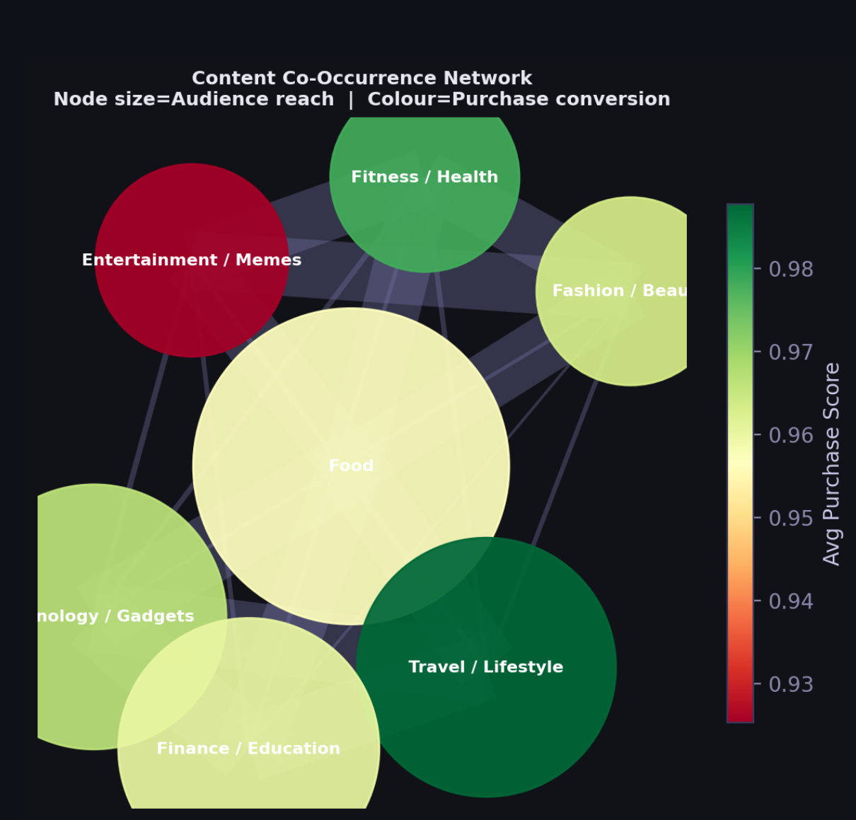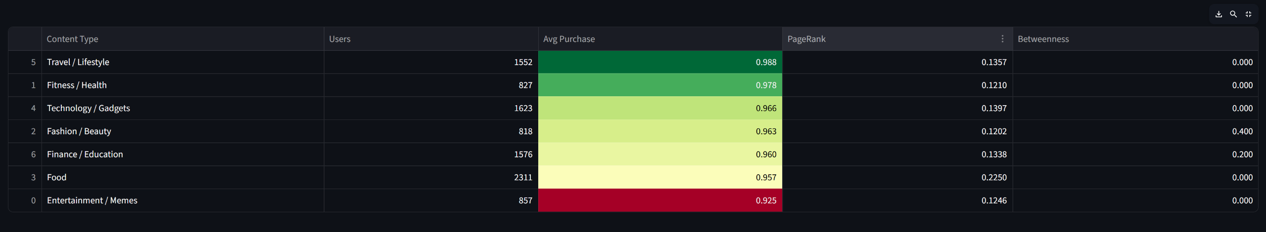

🧠 3. What “Content Co-Occurrence” ACTUALLY means
👉 Your data has rows like:
User 1 → Food; Travel; Fitness
User 2 → Tech; Finance
User 3 → Food; Fashion

🔗 What your code does
For each user:
👉 It connects content types used together
So:
- Food ↔ Travel (same user)
- Food ↔ Fitness
- Travel ↔ Fitness

💡 Meaning
“These content types are consumed together by the same person”

🎯 What does ONE respondent choosing multiple content types mean?
This is the key insight 👇
👉 It means:

🧠 That user does NOT think in categories
They behave like:
- “I watch food + travel reels”
- “I follow fitness + lifestyle influencers”

💥 Business Interpretation
👉 Users are multi-interest consumers
NOT:
❌ “only food audience”
❌ “only tech audience”
BUT:
✅ “clustered interests”

🔗 What does the NETWORK show?
Each connection (edge) =
“How often two content types appear together”

Example:
If many users do:
Food + Travel
👉 Strong edge between:
- Food ↔ Travel

🎨 What your visual means (VERY IMPORTANT)

Node size = Audience reach
👉 Bigger = more users consume it

Node color = Avg Purchase Score
👉 Green = high conversion
👉 Red = low conversion

🔥 Let’s decode YOUR graph

🟢 Travel / Lifestyle (Dark Green)
👉 Highest purchase (0.988)
💡 Meaning:
People consuming travel content are MOST likely to buy

🟡 Food (Biggest node)
👉 Largest audience (2311 users)
BUT:
👉 Lower conversion (0.957)
💡 Meaning:
Great reach, but weaker conversion

🔴 Entertainment / Memes
👉 Low conversion (0.925)
💡 Meaning:
High engagement, low purchase intent

🔗 So what does co-occurrence HELP with?
This is your main question 👇

❓ “If a user consumes multiple content types, what does it help?”

Answer:
👉 It helps you understand content pathways to purchase

🔥 Example insight:
User behavior:
Entertainment → Food → Travel → Purchase
👉 Meaning:
- Entertainment attracts
- Travel converts

🚀 REAL BUSINESS USE (VERY IMPORTANT)

🎯 1. Cross-content targeting
👉 Instead of:
❌ Only “food influencers”
👉 Do:
✅ Food + Travel combo campaigns

🎯 2. Funnel strategy
Stage | Content Type
Awareness | Entertainment
Interest | Food / Fitness
Conversion | Travel / Lifestyle

🎯 3. Influencer collaboration
👉 Choose influencers who:
- Post multiple content types
NOT:
❌ Single niche only

💥 KEY BUSINESS INSIGHTS FROM YOUR DATA

🔥 Insight 1:
“Travel/Lifestyle content drives the highest purchase conversion”

🔥 Insight 2:
“Food has the largest reach but weaker conversion—ideal for awareness, not final conversion”

🔥 Insight 3:
“Entertainment attracts users but does not convert—use it only as entry content”

🔥 Insight 4:
“Users consume multiple content types, so single-category marketing is ineffective”

🧩 FINAL STORY (PUT THIS IN REPORT)
Content co-occurrence analysis reveals that consumers engage with multiple content categories simultaneously rather than operating within a single niche.
While categories like Food and Entertainment attract the largest audience, they exhibit relatively lower purchase conversion rates, indicating their role in awareness and engagement stages of the funnel.
In contrast, Travel/Lifestyle content demonstrates the highest purchase conversion, suggesting its effectiveness in driving final purchase decisions.
The strong co-occurrence between content types indicates that consumer journeys are multi-touch and nonlinear, where different content categories influence different stages of the decision-making process.
Therefore, brands should adopt a multi-content strategy, leveraging high-reach categories for visibility and high-conversion categories for driving sales.

🎯 ONE-LINE VIVA ANSWER
“Content co-occurrence shows that users consume multiple content types together, and while some content drives attention, others drive conversion—so marketing should combine both.”

🔧 Extra twist here
👉 This network adds purchase behavior

Step 1: Co-occurrence
Same as platforms

Step 2: Add purchase signal
content_purchase[item].append(pur)
👉 For each content:
- Store purchase scores

Step 3: Node attribute
avg_purchase = np.mean(...)

🎯 Visualization meaning
Feature | Meaning
Node size | Audience reach
Node color | Avg purchase (conversion power)

💥 Metrics
nx.pagerank()
nx.betweenness_centrality()

🔥 Insight logic
top_buy = highest avg purchase
top_hub = highest PageRank
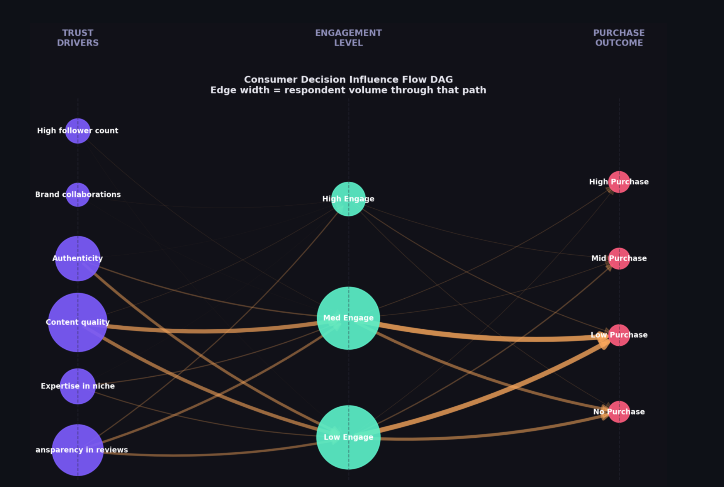
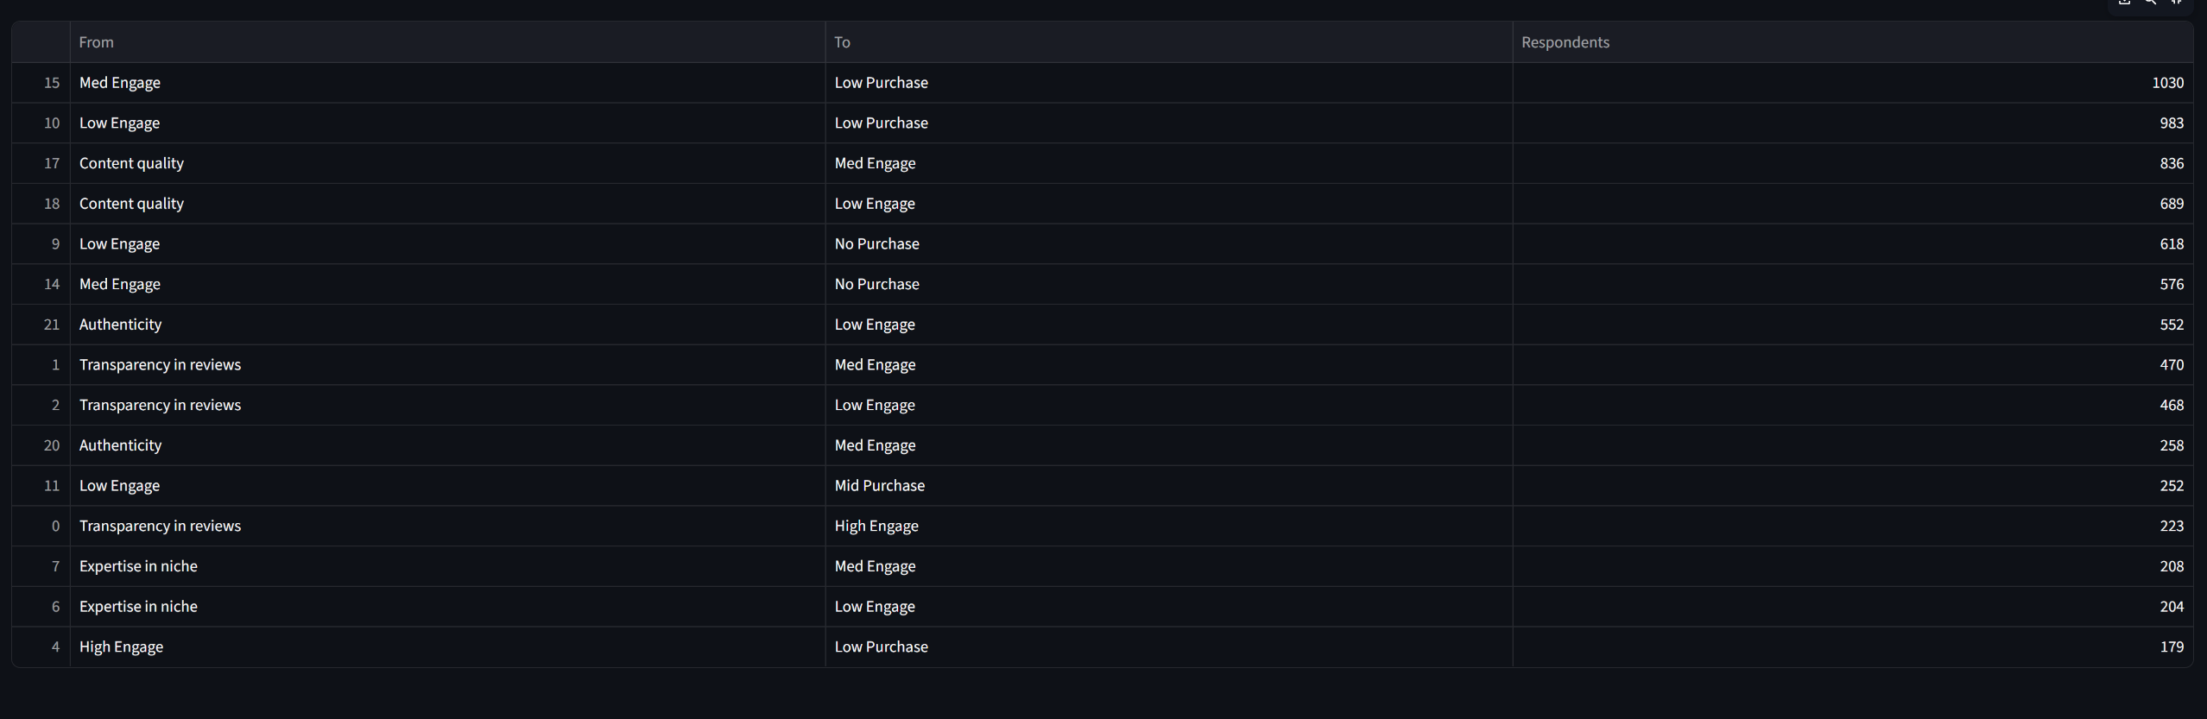

🔴 4. INFLUENCE FLOW DAG (MOST IMPORTANT)
This is the funnel model

🧠 1. What “Influence Flow DAG” means
👉 DAG = Directed Acyclic Graph
👉 In simple terms:
It shows the flow of user decisions step-by-step

🔗 Structure of YOUR graph
Trust Driver → Engagement Level → Purchase Outcome

Example path:
Content Quality → Medium Engagement → Low Purchase
👉 This is ONE user journey

⚙️ 2. What your code is doing
From your file

Step 1: Convert raw data
engage_map_sna
purchase_lbl_sna
👉 Converts:
- “Sometimes” → Med Engage
- “1-2 times” → Low Purchase

Step 2: Build flow edges
DAG.add_edge(t, e)
DAG.add_edge(e, p)
👉 For each respondent:
- Trust → Engagement
- Engagement → Purchase

Step 3: Count users per path
weight += 1
👉 Edge weight =
Number of users following that path

🎨 3. How to read YOUR graph

🟣 Left = Trust Drivers
- Content quality
- Authenticity
- Transparency
- etc

🟢 Middle = Engagement
- Low
- Medium
- High

🔴 Right = Purchase
- No purchase
- Low
- Medium
- High

📏 Edge thickness
👉 Thicker = more users

🔥 4. Let’s decode YOUR graph

🚨 MOST IMPORTANT PATTERN

🔥 Thickest path:
Med Engage → Low Purchase (1030 users)

💡 Meaning:
👉 People are:
- Engaging with content
BUT
- NOT converting to purchase

⚠️ Second big pattern:
Low Engage → Low Purchase (983 users)
Low Engage → No Purchase (618 users)

💡 Meaning:
👉 If engagement is low → purchase is almost zero

🔗 Trust → Engagement

Strong paths:
Content Quality → Med Engage (836 users)
Content Quality → Low Engage (689 users)

💡 Meaning:
👉 Content quality drives engagement
BUT not always high engagement

🔍 Transparency & Authenticity
👉 These also lead mostly to:
- Low / Medium engagement

🚀 5. So what does this HELP with?
This is your key question 👇

❓ “What does this graph tell about influencer impact?”

Answer:
👉 It shows:
Where the customer journey is breaking

💥 6. BIGGEST BUSINESS INSIGHT

🎯 FUNNEL PROBLEM
Trust → Engagement → Purchase
👉 Your data shows:
✔ Trust is working
✔ Engagement is happening
❌ BUT conversion is failing

💡 Conclusion:
“The problem is NOT awareness, it is conversion”

🔥 7. Real-world interpretation

Current situation:
Stage | Status
Trust | Good
Engagement | Moderate
Purchase | Weak ❌

🎯 8. BUSINESS ACTIONS

🔥 1. Fix conversion layer
👉 Add:
- Discount codes
- Clear CTA (“Buy now”)
- Limited offers

🔥 2. Improve content intent
👉 Current content:
- Engaging but not persuasive
👉 Add:
- Product benefits
- Reviews
- Demonstrations

🔥 3. Retarget engaged users
👉 Target:
- Medium engagement users
👉 Because:
- They are closest to purchase

📊 9. Top paths (from your table)

🔝 Examples:
Path | Meaning
Med Engage → Low Purchase (1030) | Engagement not converting
Content Quality → Med Engage (836) | Good trust driver
Low Engage → No Purchase (618) | Low engagement = no sales

🧩 10. FINAL REPORT STATEMENT
The influence flow analysis reveals that while trust drivers such as content quality and authenticity successfully generate user engagement, the transition from engagement to purchase remains weak.
A significant proportion of users are clustered in the medium engagement to low purchase path, indicating a critical bottleneck in the conversion stage of the decision-making funnel.
Additionally, low engagement consistently leads to no or minimal purchases, highlighting the importance of improving engagement quality.
Overall, the findings suggest that the marketing strategy is effective in building awareness and engagement, but lacks strong conversion mechanisms, necessitating targeted interventions such as personalized offers, stronger call-to-actions, and persuasive content strategies.

🎯 ONE-LINE VIVA ANSWER
“The DAG shows that users move from trust to engagement, but most drop off before purchase—so the main issue is conversion, not awareness.”

🔧 Step 1: Map categories
engage_map_sna
purchase_lbl_sna

Example mapping:
Raw | Converted
frequently | High Engage
1-2 times | Low Purchase

🔧 Step 2: Build flow
Trust → Engagement → Purchase
DAG.add_edge(t, e)
DAG.add_edge(e, p)

👉 For each user:
- Add path:
Content quality → Med Engage → Low Purchase

🔥 Edge weight
weight += 1
👉 Number of users following that path

🎯 Visualization meaning
Feature | Meaning
Layers | Funnel stages
Edge thickness | Number of users
Node size | Influence volume

📊 Path table
paths_df = [(u,v,weight)]
👉 Shows:
Most common behavior flows

💥 Key insight generated
Funnel Bottleneck → Engagement → Purchase
👉 Meaning:
- Users are engaging
- But not converting

🚀 7. WHY THIS SNA IS POWERFUL
Your dashboard is doing:
✅ Graph theory
✅ Behavioral modeling
✅ Funnel analysis
✅ Multi-variable relationships

🎯 FINAL VIVA EXPLANATION (USE THIS)
“The SNA module constructs multiple graph models from survey co-occurrence data. Platform and content networks capture user behavior overlaps, the bipartite graph links trust drivers to purchase motivations, and the DAG models the full decision funnel from trust to purchase. Edge weights represent respondent volume, and centrality measures like PageRank and betweenness identify the most influential nodes in the system.”

