Exploratory Data Analysis and Pharmacokinetic Assessment of the Theophylline Dataset

1.Abstract
This study presents an exploratory data analysis and preliminary pharmacokinetic assessment of the Theoph dataset. The dataset contains serum theophylline concentration measurements collected from 12 subjects following oral administration. Data quality, distributional characteristics, concentration–time relationships, and pharmacokinetic parameters were evaluated. Concentration values were found to be non-normally distributed (Shapiro-Wilk p < 0.05). Concentration–time profiles demonstrated the expected pharmacokinetic pattern consisting of absorption, peak concentration, and elimination phases. Significant inter-subject variability was observed. Area Under the Curve (AUC) analysis revealed notable differences in drug exposure across subjects. Linear regression showed poor explanatory power (R² = 0.092), whereas mixed-effects modeling was identified as a more suitable framework for future analyses. Overall, the dataset exhibits typical pharmacokinetic behavior and provides a useful foundation for advanced pharmacokinetic modeling.

2.Introduction
The Theoph dataset contains pharmacokinetic measurements of theophylline concentration in blood plasma collected from multiple subjects after administration of a single oral dose. The objective of this study is to perform exploratory data analysis, evaluate concentration-time relationships, estimate pharmacokinetic parameters, and investigate subject-level variability.

3. Objectives
The objective of this analysis is to understand the structure and characteristics of the Theoph dataset, evaluate the concentration-time relationship of theophylline, assess data quality and distributional assumptions, and obtain preliminary pharmacokinetic insights through exploratory data analysis.
- Explore data distribution and quality
- Assess concentration-time profiles
- Evaluate normality assumptions
- Calculate pharmacokinetic parameters (Cmax, Tmax, AUC)
- Examine inter-subject variability
- Identify appropriate statistical model

4. Methodology
Statistical Software
- R
- nlme package
- ggplot2 package
- pracma package
Analysis Workflow
- Data quality assessment
- Descriptive statistics
- Distribution analysis
- Normality testing
- Concentration–time visualization
- Correlation analysis
- Pharmacokinetic parameter estimation
- Statistical modelling

5. Dataset Description
Variables:
- Subject: Subject identifier
- Wt: Body weight (kg)
- Dose: Administered dose (mg/kg)
- Time: Sampling time after administration (hours)
- conc: Plasma concentration of theophylline (mg/L)
The dataset contains repeated measurements for each subject, making it a longitudinal dataset.
Dataset Structure
- Number of observations: 132
- Number of variables: 5
- Number of subjects: 12
The dataset represents repeated measurements collected from the same subjects over time and is therefore a longitudinal pharmacokinetic dataset.

6. Data Quality Assessment
Missing Values
No missing values were identified in any variable.
Duplicate Records
No duplicate observations were detected.
Interpretation:
The dataset is complete and suitable for further analysis without requiring data cleaning or imputation.

7. Descriptive Statistics

Concentration (conc)
Statistic | Value
Mean | 4.96 mg/L
Median | 5.28 mg/L
Standard Deviation | 2.87 mg/L
Minimum | 0.00 mg/L
Maximum | 11.40 mg/L

Weight (Wt)
Statistic | Value
Mean | 69.58 kg
Minimum | 54.60 kg
Maximum | 86.40 kg

Time
Statistic | Value
Mean | 5.90 hr
Maximum | 24.65 hr
Interpretation:
The concentration measurements show substantial variability among observations, which is expected in pharmacokinetic studies due to differences in absorption and elimination across subjects.

8. Distribution Analysis
Histogram of Concentration
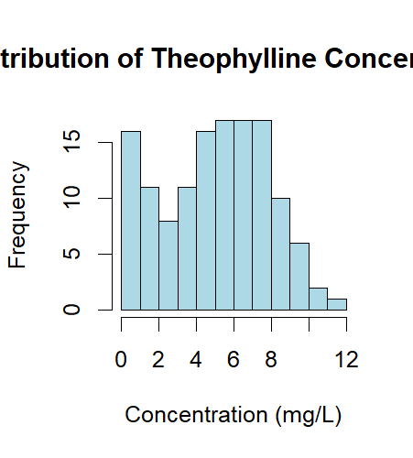
- As shown in Figure 1, the concentration distribution demonstrates moderate skewness and is not perfectly symmetric.

Interpretation:
- The distribution suggests that concentrations are spread across a broad range of values, reflecting both absorption and elimination phases.

Figure 1. Histogram of Theophylline Concentration Distribution
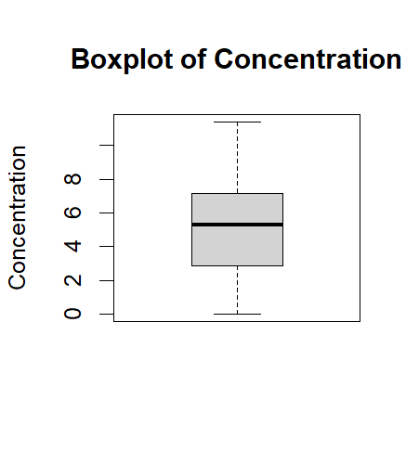
Boxplot of Concentration
As shown in Figure 2, The boxplot indicates a wide spread of concentration values.
- No extreme outliers were observed.
Interpretation:
- Observed high concentrations likely represent legitimate peak drug exposure rather than measurement errors.

Figure 2. Boxplot of Concentration

9. Normality Assessment
Q-Q Plot
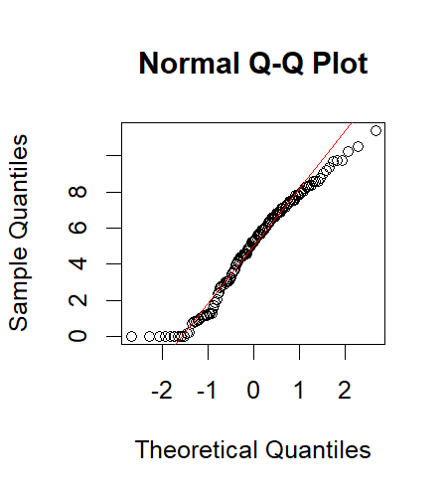
The Q-Q plot shows noticeable deviation from the reference line, particularly at the tails.
Shapiro-Wilk Test
Results:
- W = 0.9668
- p-value = 0.00257

Figure 3. Q-Q Plot with Reference Line
Interpretation:
- Since p < 0.05, the null hypothesis of normality is rejected.
The concentration measurements are not normally distributed.
Log Transformation
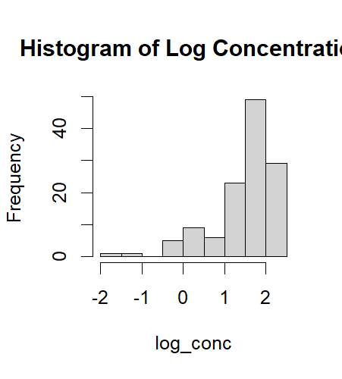
Nine observations contained concentration values equal to zero, resulting in negative infinity values after logarithmic transformation.
After removing non-finite values:
- W = 0.8327
- p-value = 1.69 × 10⁻¹⁰

Figure 4. Histogram of Log-Transformed Concentration.
Interpretation:
- The log-transformed concentrations also failed the normality test.
Therefore, neither the raw nor log-transformed concentration data follow a normal distribution.

10. Concentration-Time Relationship
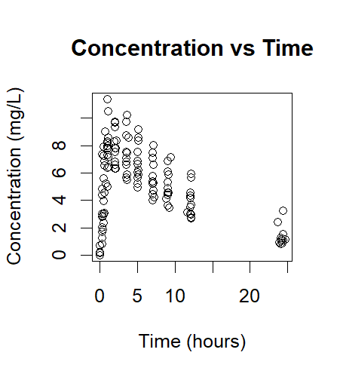
Scatter Plot: Concentration vs Time
As shown in the Figure5, The concentration-time plot shows a characteristic pharmacokinetic profile:
- Initial increase in concentration following administration.
- Peak concentration phase.
- Progressive decline over time.
Interpretation:
Figure 5. Scatter Plot: Concentration vs Time.
- This pattern reflects drug absorption followed by elimination.
- The relationship is clearly nonlinear.

11. Subject-Level Pharmacokinetic Profiles
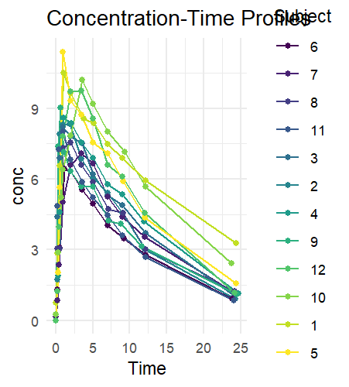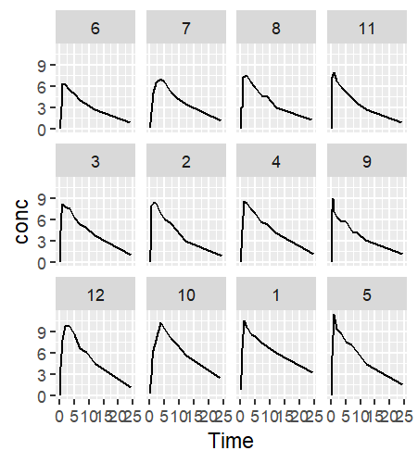
Figure 6. Concentration-Time Profiles for All Subjects. Figure 7. Subject-wise Concentration-Time Profiles
Individual subject concentration-time profiles show similar overall patterns but different peak concentrations and elimination rates.
Interpretation:
Significant inter-subject variability exists.
Possible causes include:
- Differences in body weight
- Metabolic variability
- Drug clearance differences
- Absorption rate differences
This variability supports the use of subject-specific or mixed-effects modeling approaches.

12. Weight-Concentration Relationship
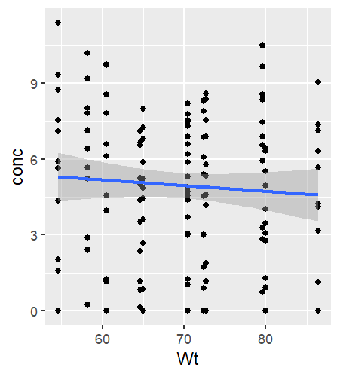
Figure 8. Weight vs Concentration with Linear Trend.

Correlation Analysis
Pearson Correlation:
r = -0.0718
Interpretation:
As shown in the Figure 8, The correlation between body weight and concentration is extremely weak.
No meaningful linear relationship was observed between body weight and concentration.
Weight alone does not appear to explain concentration variability.

13. Pharmacokinetic Parameters
Maximum Concentration (Cmax)
Subject | Cmax
5 | 11.40
1 | 10.50
10 | 10.21
12 | 9.75
Time to Maximum Concentration (Tmax)
Most subjects achieved maximum concentration between 1 and 4 hours after administration.
Interpretation
Theophylline absorption occurred relatively rapidly following administration.

14.Area Under the Curve (AUC)
AUC is a fundamental pharmacokinetic parameter that represents the total systemic exposure of a subject to the drug over time. It is calculated as the area under the concentration–time curve and provides an overall measure of the amount of drug that reaches systemic circulation.
AUC Comparison Across Subjects
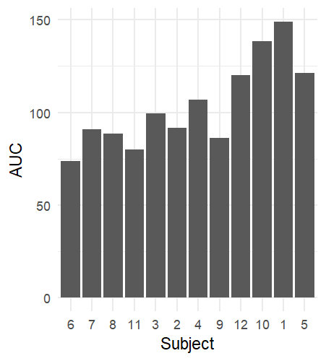
Figure 9. Area Under the Curve (AUC) by Subject.
Results
The calculated AUC values showed considerable variability among subjects, indicating differences in drug exposure and pharmacokinetic behaviour. The highest AUC values were observed in:
Highest Exposure
Subject | AUC
1 | 149.0
10 | 138.0
5 | 121.0
12 | 120.0
The lowest AUC value was observed for Subject 6 (73.8).
Interpretation
As shown in Figure 9, substantial variability exists in AUC across subjects. Subjects 1 and 10 exhibited the greatest overall drug exposure, whereas Subject 6 exhibited the lowest exposure. These differences suggest variability in individual pharmacokinetic characteristics such as drug absorption, distribution, metabolism, and elimination.
Higher AUC values indicate that the drug remained in systemic circulation for a longer duration or at higher concentrations, resulting in greater overall exposure. Conversely, lower AUC values may reflect reduced absorption or more rapid elimination of the drug.
The observed variability in AUC highlights the presence of inter-subject differences in theophylline pharmacokinetics and supports the need for subject-specific analytical approaches, such as mixed-effects pharmacokinetic modelling, to better characterize individual responses to the drug.

15. Statistical Modelling
Linear Regression
- R² = 0.092
- p = 0.0004
Interpretation:
The regression model indicated a statistically significant negative association between time and concentration (β = -0.1257, p = 0.0004). However, the model explained only 9.2% of the variability (R² = 0.092), indicating poor predictive performance.
Although time significantly influences concentration, the model explains only 9.2% of the observed variability.
The low R² indicates poor model performance.
Mixed Effects Model
A linear mixed-effects model was fitted with concentration (conc) as the response variable, time (Time) as a fixed effect, and subject (Subject) as a random effect to account for repeated measurements within individuals.
- The mixed-effects model accounted for repeated measurements within subjects and is therefore more appropriate for longitudinal pharmacokinetic data.

Model Results
Parameter | Estimate | Standard Error | t-value | p-value
Intercept | 5.701 | 0.318 | 17.91 | < 0.001
Time | -0.126 | 0.035 | -3.64 | 0.0004

Random Effects
Effect | Standard Deviation
Subject (Intercept) | 0.199
Residual | 2.736

Interpretation:
The mixed-effects model identified a statistically significant negative association between time and theophylline concentration (β = -0.126, p = 0.0004). On average, theophylline concentration decreased by approximately 0.126 mg/L for every additional hour following drug administration. The inclusion of subject-specific random effects accounted for variability between individuals and the correlation arising from repeated measurements within subjects. The estimated random intercept standard deviation (0.199) suggests modest between-subject variability, whereas the residual standard deviation (2.736) indicates substantial unexplained variability within subjects. Overall, the mixed-effects model is more appropriate than ordinary linear regression for this longitudinal pharmacokinetic dataset because it accounts for repeated observations from the same individuals.

16. Discussion
The analysis demonstrated that the Theoph dataset exhibits the characteristic pharmacokinetic profile expected following oral administration of theophylline. Concentration levels increased rapidly after administration, reached a peak concentration within the first few hours, and subsequently declined as the drug was eliminated from the body.
The substantial variation observed between subjects suggests the presence of biological variability in absorption, metabolism, and clearance mechanisms. The weak association between body weight and concentration indicates that additional physiological factors may contribute to drug disposition.
The non-normal distribution of concentration values is consistent with pharmacokinetic datasets and supports the use of specialized modelling approaches rather than traditional statistical methods relying on normality assumptions.
The concentration–time relationship exhibited a clear nonlinear pattern, indicating that ordinary linear regression is inadequate for accurately describing the underlying pharmacokinetic process. Because the dataset contains repeated measurements collected from the same subjects over time, a mixed-effects modelling framework is more appropriate as it accounts for both within-subject correlations and inter-subject variability. However, the concentration–time profiles demonstrated the characteristic pharmacokinetic phases of drug absorption, peak concentration, and elimination, which cannot be fully captured by a linear mixed-effects model. Consequently, nonlinear mixed-effects pharmacokinetic models are likely to provide a more realistic and biologically meaningful representation of the drug's behaviour and underlying pharmacokinetic mechanisms.

17.Conclusion
This analysis demonstrated that the Theoph dataset exhibits the expected pharmacokinetic behaviour of oral drug administration. Concentration values increased during absorption, reached a peak, and declined during elimination. Significant variability was observed among subjects.
The concentration data were not normally distributed, and simple linear regression was unable to adequately describe the nonlinear concentration-time relationship. Mixed-effects modelling represents a more suitable analytical framework for future studies.
Overall, the dataset provides a valuable foundation for advanced pharmacokinetic modelling and investigation of inter-subject variability.

