Adult-type grammatical relations in children's early language

Adult-type grammatical relations in children's early language*

ANAT NINIO
The Hebrew University of Jerusalem, Israel

To appear in Bokus, B. (Ed.), (2005). Studies in the psychology of child language (in honor of Grace Wales Shugar).

[*]I wish to thank the parents who participated in the study. Thanks are due to Dana Litman-Alperon who participated in the construction of the parental questionnaire and collected much of the data as part of the requirements of her Masters thesis and to Michal Arbili, Shani Ben Ari, Moria Flint, Keren Haroush, Yael Rebhun, Naama Reivenbach and especially Michal Ta-Shma and Lior Somech who took part in the collection of the questionnaire data and its analysis. The research reported in this paper was supported by grants from the Levi Eshkol Institute for Social, Economic and Political Research in Israel and from the Sturman Human Development Center of The Hebrew University of Jerusalem. Address for correspondence: Department of Psychology, The Hebrew University, Jerusalem 91905, Israel. E-mail address: msninio@mscc.huji.ac.il
Adult-type grammatical relations in children's early language

ABSTRACT

The reported study focused on the period of first word combinations, and its aim was to find evidence regarding the psychological reality of adult-type grammatical relations in children's early linguistic system. Hebrew-speaking children's production of four different kinds of two-word constructions was assessed on the basis of a parental report questionnaire, using a checklist technique. The constructions were subject-verb, verb-object and adjective-noun, and a control group of closed-class predicates and their complements. Each type of grammatical relation was represented by four concrete examples, using a simple vocabulary. The questionnaire was filled by 278 parents of young children between 1;2.15 and 2;10.15. The results showed that grammatically similar items were significantly more highly correlated in acquisition than unrelated items. The differential correlations were not accounted for by semantic similarity. It appears that young children do have some sense of adult-type grammatical relations right from the beginning of producing word-combinations.
Introduction
Piecemeal acquisition
Ever since the early days of modern developmental psycholinguistics, researchers have pointed out that young children's grammatical rules do not show uniformity of application across all potential lexemes. In particular, in most young children's speech there is a pronounced lack of uniformity in the syntactic frames in which different verbs appear in the same period. The relevant grammatical patterns for which this phenomenon has been documented include syntactic constructions expressing argument structures, wh-question constructions, and constructions with complement-taking matrix verbs getting to infinitives (e.g. Klima & Bellugi-Klima, 1966; Clark, 1978; MacWhinney, 1982; Maratsos, 1983; Slobin, 1985; Bloom, Rispoli, Gartner, & Hafitz, 1989; Tomasello, 1992). This phenomenon is the most conspicuous when some of the candidate lexical items are already within the children's productive vocabularies (e.g. Bowerman, 1976: 157). Typically it takes children several months to extend each new grammatical frame to 10 or 20 different verbs (e.g. Ninio, 1999; Kiekhoefer, 2002).
Are children's item-specific multiword formulae interrelated?
If children at the early stages of grammatical development learn to produce syntactic patterns in a piecemeal fashion, the question is, do they encode each lexeme-specific construction as a separate and unrelated piece of knowledge, or do they detect the relatedness of items expressing similar grammatical relations in terms of adult grammar? This question is explored in the reported study that focuses on the period of very first word combinations, and its aim is to find evidence regarding the psychological reality, or lack thereof, of adult-type grammatical relations in children's productive linguistic system at this period of development.
Piecemeal learning does not necessarily imply the absence of connections among the grammatical patterns of separate predicates. Even in such an abstraction-oriented theory of linguistic structure as Chomsky's (1981), it is assumed that the lexical entry of each verb registers the `subcategorization frames' of that verb on an individual basis. This does not mean that the `subcategorization frames' are defined in unrelated terms for different verbs; quite the contrary, the notation of syntactic behaviour within different specific lexical entries makes use of a small set of abstract category symbols and frames are defined as verb-general patterns. Namely, theoretical linguistics acknowledges the need to register on an individual basis which structure applies to which predicate, regardless of the generality of the structures and constructions themselves. Moving to developmental psycholinguistics, we, too, need to acknowledge that there is a pronounced lexical element in syntactic knowledge whichever way it is defined in children's internalized grammar, and this could be the reason for the verb-specific learning of argument structure constructions in young children. Beyond that, it is an open question whether or not young children's verb-specific combinatory formulae are related to each other in cases where they express similar grammatical relations.
Recent findings have raised the intriguing possibility that adult-type grammatical relations do have a functional role in the process of syntactic development at its earliest stages. First, three priming experiments found that it is possible to increase significantly 2 1/2 year old children's tendency to use the transitive construction with novel nonce verbs which have not been introduced to them in this construction, if the children are first trained with transitive sentences using other verbs (Tomasello & Brooks, 1998; Childers & Tomasello, 2001; Abbot-Smith, Lieven & Tomasello, 2004). Importantly, the priming effects were not influenced by the degree of semantic similarity of the primer verbs to the novel verbs, suggesting that the priming was triggered by the formal and not the semantic similarity of the different transitive constructions.
Naturalistic longitudinal observations also suggest that verb-specific constructions expressing the same adult-type grammatical relation are in a facilitatory relation with each other. Typically, the growth curves plotting the cumulative number of different verbs in the same syntactic construction as a function of age at first production have an accelerating slope. Namely, the more verbs a child already knows how to combine in a certain syntactic pattern such as the subject-verb-object or the ditransitive constructions, the faster he or she learns new ones in the same pattern (Ninio, 1999; Kiekhoefer, 2002; Abbot-Smith & Behrens, 2003). Apparently, children's lexically specific, item-based learning of individual word-combinations for some verbs facilitates the lexically specific, item-based learning of a similar construction for other verbs. Ninio (2005) checked the degree of semantic similarity among the items forming the accelerating growth curves and found that most items were not preceded by semantically similar antecedents, suggesting that it is formal and not semantic similarity that underlies the facilitation of learning implied by the acceleration of the learning curves.
The research strategy of the present study for testing the organization of early grammars
The results above suggest formal connectedness among verb-specific combinatory formulae in early child grammars that match adult grammatical lines but they are by no means conclusive. The present study used a new design to approach the question of formal relatedness among early combinatory formulae. The research strategy involved assessing the production of some early combinatory formulae by a sample of young Hebrew-speaking children at the start of multiword speech, then correlating the scores of the different item-specific formulae across the sample. On the hypothesis that item-specific formulae are acquired independently, all items should be equally correlated, whether or not they expressed the same grammatical relation on adult principles. For example, the presence of one formula expressing the verb-object relation in children's speech should not predict the presence of other ones expressing the same relation more than of formula expressing, for instance, the subject-verb relation. On the alternative hypothesis that the learning of one multiword format facilitates the learning of others which are formally similar to it, we expect higher correlations between items exemplifying identical syntactic constructions than between items expressing different syntax. Thus, it is expected that two verb-object combinations using different verbs would be more highly correlated that an item expressing the verb-object relation with an item expressing the subject-verb relation. Namely, knowing one verb-object item should make it more probable that the child knows other ones of the same kind.
The study mapped the production of 16 different item-specific formulae, four of them expressing the subject-verb (SV) relation, four, the verb-object (VO) relation, and four, the noun-adjective (NA) relation. For example, the SV relation was represented by the Hebrew equivalents of 'X came', 'X went', 'X fell' and 'X sleeps'. In addition, four other multiword patterns involving closed-class, nonverbal predicates and their complements (PC) constituted a control group as they did not form a grammatically homogenous group on adult grammatical principles. The four items were (in English translation): 'more X', 'no X', 'where X', and 'here X'. We looked for intercorrelations among these items in the speech of a large group of young children, and contrasted within-group correlation coefficients with between-group ones. In addition, we contrasted the intercorrelations in the three grammatically homogenous groups with those of the control group. Unrelated learning as well as nonspecific transfer and facilitation should generate about the same correlations among all of kinds of items. If, however, syntactic similarity has a role in learning, it should show up in higher correlations in both kinds of comparisons.
Method
Participants
A sample of 278 parents to young children was located through well-baby clinics, daycare centers, kindergartens, and informal recruiting. The parents were recruited in three areas of Israel: Jerusalem, the Negev or Beer Sheva area, and in the North of Israel. The parents completed a short demographic questionnaire describing the child's gender, birth date, birth order and number of siblings; the languages besides Hebrew spoken at home, as well as the parents' level of education. They were also asked for information about the medical history of the child, including pregnancy and birth, and whether the child had been diagnosed or treated by a speech pathologist.
The children included in the sample were between 1;2.15 and 2;10.15, half of them male, half female, with no diagnosed speech pathology or neurological problems. The sample was heterogenous with respect to children's number of siblings and birth orders and the parents' educational level. The mean age was 1;11.01, (S.D. 4.0). Only children who already produced multiword utterances were included in the sample. A further criterion was that the children produced at least one of the 16 items of the checklist. In five cases the parents reported that children had already began to combine words into multiword combinations but these were not the items included in the checklist; they were contacted again after about a month and asked to fill the questionnaire again.
Materials
Parental checklist
A parental checklist was developed for the study, containing 16 types of two-word utterances children typically produce at the start of multiword speech. Parents were presented with three examples of each sentence type and asked if their child produced similar sentences; if they answered positively, they were asked to provide examples of sentences of that type that their own child produced.
The checklist covered three grammatical relations, exemplified by four items each, and a control set of four unrelated items. The grammatical relations were:
1. Subject - Verb (SV), using the intransitive verbs ba `come', halak `go', nafal `fall', yashan `sleep' (e.g. Ima baa, `Mommy came'). The canonical word-order of this construction in Hebrew is SV, except for the verb nafal `fall' which often generates VS patterns.
2. Verb - direct object (VO), using the transitive and ditransitive verbs natan `give', raca `want', hevi `bring' and laqax `take' (e.g. Rotze kadur, 'Want ball'). The canonical word-order of this construction in Hebrew is VO.
3. Noun - Adjective (NA) constructions, the examples allowing both for an attributive adjective modifying a noun (e.g. Baqbuq gadol, 'Big bottle') and predicative adjective with subject (e.g. Ha-kadur gadol 'the-ball (is) big'). The canonical word-order of both construction in Hebrew is NA, and the difference is in the asymmetrical use of the definite article ha- in predicative combinations. At the two-word stage when children mostly drop the article, it is largely impossible to differentiate between predicative and attributive uses of noun-adjective combinations. The following adjectives were used: adom `red', gadol `big', qatan `small', and yafe `pretty'.
4. Closed-class predicate with complement (PC). The predicates used were od `more', lo `no', eifo `where' and hine `here' (e.g. Od mayim 'more water'). The closed-class predicates belong to four different form-classes in Hebrew grammar: quantifiers, negators, wh-question words, and a class containing only the unique predicative adverb hine. The canonical word-order of two-word constructions with all four predicates is PC, namely, Predicate-Complement.
The order of the 16 items representing the four different grammatical relations was randomized in the questionnaire. The order was: SV: ba `come', NA: adom `red', NA: gadol `big', SV: yashan `sleep', VO: natan `give', PC: hine `here', PC: eifo `where', PC: od `more', SV: halak `go', VO: raca `want', NA: qatan `small', PC: lo `no', VO: hevi `bring', SV: nafal `fall', VO: laqax `take', and NA: yafe `pretty'.
For each item, parents were provided with three examples using the relevant predicate, e.g. the specific verb in the case of SV combinations. For example, the SV pattern with the verb ba `come' was exemplified by the three sentences Ha-kelev ba `The-dog came', Ima baa `Mommy came', and Ha-ish ba `the-man came'. They were asked to indicate if their child was already producing these or similar sentences, and to give some examples of actual sentences their child was saying. The latter were used to ascertain that parents had understood the definition of the relevant item, and as a basis for feedback on their answers.
All the words used in the checklist were highly familiar. In particular, the verbs, adjectives and closed-class predicates were among the 10 most frequent in their respective category to be used in word-combinations by a sample of 40 Hebrew-speaking children in the 1;0-2;8 age range (Ninio, 1984). In the case of verb-direct object combinations, the choice of verbs was also directed by the very first set of transitive verbs Hebrew-speaking children were found to combine in verb-object constructions (Ninio, 1999).
In addition to the checklist, parents were asked to list any other type of word-combination produced by the children, including three-word combinations. The wording of the questionnaire and checklist was finalized in a pretest on a group of 20 parents.
Scoring of parental checklist
Children were given credit for a particular item in the checklist if they produced the desired kind of word-combination (e.g. SV) using the relevant predicate (verb, adjective, or closed-class predicate) regardless of its inflection for tense, person, number or gender. The example sentences supplied by parents for items they marked as having been produced by the children were evaluated and items were re-scored if the parents made a mistaken attribution. In addition, the sentences listed by parents as examples of other kinds of word-combinations were scrutinized and the scoring of the checklist was revised accordingly. For instance, sometimes parents listed a longer sentence embedding some word-combination but did not mark the checklist positively on the relevant two-word item. In these cases the child was credited also with the two-word combination.
Results and discussion
Each item was scored 1 if the child was producing the relevant word-combination and 0 otherwise. The mean score in the sample out of a maximum of 16 was 9.54 (S.D. 4.90), the range between 1 to 16. The wide distribution of the scores showed that the sample adequately represents children at the very start of combinatory speech.
Testing the grouping of items with Smallest Space Analysis
Children's scores on the 16 items of the checklist were subjected to a Faceted Smallest Space Analysis (F-SSA, Shye, Elizur & Hoffman, 1994). SSA is a statistical procedure whereby a matrix of intercorrelations or other measures of relative distance between variables is mapped onto spacial distances, aiming at the smallest-dimensional space possible. The `faceted' or F version of the SSA program allows, in addition, the testing of a priori hypotheses about the grouping of the data. In the present case, the program generated non-parametric Monotonicity Correlation Coefficients between each pair of items and mapped these to two-dimensional space. For the 12 items belonging, in adult grammar, to the categories subject-verb, verb-object and noun-adjective, we tested the hypothesis that they group in the developmental data according to the categories they form in adult grammar. This means that the 12 grammatically classifiable items were expected to organize in two-dimensional space, forming 3 separate regions. Figure 1 presents the results.

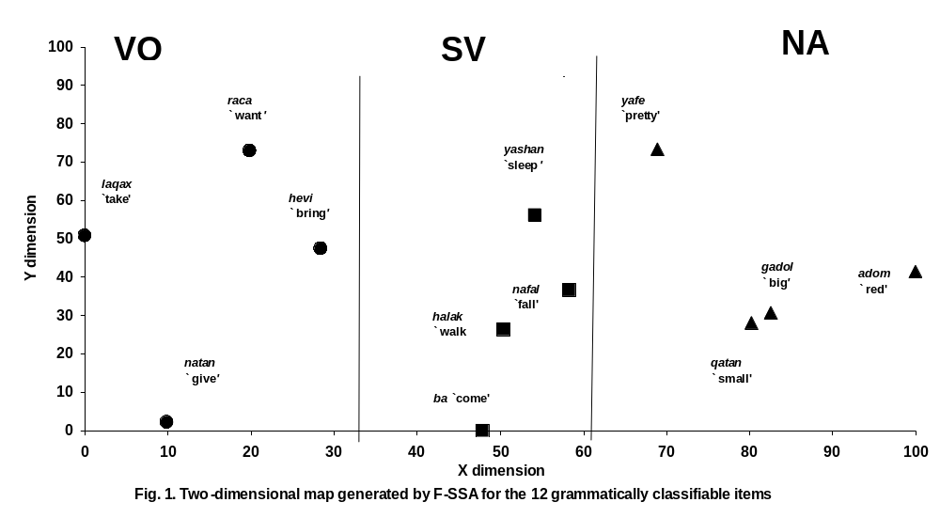
In the two-dimensional map three clear regions emerged, one each for SV, VO, and NA items. The measure for the fit of an n-dimensional solution is the Coefficient of Alienation; in the present case the value of the coefficient for a two-dimensional solution was 0.15, which is considered indicative of a good fit (Shye et al., 1994: 125). The hypothesis that the 12 items will be grouped according to the grammatical relation expressed was confirmed. The figure shows a perfect partitioning of the concept-space into three distinct regions according to the grammatical categorization of the items, organized in parallel. The measure for the partitioning of space according to the hypothesis is the Separation Index; in the present analysis the index had the maximal value of 1.00 and the number of deviant points (items positioned outside their expected region) was 0. Therefore, we can conclude that the four items, respectively, of SV, VO, and NA do form groups in early child grammars.
The three categories were organized in space so that the SV category was in the middle, in between the items of the VO and the NA categories. The SV grammatical relation is apparently the most central among the three explored in this study, being more highly related to the two others than they are to each other.
PC items were a control group, not forming a homogenous group on adult grammatical principles. To test the hypothesis that PC items do not form a group on their own in child grammar either, a second F-SSA program was run in which we tested the data for four a priori categories: for SV, VO, and NA, as before, as well as for PC. The results showed that the 16 items did not fall into 4 categories in two-dimensional space. First, the two-dimensional solution was unacceptable, the Coefficient of Alienation was 0.26, which is considered a bad fit (Shye et al., 1994: 125). Second, the measure for the partitioning of space according to the hypothesis, the Separation Index, was 0.92, 0.87, and 0.87 for three different models of spacial organization, the axial (i.e., parallel regions), angular (i.e., regions organized as fanning out from a point) and the radial (i.e., concentric circles). The number of deviant points was 2, 2, and 4 for the three models. The separation indices were too low and the number of deviant points were too many for what is considered an acceptable solution. Namely, the attempt to define four a priori categories in these data was not successful. It is possible to conclude that the four items of PC do not form a class of their own in early child grammar, comparable to the classes formed by the items expressing the SV, VO, and NA relations.
Contrasting correlations with class-mates and with unrelated items
In order to explore the results in finer detail, the relation among the items was also examined by parametric statistics. Pearson product-moment correlation coefficients were computed between each pair of items. Pearson coefficients are acceptable approximate statistics for binary data such as the yes/no scores in the present study.
Figure 2 presents the average within-group correlations of the four items belonging to the SV, VO, NA, and PC groups, compared to the average correlations with members of other groups. For each group there were six within-class (i.e., classmate) correlations and 48 correlations with unrelated items.
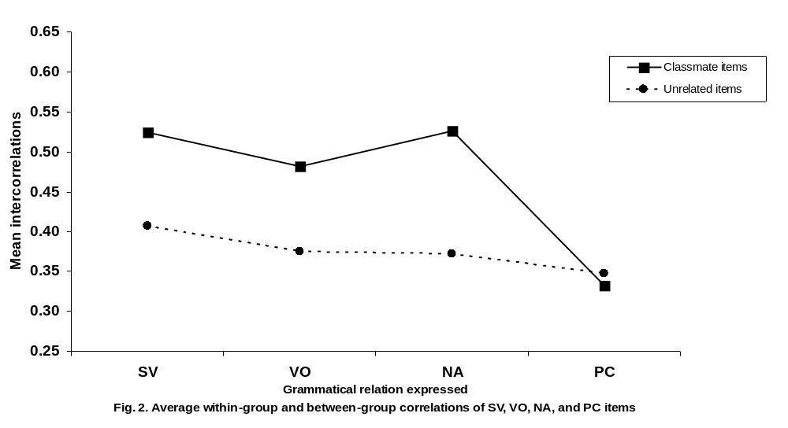
The difference between correlations with classmates and with unrelated items was tested by two-tailed t-tests, for each of the groups SV, VO, NA, and PC separately. It was found that in the SV, VO, and NA groups the classmate correlations were significantly higher than the correlations with unrelated items (SV: t(52) = 3.03, p < 0.01; VO: t(52) = 2.95, p < 0.01; NA: t(52) = 2.65, p < 0.05).
Overall, the 12 items belonging to the grammatically homogenous groups had significantly higher correlations with classmates than with unrelated items. The mean inter-correlation with classmates was 0.51, with unrelated items it was 0.37, a difference of 0.14 (t(112) = 5.36, p < 0.001). In terms of percent of variance explained (R²), the correlation with a classmate explained a mean 26.2% of the variance of a given item, whereas the correlation with an unrelated item explained a mean 14.1% of the variance, namely, on the average, a classmate accounted for almost twice as much variance as an unrelated item.
In the PC group, the mean inter-correlation with putative classmates was 0.33, and with unrelated items, 0.35. This difference was not significant by t-test (t(52) = 0.30, p > 0.05). The percent of variance explained was 11-12%, namely, about the variance explained by unrelated items in the case of the grammatically classifiable items. It appears that word-combinations employing closed-class, nonverbal predicates are no more similar to other combinations with closed-class predicates than to ones using verbs and adjectives.
In addition, the three different grammatical groups did not differ in their average correlations with the PC items (SV vs. VO: t(30) = 0.93, VO vs. NA: t(30) = 1.19, p > 0.05), suggesting that PC items do not form specific relations with either the SV, the VO, or the NA kind of items.
The item with which each word-based formula is the most correlated
Lastly, we asked, what is the item with which each word-based formula is the most correlated. Table 1 presents the results.
Table 1. The item with the highest correlation with each item of the checklist

Items of the checklist | Highest correlated item | Correlation coefficient
X ba `X come' | X yashan `X sleep' | .51
X halak `X go' | X yashan `X sleep' | .58
X nafal `X fall' | X yashan `X sleep' | .60
X yashan `X sleep' | X nafal `X fall' | .60
natan X `give X' | hevi X `bring X' | .51
raca X `want X' | hevi X `bring X' | .55
hevi X `bring X' | raca X `want X' | .55
laqax X `take X' | hevi X `bring X' | .51
X adom `red X' | X gadol `big X / X qatan `small X' | .54
X gadol `big X' | X qatan `small X' | .72
X qatan `small X' | X gadol `big X' | .72
X yafe `pretty X' | X qatan `small X' | .48
od X `more X' | X halak `X go' | .51
lo X `no X' | eifo X `where X' | .56
eifo X `where X' | X halak `X go' | .34
hine X `here X' | eifo X `where X' | .46

In all 12 items belonging to clear grammatical-relation categories, the highest correlation is with a classmate. It is not so in the PC group where two of the four items are best correlated with a verb-based pattern and not with another closed-class item.
Interestingly, in each group there emerged one or two central items with which all the others were most highly correlated. In the SV group it was X yashan `X sleep', in the VO group, hevi X `bring X', and in the NA group the contrastive pair X gadol `big X and X qatan `small X'. The central item was not the one that had the closest semantic similarity to the majority of the other items in its category, or even to any of the other items. Thus, X yashan `X sleep' is not semantically similar to X ba `X come', X halak `X go', X nafal `X fall', and its centrality in the SV group cannot be on the basis of its semantics. Similarly, `big X' and `small X' are not semantically similar to `red X' and `pretty X'. In general, except for the couple `big'/`small', it is difficult to find any evidence for closer relations among combinatory formulae on the basis of semantic similarity that on the basis of sheer formal similarity.
Conclusions
The method of correlating item-based combinatory formulae in acquisition data has not been applied previously, probably because the typical research design for studying syntactic development is longitudinal with few subjects, and not cross-sectional with a large sample, as in the present study. The results of the present study indicate that when children's item-specific formulae are inter-correlated in a large sample, the conditional probability of finding one kind of format is higher if the child also produces at the time another word-combination of the same grammatical type. For example, when a child produces a combination type such as Ima baa `Mommy comes', there is a higher probability that she will have in her productive repertoire at that time period another combination expressing the subject-verb relation than, for instance, a verb-object one. The results suggest that item-based combinatory formulae produced at the earliest stages of multiword speech are interrelated in acquisition, rather than each verb being its own island of organization in an otherwise unorganized system, as suggested, for example, by the Verb Island hypothesis (Tomasello, 1992).
High correlations between a given pair of combinatory formats can point to coordinated learning. For example, it is possible that many young children learn the two word-combinations X gadol `big X' and X qatan `small X' together, as a pair of contrastive expression-types. This would explain why these two items are highly correlated in the present acquisition data. The same explanation, however, cannot account for other high correlations between items in the checklist. For instance, X gadol `big X' is also highly correlated with the item X adom `red X', and in this case there is very little likelihood that the two formats are learned in the same context.
As items are not on the main learned simultaneously, high correlations between combinatory formulae can probably be interpreted as pointing to the operation of transfer of learning and facilitation. According to the present findings, in syntactic development there is apparently both nonspecific facilitation and facilitation depending on the specific grammatical relation expressed in the formula. SV, VO, and NA items facilitate each other about twice as much as grammatically unrelated items facilitate each other. The early-acquired PC items apparently facilitate later-learned items indiscriminately, reflecting small nonspecific gains from learning basic principles of the production of word-combinations.
The data appears to exclude the possibility that the relationships found between items rely heavily on semantic similarity. The size of the correlation coefficients appears not to be proportional to similarity of meaning between the items. It seems that formal grammatical similarity underlies the relations among combinatory formulae, and not something less formal such as similarity in semantics, or else in sheer word-order of the pivotal element and its variable slot-filler. Thus, the present study supports the tentative conclusion reached in previous studies that seemed to indicate the presence of formal transfer in syntactic development. This includes the priming experiments reviewed above (e.g. Abbot-Smith et al., 2004) and suggests that priming was indeed triggered by formal and not semantic similarity between the primes and the novel constructions. In addition, it strengthens the conclusion that the accelerating growth curves of specific constructions obtained in naturalistic observations (e.g. Ninio, 2005) reflect facilitation based on formal and not semantic similarity between the items.
It appears that young children do have some sense of adult-type grammatical relations right from the beginning of word-combinations. At the earliest stage of syntactic development, the grammatical relations that apparently have psychological reality in children's internalized grammar are subject-verb, verb-object, and adjectival adjunct of nouns. Piecemeal learning shows that their knowledge is not abstract and it is unlikely to be innate. Instead, the combination of item-specific learning and mutual facilitation points to similarities between individual concrete items as the organizing dimensions of children's repertoire of combinatory formats. Detection of similarity need not necessarily imply that the child is in possession of abstract schematic knowledge about the grammatical relation or the categories participating in it. It could merely be that the child is able to react to shared or analogous structural features of the word-combinations regardless of specifics. Further study is needed to determine what features of word-combinations children's processing of grammatical similarity is based on.
References
Abbot-Smith, K. & Behrens, H. (2003). Construction conspiracies in the acquisition of the German passive. Unpublished manuscript, Max Planck Institute for Evolutionary Anthropology, Leipzig, Germany.
Abbot-Smith, K., Lieven, E. & Tomasello, M. (2004). Training 2;6-year-olds to produce the transitive construction: the role of frequency, semantic similarity and shared syntactic distribution. Developmental Science, 7, 48-55.
Bloom, L., Rispoli, M., Gartner, B., & Hafitz, J. (1989). Acquisition of complementation. Journal of Child Language, 16, 101-20.
Bowerman, M. (1976). Semantic factors in the acquisition of rules for word use and sentence construction. In D. Morehead & A. Morehead (eds), Directions in normal and deficient child language. Baltimore: University Park Press.
Childers, J., & Tomasello, M. (2001). The role of pronouns in young children's acquisition of the English transitive construction. Developmental Psychology, 37, 730-48.
Chomsky, N. (1981). Lectures on government and binding. Dordrecht: Foris.
Clark, E. V. (1978). Discovering what words can do. Papers from the Parasession on the Lexicon, CLS 14. Chicago: University of Chicago Press.
Kiekhoefer, K. (2002). The acquisition of the ditransitive construction. Paper presented at the Ninth International Congress for the Study of Child Language and the Symposium on Research in Child Language Disorders (IASCL/SRCLD), Madison, Wisconsin, July 16-21.
Klima, E. S. & Bellugi-Klima, U. (1966). Syntactic regularities in the speech of children. In J. Lyons & R. J. Wales (eds), Psycholinguistics papers. Edinburgh: Edinburgh University Press.
MacWhinney, B. (1982). Basic syntactic processes. In S. Kuczaj (ed.), Language development: Vol. 1. Syntax and semantics. Hillsdale, NJ: Erlbaum.
Maratsos, M. (1983). Some current issues in the study of the acquisition of grammar. In P. H. Mussen (ed.), Handbook of child psychology: Formerly Carmichael's manual of child psychology. Fourth edition. New York: Wiley.
Ninio, A. (1984). Functions of speech in mother-infant interaction. Final Science Report to the United States-Israel Binational Science Foundation (BSF), Jerusalem, Israel.
Ninio, A. (1999). Pathbreaking verbs in syntactic development and the question of prototypical transitivity. Journal of Child Language, 26, 619-653.
Ninio, A. (2005). Testing the role of semantic similarity in syntactic development. Journal of Child Language 32, 1–27.
Shye, S., Elizur, D. & Hoffman, M. (1994). Introduction to facet theory: Content design and intrinsic data analysis in behavioral research. Thousand Oaks, CA: Sage.
Slobin, D. I. (1985). Crosslinguistic evidence for the language-making capacity. In D. I. Slobin (ed.), The crosslinguistic study of language acquisition, Vol. 2. Hillsdale, NJ: Erlbaum.
Tomasello, M. (1992). First verbs: A case study of early grammatical development. Cambridge: CUP.
Tomasello, M. and Brooks, P. (1998). Young children’s earliest transitive and intransitive constructions. Cognitive Linguistics, 9, 379-395.

