Syntactic development: Lessons from complexity theory
Anat Ninio
Paper presented at the Eight Annual Gregynog/Nant Gwrtheyrn
Conference on Child Language, 6-8 April, 2006
Based on Chapter 5 of Ninio, A. (in press). Valency and the Learning Curve: The acquisition of syntax. London: Oxford University Press.

Complex systems

Complex systems consist of a large number of connected components, typically many different kinds linked by multiple relationships, interfaces or interactions, forming an intricate structure. Language undoubtedly qualifies as a complex system, and it pays off to approach its acquisition with methods and viewpoints originating in complexity theory.

It is customary to represent a complex system graphically as a network. Figure 1 presents a hypothetical network.

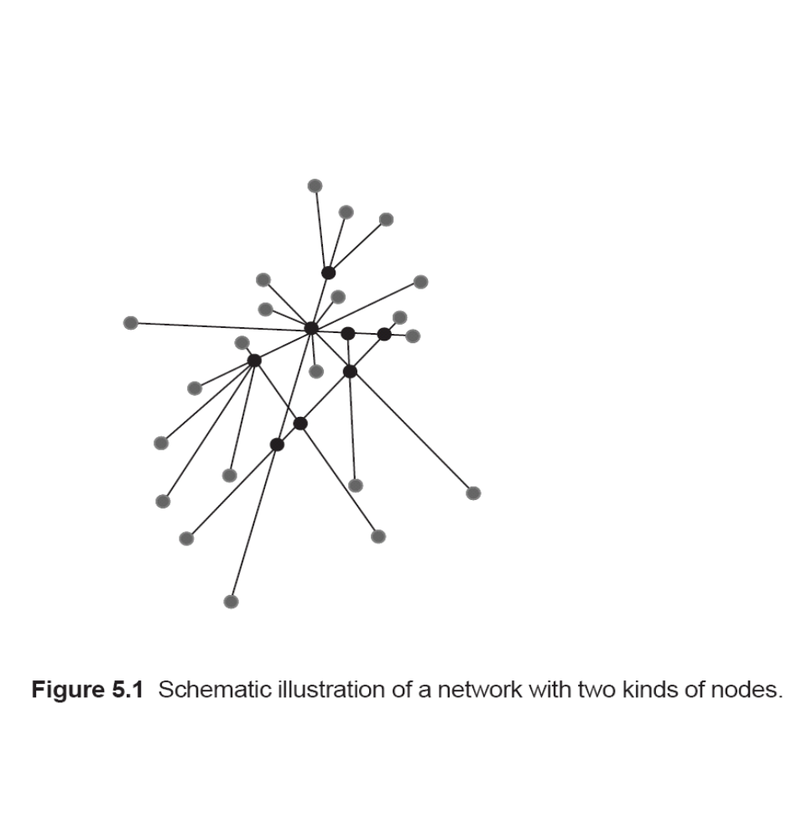

A network (or net) is a directed graph consisting of nodes (vertices) that represent the entities, and of links (edges, arcs, pointers or connections) that represent relations between the entities.
Naturally occurring networks share an important global statistical feature that is an extremely skewed distribution of the number of links connected to nodes. A few nodes have a very large number of links, whereas most nodes have only a very few. The distribution of the node connectivities can be best described by a power-law function, or, in some cases, by an exponential function, never by a Gaussian normal distribution.

Zipf's Law

A central example of the skewed distribution characteristic of complex networks is Zipf's Law. It is a very old finding, and it has the status of a universal law, that if we take a very large collection of items forming a complex systems and rank the items in order of their frequency, we get a severely skewed distribution, with a few very frequent items and very many infrequent ones. According to the Zipf-Mandelbrot law, this distribution follows a power-law function. Importantly, Zipf's Law applies also to the rank/frequency distribution of words in a large corpus.

Figure 2 presents a Zipf-curve, plotting the token frequency of words in a large speech corpus. We shall see in a minute how to derive Zipf's rank/frequency distribution from a network representation.

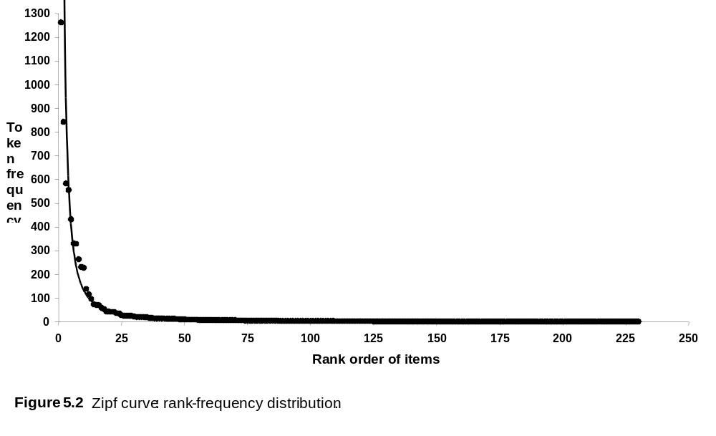

The language web

It is well-established that language is a complex network, with many different types of linguistic units and many different kinds of relations between units.

Let us imagine the language environment from the point of view of young children faced with the task of learning to speak. The children are confronted with an intricate and multi-layered complex network. It consists of linguistic units of many different types and sizes, be it words, sentences, phonemes, morphemes, intonation patterns, stress patterns and more, with diverse relationships among them.

For our present purpose, the important point is that the language network also consists of speakers, linked to the linguistic units by the act of producing them. In the following, we shall ignore the links among the linguistic items (for example, of semantic similarity) and among the different speakers, and will focus only on the speakers-words network abstracted out of the total complex language system.

Bipartite network

In our speakers-words network we represent two kinds of entities: words and speakers. Each word is represented by one kind of node, and each speaker (or speech-event), by a node of another kind. We are ignoring inter-word relations and only concentrating on directional links between speakers and words they produce.

The graph we have defined is a so-called bipartite network. Figure 3 presents a hypothetical bipartite network of words and speakers.
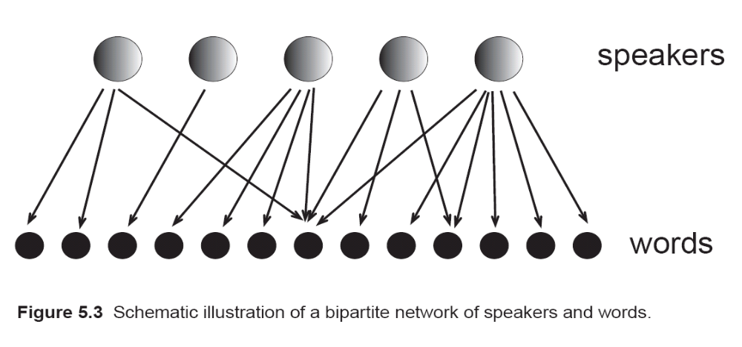
In a bipartite graph there are two types of nodes, with links running only between unlike types. In our case, the nodes are linguistic items and speakers; the links are unidirectional, representing the act of production of a certain linguistic item by a speaker.
In networks, the number of links of a given node is called its degree. For directed graphs each node has both an in-degree and an out-degree. The node's in-degree is the number of directional links having the node as their target, and the node's out-degree is the number of directional links leaving the node and targeting some other node. In the bipartite network of speakers and words, we get the words' frequency of use as the in-degree of word-nodes.

Similarity to the WWW

Modelling language as a complex system consisting of both speakers and the words they produce puts in high relief the similarity between language use and surfing in the World-Wide Web (WWW). A surfer of the WWW is a user of the Web, but, at the same time, he or she is also a component of the Web: it is impossible to use the WWW without linking to it and hence becoming part of the network. Similarly, language is a joint produce of all the people speaking it; emitting some utterance is both using and creating language.

Preferential attachment

We know quite a lot about the behaviour of new users vis a vis the Web. They appear to follow a principle called `Preferential Attachment' (Barabבsi & Albert, 1999) and link their homepages to pages that are already highly connected, in preference to pages with few or no connections. However, we should not confuse the principle of Preferential Attachment with a gross frequency effect, as it only works conditional on the users' focus of interest. Indeed, this principle acts rather like the Google search engine's original PageRank algorithm (Brin & Page, 1998): The starting point is always the content users are looking for, and only then do considerations of relative popularity enter into the choice of the preferred websites. A site describing Britney Spears' wardrobe may be among the most popular sites in the year 2005 in terms of absolute number of visits, but Google will not offer it as a first choice to a user looking for information on reasonable apartments for rent in New York City. It may offer the homepage of Craigslist instead, based on its immense relative popularity among apartment seekers. In other words, Web-users' behaviour is first of all guided by the principle of goal-directedness, and only then, by the principle of preferentially seeking out the most popular site relevant to their concerns.

Developmental prediction

According to our theory, children acquire a lexicalist grammar in which information about the syntactic behaviour of individual predicates (e.g., verbs) is stored in their lexical entry, in the form of valency information. To simplify the discussion, let us assume that syntactic valency of individual verbs is stored in the form of slot-and-frame formulae such as `eat X', with X representing some term referring to the semantic object of `eat' which is a-thing-to-be-eaten. This allows us to represent the different sentence types by the verbs heading the sentence.

Our prediction is that just like a new user of the WWW, children exercise choice over which items to learn and produce, in which order, following the universal principle of Preferential Attachment. Following this principle should result in links with a probability proportional to the relative frequency with which previous speakers in the linguistic environment (namely, the mothers) produced combinations with the different verbs. However, Preferential Attachment is a probabilistic rather than a deterministic principle; it is possible that children will choose to link to another node than the next most frequent item, if this suits their momentary preferences better.

The use of Preferential Attachment by a group of child-speakers newly learning some syntactic pattern should generate a child-network with the global scale-free statistical features of the mother-network right at the beginning of acquisition. We claim children behave just like other speakers of the same pattern, continuing to build the same network as their elders in the linguistic environment. This against the alternative hypothesis that children do not choose the items they learn but are passively influenced by such features as input frequency. Under the alternative hypothesis, children will copy the frequency ranking of items in the input in the order of acquisition.

Maternal form-class is scale-free

First, we identified the global statistical features of maternal speech, focussing on a single syntactic construction, the verb-indirect object (VI) combination in Hebrew. This construction consists of the addition of an indirect object with the preposition le- ('to') to a verb or adjective, for example, ten le-ima `give to Mommy'. Adjectives were included in the corpus because their syntax with an indirect object is indistinguishable from that of verbs. The sentences could and sometimes did contain other elements besides the verb and the indirect object, such as the subject, direct object, or some adjunct. Like the English `to', the Hebrew le- has a homophone used as an adverb of direction; sentences with the adverbial use were not included.

Data were obtained from the pooled spoken corpus of 48 Hebrew-speaking mothers addressing young children in 81 hours of free interaction videotaped at home observations. The children were between 10-32 months old, mean age about 22 months. This corpus was considered to give a representative sample of speech heard by Hebrew-speaking children at the relevant age-group. The corpus was searched by hand for VI sentences. Overall, there were 6,956 utterances of this kind, employing 230 different verbs and adjectives.

Figure 4 presents the rank-frequency distribution of all the verbs appearing with an indirect object in the pooled corpus. The statistics plotted are number of utterance tokens per verb, namely, the in-degree of the different verbs, when each speech event is counted separately. This figure replicates Figure 2.

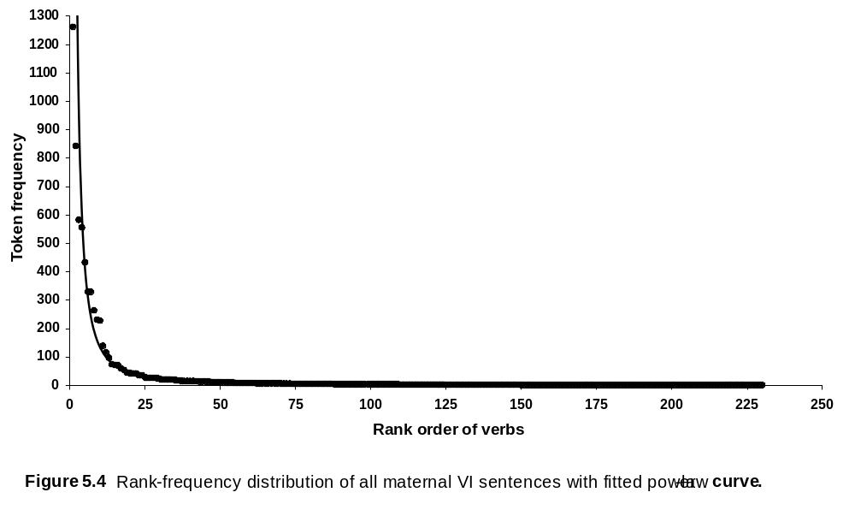
The line indicates the closest Zipf-like power-law curve fit to the data. We can observe the very clear power-law distribution of the 230 verbs; the fit of the power-law curve is excellent (R² = 0.98, namely, a 98% fit). It can be concluded that the use frequency of verbs participating in the indirect-object construction has a typical Zipf distribution.

A second possible statistic is the number of different speakers using each verb in the relevant construction, producing at least one sentence with the verb. This measure defines the relative popularity of each verb not in terms of how often it is used but, rather, by how common is its use in a group of speakers. Figure 5 presents distribution of verbs in VI among 48 mothers.
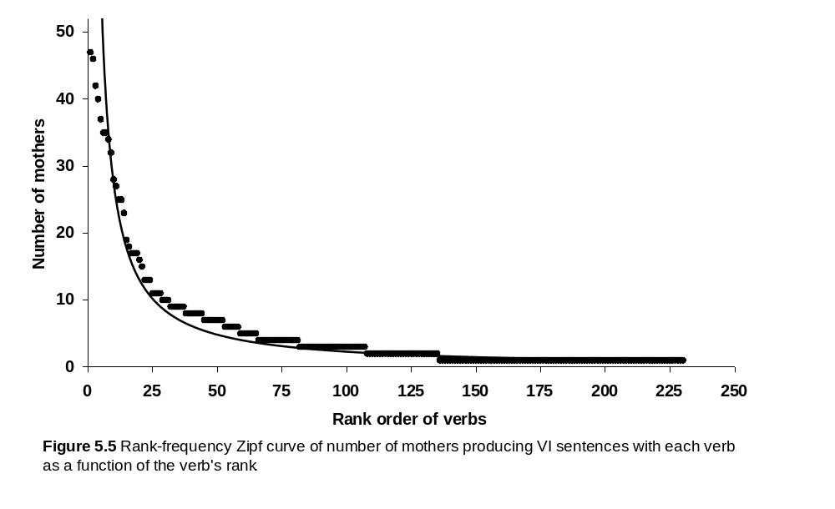
The number of mothers' distribution also has a typical power-law or Zipf-curve shape. The fit of the power-law curve is very good over most of the range (R² = 0.90, namely, a 90% fit).

There is another way to present the same statistical feature and that is the Pareto presentation. Mathematically the two are transformations of each other, but graphically they turn the axes around. Figure 6 presents the Pareto cumulative probability distribution of number of mothers producing at least one sentence with each verb, using logarithmic scales.
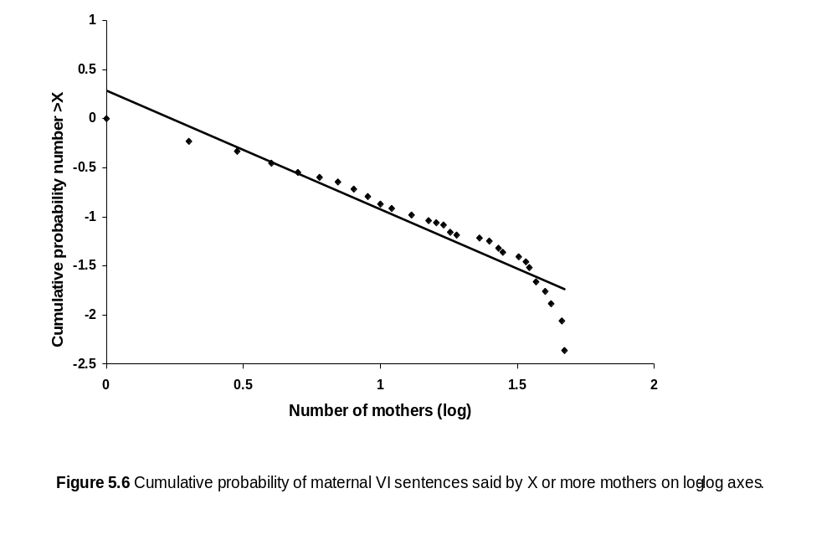
On the X axis we plot the token frequency of items ordered by rank, and it increases as we get higher values; on the Y axis we plot the cumulative probability of an item having equal or larger frequency than X. For the lowest value, the probability is 100%, and it decreases as the frequencies get higher.

The cumulative probabilities also distribute under a power-law function, but Figure 6 presents them on a log-log plot, in which the power-law distribution shows up as a straight line. As we can see, the relationship is almost linear on the log-log plot. To summarize, Figures 4-6 demonstrate that the in-degrees of the linguistic nodes -- in the bipartite network of mother-speakers and verbs-in-VI -- follow a power-law, whether we compute them by number of utterance tokens or number of speakers.

The maternal network represents the linguistic environment of children acquiring the syntax of indirect objects. In the following, we shall compare children's emerging syntactic network for the same grammatical relation with the mothers' network, and test the hypothesis that children recreate the global statistical features of the input-network without necessarily adopting the very same items as the mothers.

Children's order of acquisition of the VI pattern

We repeated the rank-frequency analysis of verbs in the indirect-object combination with a group of 14 young children as speakers (taken from Ninio, 2005a). The children were unrelated to the mothers studied above. There were a total of 11 different verbs with which the children of the sample produced their first 10 VI sentences.

We made separate analyses for the distribution of the first two verbs acquired by the sample, the first three verbs, the first four verbs and so on, up to the first 10 different verbs they produced in this construction. Figure 7 presents the rank-frequency distribution of the different verbs, in terms of number of children out of 14 producing at least one sentence with the verb, namely, the in-degree of the verbs. The statistics plotted are number of children-speakers per verb, for the first two, first three, four, five, six, seven, eight, nine, and first 10 different verbs used by the children in the VI pattern. (The set of the very first verbs had only three different points and was not plotted). The lines indicate the closest Zipf-like power-law curve fitted to each set of the data.

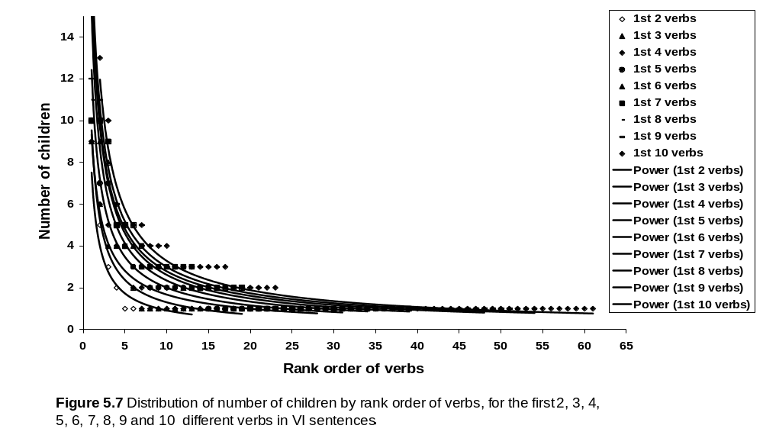
Figure 7 shows that the rank-frequency distribution follows a power-law, and that the slopes are unchanging with increasing number of different items produced.

As we saw in Figure 6, there is another way to present the same distribution and that is the Pareto presentation. Figure 8 presents the Pareto cumulative probability distribution of number of children producing at least one VI sentence with each verb, for the first two, first three, four, five, six, seven, eight, nine and first 10 verbs for the children.

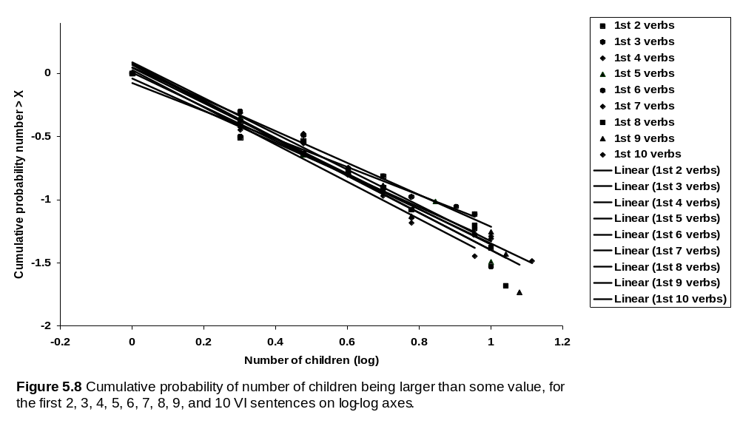
As we can see in Figure 8, there is no systematic change with the added number of verbs. The estimated power-law exponents are, respectively, -2.11, -2.27, -2.47, -2.40, -2.42, -2.26, -2.48, -2.47 and -2.35. In all cases, the fit of the power-law curve is excellent, with R² = 0.96 or above.

Pareto log-log presentation in Figure 8 of the nine fitted lines demonstrates that the children's group immediately recreates the power-law distribution of the mother-network of the same construction, and that the exponent does not change with development. The frequency distribution of the very first two verbs produced by a group of children in this syntactic construction already has a power-law distribution, with an estimated exponent of -2.11, almost identical to the exponent of the maternal network which is -2.21. As we predicted, the scale-free characteristic of the children's syntactic network is not the result of gradual development; it appears immediately as the children start producing the relevant syntactic combination. This finding is quite surprising; the children's group recreated with a mere 28 utterances the global statistical features of a network consisting of 6,954 nodes. Apparently, syntactic knowledge grows in a fractal manner. In a true scale-free manner, the link structure of the language network is the same at every stage, regardless of the size of the system. Such a process of propagation well suits language, the archetypical complex system.

Replication in another syntactic pattern

To double-check the generality of the findings, the same analysis was performed on a second syntactic construction, the combination of a verb with a direct object (VO). Data were obtained from a study of 20 Hebrew-speaking young children's six earliest sentences with different verbs (Ninio, 2005b). Figure 9 presents the rank-frequency distribution of the different verbs, in terms of number of child-speakers for the first 2, first 3, 4, 5, and first six different verbs used by the children in the VO pattern.

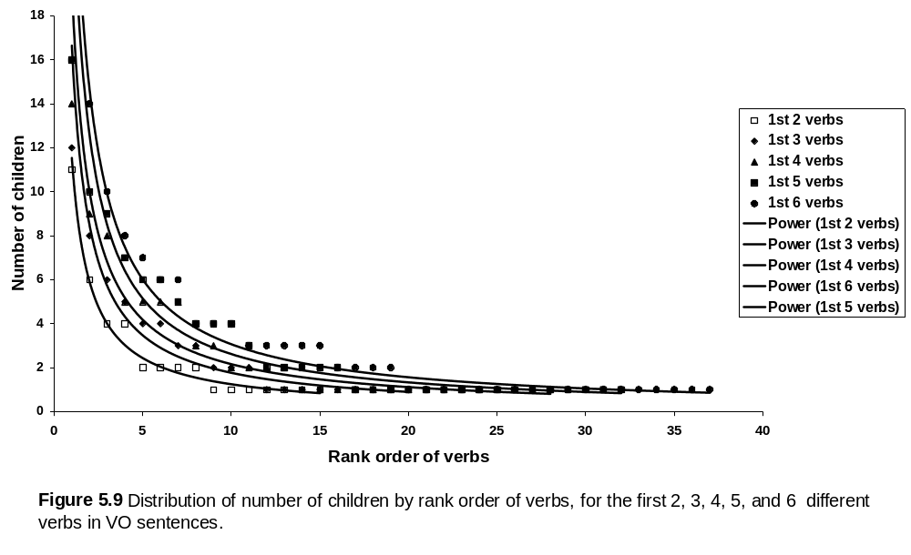
Figure 10 presents the Pareto cumulative probability distribution of number of children producing a VO sentence with each verb, on a shared log-log scale.

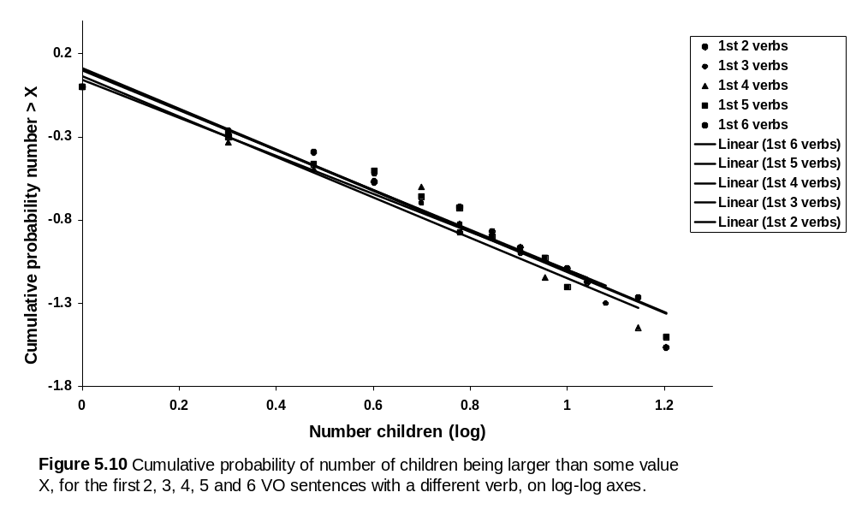
As we can see in Figures 9 and 10, the results obtained from the analysis of the VO pattern were similar to those obtained from the VI construction. The estimated power-law exponents are, respectively, -2.14, -2.20, -2.22, -2.22 and -2.22, and there is no systematic change with the added number of verbs. In all cases, the fit of the power-law curve is excellent, with R² = 0.96 or above. An estimate of the in-degree distributions of the maternal network of this syntactic pattern gave a power-law exponent of -2.17. Figure 10 shows that in this case, too, the log-log linear lines collapsed to a line closely similar to the maternal one, namely, the very first verbs already had a power-law distribution in this sample (with an exponent of -2.14), and the power-law exponent did not change while the children gradually increased their production of the construction to six different verbs.

Children do not copy the input by relative frequency

A deterministic explanation to the similarity between maternal and child networks would be that children follow the relative frequency of items in maternal use and produced the items in the order representing their relative frequency of use by adults. We tested the feasibility of this process by comparing children's first 10 verbs in the VI pattern to mothers' most frequent 10 verbs. Because we did not have information about the children's own mothers' speech, we randomly selected 14 mothers of our maternal sample whose children were at the 12-28 months' age range, identified the 10 most frequent verbs produced by them in this syntactic pattern, and checked if these items give the same distribution as the children's first 10 verbs. The answer is that they do not. Mothers' 10 most frequent verbs closely overlapped so that a mere 31 different verbs accounted for the group's 10 most frequent each (which could have been a maximum of 140 verbs if there were no overlap among the different mothers' verbs). The children's verbs were much less similar to each other's; the group's first 10 consisted of 61 different verbs. A considerable degree of overlap among different mothers has been reported before by, for instance, Serratrice, Joseph, and Conti-Ramsden (2003).

It appears unlikely that children simply copied their network from the mothers' in order of relative frequency, starting with the most frequent maternal items and working their way down to less frequently heard ones. Such a frequency-driven ordering of learning would have created in the children's group a highly similar set of verbs, in fact one that does not have the characteristic power-law distribution but a `star topology'. If all children started the production of a given syntactic construction with the verb with the highest frequency of use in their linguistic environment, all children would start with the very same verb. There would be no power-law distribution, and in fact no distribution at all, simply one very popular verb serving as the starting verb for everybody. The same with the second verb, and the third and so forth. Even if we allow some variability among families, so that the overall frequency ranking of verbs that different children hear would not be completely identical, it would still be the case that different children's first verbs would be nearly identical to each others', in order of acquisition. It is clear that this is not the case; children's starting verbs have a nicely variable frequency of use in terms of popularity of use among mothers, as well as in terms of token frequency in the speech produced by a large group of mothers.

The very frequent use of a verb by mothers did make some of the verbs very attractive to children. The Hebrew equivalents of the verbs `give', `bring' and `have', the three most popular with children, were among the ten most frequent verbs of all the mothers. However, even extreme frequency in the input is not a sufficient condition for a verb to be learned early in the relevant syntactic construction: other verbs with equally high frequency in the maternal sample were produced by practically none of the children at this early stage, for example] the verbs translating as `say', `show' or `tell' (as in `tell me'). The reason why they do not learn these verbs very early is probably mostly pragmatic: the verbs they did not produce early are used for eliciting communication (saying, showing, singing) from the other, apparently not a pragmatic function that young children take upon themselves when interacting with their mothers. As we predicted above, relative frequency is relevant for acquisition only if the content is one that the learner is interested in.

High input frequency is not a necessary condition for early production by children, either. More than 60% of the children's first 10 verbs (38 of 61) were not among the 10 most frequent verbs of any of the mothers sampled. These findings imply that the global statistical features of the children's network has probably not been generated by a deterministic process by which children picked verbs in an order following the input frequency.

Conclusions: Children join the language network

Application of complexity theory to language development sheds new light on the stance of the learner vis-a-vis the linguistic environment. It sees language as a network of speakers and the speech items they produce which children join when they, too, start to produce similar items. Developmental data shows that children act just like adults: they pick popular items, but only if their content is relevant for them. The results support a view of children as free agents exercising Preferential Attachment when they develop their minds and acquire knowledge in a social environment.

Complexity theory gives us a powerful new tool to investigate the relation between child and environment, and that is the global statistical feature of the network composed of actors and their various actions. We understand that adults' language nets are scale-free because adults are free to choose what to say, and they prefer to use the most useful, best-working expressions. We used this fundamental truth to make a strong prediction about children's behaviour when acquiring language in general and syntax in particular. If children learning language indeed behave just like adults and freely choose the best available expressions for their own communicative needs, it is expected that they, too, create a scale-free language network, identical in its parameters to the input network. This, however, does not mean that their network will include exactly the same items as the adults'. As their needs are not identical to those of adults, they will not choose the same expressions, even if these are very frequently said by the adults in their environment. Basically, if we are ready to treat children as the equals of adults in their pragmatic motivations, we are expecting a break with the customary frequency effect, while we are expecting a replication of power-law function best fitting the children's own network.

The conception of children linking into a social network consisting of adults and the social behaviors they produce is strongly reminiscent of a well-known model of development going by the name of Social Learning Theory and similar Vygotzkian approaches to cognitive development. The novelty resides merely in the introduction of Complexity Theory as a formalism. Social Learning Theory and its relatives were developed in the 60s and 70s of the last century, by such figures as Bandura, Stern, Trevarthen, Bruner, Snow, Garvey and Golinkoff. Regarding language acquisition, it was pointed out that the ability to communicate verbally must be learned in the context of interaction between the child and his or her social environment, and that such an intersubjective, culturally determined medium of social exchange as language cannot but be culturally transmitted.

It is now clear that social-learning or interactive cognitive development can be formulated in the simplest way in complexity terms. We can say that there exists a complex system of human actors and the actions produced by them, and on producing similar acts, the child links into the existing complex network as yet another entity connected to it. Complexity is a `tough' and mathematically sophisticated formalism; it gives us -- maybe for the first time -- a robust tool of hypothesis testing, some of which I have applied in this study.

