Self-Organized Criticality and the Properties of English
Anat Ninio
The Hebrew University of Jerusalem
Homepage: http://micro5.mscc.huji.ac.il/~msninio/
Paper presented at ECCS 2008, Jerusalem September 2008

It is common doctrine that language is a system with hierarchically organized units, lower-level units contained in higher-level ones. These levels are distinguished by their grammar. Figure 1 presents the three level schematically.
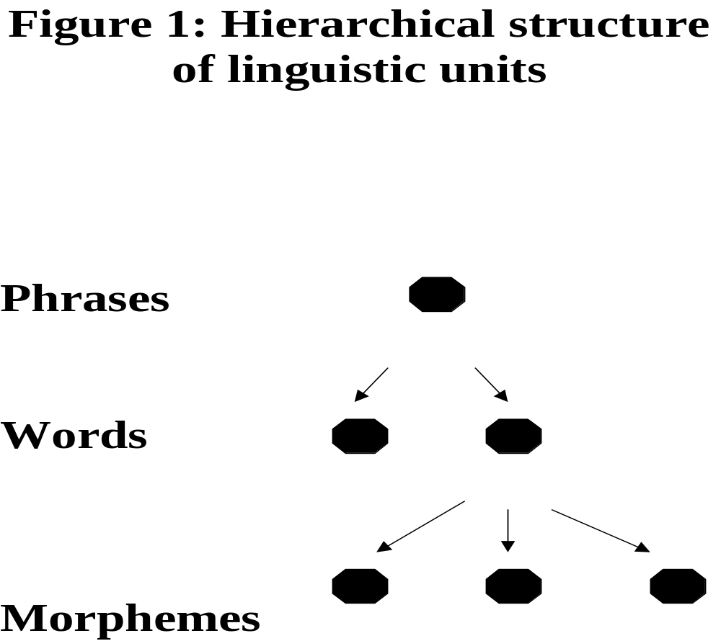

At the central level are words. Words are the units of speech that stand on their own, can be moved around in a sentence, can be separated from each other by pauses, and are, in general, independent elements with a definition of their own. They are the units which are listed in the lexicon, with their sound and meaning specified.

At the level below the word are morphemes; they are the components from which words are built. Morphemes combine to build up words in processes covered by morphology. Morphemes are, fundamentally, dependent elements that cannot stand on their own, and the whole point of hypothesizing their existence is so that it will be possible to recognize combining units below the level of the word.

At the level above words are multiword units or constructions such as phrases, clauses and sentences. The processes of word-combination are covered by the rules of syntax. In models of grammatical analysis, and in theoretical linguistics in general, these levels and their processes are seen as clear-cut and modular, so that morphology, the lexicon, and syntax operate separately in the language system, one regulating morphemes, the second the lexicon, the third the combination of words into multiword phrases and sentences.

This nicely organized hierarchical structure, however, is more wishful thinking than reality. In maybe the most extensively studied language, namely English, we find a wide variety of phenomena that subvert the clean division into morphemes, words and phrases.

First, English has clitics, which are grammatically and syntactically independent words which, nevertheless, appear prosodically glued to a neighboring word, just like dependent morphemes do. Figure 2 presents a clitic in English.

Figure 2: A clitic in English: "s" of possession

The girl's name is Marie.
The middle daughter of the King of France's name is Marie.

The "'s" of possession is the most prototypical clitic in English. It is easy to demonstrate that syntactically it functions exactly like an independent word. For one, it does not sit on any particular word but, rather, on the last word of the noun-phrase. However, it cannot appear independently of some host-word -- which makes it into a kind of dependent morpheme.

Clitics are notorious for being hybrid units, and it is an embarrassment for linguistic theory that they exist at all (Zwicky, 1977). All clitics share some of the characteristics of free lexemes and some of the characteristics of bound morphemes, and they are inherently in-between these two types of categories. Languages that have clitics, possess thereby strong counter-evidence to a clear-cut differentiation of morphology and syntax in that language.

The second type of problem phenomenon in English is multiword, phrasal lexemes, which are lexical items that, nevertheless, undergo syntactic combination in the sentence. English is especially rich in so-called "complex predicates", which are verbs that combine with other words to form a new verb that possesses its own meaning which is sometimes completely unpredictable from its components.

One kind of complex predicate in English is the verb-particle combination, such as give up, take up, look up and so on. Figure 3 presents them with their meaning.

Figure 3: Verb-particle combinations in English and their meaning

Verb-particle combo Its meaning
to give up to stop trying; quit; admit defeat, failure
to take up to begin doing something
to look up to visit someone; to check a fact

In none of the examples is there a clear relationship between the literal meaning of the particle "up" and the meaning of the combination; nor do the verbs give, take and look function in these combinations with their usual main meaning. It is obvious that the verb-particle combination needs to be learned as a unit and needs to be registered in the mental lexicon as a unit with its form and meaning, just like simple, single-word entries. However, in sentences the two parts of the expression function as independent words that can be separated and placed at distant parts of the clause, their appearance and placement dictated by rules of syntax just like for other words. This places the verb-particle construction in an in-between position, between single words and phrases.

The same occurs with other kinds of multiword verbs in English, such as the so-called "Light Verb combinations", sometimes also called "expanded predicates", e.g. Algeo (1995). Figure 4 presents some examples.

Figure 4: Light Verb combinations in English, with their meaning

Light Verb combo Its meaning
take a bath bathe
take a nap nap, sleep
take a beating be defeated, lose money
take pity do something for someone

These are multiword verbs based on some verb partially or totally emptied of its semantic content, combined with a nominal expression (its object) referring to some activity, the nominal carrying most of the semantics of the combination.

As with the verb-particle pattern, it is not clear how linguistic analysis should treat these construction. On the one hand, their components are combined by syntax, so that the nominal is in most cases the verb's proper direct object. On the other hand, it is clear that the whole multiword combination -- the phrase -- is to be registered in the lexicon, as its meaning is unpredictable from its components. Lexical registration defines the phrase as an a priori frozen combination, just like a single word consisting of multiple morphemes. . The notion of freedom to combine words with each other -- the very foundation of syntax -- is missing here
Such hybrid units, falling in between words and morphemes or in between words and phrases, generate problems for theoretical linguistics, if it keeps insisting on the existence of clearly separated, hierarchically organized categories of linguistic units, consisting of morphemes, words and phrases.

I want to claim that all these problem phenomena are the outcome of language exhibiting "Self-Organized Criticality" (Bak, 1996). The idea is that a complex system, consisting of many different components that are in various different types of interaction with each other, spontaneously evolve out of its internal dynamics until it reaches a critical point at which the state of the system undergoes a radical change. Bak, Tang and Wiesenfeld's (1987) example is a sand pile. There is a constant process by which grains of sand drop onto the pile, and each event of added grain of sand increases the pile's slope by a small amount. At some point the slope reaches a critical point and the sand pile begins to disintegrate in an avalanche.

In order to prove that some complex system possesses self-organized criticality, we need to show that the following conditions hold. They appear in Figure 5:
Figure 5. Criteria for a system possessing self-organized criticality

1. There should be at least two radically different states to the system, so that the shift between them will count as a catastrophic event;
2. There should be a process of gradual change driven by system-internal forces that ultimately causes the radical state shift at some critical point;
3. For not-quite understood reasons, complex systems possessing self-organized criticality are marked by the presence of power-law shaped, skewed frequency distributions (Bak et al., 1987). Therefore, our applicant system should also exhibit such power-law shaped distributions in order to be a convincing example of self-organized criticality.

Returning to languages in general and to English in particular, I want to claim that such features are to be found and that they account for the anomalous hybrid units listed above.

Let us start with the last criterion because it needs no special introduction. It is very well known that practically any aspect of language shows a power-law distribution (Zipf, 1949). Zipf, however, did not examine the distribution of the use-frequency of verbs belonging to a particular grammatical subclass. It is predicted that since the locus of grammaticalization is morphosyntax and since the items undergoing grammaticalization are lexical items, we should find power-law distributions in the use frequencies of the different verbs belonging to syntactic form-classes. This is indeed what we find if we examine a large corpus of English-speaking parents' speech to children, taken to represent the child-addressed speech register that serves as the input to acquisition. Figure 6 presents a Zipf-curve of English parental speech of verbs in Subject-verb combinations.

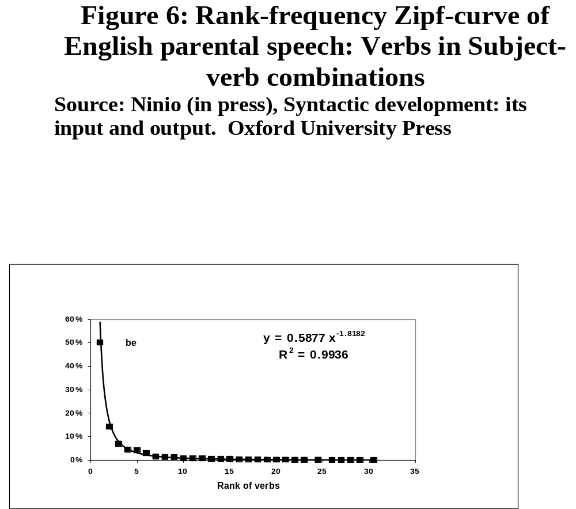

In a self-organizing system, we also expect the same skewed distribution to characterize children's use distributions in syntactic formclasses. Developmental evidence shows that syntactic formclasses are indeed severely skewed in distribution in young children's speech. (see Figure 7.) We also demonstrate that this must be the effect of self-organization, as gross input frequency has no deterministic effect on order of acquisition. The conclusions is that frequency differentials reflect self-organization in input language and output language, under the influence of the linguistic cycle. (Ninio, 2006; in press).

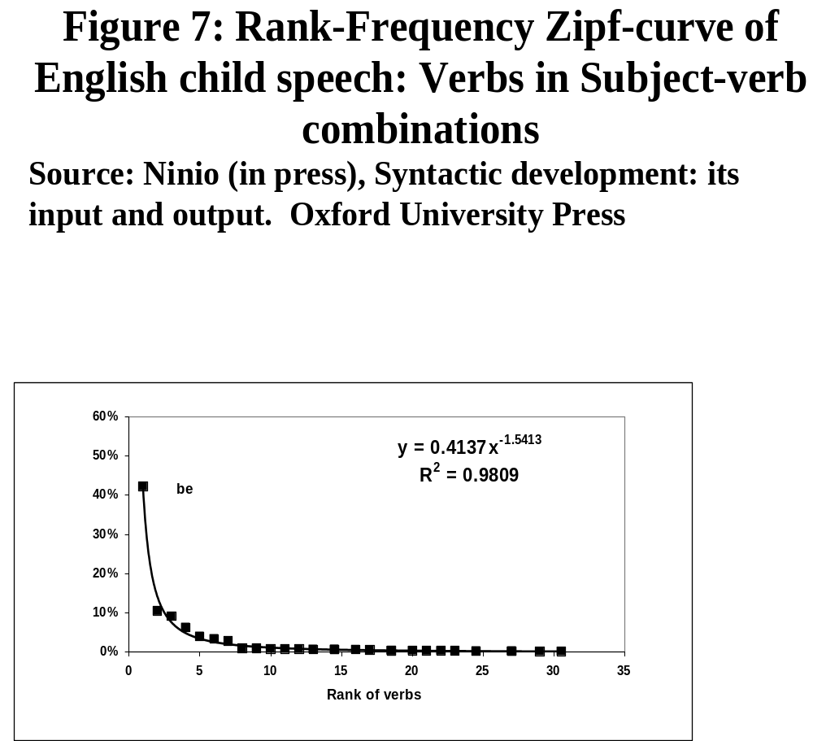
As to states and state changes, languages indeed differ radically in their typological characteristics, or in their language type: some languages are "synthetic" and some "analytic". Synthetic languages possess rich morphology, and they are the agglutinative, synthetic, and polysynthetic languages. Other languages have lean morphology -- and they are the isolating or analytic languages (Sapir, 1921).

As expected, languages indeed change over time their morpho-syntactic typological character. In fact, they may change their typological features several times over their documented existence. There is a type of global type change that has been observed to effect languages in a cyclic manner. This periodic change in the morphosyntactic characteristics of the language is called in the linguistic literature "The Linguistic Cycle" (the term is Carleton Hodge's, 1970; see also Givon, 1971; Haspelmath, 1999). This cycle consists of two alternating periods in which the typological nature of languages changes. One of the phases is one in which the language gains in dependent morphemes, increasing its morphological richness, and becoming more synthetic. The other phase is of an opposite tendency in which morphemes undergo erosion and are lost, the language becomes more isolating and analytic.

Second, as fitting for a system with self-organized criticality, it is possible to identify a process of internally driven, gradual change that feeds these global analysis–synthesis cycles. The process is local, and it affects individual lexemes and morphemes. This is the process of grammaticalization. Grammaticalization is a mechanism by which free words gradually turn into prosodically dependent morphemes, used for inflection of number, gender, case, tense, aspect, mood and so on. According to grammaticalization theory, all dependent morphemes originate in free lexemes (e.g., Bybee, Perkins & Pagliuca, 1994). For example, lexical verbs are the typical source for auxiliary verbs and tense inflections; nouns often the source for adpositions and case markers. Figure 8 presents some examples of verbs as sources of affixes and prepositions.

Figure 8: Verbs as sources of affixes and prepositions

Verb grammatical affix, etc
to finish past tense
to will future tense
to take preposition marking direct object
to give preposition marking indirect object ("to")

Processes of grammaticalization operate locally, on each individual lexeme and inflection. These local processes are gradual, and very often the original version of the source lexeme remains in use in parallel to the newly arising grammatical use for the same lexeme. The "catastrophic event" is one in which the original use is lost or gets completely disconnected from the novel morpheme, so that users no longer connect the two. For example, the case-marking function word ba in Mandarin Chinese originates from the Old Chinese lexical verb meaning "hold, take", and ancient Chinese texts keep using it as a full verb as well as a case-marker for a very long time (Li & Thompson, 1974; Sun, 1996). At some point the old verb disappeared from use; that was the catastrophic event in which this word flipped category from free verb to case-marking adposition.

According to the authorities, during the process of grammaticalization free words undergo small, gradual changes in form and use, losing length, stress and prosodic independence, losing some or most of their meaning, and being shifted in use to some grammatical purpose. (Heine and Reh, 1984; Hopper and Traugott, 1993). One of the substages in the development of affixes is cliticization, and it is considered as an intermediate stage on the way from free lexeme to dependent morpheme. At some point, the word undergoes a fundamental change, flipping in its status from a free word to that of a dependent morpheme or affix.

Grammaticalization is also responsible for the development of semi-lexical words such as the Light Verbs mentioned earlier which are used in periphrastic, or analytical, constructions. These verbs have "full verb" counterparts that possess a rich, not an emptied-out semantics. Semantic "bleaching" is one of the phenomena occurring in grammaticalization, and these Light Verb are considered semi-lexical, semi-functional words. Figure 9 presents some of the verbs serving as Light Verbs in English.
Figure 9: Light Verbs in English
take take a look
have have a walk
give give a shout
do do a pirouette
make make a hit
The development of periphrastic, or analytical, constructions themselves is seen as part of the analytical period of the Linguistic Cycle. This phase involves the erosion of affixes, so that the old inflections do not function adequately any more to distinguish e.g. tense, aspect, or different shades of a verb's meaning. This, according to theory, may result in an analytic multiword constructions developing in order to fulfill the role of the now no longer operative inflections and other bound morphemes. Namely, in the period characterized by "analytic drift" (Edward Sapir's term, 1921), the language loses its dependent morphemes and the inflections these were used to mark, for example, the tense of actions. In order to express the same meanings by other means, the language compensates by generating periphrastic (multiword) constructions and phrasal lexemes, becoming analytic.

As we said above, the typological change from a language with rich morphology to one with bare uninflected words and analytic constructions and back, is a cyclical happening that may repeat itself for one particular language within historical time. In complexity theory, systems undergoing such cyclical phase changes are often said to demonstrate "Self-organizing Criticality". As we showed, language appears to be one such system, and grammaticalization exhibits all the features and characteristics of the required process of change.

We can now connect the hybrid units causing such a problem to linguistic theory, to the fact that language is a complex system with self-organized criticality. The process feeding type change in English as in other languages is grammaticalization. As we saw, it gradually shifts units from their source level to a level one step lower on the hierarchy of linguistic units (Lehmann, 1993). Grammaticalization shifts words until they become dependent morphemes -- one level below words. Grammaticalization shifts phrases to become words, as in the verb-particle and Light Verb combinations. Hybrid units are in between levels. Figure 10 presents this schematically.
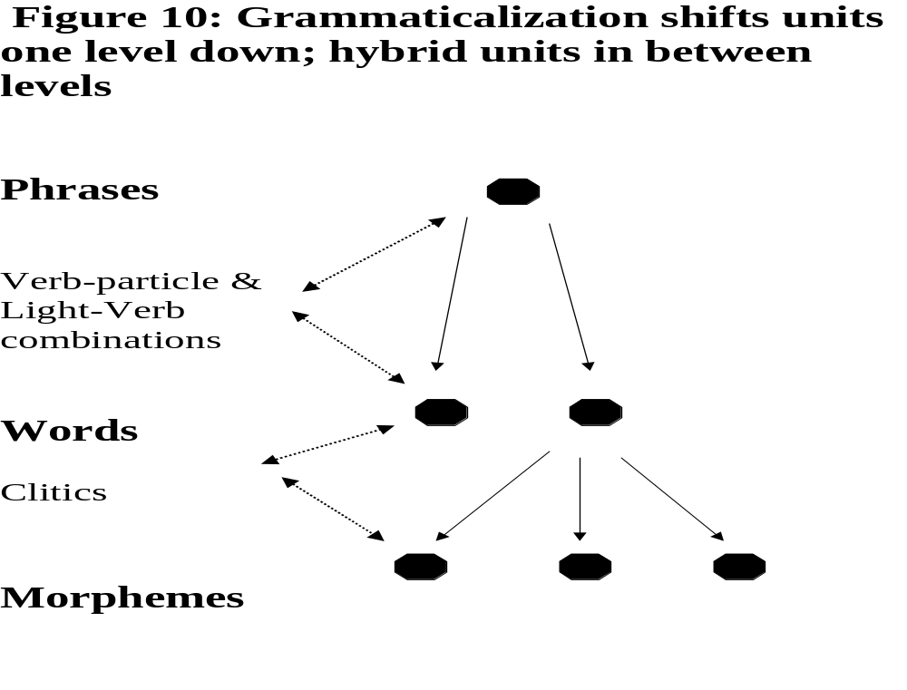
Namely, the hybrid units are units we caught in a middle stage along the gradient of grammaticalization from one level of grammatical unit to another. Clitics will at some point become affixes, and multiword phrasal verbs will metamorphose into single-word lexemes. Until that happens, English will continue to exhibit in-between units that do not belong completely to either level. As English is a system self-organized to hover on the edge of the critical point, it is very possible that these hybrid forms are with us for a very, very long time.

Biology also describes processes of evolution and metamorphosis that generate similar intermediate entities (for some of the literature, see Margulis & Sagan, 2002; Ochman & Moran, 2001; and Okamoto & Inouye, 2005). The analogy is of grammaticalization with the development of complex cells in eukaryotes, and, maybe, with development of complexity in living organisms in general:

1. Organelles can be traced to bacteria, sometimes to eukaryotic fungi;
2. The nucleus can be traced to other bacteria;
3. Endosymbiosis may account for the formation of eukaryotes from two prokaryotes.

Namely, in biology there exists the same kind of process in which a whole unit turns to be the part of another one, as in grammaticalization. In addition, it is well known that embedded organisms lose some of their genetic material and their ability to exist independently of the host; the loss of genes is like the loss of phonetic material in erosion, and the loss of independence is the same as in grammaticalization of words to morphemes in linguistics. Lastly, there are many different degrees of symbiosis and of parasitic relations, similar to the cline of grammaticalization. These generate units of intermediate status (so-called "living intermediates"), between one complex organism and two simplex ones, similar to the intermediate-status units we have described for linguistics.

The similarity between these evolutionary processes in language and in biology is no coincidence. There are only that many ways to increase the complexity of some entity, and one main way is to insert one entity into another, resulting in hierarchical structure.
Namely, grammaticalization and symbiogenesis are similar schemes by which units gain in complexity by incorporating other units.

The existence of intermediate units in linguistics and in biology (and in other domains as well) requires that the relevant disciplines as well as Complexity Science develop more sophisticated tools to define their units and relations. We know that complex systems are dynamic and constantly undergo development; it is inevitable that units and relations be less unchanging than is sometimes assumed.

References

Algeo, J. (1995). Having a look at the expanded predicate. In B. Aarts & C. F. Meyer (Eds.), The verb in contemporary English (pp. 203-217). Cambridge: Cambridge University Press.
Bak, P. (1996). How nature works: The science of self-organized criticality. New York: Copernicus.
Bak, P., Tang, C. & Wiesenfeld, K. (1987). Self-organized criticality: an explanation of 1/f noise. Physical Review Letters, 59, 381–384.
Bybee, J., Perkins, R. & Pagliuca, W. (1994). The evolution of grammar: tense, aspect and modality in the languages of the world, University of Chicago Press, Chicago.
Givon, T. (1971). Historical syntax and synchronic morphology: an archaeologist's field trip. Chicago Linguistic Society, 7, 394–415.
Haspelmath, M. (1999). Why is grammaticalization irreversible? Linguistics, 37, 1043–1068.
Heine, B. and Reh, M., (1984). Grammaticalization and reanalysis in African languages. Hamburg: Helmut Buske.
Hodge, C. (1970). The Linguistic Cycle. Language Sciences 13, 1-7.
Hopper, M. & Traugott, E. (1993). Grammaticalization. Cambridge: Cambridge University Press.
Lehmann, Ch. (1993). Theoretical implications of processes of grammaticalization. In William A. Foley,(ed.) The role of theory in language description (pp. 315-340). Berlin & New York: Mouton de Gruyter (Trends in Linguistics, 69).
Li, Ch. N. & Thompson, S. A. (1974). An explanation of word order change SVO > SOV. Foundations of Language, 12, 201-214.
Margulis, L. & Sagan, D. (2002). Acquiring genomes: A theory of the origins of species. Amherst, MA: Perseus Books Group.
Ninio, A. (2006). Language and the learning curve: A new theory of syntactic development. Oxford: Oxford University Press.
Ninio, A. (in press). Syntactic development: Its input and output. Oxford: Oxford University Press.
Okamoto, N. & Inouye, I. (2005). A secondary symbiosis in progress? Science, 310, 287.
Ochman, H. & Moran, N. A. (2001). Genes lost and genes found: Evolution of bacterial pathogenesis and symbiosis. Science, 292, 1096-1099.
Sapir, E. (1921). Language : an introduction to the study of speech. New York : Harcourt Brace Jovanovich.
Sun, Ch. (1996). Word-order change and grammaticalization in the history of Chinese. Stanford, CA: Stanford University Press.
Zipf, G. K. (1949). Human behavior and the Principle of Least Effort. New York: Hafner.
Zwicky, A. (1977). On clitics. Bloomington: Indiana University Linguistics Club.

