Ninio, A. (1991, April). Introduction to the Ninio and Wheeler taxonomy of verbal communicative acts and to the INCA abridged version. Paper presented at the Biennial Meeting of the Society for Research in Child Development, Seattle, Washington, April, 1991.

SYMPOSIUM: EARLY COMMUNICATIVE DEVELOPMENT:
THE CENTRALITY OF PRAGMATIC ANALYSIS

Introduction to the Ninio and Wheeler (1984) taxonomy
of verbal communicative acts and to the INCA abridged version

Anat Ninio
Department of Psychology, The Hebrew University

Paper presented at a symposium on Early Communicative Development: The Centrality of Pragmatic Analysis, chaired by B. A. Pan & C. E. Snow. The Biennial Meeting of the Society for Research in Child Development, Seattle, Washington, April, 1991.

The construction of the coding system and the research reported here was supported by Grant no. 2467/81 from the United States-Israel Binational Science Foundation (BSF), Jerusalem, Israel, to Anat Ninio and Carol Eckerman, by Grant no. 84-00267/1 from the United States-Israel Binational Science Foundation (BSF), Jerusalem, Israel, to Anat Ninio and Catherine Snow, and by a grant from the Israeli Academy of Sciences.
INTRODUCTION to the Ninio and Wheeler (1984) taxonomy of verbal communicative acts and to the INCA abridged version

The three presentations in this symposium are reports from research projects utilizing a taxonomy of verbal communicative acts developed by my collaborator Polly Wheeler and myself in 1981-82. I was asked to introduce the taxonomy and to explain the principles on which it was built. The investigations be presented applied two different coding systems derived from the taxonomy; Ninio's used the full system (Ninio & Wheeler, 1984a), whereas Pan, Rollings and Snow, and Tingley used INCA, an abridged version (Ninio, Wheeler, Snow, Pan & Rollings, 1991) that had been derived from the full system by combining certain of its categories in a principled way. I shall present both the full taxonomy and this abridged version. As it will become clear in the following, the taxonomy allows the derivation of many different pragmatic coding systems, according to the particular research questions addressed in a given project, of which the abridged inventory used by these groups is one example.
The initial impetus for developing the taxonomy came from a wish to study the development of speech production in young children, and more specifically, the development of the production rules they employ to verbalize communicative intents. Coding systems for the categorization of communicative intent existing at the time were neither detailed enough nor systematic enough for this purpose, and most had serious shortcomings (cf. Chalkley, 1982; Chapman, 1981; Dore, 1979). Moreover, the prominent theory of utterance meaning, namely, Searle's Speech Act Theory (1969, 1975) had been repeatedly criticized e.g., for its focussing on individual utterances as the unit of analysis, and in general, for working with a simplistic and unacceptable model of the organization of talk and of social acts in general (cf. Dore & McDermott, 1982; Edmondson, 1981; Streeck, 1980).
The goal was to develop a category system that would capture psychologically real discrete types of communicative acts in mother-child interaction. The question is, does such a system of categories actually exist in children or for that matter in adults? Rules imply some form of internal representation of fixed options or meanings that the speaker has recourse to when producing or interpreting utterances. The presupposition that such fixed representations exist, either for word meanings, for utterance meanings or for any other type of social meanings in the broadest sense, has been repeatedly challenged ever since Wittgenstein (1953), both by sociologists of the ethnomethodological persuasion (Cicourel, 1970; Garfinkel, 1967) and by linguists and psycholinguists (Shanon, 1988). Social or verbal meanings are said by many to be created ad-hoc in each unique set of circumstances, to be essentially indexical. In some parts of sociology, all attempts at formalization have been more or less abandoned, in favour of explication of the methods or procedures by which a gloss on intended meaning is produced, and on the basis of which meaning is experienced at the same time as an ordered phenomenon. In this intellectual climate, setting a goal of formalizing pragmatics appears an anachronism. Nevertheless, there is some basis for believing that utterance meanings do form discrete categories rather than an infinite and indivisible continuum, a field or space of options flowing into each other.
The principles underlying the construction of the taxonomy
The basic insight on which the taxonomy is built is that speech is a type of social behavior, and as such, utterances are social acts which are meaningful as moves in the currently operative social situation (cf. Goffman, 1976; Wittgenstein, 1953).
According to theories of social behavior, the meaningfulness of any kind of action is derived from its being systematically related to some agreed-of definition of what is going on between the participants in a social scene (Bateson, 1955; Goffman, 1974; Gumperz, 1971; Hymes, 1972). In Scheflen's (1974) words, "meaning applies... to a relation between behavior and context" (p.179). The same is true of language; utterance meaning is a type of social meaning (Halliday, 1975). Thus talk, being a kind of social action, also derives its meaningfulness from its having a systematic relationship with the interactive context. To understand what is it that is said is first of all to understand what is happening in face-to-face interaction in uttering the utterance.
Talk both defines and is defined by the currently operative social reality. When what is said cannot be assimilated to the current definition of social reality, it is meaningless. For example, when somebody says "the water is boiling " in the middle of a marriage ceremony, the result is nonsense (Baier, 1967). Thus, a theory of utterance-meaning should explain how talk contributes to the definition of the situation and how is it interpreted in light of the definition of the situation. To make principled distinctions among types of utterances one should look for differences in the ways speech functions as a contextualized interpersonal behavior.
From the point of view of identifying the dimensions along which communicative acts differ, the question then becomes, how an utterance relates to, or is defined in terms of, the currently defined social reality. This question can be decomposed into two: First, what is the state or event or entity of social reality that the current speech act relates to; and second, how the speech act relates to, defines, or constitutes that state or event of social reality. As it will become clearer in the following, it appeared that there are a finite number of different states and events in terms of which people construe face-to-face interaction, and there are a finite number of distinct ways in which speech operates on the immediate social reality. These two dimensions are taken jointly as defining the social meaning of utterances, and the taxonomy formalizes the resulting categories of social meaning. The reason why there exist distinct types or categories of utterance meaning is, then, that the conceptual systems underlying utterance meaning -- social-cognitive concepts such as interactive states or actions, and linguistic-communicative concepts such as kinds of meaning operations on contextual arguments -- are themselves finite systems of discrete categories rather than infinite and indivisible continua.
A model of face-to-face interaction
To answer the question how talk relates to immediate social reality, first of all a model or theory of face-to-face interaction was needed. Such a model was to identify the system of social-cognitive concepts of different type of states and events that are used by participants in interaction in their definition of the current situation. The formulation of the model relied on two different sources. The first were mothers' descriptions of videotaped interaction sessions in which they participated, which were content analyzed (Ninio & Wheeler, 1984b). The second were the theoretical writings of sociologists such as Goffman (1953, 1961, 1963, 1964, 1976) on the nature of face-to-face interaction.
From both sources this model emerged. Participants define or "frame' the current social reality on several levels simultaneously. These may be viewed as hierarchically embedded definitions going from the most general to the most specific. Figure 1 presents a schematic model of the different states and events of face-to-face interaction.
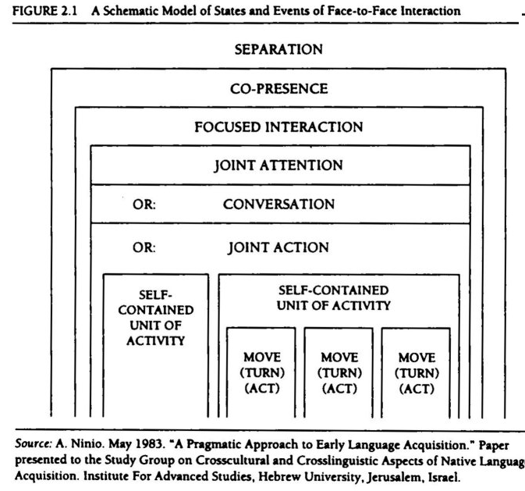
The key element in this taxonomy of interactive states is the degree of communality or intersubjectivity achieved. The model thus starts at the most general distinction to be made among interactive states, that of the distinction between co-presence and separation. Co-presence offers the possibility of mutual visual monitoring and a potential for focussed interaction. Focussed interaction occurs when the participants attend to the same perceptual or mental focus. They might interact around a joint focus of perceptual attention, they might carry on a conversation on a jointly contemplated topic, or else they might achieve intersubjectivity by carrying out a joint activity. Each of these types of focussed interaction (or encounter) is seen as further articulated into smaller structural units and their boundaries. In addition, breakdowns of frame might occur when one of the participants discontinues the expected flow of events. Lastly, interactants might be at a state of transition between any two given interactive states.
The following is a list of the states or events of social situations, from the general to the specific:
* co-presence/ separation/ transitions between them;
* focussed interaction/ unfocussed co-presence;
* types of focussed interaction: joint attention/conversation/joint action;
* beginning/ middle/ discontinuity/ end of focussed interaction;
* self-contained units of focussed interaction and their boundaries; * acts/ their boundaries/ between-act breathing spaces;
* other elements of immediate social situation: roles, turns, moves.

The relation of talk to current social reality
Given this system of participant-defined interactive states and events, the next question is, how does speech function to establish, sustain or modify the current definition of social reality?
There are several qualitatively different modes of employing speech, each representing a different type of relationship of speech to the interactive situation. Utterances may:
* explicitly negotiate the occurrence and characteristics of future states and events. Negotiations consist of directives to hearer to bring about some future state of affairs, and of commitments by which speaker undertakes to bring about some state of affairs. In addition, the giving and requesting of information necessary for effective negotiation is also seen as a type of action negotiation.
* mark, signal, acknowledge the occurrence of some happening, thereby turning it into a ratified, publicly acknowledged event of social reality. For example, a greeting ratifies a meeting; or an expression like "That's it!" publicly marks the completion of an action.
* establish and sustain a state of conversation; conversations are discussions consisting of the exchange of information on some topic.
* perform or enact verbal moves of rule-bound activities such as games.
* evaluate past, ongoing and future actions of the participants.
* acknowledge the reception of previous communicative messages.
* metacommunicate about unsuccessful communication.
* text-edit previous talk, e.g., correct, repeat, complete, etc.
Figure 2 presents the model of interactive states and events, with types of speech superimposed on it.
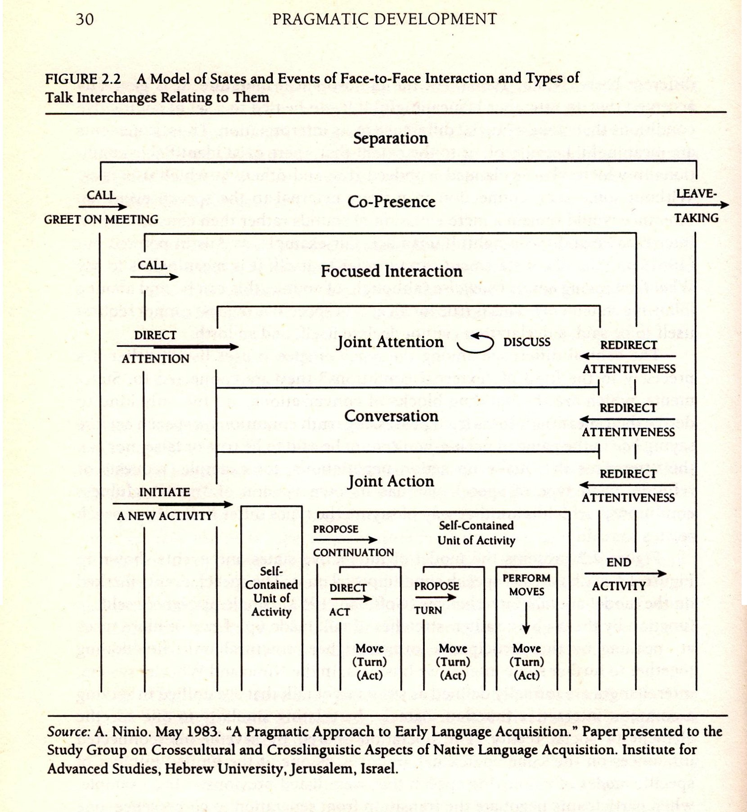
The speech events marked on the model are talk interchanges (Goffman, 1953). Single utterances very seldom function by themselves but rather there are stretches of talk made up of two or more turns at speaking by the participants that form a higher structural unit, functioning together. We call an interchange such stretches of talk that are unified by their serving a common interactive function, i.e., by relating similarly to one specific element of social reality. This shared operation of several interconnected utterances on the same contextual argument is one of the specific mode of employing speech, as listed above. So when participants for instance negotiate the transition from separation to co-presence, one may call out to the other, request that the other join her, and the other may answer by agreeing to come or by refusing to come. The exchange as a whole relates to the future event of the participants entering co-presence by the meaning-operation of negotiation, which is one possible mode of employing speech meaningfully in interaction.
Apart from the interchange types marked on the model, there are interchanges dealing with metacommunication, such as clarifying some failed message. As these may appear in the context of any kind of utterance or talk interchange, they cannot be displayed on the model.
Another way to clarify the cross-classification underlying the Interchange categories of the taxonomy is to say that the taxonomy distinguishes among talk interchanges not only by the kind of operation they exert on social interaction but also according to the states and events they operate on.
Negotiations are distinguished according to the state or event that is being decided on. Choices about the future of the interaction are made on various levels, from the most general decision whether the interactans will remain in each other's presence, to minute details of an ongoing activity, e.g., who is to perform the next move.
Markings are differentiated according to the event which is acknowledged, e.g., Meeting, Returning to co-presence, Parting; Going to sleep; Hearer being about to eat or eating ; Hearer having sneezed or burped; Fall of object; Completion of action; Object transfer etc.
Evaluations are distinguished according to whose action is being evaluated: Hearer's or Speaker's .
Conversations are distinguished according to the immediateness of their topic: Topic is the focus of joint attention, a recent event; the non-present or the non-observable etc.
Performances of verbal moves in games are differentiated according to the specific game which is played. For example: Swinging game; Peek-a boo; Jumping game; Telephone talk.
Acknowledgements of the receipt of past communications are considered expressions of attentiveness and are not distinguished further according to the kind of communication which is acknowledged.
Metacommunication is distinguished according to the kind of communicative move which is clarified, namely, verbal communication or nonverbal communication.
Text-editing can occur in any kind of talk, irrespective of its interactive arguments, and is coded as part of that talk. Distinctions among different kinds of text-editing (e.g., correction or repetition) are coded on the level of the utterance.
The Interchange level of the taxonomy
The 1984 version of the taxonomy distinguishes between 65 distinct types of talk interchanges. These are presented in Table 1.
Table 1. Types of verbal interchanges according to interactive function in the Ninio & Wheeler (1984) taxonomy of verbs communicative acts

Management of the transition between separation and co-presence
CFA: Call from afar.
GMO: Greet on meeting.
MCP: Mark co-presence.
Management of the transition between co-presence and separation
GPO: Greet on parting.
GNO: Wish good night.
LTT: Temporary leave-taking.
-LTT: Prevent H's leaving.
Initiating focussed interaction: establishing mutual attentiveness and proximity
CAL: Call.
SAT: Show attentiveness.
Re-establishing focussed interaction after a break
ICS: Initiate: "Come and start".
RCN: Renew: Propose continuation of activity after a break.
Withdrawing from interaction
WFI: Withdraw from interaction.
Management of joint attention
DHA: Direct addressee's attention.
DJF: Discuss joint focus of attention.
DRE: Discuss a recent event.
Holding conversations on topics other than under joint focus of attention.
DNP: Discuss the non-present.
DHS: Discuss addressee's non-observable state.
DSS: Discuss S's non-observable state.
PSS: Negotiate possession of objects.
The management and verbal performance of joint action
The negotiation of joint action
Negotiating the initiation of a new activity
IOQ: Initiate: Open-ended question about addressee's wishes.
IPA: Initiate: Propose specific activity.
IPR: Initiate: Propose a preparatory move of a new activity.
IPM: Initiate: Propose performing move.
ICS: Initiate: "Come and start".
Allocating roles, turns and moves in activities
AAH: Offer next move, turn, role to addressee or to third person.
AAS: Demand role, turn or move for S.
Setting up rules of turn-taking
RTT: Set rules of turn-taking.
Renewing/repeating an ongoing activity
RRP: Renew: Propose repetition of last unit of activity.
RNF: Renew: Propose a new focus of activity.
MOR: Propose addition of a recursive act.
Directing addressee to do - regulating addressee's next act
RHA: Regulate addressee's acts.
Directing addressee not to do - stopping/preventing addressee's act
-RHA: Stop/prevent addressee's act.
MHP: Make addressee pause in action.
Directing speaker's actions
RSA: Regulate S's next act.
OHH: Offer to help addressee.
Evaluating addressee's & speaker's actions
EHP: Evaluate addressee's performance.
ESP: Evaluate S's performance.
Stopping, ending and preventing activities
-IPA: Prevent new activity (Negative initiate new activity).
AEA: Attempt to end activity or sub-unit of activity.
MCA: Mark completion of action.
Performance of verbal moves in games and other activities
P--: Perform verbal move. (Each different game a different interchange type). Main types:
PR1-PRT: Perform move in social games such as ring-around-the-rosy.
PRO: Perform move in elicited imitation format.
PRA (P01-P40): Perform move in game of mimicking animal and inanimate noise.
Marking events: socially expected verbal interchanges.
MTK: Thank.
MPG: Politely wish a good appetite.
MPS: Politely bless on sneezing.
MNC: Mark new clothes.
MCN: Congratulate.
MAZ: Apologize.
MEE: Mark exertion of effort.
MEB: Mark swallowing of food.
MEF: Mark falling of object.
MEH: Mark addressee's falling.
CMO: Comfort.
MRK: Mark events not specified above.
Metacommunication: Demand clarification or confirmation of addressee's meaning.
DCC: Demand clarification of verbal communication and word-like vocalizations.
DCA: Demand clarification of action (or non-action).
In the coding system built on the taxonomy, the first level of coding, then, is to identify the type of interchange an utterance belongs to, according to the mode of speech use and according to the kind of contextual argument it relates to.
The utterance level of the taxonomy
On the second level of coding the communicative function of the single utterance is classified, within the relevant interchange. For instance, in a verbal exchange that comprises of the negotiation of the next activity, a certain utterance might suggest a specific new activity to be engaged in, while another utterance might serve to agree to carry out that suggestion or else might reject it. Although the common business of both turns at speech is the negotiation of the immediate future activity, each utterance has its unique communicative meaning or unique contribution to the business of the interchange. This component of utterance meaning is captured in the taxonomy and coding system by speech act category names using, mostly, the ordinary illocutionary act vocabulary. On an abstract level, the same analysis of decomposing meaning into operations on arguments applies to speech act (SA) codes too, each combination of type of operation and type of argument defining a specific distinct code (see also Ninio, 1986). Table 2 presents the most prominent operations of individual utterances, and the kind of arguments they take.
Table 2. Meaning operations of individual utterances and their arguments
Operations Arguments

Represent State of affairs, real, hypothetical or fictive;
past, present or future. (Truth conditions)
(subspecies: full, uncommitted, product-incomplete)
Commitment-complete Previous uncommitted representation (e.g.,
yes/no question).
Product-complete Previous product-incomplete representation (e.g., wh-question).
Direct Future action by addressee satisfying directive.
(Compliance conditions)
Comply Past directive complied with.
Commit Future action by speaker fulfilling obligation.
(Fulfillment conditions)
Mark, acknowledge Present or immediate past events; including speech events.
Evaluate State of affairs, actions.
Declare State of affairs to be created by declaration.
Perform, constitute Move in rule-bound activity.
Imitate Previous utterance or part of it.
Correct Previous utterance or part of it.
Complete Previous utterance; incomplete word or sentence.
Recite Rote-learned text.
The meaning of some speech acts decompose to two or more pairs of operations on arguments, for instance wh-questions are both directives with respect to their answer and product-incomplete representations of some state of affairs. The SA code system acknowledges each unique combination of pairs of operations and arguments actually found in the observational data base. In the 1984 taxonomy and coding system, there are 64 categories of speech acts for individual utterances which are moves in interchanges. Table 3 presents them in families according to the major pragmatic force or type of operation.
Table 3. Speech act codes, categories and definitions, by major pragmatic force in the Ninio & Wheeler (1984) taxonomy of verbs communicative acts.

Directives and responses

RP Request/propose/suggest action for hearer. Proposed action might also involve speaker.
RQ Yes/no question about hearer's wishes and intentions which functions as a suggestion.
DR Dare = challenge hearer to perform action.
WD Warn of danger.
CL Call attention to hearer by name or by substitute exclamations.
SS Signal to start performing an act, e.g., to run or roll a ball.
Pace performance of acts by hearer.
AD Agree to do = agree to carry out act requested or proposed by other.
AL Agree to do for the last time.
RD Refuse to do = refuse to carry out act requested or proposed by other.
Including refusals by giving excuses and reasons for noncompliance.
CS Counter-suggestion; an indirect refusal.
GI Give in: accept other's insistence or refusal.
AC Answer calls; show attentiveness to communications.
GR Give reason; justify a request for action, refusal or prohibition, etc.

Speech elicitations and responses

EI Elicit imitation of word or sentence by explicit command.
MU Model utterance, without explicit request for imitation.
EC Elicit completion of word or sentence.
EX Elicit completion of rote-learned text.
RT Repeat/imitate other's utterance.
SC Complete statement or other utterance in compliance with request
eliciting completion.
CX Complete text if so demanded.

Commitments and responses

SI State intent to carry out act by speaker.
FP Ask for permission to carry out act by speaker.
PD Promise.
TD Threaten to do.
PA Permit hearer to perform act.
PF Prohibit/forbid hearer to perform act.

Declarations and responses

DC Declare = create a new state of affairs by declaration.
DP Declare (phantasy) = create make-believe reality by declaration.
YD Agree to a declaration.
ND Disagree with a declaration.

Markings and responses

MK Mark occurrence of event (i.e. thank, greet, apologize, congratulate, etc.)
TO Mark transfer of object to hearer.
CM Commiserate, express sympathy for hearer's distress.
EM Exclaim in distress, pain.
EN Endearment = express positive emotion.
ES Exclaim in surprise = express surprise.
XA Exhibit attentiveness to hearer.
PT Polite response to thanking.

Statements and responses

ST State = make a declarative statement.
AP Agree with proposition expressed by previous speaker.
DW Disagree with proposition expressed by previous speaker.
WS Express a wish.
CN Count.

Questions and responses

QN Wh-question = ask a product-question.
YQ Yes/no question = ask a yes/no question.
TQ Restricted-alternative.
SA Answer a wh-question by a statement.
AA Answer in the affirmative to yes/no question.
AN Answer in the negative to yes/no question.
QA Answer a question with a wh-question.
YA Answer a question with a yes/no question.
NA Non-satisfying answer to question.
RA Refuse to answer.

Performances

PR Perform verbal move in game.

Evaluations

PM Praise for motor acts, i.e. nonverbal behavior.
ET Exclaim in enthusiasm = express enthusiasm for hearer's performance. CR Criticize = point out error in nonverbal act.
AB Approve of appropriate behaviour. Express positive evaluation of
hearer's or speaker's acts.
DS Disapprove, scold, protest disruptive behavior. Express negative
evaluation of hearer's or speaker's behaviour as inappropriate.
ED Exclaim in disapproval.

Demands for clarification

RR Re-run request = request to repeat utterance.

Text editing

CT Correct = provide correct verbal form in place of erroneous one.

Vocalizations

VC Word babble = utter a word-like utterance without clear function.
XX Idiosyncratic words.
Level of detail of the full taxonomy
The final unit of verbal communicative acts in the taxonomy are SA-Interchange combinations, like "Suggest the initiation of a new activity" (e.g., "Let's do a puzzle now") or "Suggest the person to perform the next move" (e.g., "You do it"). The full coding system generates a large number of different types of communicative acts, differing either in the type of operation(s) on their contextual argument(s), or the identity of these arguments, or in both.
This level of detail is the appropriate one for the original research purpose for which the taxonomy was constructed, namely, the identification of verbal realization rules defined on psychologically real categories or types of communicative intent in young children. Such level of detail may be neither necessary nor optimal for all possible applications, nor is it the only level at which a pragmatic coding system may be derived from the taxonomy.
Derivations of other coding systems from the taxonomy and the abridged coding system INCA used by Snow and collaborators
As the taxonomy creates categories by the cross-classification of communicative intent along four different dimensions, other category systems may be derived from it in a principled way by collapsing distinctions along one or more of these dimensions. Either interchanges or speech act categories or both may be grouped to form wider coding categories, by eliminating some or all distinctions according to types of speech use or according to the type of contextual argument that speech relates to. Moreover, either the interchange level of coding or the speech act level of coding may be eliminated altogether. For example, interchanges can be grouped only according to major type of speech use, e.g., all action negotiations, all discussions, all markings, etc. In this case, the identity of the contextual arguments of talk will not be coded for. Or, interchanges may be grouped according to the interactive states they operate on; e.g., all talk to do with managing the transition between separation and co-presence, whether negotiations or marking; or all talk to do with directing and sustaining joint attention. This may be the correct level for studying social cognition underlying speech use. If however the focus of the investigation is some phenomenon on the level of individual utterances, such as the relative frequency of initiations and responses, the interchange code can be eliminated and only the utterance-level SA codes used. Such decisions require a theoretical justification and an awareness of what sort of information about utterance meaning may be lost in the process of creating wider categories.
INCA, the version used by Catherine Snow and her collaborators (Ninio et al., 1991) groups interchanges into wider categories according to type of speech use, eliminating most of the distinctions according to type of contextual argument. For instance, all negotiations of immediate action are grouped into a single category NIA, not distinguishing between negotiations of whole activities, of subunits of activities, and of single acts; or between negotiating the beginning of activities or their ending; repetition or stopping, and so on. Or another example: in this abridged system all marking interchanges are grouped into a single category, not distinguishing between them according to the event marked. Table 4 presents the Interchange categories of the abridged INCA coding system.
Table 4. INCA: an abridged interchange category system

NCS NEGOTIATE CO-PRESENCE AND SEPARATION
GRT GREETING ON MEETING OR PARTING
NMA NEGOTIATE MUTUAL ATTENTION AND PROXIMITY
SAT SHOWING ATTENTIVENESS
DHA DIRECTING HEARER'S ATTENTION TO OBJECTS AND PERSONS
DJF DISCUSSING A JOINT FOCUS OF ATTENTION
DRP DISCUSSING THE RELATED-TO-PRESENT
DRE DISCUSSING A RECENT EVENT
DNP DISCUSSING THE NON-PRESENT
DFW DISCUSSING THE FANTASY WORD
DHS DISCUSSING HEARER'S NON-OBSERVABLE THOUGHTS AND FEELINGS
DSS DISCUSSING SPEAKER'S NON-OBSERVABLE THOUGHTS AND FEELINGS
PSS NEGOTIATING POSSESSION OF OBJECTS
NIA NEGOTIATING THE IMMEDIATE ACTIVITY
NFA NEGOTIATING AN ACTIVITY IN THE FUTURE
PRO PERFORMING VERBAL MOVES IN AN ACTIVITY
MRK MARKING
CMO COMFORTING
DCC DEMANDING CLARIFICATION OF VERBAL COMMUNICATION
DCA DEMANDING CLARIFICATION OF ACTION
TXT READ WRITTEN TEXT
NIN NON-INTERACTIVE SPEECH
XXX UNINTELLIGIBLE UTTERANCES
YYY UNINTERPRETABLE UTTERANCES
This abridged version of the coding system does not represent the most radical collapsing across contextual categories that can be made on the level of interchanges. Some distinctions remain, for instance there are two specific action negotiation categories Negotiate copresence and separation and Negotiate mutual attention. For purposes of documenting the overall frequency of major types of speech use (e.g., action negotiation, discussions, markings) even these contextual distinctions could be eliminated, and the system would still be adequate. On the other hand, the abridged version may not be the correct one to use to study the range of communicative acts mastered by a child because the Negotiate Immediate Action category is a superordinate one subsuming many very different acts with differential developmental timetables and its use certainly causes an underestimation of the size and variability of communicative repertoires. As in a typical observational session about 35 - 80% of all utterances fall into this Interchange category, its impact is considerable.
Apart from collapsing across the various dimensions of the taxonomy and thus creating wider and less detailed coding categories than the ones in the original Ninio and Wheeler (1984a) coding system, the taxonomy makes possible also the principled creation of more specific and more detailed coding categories than in the original 1984 version. In an investigation of input-output relations in single-word speech carried out by me about a year or two ago (Ninio, 1992), several of the original Interchange and Speech Act categories were broken into sets of more specific coding categories. For instance, the Interchange category of "Perform move in game of mimicking animal and inanimate noise" (PRA in the 1984 version) was replaced by 40 categories (P01-P40) each coding for a specific elicitation stimulus, e.g., cat, train, bird, and so on. Similarly, the original QN speech act code (wh-question or product question) was replaced by 8 specific codes according to the type of question, namely, a question about animate entities, inanimate entities, place, time, quantity, manner, cause and so on. Several other Interchange and SA categories were similarly elaborated. This level of detail was deemed more correct or more appropriate for that investigation than that of the original categories, for various reasons outside the scope of this paper. In all cases, however, the further elaboration was justified by some inherent heterogeneity of the original categories with respect to the principles according to which discriminations had been made, rather than by the application of some novel set of criteria.
The abridged version INCA used by Catherine Snow and associates also exploited an existing heterogeneity of category definitions in order to make further subdivisions in one of the original Interchange codes, Discussions of non-present topics. Because the original coding system was built to capture very young children's speech, where such discussions are very rare, this Interchange category was not maximally elaborated and, in the original coding instructions, made reference to several different types of conversations. Because of Snow's special interest in decontextualized language use, and her intent to study older children, it made sense to break the category into several more specific ones, splitting the existing multiple category definition into its components. This resulted in three categories instead of the original one: 1. Discussing the related-to-present; 2. Discussing the non-present; and 3. Negotiating an activity in the far future. In consequence, the INCA version is much better suited to the study of the development of decontextualized language use than the original Ninio and Wheeler (1984) version.
In addition to the possibility of the creation of different coding systems derived from the taxonomy according to the specific research question addressed, it is of course possible to code some data base with the help of a detailed instrument, but later group the results into more general categories for purposes of presentation or analysis, according to the level of detail necessary or appropriate for the particular study. In terms of theoretical considerations, grouping categories for the sake of analysis and presentation is equivalent to creating a priori more general coding categories, and in both cases the creation of superordinate categories should follow the principles on which the taxonomy is built.
In summary, even if the basic principles on which the Ninio and Wheeler (1984a) taxonomy of verbal communicative acts is built are accepted as representing psychologically real dimensions along which utterance meaning is categorized and represented in our cognition, no single pragmatic coding system derived from the taxonomy is suitable for all research purposes. In all cases, the correct procedure is to derive a unique set of coding categories from the basic taxonomy (and from the original version of the coding system) to fit the research question addressed at that particular moment.

References
Baier, A.C. (1967). Nonsense. In P. Edwards (Ed.), The encyclopedia of philosophy. New York: Macmillan and the Free Press.
Bateson, G. (1955). A theory of play and phantasy. Psychiatric Research Reports, 2.
Chalkley, M.A. (1982). The emergence of language as a social skill. In S. Kuczaj (Ed.), Language development (Vol. 2). Hillsdale, NJ: Lawrence Erlbaum.
Chapman, R.S. (1981). Exploring children's communicative intents. In J. Miller (Ed.), Assessing Language Production in Children: Experimental Procedures. Baltimore: University Park Press.
Cicourel, A.V. (1970). The acquisition of social structure. In H. Garfinkel & H. Sacks (Eds.), Contributions to ethnomethodology. Bloomington, IN: Indiana University Press.
Dore, J. (1979). Conversation and preschool language development. In P. Fletcher & M. Garman (Eds.), Language acquisition. Cambridge: Cambridge University Press.
Dore, J. & McDermott, R.P. (1982). Linguistic indeterminacy and social context in utterance interpretation. Language, 58, 374-398.
Edmondson, W. (1981). Spoken discourse. London: Longman.
Garfinkel, H. (1967). Studies in ethnomethodology. Englewood Cliffs, NJ: Prentice-Hall.
Goffman, E. (1953). Communication conduct in an island community. Unpublished Ph.D. Dissertation. Chicago: University of Chicago.
Goffman, E. (1961). Encounters: two studies in the sociology of interaction. Harmondsworth: Penguin.
Goffman, E. (1963). Behavior in public places: notes on the social organization of gatherings. New York: Free Press.
Goffman, E. (1964). The neglected situation. American Anthropologist, 66, 133-137.
Goffman, E. (1974). Frame analysis. Cambridge, MA: Harvard University Press.
Goffman, E. (1976). Replies and responses. Language in society, 5, 257-313.
Gumperz, J.J. (1971). Language in social groups. Stanford: Stanford University Press.
Halliday, M. A. K. (1975). Language as social semiotic: towards a general sociolinguistic theory. In A. Makkai & V. B. Makkai (Eds.), The first LACUS forum, 1974 (pp. 14-46). Columbia, SC: Hornbeam Press.
Hymes, D. (1972). Toward ethnographies of communication: The analyses of communicative events. In P. Giglioli (Ed.), Language and social context (pp. 21-24). London: Penguin.
Ninio, A. (1986). The illocutionary aspect of utterances. Discourse Processes, 9, 127-147.
Ninio, A. (1992). The relation of children's single word utterances to single word utterances in the input. Journal of Child Language, 19, 87-110.
Ninio, A. & Wheeler, P. (1984a). A manual for classifying verbal communicative acts in mother-infant interaction. Working Papers in Developmental Psychology, No. 1. Jerusalem: The Martin and Vivian Levin Center, Hebrew University. Reprinted as Transcript Analysis, 1986, 3, 1-82.
Ninio, A., & Wheeler, P. (1984b). Functions of speech in mother-infant interaction. In L. Feagans, G.J. Garvey, & R. Golinkoff (Eds.), The Origins and Growth of Communication (pp. 196-207). Norwood, NJ: Ablex.
Ninio, A, Wheeler, P, Snow, C. E., Pan, B. A., & Rollins, P. R. (1991). INCA-A: Inventory of Communicative Acts - Abridged. Unpublished manuscript, Harvard Graduate School of Education.
Scheflen, A.E. (1974). How behavior means. Garden City, NY: Anchor Press.
Searle, J.R. (1969). Speech acts. Cambridge: Cambridge University Press.
Searle, J.R. (1975). A taxonomy of illocutionary acts. In K. Gunderson, (Ed.), Minnesota Studies in the Philosophy of Science (Vol. 7, pp. 344-369). University of Minnesota Press.
Shanon, B. (1988). Semantic representations of meaning: a critique. Psychological Bulletin, 104, 70-83.
Streeck, J. (1980). Speech acts in interaction: a critique of Searle. Discourse Processes, 3, 133-154.
Wittgenstein, L. (1953). Philosophical investigations. Oxford: Blackwell.

