Convergence of Output to Input in Stage I Syntax of English-speaking Children
Anat Ninio
IASCL, 2011 July, Montreal
Ninio, A. (2011, July). Convergence of output to input in Stage I syntax of English-speaking children. Paper presented at a symposium on Close Matching of Adult Input and Child Output in Morpho-Syntactic Development, chaired by P. Brooks. The 12th International Congress for the Study of Child Language, Montreal, Canada, July 21, 2011.

One of the characteristic features of a language is its preferred argument structure (Du Bois, Kumpf and Ashby, 2003). This notion covers first of all the morpho-syntactic alignment of the language, that is, the way it differentially encodes the various semantic arguments of verbs, and in particular, the single argument of intransitive verbs and the two arguments of transitive verbs. In the second place, this term covers also the statistical tendency of argument distribution in utterances, that is, what is the relative frequency of the various verb complements in sentences.

We know that English is a nominative-accusative language, organizing its verbal morphosyntax into subjects, objects and indirect objects. These core complements are expressed in a typical hierarchical pattern in adult speech. The question we are asking today is how do children come to resemble adults in the preferred argument structure of their speech?

To explore this topic, we used a large corpus of English speaking children, covering the early period of word-combinations known as Brown's Stage I grammar (Ninio, 2011). The investigation focused on the three core grammatical relations of English which are Subject-Verb, Verb-Object and Verb-Indirect object. In order to trace the developmental trends in children's syntax, we compared their speech to that of a large group of parents. We assumed that the immediate developmental goal of children is to be similar to the speech they hear addressed to them, namely, to the so-called parental register, rather than to adult-addressed speech or writing.

We built a large corpus of parental sentences addressed to young children and a second corpus of child sentences, based on the English language observations transcribed and stored in the CHILDES archive. Table 1 presents the corpus data.
Table 1. The corpora
Speakers | No. different speakers | Tokens of core grammar | Mean age of children (SD)
Parents | 506 | 338,970
Children | 421 | 25,796 | 2;3.17 (0;4.1)

A total of 506 parents and 421 children contributed multiword sentences to the systematically constructed pooled corpora. The mean age of the children was a little over two years and 3 months.

First we analyzed parents' utterances for the relative frequency of the three core grammatical relations. Figure 1 presents the distribution in a pie format:

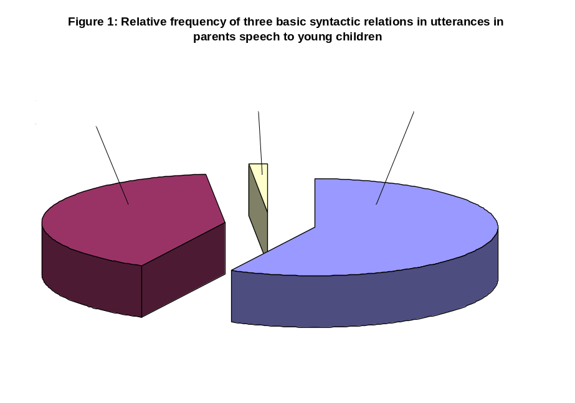
To determine how similar are children to parents by the end of Stage I grammar, we looked at the distribution in children's speech beyond 28 months of age. Figure 2 presents the pie graph:
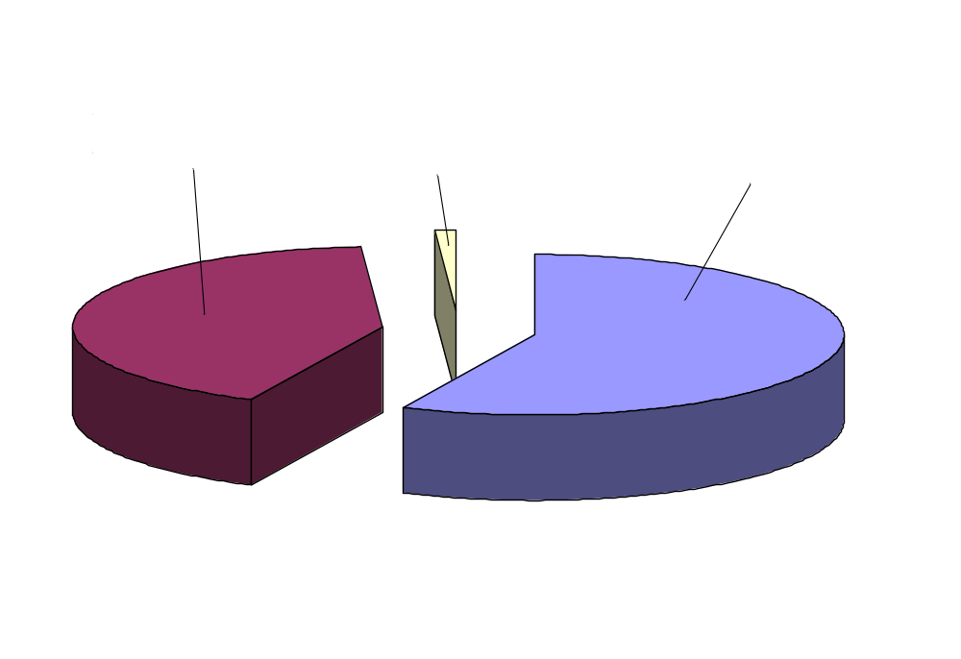

We can see that at the second half of Stage I grammar, children's use of the three syntactic complements is almost exactly identical to the parental register in the distribution of the three grammatical relations in utterances.

How does it happen that children at this early stage of syntactic combinations come to closely resemble parents in the distribution of the three core syntactic relations in their speech?

We can get closer to the answer if we trace the development of these verbal complements with age.

First, we trace the increase in syntactic complexity of children's utterances throughout the Stage I period. Figure 3 brings the average number of core grammatical relations per utterance, as a function of age. We only included utterances where there was at least one core complement to a verb, hence the lowest possible number of core grammatical relations in this analysis is 1.

We can see that number of syntactic complements per utterance increases from 1 in the start of word combinations including verbs with some complement, to about the parents' average of 1.7 complements per utterance at the end of the period.

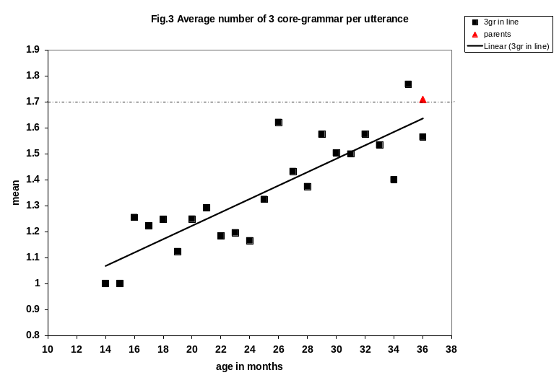
If we now map each of the three complements - subject, object and indirect object - -separately, we can see the way their relative frequency developed. Figure 4 presents the development of subjects in utterances by age.
Fig 4. Average number of subjects per utterance by age
0.40
0.50
0.60
0.70
0.80
0.90
1.00
1.10
12
14
16
18
20
22
24
26
28
30
32
34
36
38
age in months
mean
SV freq
parents
Linear (SV freq)
We see that their number increases monotonically to the level of the parents, to one subject per utterance.

The explanation for this development is in what is obligatory in English. It is perfectly possible not to express subjects in clauses where there is an object, if the verb is transitive and it is in imperative. Parents sometimes also omit the subjects in other kinds of sentences, like "want"-sentences. Table 2 presents some sentences in parents' speech.

Table 2. Some sentences with want in parents' speech without a subject:
want to make a tower ?
want to play with those ?
want to put that in here ?
want to take somebody for a ride in the car ?
want me to make a tower again ?
want Mommy to show you ?
want to finish the tower ?
want to put them back ?
want me to do it for you ?
want to sing a song or something ?
want some more yogurt ?

Although there are some sentences like these and especially in questions asking about the addressee's wishes, they make up a very small minority of parental sentences, and in the great majority of sentences parents do express subjects with want also.

Children initially use quite a few subject-less sentences with an object. Some of these are presented in Table 3 -- these are dropped subject of want . Not as parents, children omit the subject of want also in statements, not just in questions:

Table 3. Some sentences with want in children's speech without a subject:
want toys .
want lunch .
want watch .
want box .
want it .
want do pictures .

The results show that by 3 years, English-speaking children basically avoid verbal sentences with objects but without an expressed subject. We might say that when in comes to verbal syntax, a major learning process within Stage I of grammar consists of the systematic increase in expressed subjects of verbs with objects.

The increase we observed with subjects does not repeat with objects:
Figure 5 brings the developmental trend for objects.
Fig 5. Average number of direct objects per utterance by age
0.30
0.35
0.40
0.45
0.50
0.55
0.60
0.65
0.70
0.75
0.80
14
16
18
20
22
24
26
28
30
32
34
36
38
age 2 months
mean
VO freq
parents
Linear (VO freq)
Here, surprisingly, there is no change with age. The average number of direct objects is 0.6 and it does not change. It is somehow lower but not very much, from parent's value of 0.7 per utterance.

Figure 6 presents the same for indirect objects: 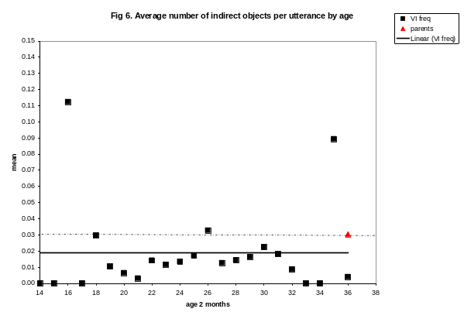
Again, the number of indirect objects per utterance stays constant at about 0.02 per utterance, a little below parents' value of 0.03 per utterance.

Interestingly, children appear to express the same amount of direct and indirect objects throughout this early period of development. Already in the earliest stages, objects are not dropped, they are expressed if needed.

Conclusions:
We found that children at the Stage I of grammar linearly increase the length of their clausal skeleton, consisting of the verb and its three core complements, subject object and indirect object. The increase stems from adding additional subjects to verbal sentences, so that the development of verbal clauses throughout Stage 1 is fundamentally that of increasing the expression of syntactic subjects. At the close of this process, children's distribution of the three core complements in verbal clauses is very similar to parents'. This similarity is the outcome of gradual increase in subjects, without changing the expression of objects and indirect objects.

When children get to the level of expression of parents, they basically come to mirror the parents' distribution of the three core syntactic relations subject, object and indirect object.

Judging from the input, English allows some omission of subjects of transitive verbs and not only in imperatives, but it seriously dislikes omitted direct objects. It appears that children are very sensitive to the "preferred argument structure" of their native language, and honor it in their own productive speech to the best of their ability.

References
Du Bois, J., Kumpf, L. and Ashby, W. (eds.) (2003). Preferred argument structure: Grammar as architecture for function. Amsterdam: John Benjamins.
Ninio, A. (2011). Syntactic development, its input and output. Oxford: Oxford University Press.

