Complex Systems' approach to the development of a morphological formclass

Anat Ninio
The Hebrew University of Jerusalem

Poster presented at SRCD 2007, Boston

Goal of study:

The reported study compared the development of morphological and syntactic form classes in young children. We wanted to find out if a morphological class forms the same way as syntactic classes do.

The three form classes compared were:

1. Hebrew verbs inflected for Past-3rd person-singular, as in nafal 'fell', halak 'went' and nigmar 'all-gone';

2. verbs appearing in Verb - Direct Object (VO) constructions as in roce tapuax 'want apple', lirot oto 'see it', or ohev pilpel 'love pepper';

3. verbs appearing in Verb - Indirect Object (VI) constructions as in ten li 'give me', koev li 'hurts me', or hirbic li 'hit me'.

Method:

The analysis was based on longitudinal home observations collected in previous research. For each form-class, we analyzed the speech of 14 children who produced at least 10 different verbs of the relevant kind. Some were the same children in two or more of the classes, some different.

The children were between 15 to 30 months old, about half of them boys and half girls.
Figure 1. presents the Rank-Frequency distribution -- the so-called Zipf Curves -- of the first 10 verbs in the three form-classes.

Rank-frequency distribution of verbs in Past 3sm, VO and VI, first 10 verbs per child (N=14)

Figure 1
Rank-frequency distribution of verbs in Past 3sm, VO and VI, first 10 verbs per child (N=14)

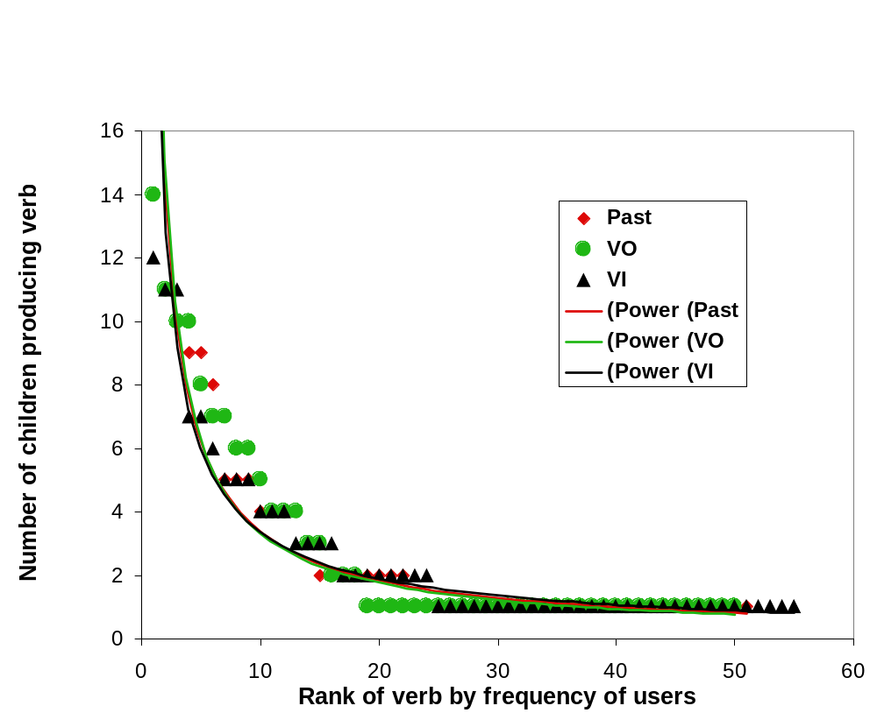
Result 1:
It is clear that the three curves are almost identical.

Question: did they develop in a similar manner?

In previous study (Ninio, 2006) we found that the global shape of the Zipf curve for syntactic formclasses VO and VI emerges right at the start of acquisition. It does not change with increased number of verbs.

Does morphology develop just like syntax?

Method 2:

We performed the rank-frequency analysis of the verbs as before, making separate analyses for the distribution of the first two verbs produced by the children of the sample, the first three verbs, the first 4 verbs and so on until the first 10 verbs they produced with this inflection.

The following graph presents the results.

Figure 2.
Development of rank-frequency distribution of first 10 verbs in Past 3sm

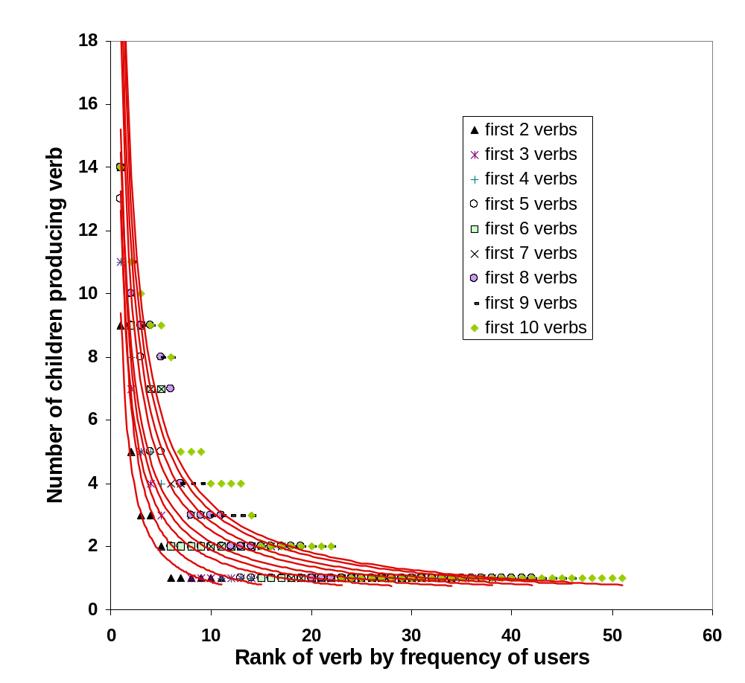

Difference:

Past starts with a much less steep curve than VO and VI.

Gradually the slope becomes more and more similar to that of VO and VI, until they become the same shape.

In the next graph we can see the gradual change in the slope of curve for the Past. The slope was estimated with the Pareto log-log representation.

Changing power-law exponents by number of different verbs in the Past 3sm formclass
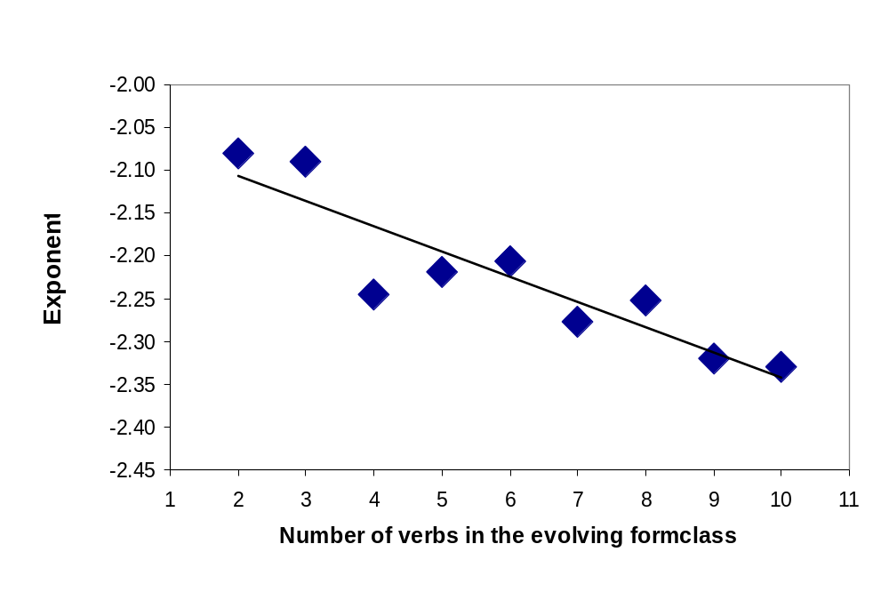

Result 2: A different relation between developmental step and the
power-law exponent in morphology and syntax

 | Past | VO | VI
Correlation  (Pearson’s r ( | -0.90 | 0.24 | -0.32
Percent variance explained (R2) | 81.35% | 5.7% | 10.15%
Significance | p < 0.001 | ns | ns

Explanation* of less steep Zipf curve at start of development of Past:

In formclasses of verbs in VO and VI there are one or at most two pathbreaking verbs at the beginning of acquisition: roce ‘want’ for VO, and natan ‘give’, hevi ‘bring’ for VI.
In the Past class there are 4 different pathbreaking verbs:

nafal ‘fell’

halak ‘went’

nishbar ‘broke’

nishpak ‘spilled’

For different children, different noteworthy events are encoded by a verb in the past tense. There is less commonality in the group of verbs in Past than there is in the verbs starting VO and VI combinations.

*The more frequent verbs there are, the more shallow the Zipf distribution.

Conclusions:

Grammatical development is driven by word meaning and communicative needs.

A Complex Systems analysis -- focussing on groups of children and not on the individual child -- provides novel insights and holds great promises for understanding grammatical development.

References:
Ninio, A. (2006). Language and the learning curve: A new theory of syntactic development. Oxford: Oxford University Press.

Thanks are due to Galila Spharim who analyzed the observations of 8 of the children for verbs in the past tense as part of the research for her Master’s thesis.

The poster can be downloaded from:
http://micro5.mscc.huji.ac.il/~msninio/

