The Past was Just a Moment Ago: Past Morphology in the Speech of Young Children and their Mothers
Anat Ninio
Department of Psychology, The Hebrew University of Jerusalem

Poster presented at the XVIth Biennial International Conference on Infant Studies

Vancouver, Canada, March 27-29, 2008

Abstract
A relatively unexplored aspect of the development of past morphology in children concerns the concept of past children may work with. Here we ask the most basic question, what is past tense for young children? When was the past? We examined the speech of three groups of Hebrew-speaking young children, 10, 18 and 26 months old, and their mothers' speech in conversation, looking for developmental trends in children's use of past morphology and age-related changes in mothers' use. Twenty four mother-infant dyads were videotaped in their homes, engaged in activities of their choice. The observational sessions lasted 30 minutes. All mothers had at least postsecondary education. Half the infants in each age group were male, half female. All utterances containing a verb inflected for past tense were categorized according to the reference of the past tense, as Recent past -- the time immediately before speech -- or Distant past -- all others. At 10 months no child produced a tense-inflected verb. Comparison of children's pooled utterances at 18 and 26 months shows extreme age-related differences, when at 18 months all past tense referred to immediately recent past whereas at 26 months only 56% of verbs did so. Namely, children begin using past verb inflections exclusively for very recent events and only later on start referring to a more distant past. Examination of mothers' speech to the three age groups revealed that when addressing 10-month-olds, mothers almost exclusively referred to the immediately recent past (88%). This bias got relatively less pronounced when speaking to 18-month-olds (62%) and further reduced in speech to the 26-month-olds (42%). The differences in distribution are significant by Chi-square test both for children and for mothers. Children's earliest concept of a linguistically encoded past event appears to be an occurrence that happened just a moment ago but does not happen any longer. This probably reflects infants' cognitive and linguistic limitations, with maternal fine-tuning to infants' abilities contributing to the conceptualization. The very recent past, however, consists mostly of events of punctual and telic character, accounting for the early achievement aspectual bias for past tense. The explanation for under-extension of the past to the immediately preceding moment is probably linguistic-pragmatic. It is almost impossible to establish distal joint reference by linguistic means for pre-linguistic and barely-verbal infants, whereas talk about the very recent past utilizes already-established joint attention to perceptually prominent events.
The Past was Just a Moment Ago: Past Morphology in the Speech of Young Children and their Mothers
Anat Ninio
Department of Psychology, The Hebrew University of Jerusalem

XVIth Biennial International Conference on Infant Studies

Vancouver, Canada, March 27-29, 2008

Poster:

1. Background and Aims:

A relatively unexplored aspect of the development of past morphology in children concerns the concept of past children may work with. Here we ask the most basic question, what is past tense for young children? When was the past?

We examined the speech of three groups of Hebrew-speaking young children, 10, 18 and 26 months old, and their mothers' speech in conversation, looking for developmental trends in children's use of past morphology and age-related changes in mothers' use.

2. Tense and aspect

It has been observed before that young children tend to restrict past morphology to completive aspect. The Aspect-before-Tense hypothesis proposes that children in fact use tense marking in order to encode aspect, not tense.

Here were test the alternative hypothesis – namely, that children do use tense morphology to encode tense, but that their concept of tense is restricted to completed events – and in particular, events that happened in the very recent past only.

3. Method-- Sample:

The spontaneous speech of 24 Hebrew-speaking children were analyzed, in three groups of 10, 18 and 26 months old, 8 children in each. The observations took place at home, in naturalistic circumstances, lasting 30 minutes. The observations were videotaped.

All mothers had at least postsecondary education. Half the infants in each age group were male, half female.

4. Method -- Verbs:

We focused on verbs inflected for past tense.

All utterances containing a verb inflected for past tense were categorized according to the reference of the past tense, as:

Recent past -- the time immediately before speech -- or as

Distant past -- all others.

5. Results -- children:

At 10 months no child produced a tense-inflected verb.
Comparison of children's pooled utterances at 18 and 26 months shows extreme age-related differences, when at 18 months all past tense referred to immediately recent past whereas at 26 months only 56% of verbs did so.
Namely, children begin using past verb inflections exclusively for very recent events and only later on start referring to a more distant past. (See Figure 1 below)
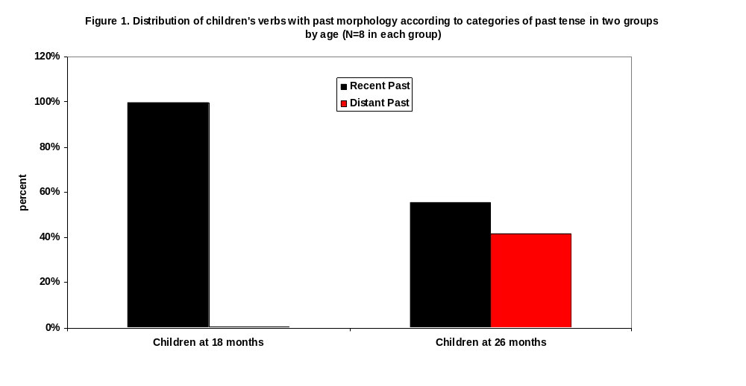
6. Results - Mothers:

Examination of mothers' speech to the three age groups revealed that when addressing 10-month-olds, mothers almost exclusively referred to the immediately recent past (88%).
This bias got relatively less pronounced when speaking to 18-month-olds (62%) and further reduced in speech to the 26-month-olds (42%).
The differences in distribution are significant by Chi-square test both for children and for mothers.

(See Figure 2 below)

7. Conclusions: Tense.

Children's earliest concept of a linguistically encoded past event appears to be an occurrence that happened just a moment ago but does not happen any longer.

Such events are, for example, objects falling, breaking or blowing up, liquids spilling, actions finishing, or entities leaving the scene.

This restricted concept of the past probably reflects infants' cognitive and linguistic limitations, with maternal fine-tuning to infants' abilities contributing to the conceptualization.

8. Conclusions: Aspect.

The very recent past, however, consists mostly of events of punctual and telic character, accounting for the early achievement aspectual bias for past tense.

The explanation for under-extension of the past to the immediately preceding moment is probably linguistic-pragmatic. It is almost impossible to establish distal joint reference by linguistic means for pre-linguistic and barely-verbal infants, whereas talk about the very recent past utilizes already-established joint attention to perceptually prominent events.

