--------------------------------------------------------------------------------------------------------------
Analogy and transfer of learning in syntactic development

Anat Ninio

The Hebrew University
Department of Psychology
The Hebrew University
Jerusalem, 91905 Israel

msninio@mscc.huji.ac.il
--------------------------------------------------------------------------------------------------

Abstract: The development of dative objects by children acquiring Hebrew was investigated. A large corpus of maternal input speech was examined, and the dative verb category was found to be extremely skewed for frequency as well as varied for semantics. Children's development was explored through the analysis of 30 longitudinal observations. The very first verbs produced with dative complements were indeed core verbs. Semantic facilitation demonstrated transfer-based learning. The effects of input frequency and obligatoriness were much smaller for the second wave of verbs learned. The results reveal that two sequentially ordered processes operate in the development of a syntactic category which immediately recreate its structure: establishment of the core, and similarity-based transfer-learning of the periphery.

Key words: syntactic development, similarity, transfer, facilitation, input, frequency effect
------------------------------------------------------------------------------------------------------------

1. Introduction
We hypothesized that similarity, analogy and transfer of learning are central possesses in syntactic development. Once some kind of syntactic construction is learned in an item-specific basis for some predicate word such as a verb, the learning of the same syntactic construction for other predicates is facilitated through the processes of analogy-based transfer of learning.
In the reported study, we explored the role of analogy in the development of dative objects or so-called "indirect objects". We hypothesized that children learn to produce ad-hoc dative objects to verbs that do not require them a priori, on the basis of analogy and semantic similarity to canonical obligatory indirect objects.
We focused on ad-hoc dative objects, sometimes called "ethical datives". Such dative objects are not required by the a priori, lexical valency structure of verbs. Nevertheless, they have the syntactic form of canonical, valency-required dative complements, and not the form of adverbial adjuncts.
The category of adhoc datives allows the complex testing of the hypotheses concerning learning by analogy. In general, it has been claimed that lexical items participating in certain grammatical relations form graded categories, with a core and a periphery. The center of the lexical category consists of verbs which are very close to the abstract core of the category; they can be said to be the prototypes of the category (Rosch 75). These core items are "nuclear" verbs (Dixon, 1982) which are semantically simple; other, more specific items belonging to the same category are its "peripheral" items. The core items are generic verbs that express the relevant combinatorial property in a relatively undiluted fashion. These are all semantically light verbs, whose meaning is almost like that of "logical predicates" for the relevant syntactic property, such as transitivity (Lehmann, 1991). The other elements of the category are semantically complex elements which are the hyponyms of the core items, or at the least, almost-hyponyms (Campbell and Wales, 1970).
When it comes to dative objects, there is an interesting complication to the theory. The category of verbs getting dative objects in Hebrew is an open class; except for the verbs getting obligatory or canonical dative objects, practically any other verb can also get an ad-hoc, extra-thematic dative object (Glinert 89). The adhoc part of the category is also graded: some verbs have a better probability of getting an adhoc dative than others (for English, see Allerton 78, Shibatani 96). This means that the category of verbs getting dative objects has an unusually complex, three-way graded structure: core, periphery and ad hoc verbs.
Our learning theory says that the order of formation of the category in child speech follows the structure of the category in adult speech. Namely, the category is learned from the core towards the periphery, inside out.
The learning hypothesis is twofold:
1. adhoc datives will be learned from obligatory datives;
2. peripherals will be learned from core exemplars.
It has been claimed that the learning of syntactic combinatorial rules progresses from the core items of the categories to their periphery. First learned in a novel syntactic pattern are the nuclear or generic verbs; as a rule, they are very frequent in use and also semantically simple and transparent in their mapping of semantics to syntax. These central core exemplars then serve as models for the more specific verbs and facilitate their learning in a process of transfer and analogy (Clark, 1996; Goldberg, 1999; Ninio, 1999).
When it comes to datives, we claim that the learning of valency verbs as well as ad hoc verbs with datives will be ordered according to their semantic similarity to the core canonical datives. As they are learned by analogy, their semantic similarity to the core exemplars facilitates their acquisition.
The dative object is semantically varied in Hebrew (Glinert 89). The canonical dative divides at least into 6 semantic fields: recipient of object (of the verbs give, bring); recipient of information, addressee (tell, say, show); benefactee (help, dress); benefactee/ultimate possessor (tell story, write); connectee (call, phone, wait, join, accompany); affectee - malfactee (hit, annoy); referent (refer, allude).
The Hebrew adhoc dative separates into several semantic fields, quite parallel to valency-required datives: recipient of object / loser of object (take, buy, put, take out, fall, throw); recipient of information, addressee (see, point); benefactee (fix, put in order, change diaper, clean); benefactee/ultimate possessor (make/do, sing, draw, build, dance); connectee (glue, touch); malfactee - affectee (turn, fly, spoil, pull, succeed); autonomous agent (be ashamed, rest).
In the following, a study is presented in which the acquisition of dative objects by a group of children is examined.
2. Method
The spontaneous speech of 30 Hebrew-speaking children were analyzed, aged 1 year one month to 2 years, 8 months. We collected sentences with dative, and focussed on their first five verbs getting dative objects.
3. Results
The percentage of valency-required verbs among the very first verbs learned by the children with a dative object was 79.4%. The order was tied in two children. Excluding ties, in 25 of the 28 children (89.3%), the first dative object was valency-required. This percentage is significantly higher than chance by binomial sign test (p < 0.01). Ad-hoc dative objects first appeared only after the children already produced required datives to a mean of about 1.27 different verbs. Among the 2nd to 5th verbs, the percentage of valency-required dative objects is 42/104 or 40.4%. Namely, the later verbs have a twice as low percent of verbs requiring obligatory dative objects, and their majority is adhoc datives. As a rule the first dative objects belong to required verbs; then the rate of learning of adhoc verbs accelerates and that of required verbs slows down, until the number of adhoc verbs getting a dative passes that of the required ones, already in the 3rd verb, significant in the 5th object. Figure 1 presents the comparison of the probability that the 1st required verb be learned before the 1st ad-hoc verb, the second required verb be learned before the 2nd ad-hoc verb, and so on until the 5th verb.

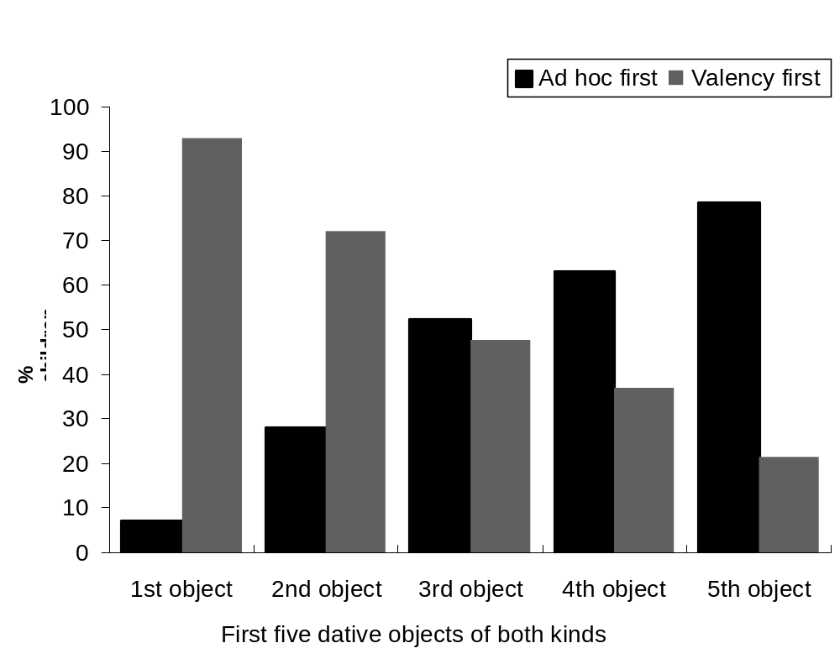

Figure 1. Pairwise comparison of order of acquisition: Valency vs. ad hoc datives

It is clear that the very first verb with an adhoc object is learned after the very first required verb; but as we get to the later verbs, the adhoc verbs start to be learned before the required ones.
Overall, we have confirmed the hypothesis of the study: required dative objects appear before adhoc; but the effect seems to be localized to the first-learned verb with a dative object, and not to even the earliest 5 verbs we investigated.
The first verbs getting dative objects tended very strongly to be the verbs 'give' and 'bring'; these accounted together for about 80% of all first datives in the sample. These are also very frequently occurring verbs with a dative object in the speech of mothers. We analyzed a corpus of maternal speech, focussing on multiword sentences with verbs and dative objects. The corpus represents the pooled speech samples of 48 mothers, videotaped interacting with young children. There were overall 3482 sentences of this kind, representing 144 different verbs. It was found that the distribution is highly skewed; the first few verbs are extremely frequent, and there are very many verbs which are extremely infrequent in maternal speech. Figure 2 presents the distribution of the first 35 different verbs in maternal speech.
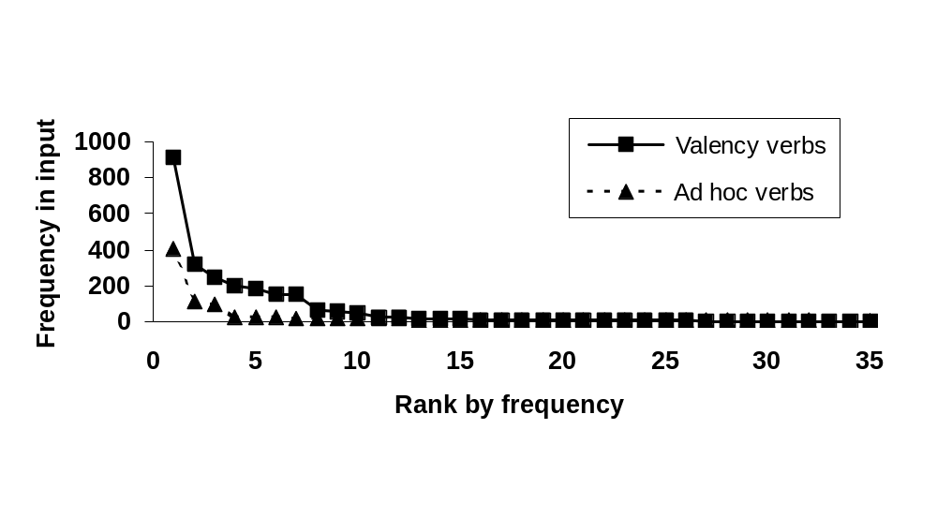
Figure 2. Distribution of valency and ad hoc verbs by number of utterances with dative objects in the maternal input

The most frequent verb was 'give' which occurred in 912 sentences, which is a full 26% of all sentences in which there is a verb with a dative object. 'Bring' occurred in 321 sentences, namely, 9% of all sentences. Together, these two verbs accounted for over one-third of all input sentences. Both 'give' and 'bring' are prototypical ditransitive verbs, which crosslinguistically are considered the core verbs of the category. The semantics of their dative object, RECIPIENT, is considered the prototypical semantic role of dative objects. Both verbs are semantically light, general and generic verbs, with a transparent mapping of semantic role to the syntactic configuration.
We might summarize that the first-acquired verbs with a dative object -- 'give' and 'bring' -- are learned first because of a confluence of factors operating in natural language: the core verbs of a category are semantically light, transparently mapped, and also very frequent in the input speech of parents talking to young children. We know from previous studies that as a rule, children start a new syntactic pattern with the multiply-such core-element of the relevant form-class, for example this was found for the first transitive verbs to appear with a direct object. The present finding regarding the priority in acquisition of 'give' and 'bring' is a further support for this model of acquisition. We think that the confluence of frequency, semantic simplicity and transparent mapping of semantics to syntax is not a coincidence but a design feature of natural language, and its fringe benefit is that it guarantees that the relevant core verbs will be first learned in their category.
Is the preference for valency verbs over adhoc verbs as the first-learned verbs with dative merely due to their lesser frequency in the input? Table 1 presents the 10 most frequent verbs in the input getting dative objects, and their learning by children as their very first verb with a dative.

Freq. in  Input | Verbs often learned first |  | Verbs rarely learned as first
 | Verbs | # learned | Verbs | # learned
912 | natan 'give' | 18
403 |  |  | asa 'make' * | 0
321 | hevi 'bring' | 6
249 |  |  | hera 'show' | 0
195 |  |  | higid 'say' | 0
185 |  |  | azar 'help' | 1
148 |  |  | kara 'call' (name) | 0
147 |  |  | siper 'tell story' | 0
110 |  |  | sam 'put' * | 1
95 |  |  | shar 'sing' * | 0
- Verbs getting ad-hoc dative objects

Table 1. The 10 most frequent verbs getting dative objects in the input, and their learning by children as their first verb with a dative object

If the token frequency of a verb is below 250, representing about 7% of all the relevant input, children don't learn the verb as their first. This is equally true for such valency verbs as 'show', 'say' and 'tell', and to adhoc verbs like 'put' and 'sing'. High input frequency is apparently a necessary condition to learning a verb as the very first one in a new syntactic pattern.
However, it is not a sufficient condition. The verb 'make/do' is highly frequent in the input with a dative object, surpassing the verb 'bring'. It occurs in 403 of the input sentences, representing 11.6% of the relevant input, 25% more than 'bring'. In addition, 'make/do' is a semantically light verb, almost a pro-verb, and in mothers' and children's speech it occurs with a wide variety of action and creational meaning, performed for the benefit of the dative object. It seems to have answered many of the criteria for a successful Starting Verb: frequent, semantically light. Why wasn't it then learned by a single child in our sample of 30 as their very first verb with a dative object?
The answer seems to be directly relatable to the fact that 'make/do' receives a dative object in an adhoc and not valency-required manner. Getting an adhoc dative object and not a valency-required one is observable in the input. Obligatoriness translates to a quite transparent quantitative feature: the percent of time this verb appears with a dative object is much lower than in valency-requiring verbs. If we count only sentences with at least two words, the percent of 'give' appearing with dative object is 90.8%, while 'make/do' appears with a dative only in 13.9% of the sentences. Because 'make/do' is an extremely frequent verb, this means that for its 403 sentences appearing with a dative, there are 2535 sentences without a dative. With only 14% obligatoriness, it is apparently impossible to associate the verb with an a priori semantic component which would underlie and license an obligatory dative object, such as "giving" or "helping". The quantitative fact distinguishing verbs with a valency-requirement for a dative object and one without it, translates to verb semantics. In valency-requiring verbs, the dative element is part of the meaning of the verb: the verb is transparent in its allocation of some recipient or beneficiary semantics to its dative object. In adhoc verbs, on the other hand, the verb does not contain the necessary semantic component. Instead, the dative object is interpreted on its own merits, apparently by analogy to a valency-required one.
It is obvious that the factor giving priority to valency-verbs over adhoc verbs weakens once the children have learned one and maybe two verbs with dative objects. Other factors come into play, and the major among them is connected, according to the hypothesis, to the possibility to learn further verbs by analogy and transfer from the already-learned verbs and dative objects.
According to our hypothesis, the first verbs serve as models for the rest of the category, so that the learning of the other verbs from the input is mediated by processes of analogy and transfer-based learning. This process reduces the role of input frequency and increases the role of semantic similarity to already learned verbs. We hypothesize, therefore, that the next verbs learned will have a much less strong input frequency effect.
First, we computed the linear correlation coefficient between input frequency and the probability of a verb being learned as the very first verb, or among the 2nd-to-fifth verbs with a dative object. The first verb learned gets a frequency correlation of .85 (72%, 142 df). The overall frequency correlation with 2nd-5th is .60 (36%, 142 df). This shows that the effect of input frequency is much higher for the first-learned verb than for the next 4 verbs. The percent of variability explained is twice as much for the first verb.
Second, we predicted that the input frequency effect will only operate conditional on the new verb's semantic similarity to the already learned dative verbs. As the first-learned verb's semantics is Object Transfer (OTR or Transfer of Possession of Concrete Objects), we predict that children will learn further verbs with the highest probability if their semantics is similar to OTR and if the verbs are relatively frequent in the input.
When we pass to the 2nd-to-fifth verbs, the disadvantage attributable to being an adhoc verb largely disappears. Among the first 5 frequent verbs learned, there are 3 valency verbs and 2 adhoc verbs. Among the 5 verbs not learned, there are 4 valency and 1 adhoc. This difference is not significant.
Now the question is, if not obligatoriness and valency status, why are some of the frequent verbs learned and some others -- are not? We predicted that the reason is their semantics. The data shows that the 2-5th learned verbs indeed resemble the first-learned ones. Among the valency-verbs, the ones learned are 'give', 'bring' and 'help' which all refer to concrete actions in which the dative object is a recipient or beneficiary; the verbs not learned despite high frequency refer to transfer of information or the provision of intangible benefits like enjoyment: 'show', 'say', 'call' (ie name), 'tell a story'. The same difference can be observed in the adhoc verbs: the ones learned are 'make' and 'put', referring to transfer of possession of a concrete object, and the one not learned despite high frequency is 'sing', concerned with transfer of intangibles.
The other side of the weak frequency effect is that there are verbs learned as 2nd to 5th verbs or "second wave" which are not extremely frequent in the input: 'fall', 'take', 'buy', 'open' and 'take-out' are among the verbs getting ad-hoc datives which were often learned despite a relatively low frequency. All deal with the procuring of concrete objects with a view to their ultimate possession by the dative object, and the odd man out, 'fall' refers to loss of an object (which the child wants to repair by the utterance...). The frequency of the verb in the input is a minor factor but it still operates: all the verbs learned by the children (at least 3) are among the most frequent 25 verbs out of 144 in the corpus, or upper 17% of the input, so that none of them is less frequent than 12 token sentences. For comparison, there are more than 50 verbs that occur with only one token sentence in the input. The extremely infrequent verbs do not as a rule get learned early, whatever their semantics.
4. Conclusions
When we look at the second wave of acquisition, the 2nd-to-5th verbs learned by children in the dative object pattern, the major factor for order of acquisition seems semantic: the closer the meaning of a verb to 'give' and 'bring', the more likely is the dative object to be produced early with this verb.
The results suggest that children learn to produce ad-hoc, "ethical" datives by analogy to the core dative objects of the verbs 'give' and 'bring'. The same process apparently drives also the acquisition of other valency-required datives as well. These results support the view that prototypicality, core exemplars, similarity and transfer by analogy play a central role in syntactic development.
5. References
Allerton, D. J., "Generating indirect objects in English", Journal of Linguistics,
vol. 14, 1978, p. 21-33.
Campbell, R., & Wales, R., "The study of language acquisition", in J. Lyons (Ed.), New horizons in linguistics, p. 242-260. Harmondsworth, England: Penguin Books, 1970.
Clark, E. V., "Early verbs, event types, and inflections", in C. E. Johnson, & J. H. Gilbert (Eds.), Children's language, vol. 9, p. 61-73, Mahwah, NJ: Erlbaum, 1996.
Dixon, R. M. W., "The semantics of giving", In R. M. W. Dixon (Ed.), Where have all the adjectives gone? And other essays in semantics and syntax, p. 117-139, Berlin: Mouton, 1982.
Glinert, L., The grammar of Modern Hebrew, Cambridge: Cambridge University Press, 1989.
Goldberg, A. E., "The emergence of the semantics of argument structure constructions". In B. MacWhinney (Ed.), Language acquisition, p. 197-212, Mahwah, NJ: Erlbaum, 1999.
Lehmann, C., "Predicate classes and participation". In H. Seiler, & W. Premper (Eds.), Partizipation, p. 183-239, Tubingen: Gunter Narr Verlag, 1991.
Ninio, A., "Model learning in syntactic development: Intransitive verbs." International Journal of Bilingualism, vol.3, 1999, p. 111-131.
Rosch, E. H., "Natural categories", Cognitive Psychology, vol. 4, 1973, p. 328-350.
Shibatani, M., "Applicatives and benefactives: A cognitive account", in M. Shibatani, & S. A. Thompson (Eds.), Grammatical constructions: Their form and meaning, p.157-194, 1996.

