Symposium on Slow Mapping in the Acquisition of Vocabulary and Syntax; The Biennial Meeting of the Society for Research in Child Development, Montreal, Canada, 2011

When the Output does Not Match the Input: Accumulation of Uses for the Verb Have by Young English-Speaking Children
Anat Ninio

Abstract
One instance of slow mapping is the accumulation of different meanings and syntactic constructions for polysemous verbs. Linguists distinguish polysemous words from homonyms, considering the former single linguistic units with a complex multi-version semantic and syntactic behaviour. To complete the acquisition of a polysemous word, children may have to resort to a gradual and drawn out process of acquisition, learning each use at a time.
Some psycholinguists propose that polysemous words have multiple entries in the mental lexicon, a separate lexeme for each different meaning. If so, children may acquire polysemous verbs as if they were several different verbs, each to be learned individually with its own syntax and semantics. The order of acquisition and frequency of use of different words does not follow their frequency of use in the input, e.g., the most frequent words in adult English are articles and prepositions, which are typically late in acquisition. By analogy, we predict that input frequency will not determine age of emergence nor use frequency by children of different versions of a single polysemous verb.
We tested this hypothesis on the input and output of the verb have, mapping the accumulation of uses by young English-speaking children in the Subject-Verb construction. We built a large corpus of parental sentences addressed to young children and a second corpus of child sentences, based on the English language observations transcribed and stored in the CHILDES archive. A total of 506 parents and 421 children contributed multiword sentences to the systematically constructed pooled corpora. The children were in Brown's Stage I, the mean age was a little over 2;3 (Ninio, 2011).
Parents produced 9,284 word combinations with have getting an expressed subject. These fell into four main types of constructions, differing by their syntax and the semantics of have: (1) main verb meaning possession: [Subject V NP] (e.g., the doll has bare feet); (2) modal auxiliary: [Subject V to-infinitive] (e.g., I have to wash them); (3) aspectual auxiliary: [Subject V past participle] (e.g., I haven't quite finished) and (4) have got: [Subject V got to-infinite/NP] (e.g., I've got them here).
Israel (2000) and others have claimed that in the acquisition of polysemous verbs, input frequency predicts both order of acquisition and proportion of use by young children. This however is not the case with the verb have. Although the most frequent parental use is as an aspectual auxiliary (30.8%), children's earliest use is the main verb signifying possession. This is also children's most frequent use, accounting for 67.2% of SV combinations.
We mapped the age trend in the use of the four type of constructions of have from 1;4 to 3;1 and found that by the end of Stage I children's use arrives at a stable plateau, but the values the use pattern converges to, are not the ones manifested by parental speech. We conclude that children do not match parental proportions of use for polysemous words, nor does their order of acquisition reflect the parental proportions.

Reference to this talk:
Ninio, A. (2011, March). When the output does not match the input: accumulation of uses for the verb have by young English-speaking children. Paper presented at a symposium on Slow Mapping in the Acquisition of Vocabulary and Syntax, chaired by A. Ninio. The Biennial Meeting of the Society for Research in Child Development, Montreal, Canada.

Introduction:
In our symposium today we shall discuss several different phenomena collectively known as slow mapping. We know what fast mapping is -- some minimal exposure to a word or some other linguistic unit is often sufficient to register this lingusitic form and its meaning in the internal lexicon. The more sophisticated view is that fast mapping provides just the beginning of learning the relevant word, providing a relatively vague, general, and approximate information about its meaning and uses; it takes much further learning to accumulate all other relevant information about the same linguistic form.

One possible instance of slow mapping and the one I shall talk about today is the accumulation of different meanings and syntactic constructions for polysemous verbs. Such verbs are typical examples of words having multiple meaning -- but they are not the only words having a range of possible meanings. In a radical approach, it is claimed that all linguistic signs are inherently polysemic (Gottdiener, 1995) or “multivocal” and open to a range of different interpretations (Bakhtin, 1981). If all lingusitic elements are polysemic, and capable of having a range of possible meanings, it is an important topic of research to explore the processes of their formation by children.

As we know, linguists distinguish polysemous words from homonyms. Homonyms are words having a similar form but this is an incidental fact as their meanings are clearly unrelated, such as rhyme (of verse) and rime (frost) or pause (stop) and paws (feeet of an animal). Homonyms are seen as different and clearly unrelated lexical items, and the coincidental similarity of their sound a result of various historical processes. By contrast, polysemous words are considered single linguistic units with a complex multi-version semantic and syntactic behaviour whose different senses can be systematically related to each other (e.g. Taylor, 1995, p. 99).

There is some unsettled question how the multiple uses of polysemous verbs are registered in the internal lexicon. One option is that there is a single, very abstract, basic lexical entry for the verb and the different uses are of such polysemous verbs are in fact several different concerete manifestations of this single lexical entry (e.g., Haegeman, 1983; Gronemeyer, 1999). This suggestion is similar to the idea that ambiguous words and maybe all words are represented in an underspecified form, and that word meaning in a given sentence is computed on the basis of context. This is the monosemy approach (Tuggy, 1993).

Other linguists and psycholinguists propose that polysemous words have multiple entries in the mental lexicon, a separate lexeme for each different sense or meaning, which often also has a different syntactic patterning (Grimshaw, 1990; Miller & Johnson-Laird, 1976; Pinker, 1989; Ruhl, 1989). Such multiple entries may be related and may actually form a kind of interconnected network, but fundamentally they are merely different words, even if with an unusually strong semantic association.

Regardless of the ultimate relatedness of the different uses, in order to complete the acquisition of a polysemous word, children may have to resort to a gradual and drawn out process of acquisition, learning each use at a time. Only at a later stage may children come to realize the ultimate relatedness of the differing uses. If so, children may acquire polysemous verbs as if they were several different verbs, each to be learned individually with its own syntax and semantics.

Gradual learning
Previous studies (Israel, 2000; Kidd & Cameron-Faulkner, 2008) of the acquisition of polysemous words suggests that children indeed learn the various different senses of such words in a gradual fashion. Kidd and Cameron-Faulkner studied the acquisition of the ambiguous preposition with and they found that its first 8-9 senses were acquired by a child over a period of two years. Israel studied the acquisition of the polysemous verb get in 8 children and he found that the first 6 different uses took six months to over a year to learn.

Relation with input
Both investigations also looked at the relation of order of acquistion and use frequency in children with the relative frequency in the adult lingusitic input. In both studies, very high correlations were found, so that children learned earlier and used more frequently sub-senses of these polysemous words the more frequently they occur in adult speech.

Despite the previous results that seemed conclusive, it seemed worthwhile to explore the topic somewhat more deeply. The reason is that the relationship with input frequency is not really expected to happen on the level of different words. I'll explain.

If children indeed acquire polysemous verbs as if they were several different verbs, the order of acquisition and use frequency of the different versions should not necessarily replicate that of the linguistic input of parents. We actually know that in general, the order of acquisition and frequency of use of different words does not follow their frequency of use in the input. It is sufficient if we remember that the most frequent words in adult English are articles and prepositions (Zipf, 1935/1965), which are typically late in acquisition. By analogy, we predict that input frequency will not determine age of emergence nor use frequency by children of different versions of a single polysemous verb.

Instead of date of first use and correlations of frequency with input frequency, we should map the changes over time in the use of the various sub-meanings of some polysemous word. This would give a clear picture of the developmental trends. On the background of these developmental trends, the comparison with the input frequencies answers the question how children are faring relative to adults in the use patterns of the polysemous verb. Our hypothesis is that different uses are like different words, and these do not have to have identical pragmatic importance and usefulness in children and adults. It follows that relative frequency of polysemous sub-meanings in input speech should not determine their relative use by young children.

The present study
In the present project, we tested this hypothesis on the input and output of the verb have, mapping the accumulation of uses by young English-speaking children in the Subject-Verb construction. We built a large corpus of parental sentences addressed to young children and a second corpus of child sentences, based on the English language observations transcribed and stored in the CHILDES archive. A total of 506 parents and 421 children contributed multiword sentences to the systematically constructed pooled corpora. The children were in Brown's Stage I, the mean age was a little over 2;3 (Ninio, 2011).

Parents produced 9,284 word combinations with have getting an expressed subject. These fell into four main types of constructions, differing by their syntax and the semantics of have. Figure 1 presents these sub-uses.

Figure 1. Four types of uses of the verb have with a subject in parents' speech (N=9,284) and child speech (N=470)
Syntactic role of verb | Syntactic pattern | Semantics | Examples
main verb | Subject V NP | possession | The doll has bare feet  Baby had tea
modal auxiliary | Subject V to-infinitive | obligation | I have to wash them  I have to cut it ?
aspectual auxiliary | Subject V past participle | perfective  aspect | I haven't quite finished  Because I haven't used it yet
idiomatic "have got" | Subject V got to-infinite  /NP | obligation or  possession | You've got to buy a new dress  He's got a new hat on

(1) main verb meaning possession: [Subject V NP] (e.g., the doll has bare feet) including idiomatic light-verb constructions (e.g., baby had tea );
(2) modal auxiliary: [Subject V to-infinitive] (e.g., I have to wash them);
(3) aspectual auxiliary: [Subject V past participle] (e.g., I haven't quite finished) and
(4) have got: [Subject V got to-infinite/NP] (e.g., I've got them here).

Figure 2 shows distribution of tokens by these 4 categories in parental and child speech.
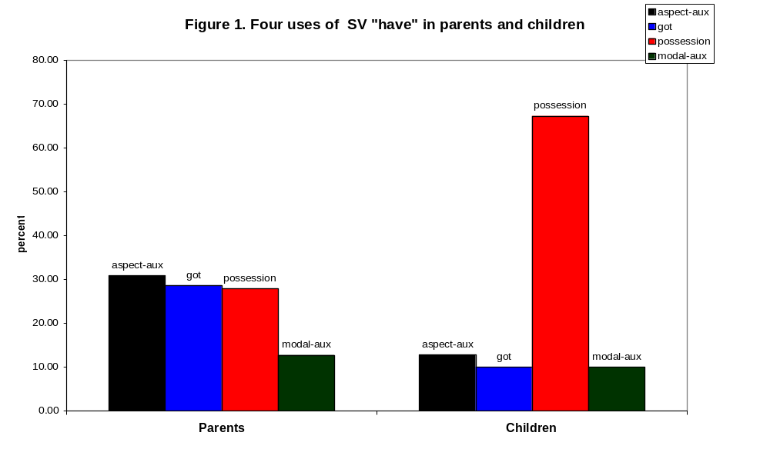

Immediately we see that the children's use is not a mirror image of the parents' use: the great majority of their subject-verb combinations with have belong to the category using have as a main verb generally expressing possession, whereas in parents' speech this use is just one of three about 30% each of tokens, together with aspectual auxiliary and multiword lexeme have got expressions.

It appears that the close similarity of relative use frequencies Israel found for the multiword occurrences of the verb get is not a general phenomenon, and at the least this not the case with the verb have. Although the most frequent parental use is as an aspectual auxiliary (30.8%), children's most frequent use is the main verb signifying possession, accounting for 67.2% of SV combinations. The correlation between parental and child frequencies of 4 categories is 0.26, obviously very low relative to the almost perfect correlations in the case of get.

We also checked children's earliest use and it was of have with a possessive meaning, Namely, the order of acquisition is also not determined by relative frequency in parental speech.

We wanted to map the development over time of the use pattern, and Figure 3 presents them as a function of age.
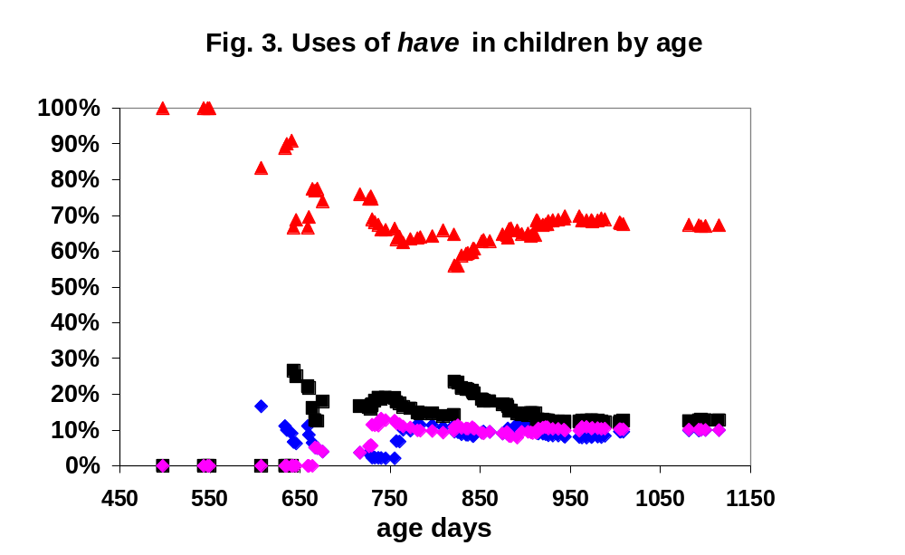
In order to see the comparison to parental proportions, we mapped each sub-use relative frequency separately. Figures 3a to 3d present the results

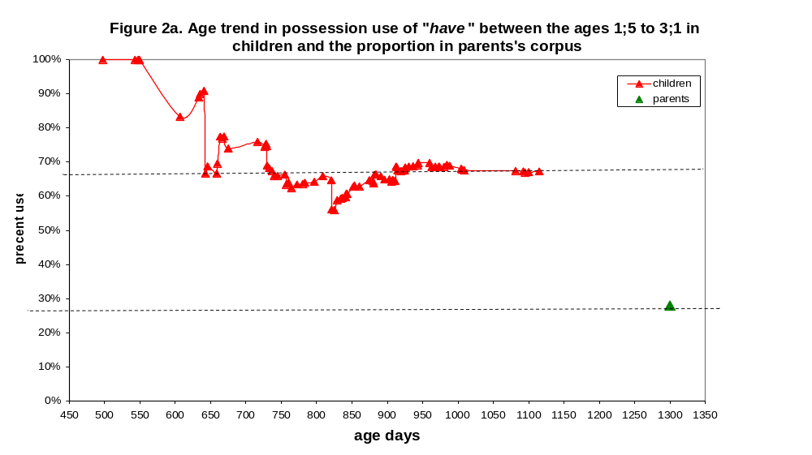
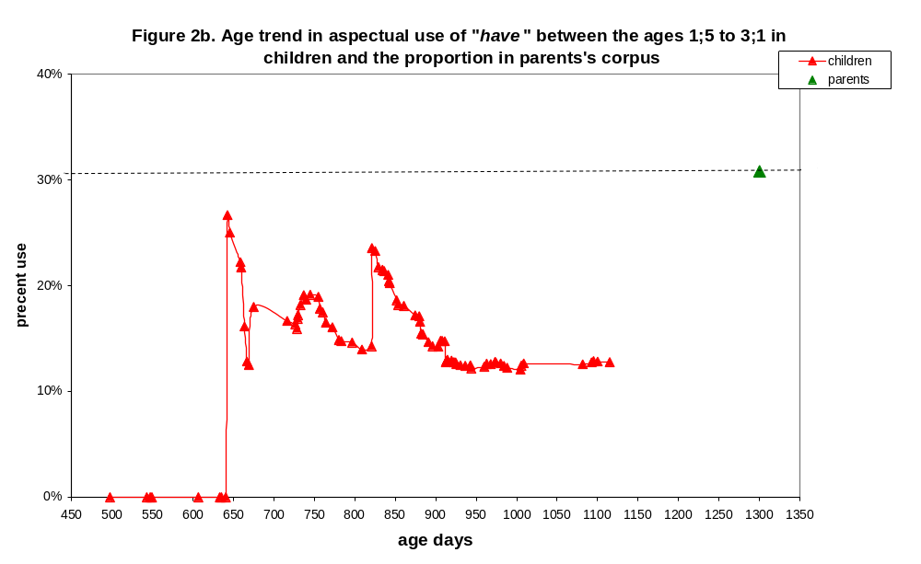
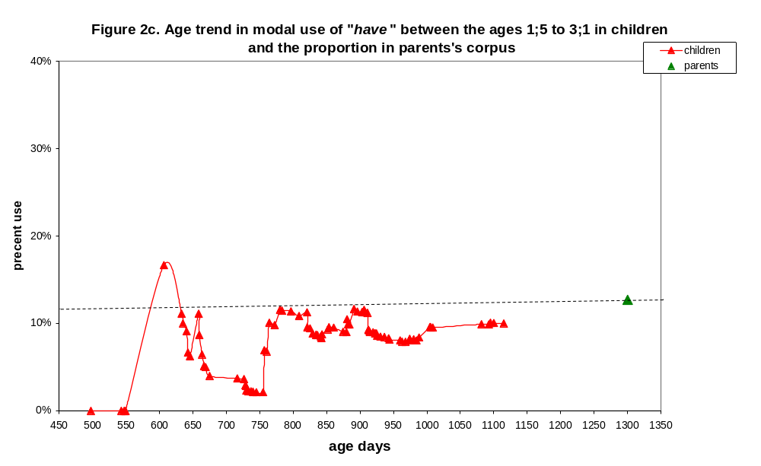
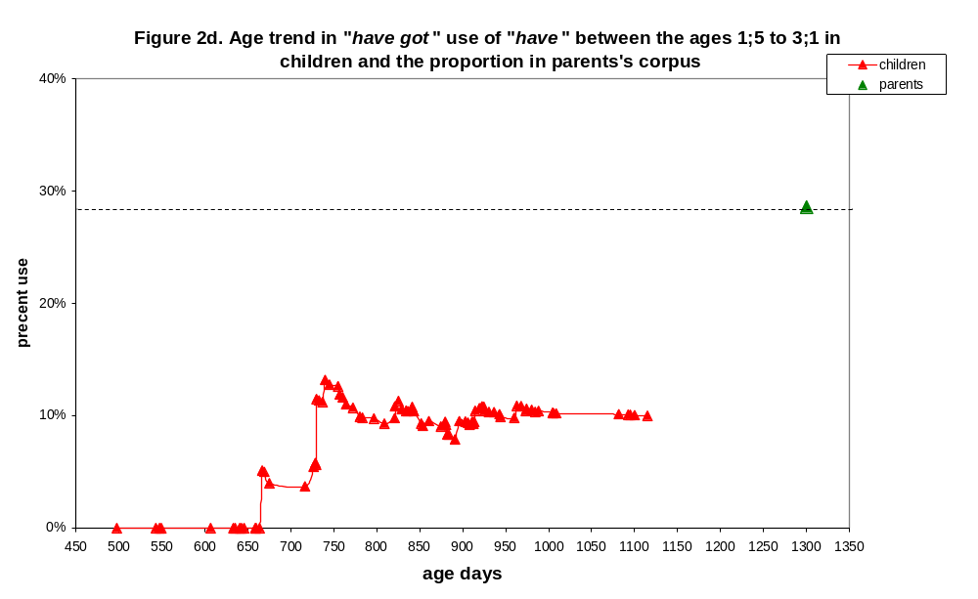
While the use of have in a subject-verb combination starts at 1;4.11, for several months this is the only kind of use we observe. Only at 1;8 children start to generate subject-verb word combinations with have in any other meaning, the first being modal auxiliary. The course of development is rather clear: for the period we are mapping out, the POSSESSION use is the one children start with; they reduce the proportion somewhat when other uses come in at a later stage, but then there is a constant around two-thirds (67%) that they do not go below. After the 1;8 landmark age, three other uses emerge, with a combined proportion of about a third (33%) of all uses. Children certainly build up the range of uses of have gradually, but they do not ignore any of the three possibilities even at this young age.

The graphs show that all four patterns of use converge to a constant proportion of the total. The interesting part is that the values children's use converges to, are not the values parents model for them. In the case of the POSSESSION type, the children coverge to 67% but the parents only use this sub-pattern in 28% of the time. Similarly with the other two patterns -- the aspectual auxiliary and have got patterns; children converge to some value but not to parents' values. The only pattern where children appear to converge to the parental percent is the modal use of have, around 10%. This is an unexpected result and it only has one explanation: children's uses are determined by some other, quite strong, factor and not by the relative frequencies in the input. Children seem to actually have learned all four patterns, but they use one in 2/3 of the time. Children indeed cumulate options and sub-meanings for the verb have, just not in the relative frequency adults use.

Conclusions:
The children we are studying are in Roger Brown's Stage I of grammar, meaning that their major task is to master the core syntactic relations of English. Brown thought this period was devoted to the verbal expression of certain semantic relations in multiword utterances. Our exploration of the use patterns of the verb have rather supports his vision. Children seem to be guided in what they say by pure pragmatic considerations of what is it that interests them to express. Given their young age, it is reasonable that they are the most interested in expressing the simplest most concerete context of all four options connected with have, and that is the sense of possession. Things like completive aspect are in all probability much less interesting for them to express.

In summary: We mapped the age trend in the use of the four type of constructions of have from 1;4 to 3;1 and found that by the end of Stage I children's use arrives at a stable plateau, but the values the use pattern converges to, are not the ones manifested by parental speech. We conclude that children do not match parental proportions of use for polysemous words, nor does their order of acquisition reflect the parental proportions.

If we return to the Israel study on get, we can see that the results are rather similar. He compared the input and output frequencies for 4 children, Eve of Brown, Nina Suppes, Naomi Sachs, and Peter Bloom. If we average over the four children, we get the following pattern of results.
Israel concentrates on three most frequent uses of get, and so shall we. These are OBTAIN, MOVE, and BECOME. the results are presented in Figure 4.
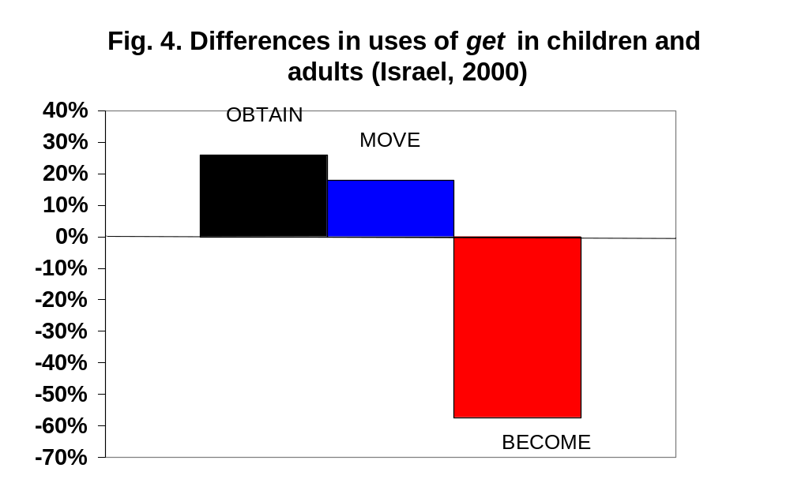
The single most frequent use of get in children is the OBTAIN semantics, the average for 4 children is 56%, whereas in adult speech the percent is only 45%, namely, children employ this use of get 25% more than adults do. This is the most semantically concrete use and the syntactically most simple one, analogous to the POSSESSION use of the verb have.

The second concrete use is with a MOVE semantics, and here the children use it in 19% of their tokens and the adults, only 16% which makes for 18% more in children than in adults. This use is also semantically concrete and syntactically simple, and the pattern of input-output relations is similar to that of OBTAIN.

The third use is BECOME, which occurs in children in 7% of the tokens and in adults, in 17% of the tokens Namely, children use this pattern less than half of the time than parents. This category contains the auxiliary uses of get, both as a modal auxiliary and as a passive auxiliary. In a repetition of our results with the verb have, auxiliary uses are less frequent at this stage of development and concrete-sematic uses, more frequent, than in the input. Israel's study does not contradict our results, rather, it supports our conclusions that children do not copy the differential frequencies of polysemous sub-uses heard in the linguistic input.

Conclusion: it seems different uses of polysemous and polyvalent verbs are indeed independent entries in the mental lexicon and are learned separately. Factors such as semantic simplicty, pragmatic usefulness and syntactic complexity are more powerful than sheer input frequency in determining the course of acquisition and early use patterns.

References:

Bakhtin, M. M. (1981). The dialogic imagination: Four essays. (M. Holquist, ed., transl. C. Emerson and M. Holquist). Austin, TX: University of Texas Press.
Gottdiener, M. (1995). Postmodern semiotics: material culture and the forms of postmodern life. Cambridge, MA: Blackwell.
Grimshaw, J. (1990). Argument structure. Cambridge, MA: MIT Press.
Gronemeyer, C. (1999). On deriving complex polysemy: the grammaticalization of get. English Language and Linguistics, 3, 1-39.
Haegeman, L. M. V. (1983). The semantics of will in present-day British English: a unified account. Brussels: Verhandeling Letteren.
Israel, M. (2000). How children get constructions. Presented at the Fifth International Conference on Conceptual Structure, Discourse and Language, University of California, Santa Barbara, CA.
Kidd, E. and Cameron-Faulkner, T. (2008). The acquisition of the multiple senses of with. Linguistics, 46, 33–62.
Miller, G. A. and Johnson-Laird, P. N. (1976). Language and perception. Cambridge, MA: Harvard University Press.
Ninio, A. (2011). Syntactic development, its input and output. Oxford: Oxford University Press.
Pinker, S. (1989). Learnability and cognition: the acquisition of argument structure. Cambridge, MA: MIT Press.
Ruhl, C. (1989). On monosemy: a study in linguistic semantics. Albany, NY: State University of New York Press.
Taylor, J. (1995). Linguistic categorization: prototypes in linguistic theory. Oxford: Oxford Clarendon Press.
Tuggy, D. (1993). Ambiguity, polysemy, and vagueness. Cognitive Linguistics,4,273-290.
Zipf, G. K. (1935/1965). Psycho-biology of language: an introduction to dynamic philology. Cambridge, MA: MIT Press.

