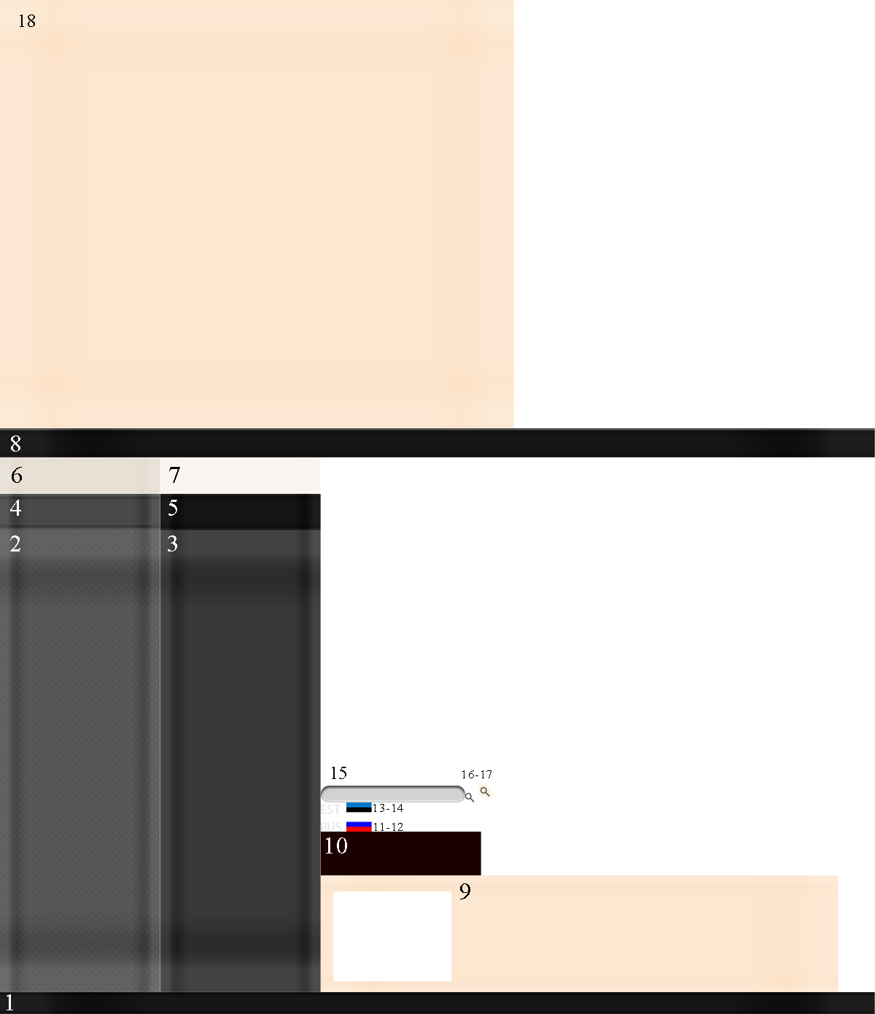

|  |  |  |  |  |
| --- | --- | --- | --- | --- |
| Номер | Х (H) | Y (V) | Ширина | Высота |
| 1 | 0 | 0 | 1200 | 30 |
| 2 | 0 | 30 | 220 | 633 |
| 3 | 220 | 30 | 220 | 633 |
| 4 | 0 | 663 | 220 | 50 |
| 5 | 22 | 663 | 220 | 50 |
| 6 | 0 | 713 | 220 | 50 |
| 7 | 220 | 713 | 220 | 50 |
| 8 | 0 | 763 | 1200 | 40 |
| 9 | 440 | 30 | 710 | 160 |
| 10 | 440 | 90 | 220 | 60 |
| 11 | 440 | 250 | 28 | 13 |
| 12 | 475 | 250 | 35 | 20 |
| 13 | 440 | 270 | 28 | 13 |
| 14 | 475 | 270 | 35 | 20 |
| 15 | 440 | 290 | 198 | 23 |
| 16 | 638 | 290 | 13 | 13 |
| 17 | 651 | 290 | 29 | 29 |
| 18 | 0 | 803 | 705 | 587 |