|  |  |  |  |  |
| --- | --- | --- | --- | --- |
| **National University of Computer and Emerging Sciences, Lahore Campus** | | | | |
| C:\Users\saif\AppData\Local\Microsoft\Windows\Temporary Internet Files\Content.Word\final design.jpg | **Course:** | **Fundamentals of Computer Vision** | **Course Code:** | **CS-4059** |
| **Program:** | **BS(Data Science)** | **Semester:** | **Spring 2024** |
| **Duration:** | **-** | **Total Marks:** | **10** |
| **Due Date:** | **24-Mar-24** | **Weight** |  |
| **Section:** | **B** | **Page(s):** | **2** |
| **Exam:** | **Assignment 2** | **Roll No.** |  |
| **Instruction/Notes:**   * Read the assignment carefully. Make sure you have understood the requirements and expectations of the assignment. * Ensure that you have all the necessary files and documents ready for submission in the CORRECT format. * This is an individual assignment. Any form of plagiarism will result in an award of ZERO marks. * The assignment must be submitted before the announced DEADLINE. One mark will be deducted for each day of late submission. | | | | |

**Title: "CNN: From Recognizing Cats to Saving the World!"**

**Background**

After failing to get a job in NASA, Anato is now an Intelligence Agent, whenever he is on a mission, he always takes his cat “Hurrair” with him. If Anato tries to leave Hurrair at home alone, Hurrair makes this kind of face:

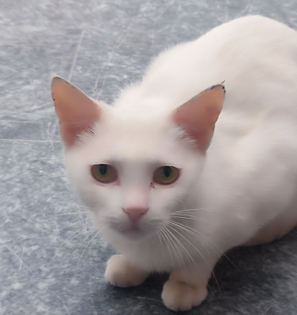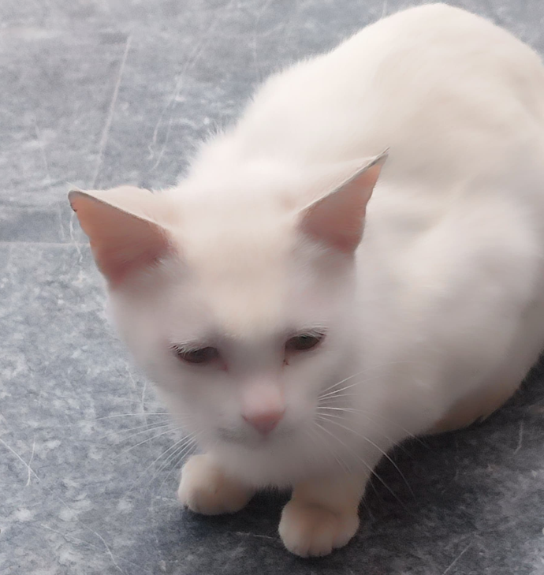  
  
Apparently, Hurrair has loneliness disorder & if Anato leaves Hurrair alone, Hurrair tries to suicide and if Hurrair dies, Anato will be sad 😢. Now Anato has given Hurrair access to his phone so in case during a mission if Hurrair is hunger while Anato is busy, Hurrair can order himself some French Fries from Foodpanda. (yes, cats do eat potatos)

Now, The issue is as Anato has given his Phone’s access to Hurrair, his enemies might try to use a cat who looks similar to Hurrair ( his evil twin ) to gain access to Anato’s phone and steal all the top secret files in the phone. Such a sample is shown below:

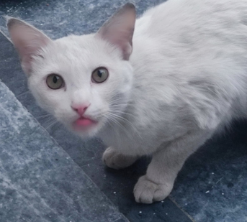 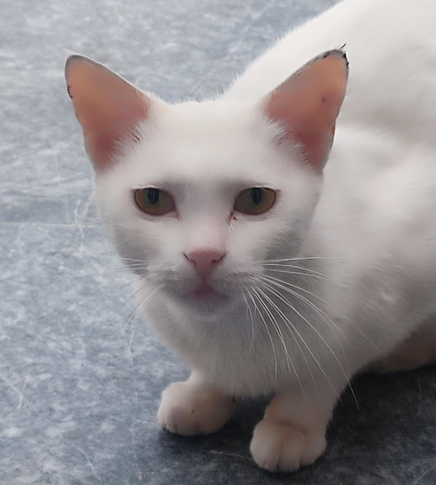  
  
Your mission is to train a Convolutional Neural Network (CNN) to recognize them with utmost precision. and identify whether the cat picture is Hurrair or his evil twin. But hold your whiskers! This isn't just about cute cat pictures; it's about understanding how CNNs, with their magical powers, can revolutionize the way we interact with technology and even save the world!

**Task #1: Train CNN without Built-in Functions**

Your first mission, should you choose to accept it, is to build a CNN from scratch without relying on any pre-built functions. You'll delve deep into the heart of neural networks, understanding every convolution, pooling layer, and activation function like a true feline detective. By crafting your CNN manually, you'll gain an intimate understanding of how each component contributes to the network's ability to learn and recognize patterns.

**Task #2: Train CNN using TensorFlow Functions**

In this task, you'll harness the power of TensorFlow, a magical library that simplifies the creation and training of CNNs. You'll discover how TensorFlow's built-in functions streamline the process, allowing you to focus more on the creative aspects of network architecture and less on the nitty-gritty details of implementation. By comparing your results with Task #1, you'll appreciate the efficiency and convenience that TensorFlow brings to the table.

**Why CNNs Matter:**

*Now, you might be wondering, "Why all this fuss about CNNs? Aren't they just fancy image recognizers?" Well, dear students, buckle up for a journey into the real-life applications of CNNs!*

*CNNs aren't just about spotting cats in photos (although that's pretty cool too). They're the unsung heroes behind facial recognition systems, enabling our smartphones to unlock with just a glance. They power autonomous vehicles, helping them distinguish between a pedestrian and a lamppost. They even aid doctors in diagnosing diseases from medical images, potentially saving countless lives.*

*But wait, there's more! CNNs are also the backbone of futuristic technologies like augmented reality, where they seamlessly blend virtual objects into our physical surroundings. From Snapchat filters to immersive gaming experiences, CNNs are the secret sauce that makes it all possible.*

*So, dear students, as you embark on your CNN adventure, remember this: whether you're identifying cats, preventing car accidents, or unlocking the secrets of the universe, CNNs are your trusty sidekicks, ready to tackle any challenge with purr-fect precision!*

**Guidelines:**

* All the necessary information is provided in the slides of Lecture 4 onwards; however, you are encouraged to explore some methods such as Yolo for better understanding.
* You can use the dataset from <https://www.kaggle.com/datasets/crawford/cat-dataset> for training your models, also using the images provided above and any creative methods that you may come across.

( MAJOR HINT: IF YOU CAN’T BE SURE WHO HURRAIR IS, TRY TO BE SURE ON WHO HURRAIR ISN’T )

* You must be able to justify your results with statistics that are available in your code, otherwise your claims will be vague and no marks will be awarded.
* In case of detection of using any LLM models such as Chatgpt, Penalty will be awarded

**Deliverables:**

* A jupyter notebook with properly formatted and documented code.
* Rename file to your student ID before submission “20L-XXXX.ipynb”