***Iblis Encryptor***

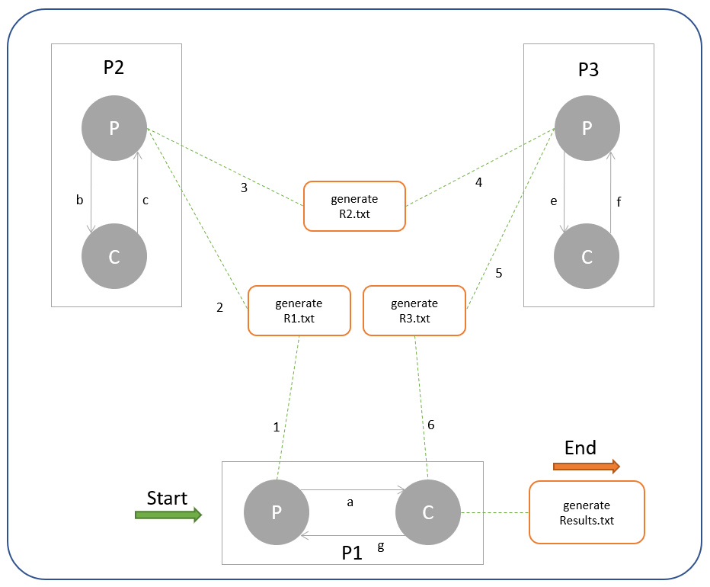

* *P1 program:*
* *Parent writes the contents to a file “R1.txt”[1].*
* *Parent also sends a message or signal to Child [a] that it has sent the contents for encryption.*
* *Child should only try to read an output from file “R3.txt” only if it has received a signal from Parent.*
* *After reading the results from “R3.txt” [6], Child replaces any character that is not alphanumeric with “-” if the index of the character is even and with “.” if the index of the character is odd and send results to Parent[g].*
* *Parent should display the results and stores them in a new text file called “Results.txt”*
* *P2 program:*
* *Parent reads the contents from file “R1.txt” [2]*
* *Parent sends them to Child [b]*
* *Child reverses the contents e.g. “Hello world, this is me” becomes “em si siht, dlrow olleH”*
* *Child sends result to Parent [c]*
* *Parent stores results in a new text file called “R2.txt”*
* *P3 program:*
* *Parent reads the contents from a file “R2.txt” and send it to Child [e]*
* *Child receives contents from Parent and also has expected result*
* *Child matches if both the contents are the same.*
* *If same, Child increments ascii value of each character by 3, otherwise, it increments value by 2.*
* *Child then sends the results to Parent [f].*
* *Parent also stores them in a new text file called “R3.txt”[5].*
* *Execution:*

*Type “make run” in terminal. Ignore the warnings and match your results with the provided results.*

*Note: make use of wait to achieve synchronization.*

***Anato’s Counter***

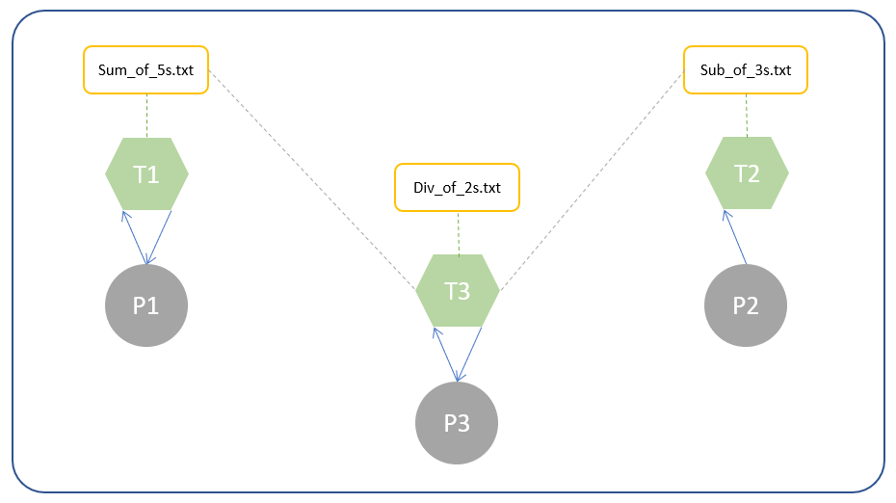

* *P1 program:*

*This program will store a number in a variable “Var”.*

* *The program will initialize 5 pthreads,*
* *In each thread, a random number is added to Var and returned to P1.*
* *P1 will calculate sum of all the results and display the sum on the screen,*
* *P1 also stores all the 5 results in a file called “Sum_of_5s.txt”.*
* *P2 program:*

*This program will store a number in a variable “Var2”.*

* *The program will initialize 3 pthreads,*
* *In each thread, a random number is subtracted from Var2 and then displayed on the screen.*
* *In each thread, the result value will also be appended in a file called “Sub_of_3s.txt”.*
* *P3 program:*

*This program will store a number in a variable “Var3”.*

* *The program will then initialize 2 pthreads, and pass them filenames ”Sum_of_5s.txt” and “Sub_of_3s.txt”.*
* *Each thread must return the multiplication of all the numbers in each file.*
* *P3 after receiving each result, will divide the values by var3 and then display on the screen*
* *P3 also appending the result values after division in a file called “Div_of_2s.txt”.*
* *Execution:*

*Type “make run” in terminal. Ignore the warnings and match your results with the provided results.*