**Report**

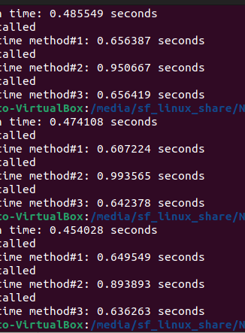

Execution times for each method

**Description:**

After comparing, we observe that method#2, in which only one row is read from the file at a time and processed, has the most time consuming as we are opening the file again and again.

But, in method#1 or method#3, where the file opens one or two times only, it gives much better results.

The results match my expectations.