1. Activate **PERSONAL** project in Epam Cloud

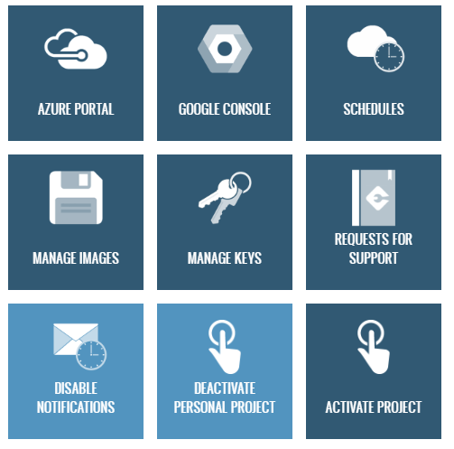

1. Download maestro-cli

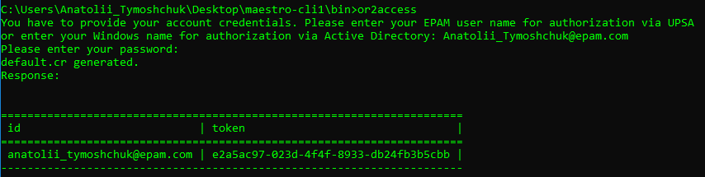

1. Execute describe regions command and choose region to run instance in it



1. Run Linux instance and Windows instances in it

Linux:

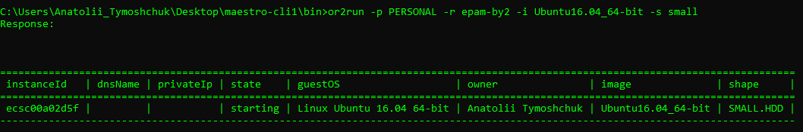

Windows:

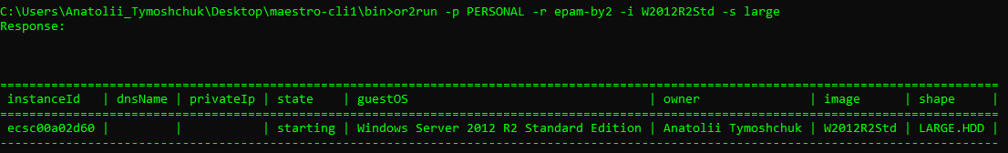

1. Execute describe instance command

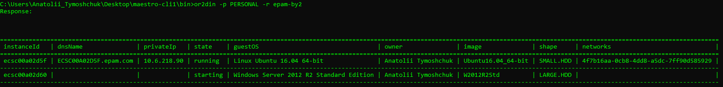

1. Login to Windows instance

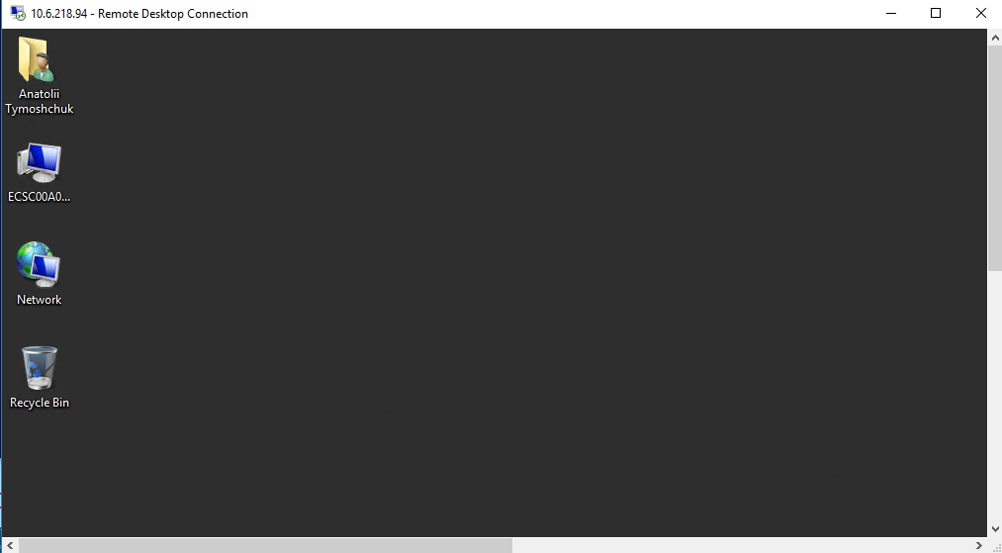

1. Login to Linux instance

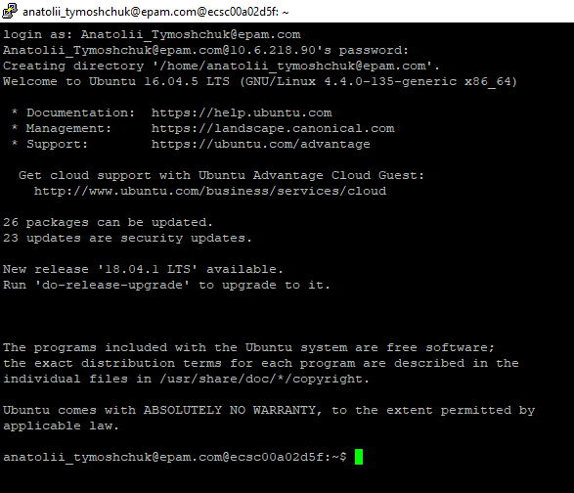

1. Reboot/suspend/stop instance

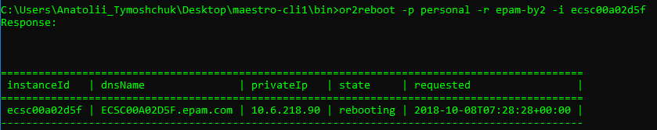



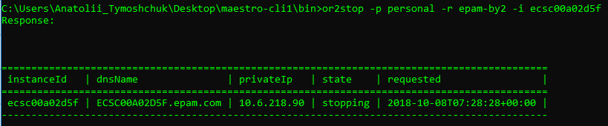

1. Change shape for instance



1. Create and attach volume. Write any information on attached volume (e.g. .doc file, .txt file, .jpg file, create any folder). Attach volume/detach volume

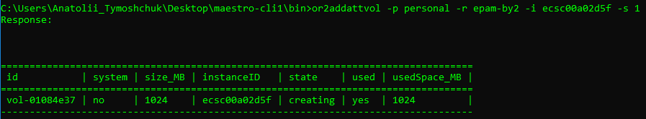

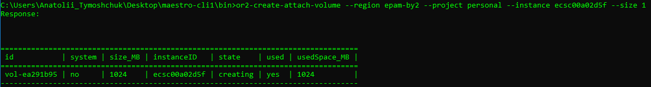

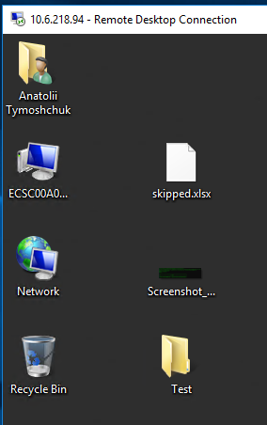

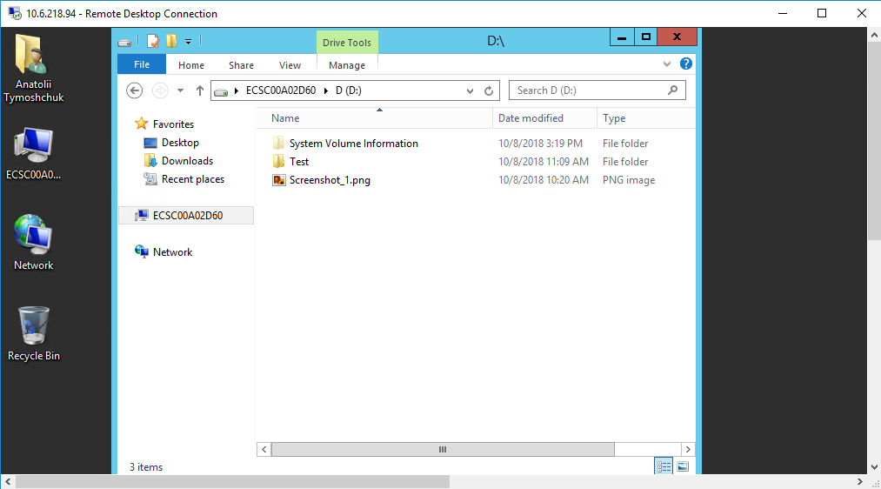

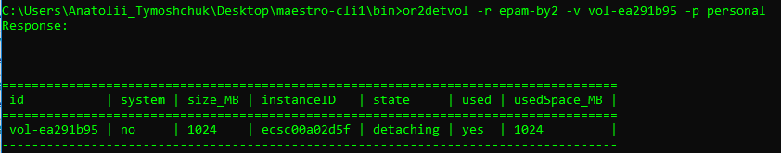

1. Create schedule for instance and check that it works

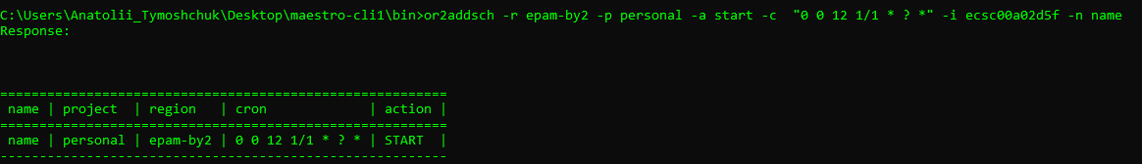

1. Add instance to schedule/remove instance from schedule

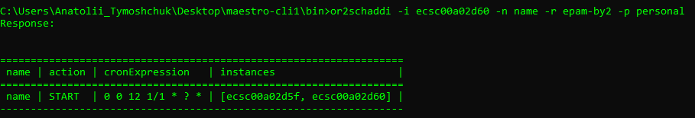

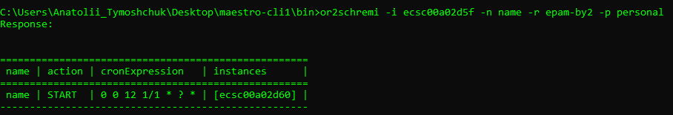

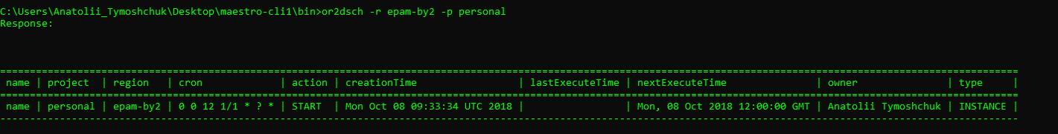

1. Create/describe/delete keypairs

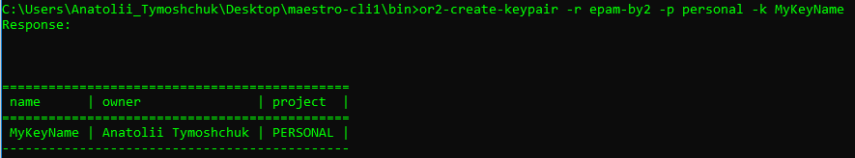

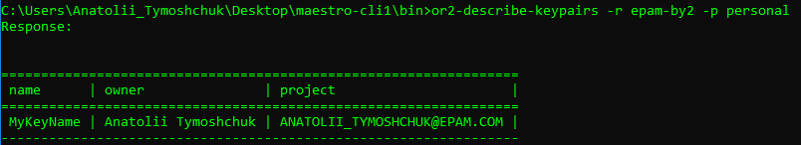

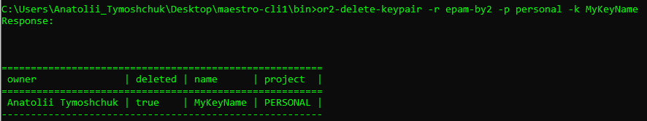

1. Set/describe tag for instance

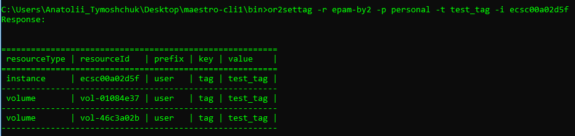

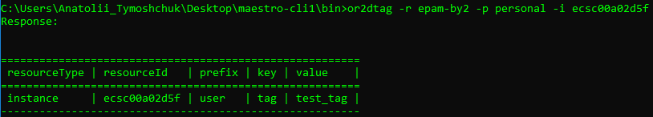

1. Set/describe instance property

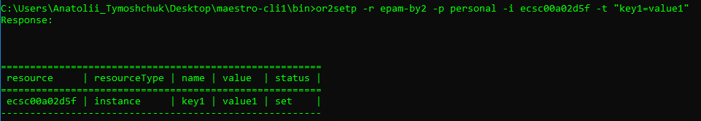

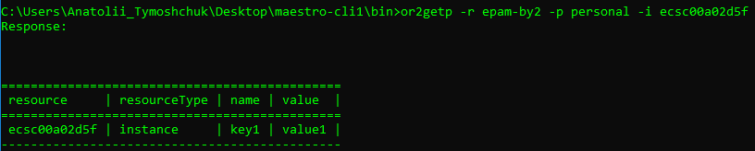

1. Retrieve instance/project audit

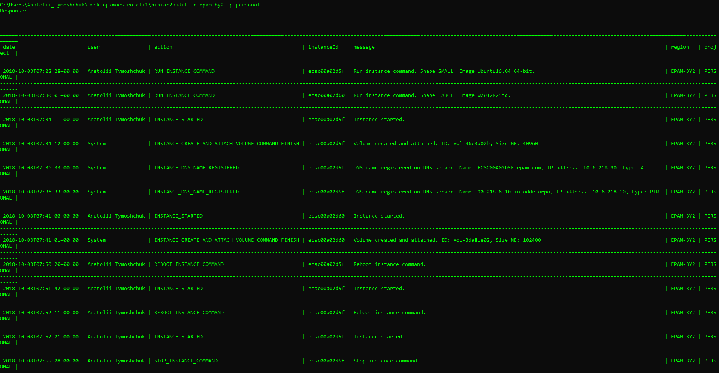

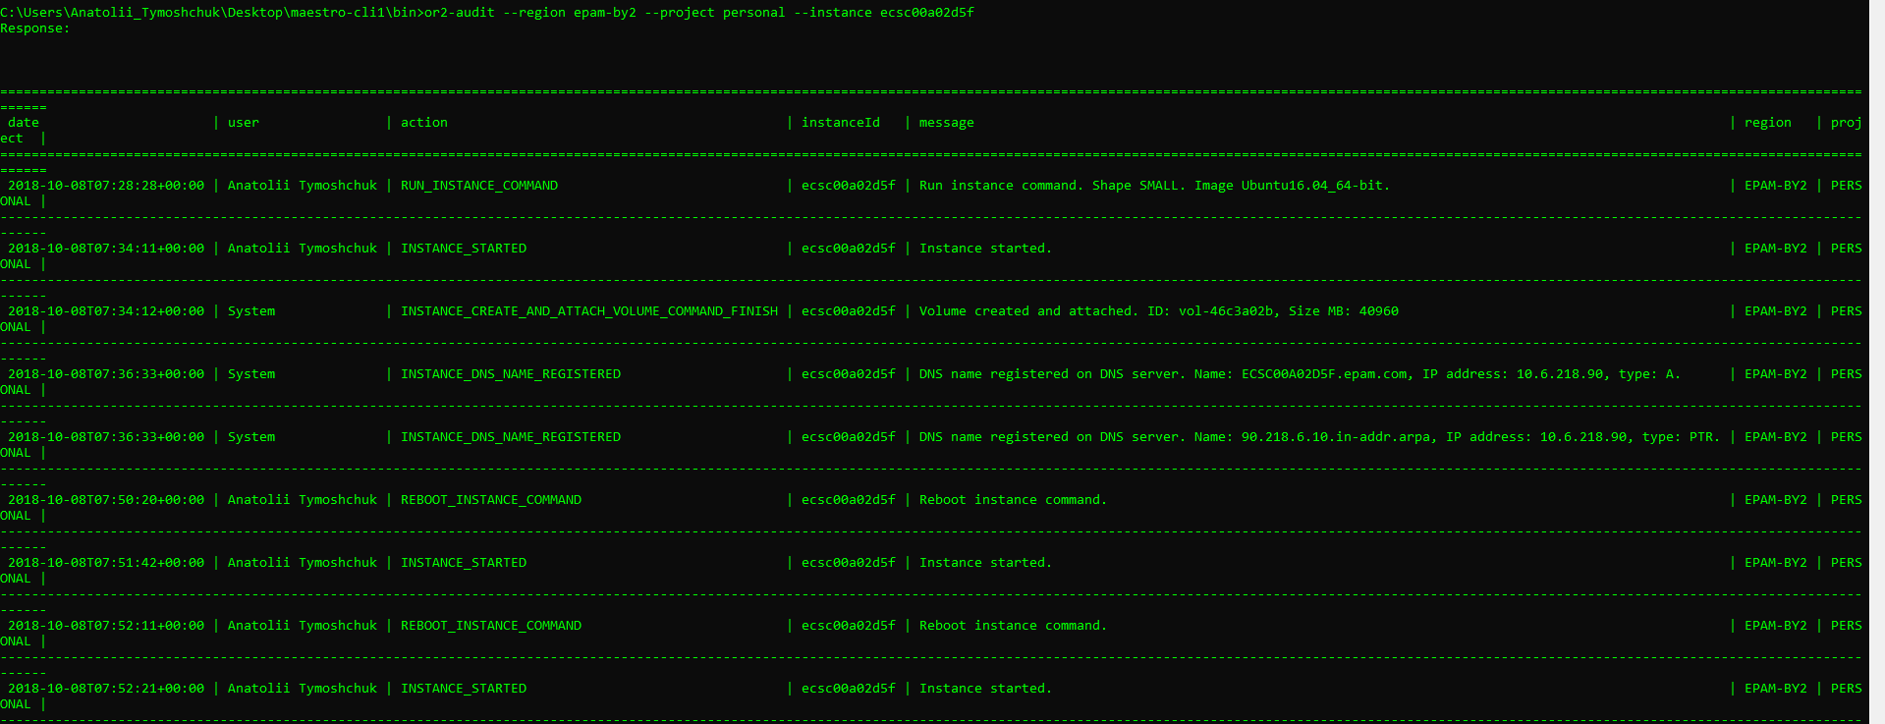

1. Generate different types of utilization report

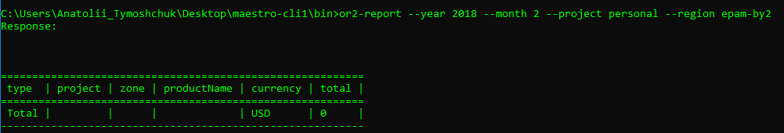

18. Analyze EPAM Cloud changes over the past six months. What of the features you are getting interested that were published to EPAM Cloud during last 6 months?

[EPAM Cloud Orchestrator version 2.1.130 is released](https://cloud.epam.com/site/about/announcements/2018/orchestrator_2/1/130_release)

EPAM Orchestrator Framework version 2.1.130 was released on September 8, 2018. The main focus was made on introduction of the new billing policy, aimed to unify the prices across private regions. The main updates on the infrastructure level include legacy infrastructure deprecation, performance improvements, OpenStack updates, and others.

 1 *AUG*

[Billing Model Changes in Private Regions](https://cloud.epam.com/site/about/announcements/2018/pricing_update)

EPAM Cloud has been facing major infrastructure updates during the latest months. These included creating new OpenStack regions and migrating virtual resources to them, updating the OpenStack versions to more recent ones, updating compute hosts and operating systems, and others.

 8 *JUL*

[EPAM Cloud Orchestrator version 2.1.125 is released](https://cloud.epam.com/site/about/announcements/2018/orchestrator_2/1/125_release)

EPAM Orchestrator Framework version 2.1.125 was released on July 8, 2018. The main focus was made on infrastructure changes: the improvements in OpenStack regions performance, EPAM-US2 region migration to the new OpenStack release and migration of EPAM Orchestrator resources to the new operating system. There is also a set of reporting and analytics upgrades, project management updates, the enhancement of OpenShift as a Service and other improvements.

 19 *MAY*

[EPAM Cloud Orchestrator version 2.1.122 is released](https://cloud.epam.com/site/about/announcements/2018/orchestrator_2/1/122_release)

EPAM Orchestrator Framework version 2.1.122 was released on May 19, 2018. The main focus was made on infrastructure changes: the new public cloud, Exoscale, is now available in beta mode via EPAM Orchestrator. There is also a set of Azure integration improvements, project management updates, a big update in Kubernetes as a Service and other improvements.