1. Select all universities. Show name and accreditation

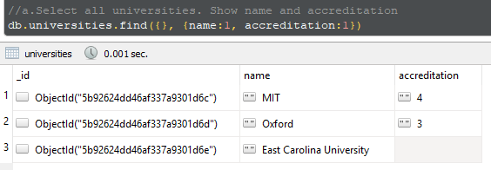

1. Select university without coordinates. Show only Address information.

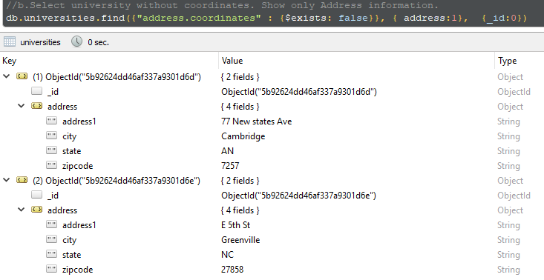

1. Select university with State = “MA” and zipcode **not** equal to “27897”. Show id, name, state, zipcode

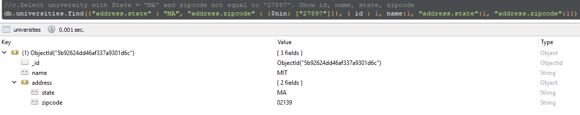

1. Select users with Date of Birth more than (>) 1980 year and less than current date. Show only Date of Birth

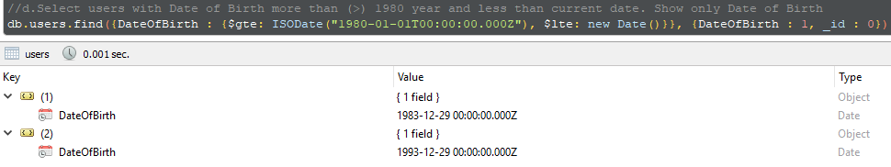

1. Change course name and delete all other information (university_id, users) for course, which contains only students.

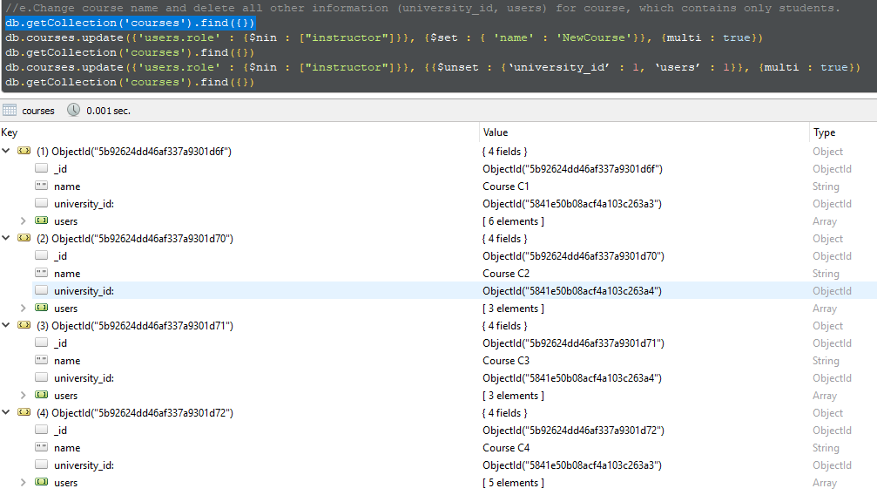

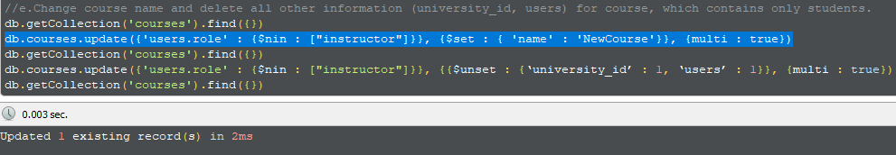

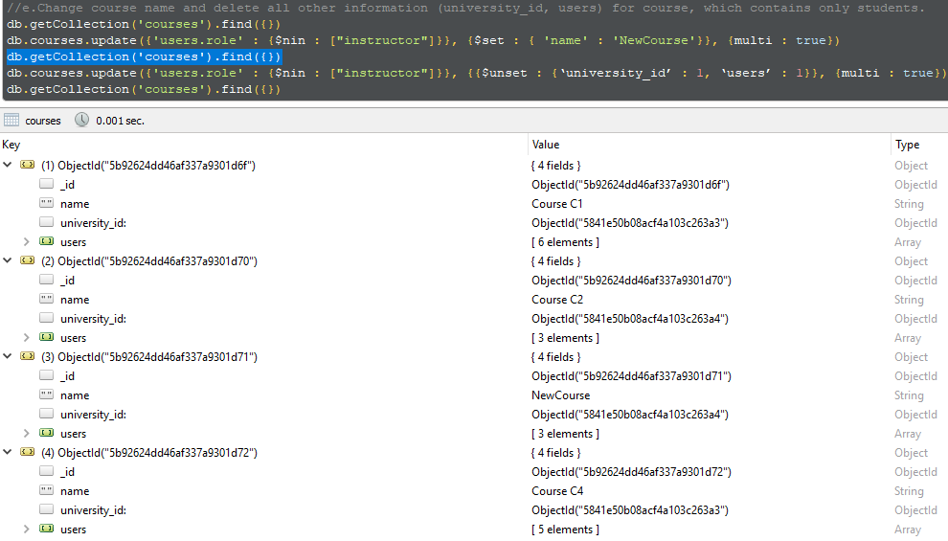

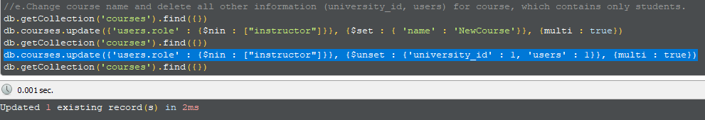

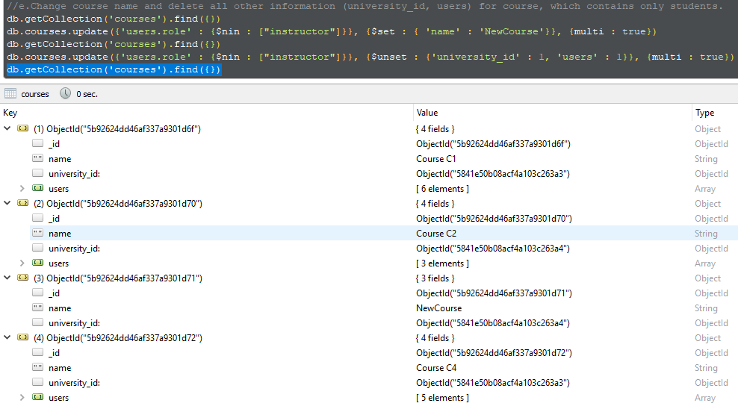

1. Select courses with max number of users. Show course name, user roles, amount of users.

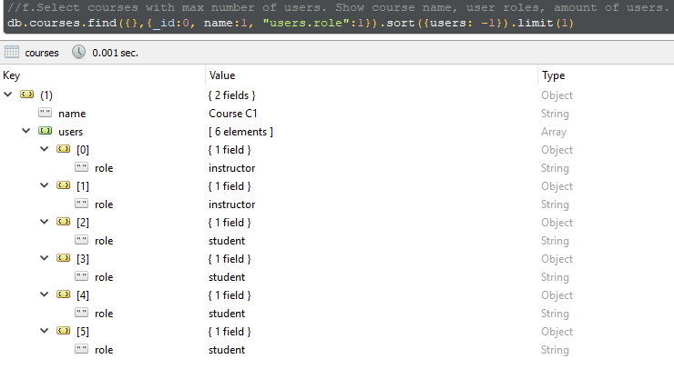

1. *Select user with the longest MiddleName. Show _id, MiddleName, length.

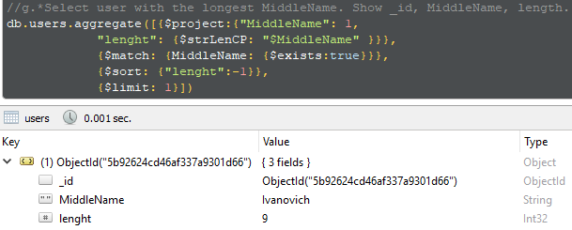

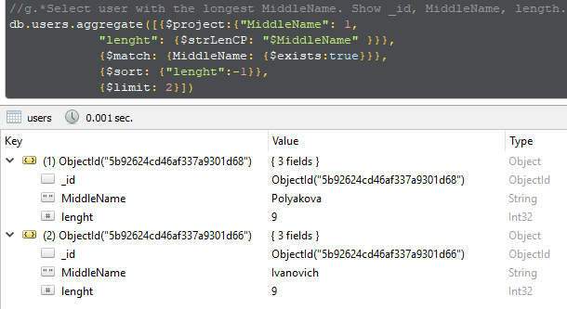

1. Update ***only*** the course name, which contains every user role.

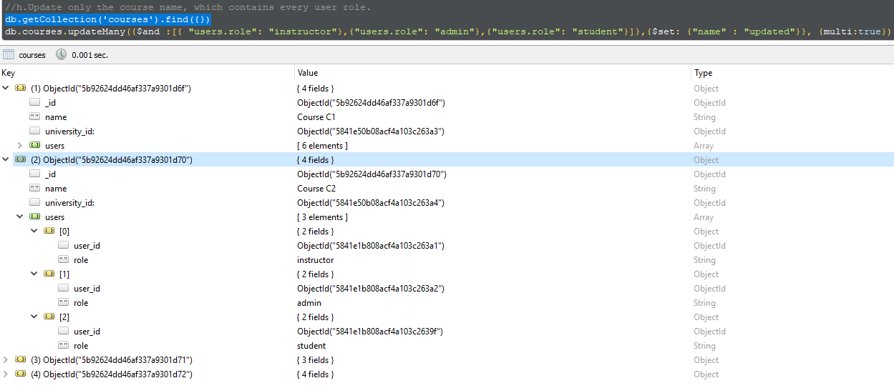

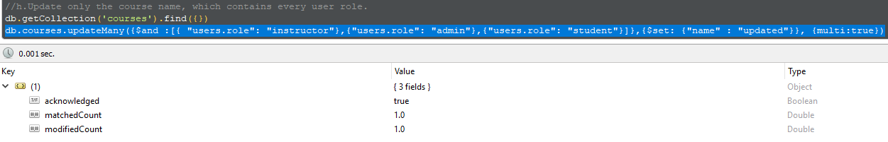

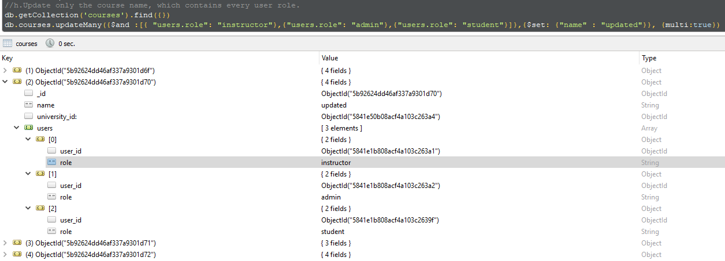

1. Replace User document with Name = “Pavel” (insert your values and pay attention for the new structure. Use .find() before replacement and compare values after)

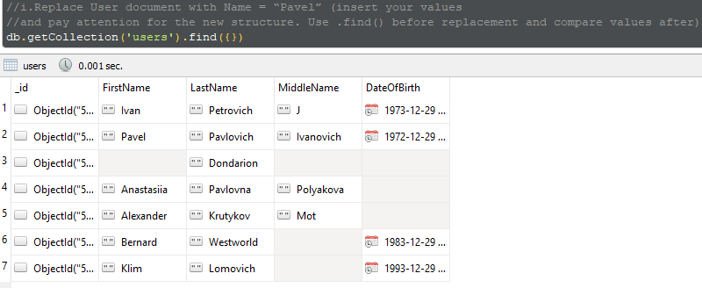

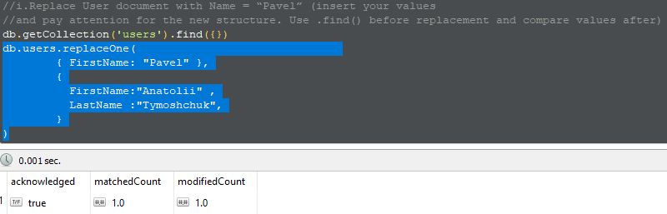

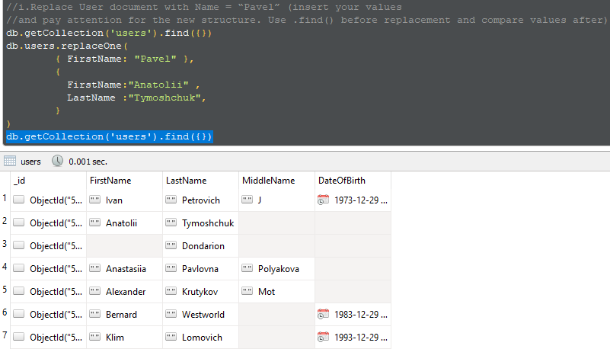

1. Delete user which has only LastName by 2 ways (use delete()and remove() commands)(i.e. MiddleName, Date of Birth, First Name are null).

